Name: _____________________ Period: _____ Date: _________________

Gummy Bears, Raisins and Osmosis

1. Background: Yesterday, we set up our gummy bear lab. One gummy was kept dry. A second was placed in water. We did the same with raisins.

2. Collecting Data
A. Visual Observations: (Note: you’ll have to observe another group’s bear to see all three treatments). How do the gummy bears and raisins look different?
____________________________________________________________________________________________________________________________________________________________________________________________
______________________________________________________________________________________________

B. Numerical Data. Carefully pour off all water before weighing. Zero the scale each time.
 | A | B | C | D
Note: you’ll have to work with another group to get one data point below | Individual data  (mass in grams) | Total class data for gummies  (mass in grams) | # of gummies | Average class data  (Total mass/# gummies )
Dry Gummy Bear
Gummy Bear in tap water
DRY RAISIN

RAISIN IN TAP WATER

Graph: Class data for our gummy bear lab  MASS (grams) Gummy Bear RAISIN  DRY Tap water DRY TAP | C. Using the concept of diffusion, can you explain what happened?  _________________________________________  _________________________________________  _________________________________________  _________________________________________  _________________________________________  _________________________________________  _________________________________________  _________________________________________  _________________________________________  _________________________________________

3. Osmosis

A. What is osmosis? | The diffusion of water.
B. How does water diffuse? | - Water diffuses just like everything else, from more concentrated (more H₂O molecules) to less concentrated (fewer H₂O molecules).
C. Review: Solutions, solvents, and solutes | - In a solution, the liquid that does the dissolving is the solvent.  - The most common solvent on earth is water  - The thing that gets dissolved is the solute.

4. Checking Understanding: a) If you mix up some powdered lemonade, the water is the ________________, and the lemonade mix is the __________________. In a cola drink, the sugar is the _______________, and the water is the _________________.
b) All molecules diffuse from _________________ concentration to _______________ concentration.

KEY POINT: Understanding osmosis is always about comparing two solutions separated by a membrane.

5. Important terms: Hypertonic & Hypotonic
A. What is a hypertonic solution? | - A solution that has a higher concentration of solute than the solution on the other side of the membrane.  - Think: less water, more solute.
B. What is a hypotonic solution? | - A solution that has a lower concentration of solute than the solution on the other side of the membrane.  - Think: more water, less solute.

6. Practice. In all problems, the two solutions have the same volume. Use hypertonic or hypotonic as your answers.
- Solution A has 10 drops of food coloring. Solution B is pure water. Solution A is ____________ to solution B. Solution B is _______________ to solution A.
- Solution X has 3 drops of ink. Solution Y has 8 drops of ink. Solution X is ________________ to solution Y. Solution Y is ____________ to solution X.
- I’ve made a solution with sugar dissolved in water. If I want to make the solution more hypotonic, I add more ___________________. If I want to make the solution more _______________, I add more sugar.
- Solution K is 90% water, 10% solute. Solution L is 100% water. Solution K is ______________ to solution L. Solution L is _______________ to solution K.

7. Back to our gummy bears
- When we put our gummy bears into water, the gummy bear was ___________________ to the water outside of it.
- You can also say, the water was ___________________ to the gummy bear.
- Because of that, the water flowed from the ____________________ into the ________________, causing it to expand and gain mass.
- A raisin placed in a cup of water will…. Because

8. Use the terms hypotonic and hypertonic to describe what’s happening in side A and side B. The dots represent SOLUTE.
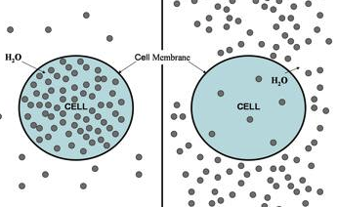  CELL B  CELL A | - Cell A is ___________________ to the surrounding solution.  - The solution outside CELL A is ___________________ to the solution inside the cell.  - As a result, water will flow.______________ CELL A.  - Cell B is _________________ to the surrounding solution.  - The solution outside CELL B is ________________ to the solution inside the cell.  - As a result, water will flow ___________ CELL B.

9. The most important idea: Water always flows from _____________________ to _______________________.

10. More Checking understanding:
- The diffusion of water is called _____________________________.
- The side of a membrane where the solution is more concentrated is the ___________________ side.
- The side of a membrane where the solution is less concentrated is the ___________________ side.

11. Reinforcement: In terms of osmosis, how does water flow across membranes? _______________________
______________________________________________________________________________________________

12. PULLING IT ALL TOGETHER: What happened in our gummy bear lab? Explain a) how we set up the lab, b) the change in mass in the gummy bears, and 3) why this occurred. Use the terms hypotonic and/or hypertonic in your response.
Language frames. | Your response
- We set up the lab as follows:  - we observed that  - This occurred because…  - Consequently  - As a result… | ___________________________________________________________________  ___________________________________________________________________  ___________________________________________________________________  ___________________________________________________________________  ___________________________________________________________________  ___________________________________________________________________  ___________________________________________________________________  ___________________________________________________________________  ___________________________________________________________________  ___________________________________________________________________  ___________________________________________________________________  ___________________________________________________________________  ___________________________________________________________________
13. Isotonic Solutions
What is an isotonic solution? | - A solution that has the same concentration of solute as the solution on the other side of the membrane.  - Think: equal concentration of water on both sides  - Result: no overall movement of solute or solvent (though molecules are moving back and forth)

14. More Checking Understanding
1. Osmosis is the ______________________ of water.
2. Two solutions are separated by a membrane. The side that has more solute dissolved in it is the _____________________ side.
3. Solution A is 94 % water, 6% solutes. Solution B is 80% water, 20% solutions. Solution A is ________________ to solution B.
4. If two solutions are both 45% water, we’d say that they were _________________ to one another.

15. Use arrows to show the direction of water movement into or out of each cell (which is 98% water). The % of water outside the cell is listed below the cell. Examine each diagram, and then complete the table.
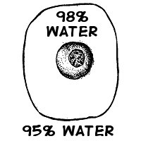 | 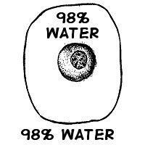 | 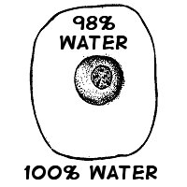
The cell is _____________ to its environment. | The cell is _____________ to its environment. | The cell is _____________ to its environment.
The outside solution is _____________ to the cell. | The outside solution is _____________ to the cell. | The outside solution is _____________ to the cell.
Water will flow ___________ the cell. | Water will flow ______ and ______ the cell and its environment at the __________ rate. | Water will flow _________ the cell.

16. More applications
A. A red blood cell is placed in a solution. The first picture shows the cell expanding. The second shows it remaining the same. The third shows it shriveling up. Was the solution isotonic, hypotonic, or hypertonic?
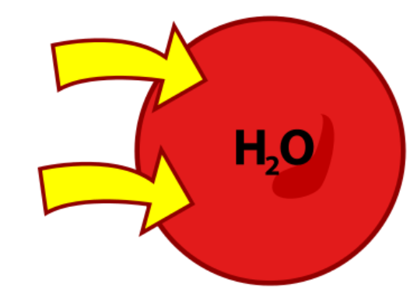 | 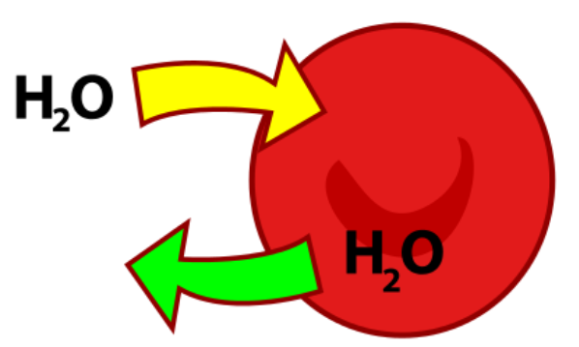 | 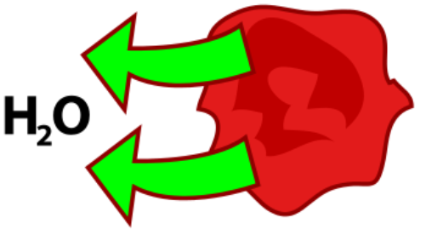
___________  solution | ___________  solution | ___________  solution
The cell must have been ____________ to its environment because water is flowing… | The cell must have been ____________ to its environment because water water is flowing… | The cell must have been ____________ to its environment because water water is flowing…

B. A plant cell, with a cell wall, is placed in a solution. The first picture shows the cell expanding. The second shows it remaining the same. The third shows it shriveling up. Was the solution isotonic, hypotonic, or hypertonic?
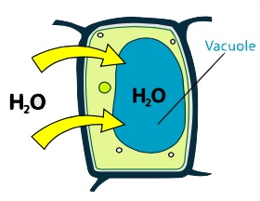 | 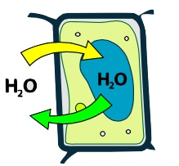 | 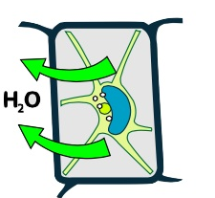
___________  solution | ___________  solution | ___________  solution
The cell must have been ____________ to its environment because water water is flowing… | The cell must have been ____________ to its environment because water water is flowing… | The cell must have been ____________ to its environment because water is flowing…
C. Think about it: Why didn’t the plant cell burst?
______________________________________________________________________________________________
______________________________________________________________________________________________

17. Yet more checking for understanding
a. isotonic b. hypertonic c. hypotonic
- _____ Solution with a lower solute concentration than the one on the other side of the membrane.
- _____ Solution in which the solute concentration is the same as the other side of the membrane
- _____ Condition plant cells require so that they don’t wilt.
- _____ Condition that animal cells require so that they don’t shrink or burst.
- _____ This solution will cause red blood cells to burst
- _____ In this solution, a plant cell wilts as it loses water..
- _____ A solution with a higher solute concentration than the one on the other side of the membrane.
- _____ A solution with a higher concentration of water than the one on the other side of the membrane.
- _____ A solution with a higher concentration of dissolved materials than the one on the other side of the membrane.

Osmosis! (Music Video)
View it at www.sciencemusicvideos.com
Glenn Wolkenfeld © 2012

I put this yummy gummy through a science experiment,
That models what happens to a cell in an environment
That’s more watery than the cell is inside,
And what I saw came as no surprise,

My gummy expanded -- quintupled in weight,
My gummy expanded, an increase so great,
So listen up as Mr. W explains this!
It’s all about osmosis!

Osmosis is the diffusion of water,
Across a membrane or a water-permeable border.
Diffusing like all molecules in fluid situations,
From higher to lower concentration.

CHORUS
OSMOSIS!
H₂0 diffusing
OSMOSIS!
See that water oozing
Hypotonic to hypertonic flow
OSMOSIS!
Let’s go!

Let’s talk about our gummy, in osmotic terms,
Hypotonic, hypertonic, isotonic are the words
You can use to discuss water’s watery diffusion,
Learn ‘em well, to avoid confusion.

Hypotonic means higher water concentration
And relatively lower solute concentration,
Hypertonic is the opposite --percent of water’s less,
With more solute dissolved inside, as you might guess

So let’s take these terms and apply them to our gummy bear,
I’m looking at the package, and seeing what it says here,
Each bear is mostly sugar with some other stuff mixed in,
And holding it together is the protein gelatin

So when you put a gummy in a cup of H₂O
It’s readily apparent that the gummy is so
Hypertonic to the water that it’s in,
and the water’s hypotonic to our little gummy friend,

And so through osmosis the water will diffuse,
Into the gummy which soon will look so huge,
The mass it gains is water which will infiltrate the gummy,
Which one day later, is looking pretty funny

CHORUS

Next I took this freshwater plant, name is elodea
It lives in lake and ponds never in the salty sea,
In fresh water elodea cells are full and firm,
It’s all about osmosis as we’re gonna confirm.

See the cells are hypertonic to their watery exterior,
So water will diffuse into the cell’s interior,
Expanding the membrane, pushing it against the wall,
In fact you can’t see the membrane at all,

But add some salty water so the outside’s hypertonic,
And water leaves the hypotonic cells, it’s so osmotic!
Membrane leaves the wall, the cells’ insides are scrunched.
With the chloroplasts all stuck together in a bunch

That’s why at the grocery they always have that mister
The water on the veggies helps to keep them crisper,
Those droplets on the veggies are a hypotonic brew,
osmosis moves the water in, the veggies look brand new.

Dried fruit and beef jerky preservation is osmotic
Their low water content makes the dry food hypertonic
So any germs or molds that fall upon them lose their water
And die and don’t contaminate the dried food in the larder

CHORUS

Animal cells, in situation hypertonic
Lose their water, shrink and shrivel look so sick
But an animal cell in hypotonic abode
Gains water and expands, eventually explodes

‘Cause animals cells lack a wall, of course
So nothing pushes back at the osmotic force,
Water flows from hypotonic to the hypertonic cell,
Which bursts cause the membrane can’t stop the swell,

If you want to keep a frog heart outside a body beating,
An isotonic fluid, is what you’ll be needing,
Water concentration’s same on each side of the cell,
No gain or loss of water, the cell’s feel so swell

And this paramecium which lives in ponds and lakes
Constantly fights osmotic water uptake,
The contractile vacuole’s a pumping adaptation
To deal with this osmotic situation

TEACHER’S GUIDE

1) Set up
a) Get a class set of beakers or cups.
b) Make a solution of 10% sucrose
c) Have water available.

2) The day before the analysis, each lab group does the following
a) In the first cup, one gummy bear gets taped to the outside the cup. The cup is filled with water. The second gummy bear gets placed in the water.
b) In the second cup, A gummy bear gets taped to the outside of the cup. The cup is filled with 10% sucrose solution. Another gummy bear is placed inside the 10% sucrose.
c) Let these sit overnight.

3) The gummy bear in water will gain a huge amount of mass and volume. I have the students weigh individually, and then we record the total mass of all the gummies (dry, in water, in 10% sucrose) and average them. That’s what we graph.

4)Target language performance for 1# 10
What happened in our gummy bear lab? Explain a) how we set up the lab, b) the change in mass in the gummy bears, and 3) explain why this occurred. Use the terms hypotonic and/or hypertonic in your response.

In our gummy bear lab, we placed gummy bears in two solutions. One was pure water, and one was 10% sucrose. After 24 hours, we observed that the gummy bear in pure water gained the most mass. The gummy bear in 10% sucrose gained less mass, and the dry gummy bear stayed the same.
Why did this happen? The gummy bear in pure water was in an extremely hypotonic environment. Consequently, water flowed from the hypotonic water to the hypertonic gummy bear, causing it to gain mass as it took up water. The 10% sucrose solution was also hypotonic to the gummy bear, but less so. As a result, less water flowed into the gummy bear, and it gained less mass.

