Name: _____________________ Period: _____ Date: _________________

sciencemusicvideos Adaptation, Natural and Artificial Selection, and Population Genetics Student Learning Guide
Getting to the tutorials.
- Go to www.sciencemusicvideos.com; Use the College Bio, AP Bio, or Learning Guide Menus to find “Adaptation, Natural and Artificial Selection, Population Genetics”
- Start with “1. Thinking Like Darwin: Adaptation, Artificial and Natural Selection.

1. Tutorial 1: Thinking Like Darwin
1a. Read, “Adaptations are traits the help organisms...” ☐
In your own words, define adaptation.

1b. In the space below, list three notable adaptations that are not described in this tutorial .

2. Read “Selective Breeding, or artificial selection...” ☐
3. Complete the Adaptation and Selective Breeding Quiz ☐
3a. Define the term species:

3b. List and briefly describe some varieties or breeds to accompany the examples in this tutorial (no dogs or members of the Brassica family).

3c. Explain why varieties or breeds are not species.

3d. What’s a phenotype, and how does it apply to selective breeding?

4. Read “Natural Selection, an interactive reading...” ☐
4a. Natural selection can be summarized as four related steps. List them below.

4b. Natural selection winds up sitting next to artificial selection at a baseball stadium They have a brief conversation where they note how similar they are, while acknowledging their differences. Write down their dialogue below.

4c. What is mutation, and how is mutation important to natural selection?

4d. What’s an evolutionary arms race?

5. Read “A few additional ideas related to natural selection...” ☐
6. Take the quiz, “Adaptation, Artificial Selection, and Natural Selection.”☐

6a. Explain why populations, and not individuals, are the units of evolution.

6b. Natural selection is sometimes summarized as “survival of the fittest.” What is evolutionary fitness?

6c. Pick an organism of your choice. Focus on one adaptation. 1. In the space below, create a speculative hypothesis about how that adaptation might have evolved through natural selection.

6d. Look over your explanation. See if you can design an experiment to test your hypothesis.

Tutorial 2: Alleles in Gene Pools
1. Read, “A Population Genetics Case Study: The Cheetah” ☐
Summarize: Genetically speaking, what’s the cheetah’s problem?

2. Complete, “The Gene Pool, Fixed Alleles…” interactive reading ☐
Define Allele:

Define Gene locus:

Define Fixed allele:

3. Take the “Checking Understanding” Quiz ☐
REFLECTION: 3 things you learned from this section:

Tutorial 3. Follow the link to “Understanding Allele Frequencies in Gene Pools.”
1. Allele Frequency. Complete the reading and interactive table (1.a.), and the quiz (1.b.) ☐
Summarize: What is allele frequency?

2. Complete the reading “Allele Frequency Case Study: The Peppered Moth” ☐
Application: Use the concept of allele frequency to explain how the color of the peppered moth changed in response to pollution in English forests in the mid-1800s. (Continue this on the next column)

3. Read the section entitled “Misconception Alert! ‘Dominant Allele’ does not mean ‘Most common Allele.’” ☐
4. Complete the reading: “Allele frequencies and fixed alleles in dogs” ☐
5. Complete the “Checking Understanding” Quiz. ☐
Reflection: The three most important things I learned from this section were …

Tutorial 4. Follow the link to “The Hardy-Weinberg Equation.”
1. Some Population Genetic Analysis to Get Us Started, including 1.a. Population Genetics Analysis Task 1
Note that the paper version of the data set is much easier to use: it’s been provided to you as a separate handout.
Read the introduction, complete the activity, and record the results of your analysis below. Then check your results (using the webpage)
Allele or genotype | fraction | decimal
a | ____/400 | 0._____
A | ____/400 | 0._____
aa | ____/200 | 0._____
Aa | ____/200 | 0._____
AA | ____/200 | 0._____
1.b. Population Genetics Analysis Task 2
Now, look back at the table, and note relationships between your results. Write them down, then click “show the answer.” As needed, make corrections or additions in the space below.

2. Read “Population Genetic Analysis is about counting…”☐
After reading, complete the “Hardy-WeinbergEquation” Flashcards. ☐
Total Recall: From memory, complete the table below:
Symbol | Represents the frequency of…
p
q
p²
2pq
q²
3. Read “Use Cross Multiplication Tables.”
More Recall: From memory, put the symbols from the table above into the cross multiplication table below.

4. Complete “Solving Hardy-Weinberg Problems Using Cross Multiplication Tables.” Solve the problems in the spaces below, and use the flashcards to check your work.

PROBLEM 1: In a population, the frequency of the homozygous recessive phenotype is 36%. Determine the frequency of
- the recessive allele
- the dominant allele
- homozygous dominants
- heterozygotes

PROBLEM 2: A study in an African nation estimated the frequency of individuals born with sickle cell anemia as 2.1%. What is the frequency of heterozygotes (individuals who don't suffer the symptoms of sickle cell anemia, but, on account of possessing the allele, have some resistance to the parasite that causes malaria)?
PROBLEM 3: In a population of butterflies, brown (B) is dominant over white (b). 40% of the butterflies are white. What's the percentage of
- the recessive allele
- the dominant allele
- homozygous dominants
- heterozygotes

PROBLEM 4: Cystic fibrosis is the most common inherited disease among North Americans of European ancestry. The disease is caused by a recessive allele. About 1 in 2500 babies are born with this condition. What percentage of the population are carriers?

PROBLEM 5: The frequency of two alleles in a gene pool is 0.19 (A) and 0.81 (a). What is the percentage of heterozygotes in the population? What's the percentage of homozygous recessives.

Tutorial 5. Follow the link to “The Hardy-Weinberg Principle.”
1 & 2. Read the introduction and “The Principle, a Starting Definition.” ☐
SUMMARIZE: Based on the text, write down the Hardy-Weinberg Principle.

3. Read “Factors that Keep Populations in Genetic Equilibrium.” ☐
4. Read “Remembering the Hardy-Weinberg Principle…” and take the fill-in-the-blanks quiz.
Remembering what you’ve learned: In the space below, write down the five conditions that keep gene pools in equilibrium.

Click the link to the next tutorial: “Natural selection in Gene Pools”
Tutorial 6. Natural Selection in Gene Pools
1. Read the introduction ☐
2. Read “Natural Selection Directly Acts on Phenotypes” and complete the “Genotype v. Phenotype” interactive table ☐
Complete the following table
Term | Definition
Phenotype
Genotype
3. Read “Natural Selection Increases the Frequency of Beneficial Alleles…” ☐
CHECKING UNDERSTANDING: How does natural selection change gene pools?

Complete this sentence: Natural selection selects _______________ in individuals. In doing so, it changes the frequency of ________________ in populations.

4. Read “Natural Selection in Action...” ☐
Answer the following questions:
4a. People select traits in domesticated animals. Who selected the colors of the peppered moths (and how)?

4b. Summarize how the ice fish evolved its red-blood cell free blood….

4c. Summarize how different phenotypes of pocket mice evolved in the Arizona desert.

5. Read “Natural Selection can Unfold in Three Ways.” ☐
Complete the table below, comparing the three modes of selection you just read about:
Type of selection | Image | Description
Directional
Stabilizing
Disruptive

6. Checking Understanding. Read the summary and take the “Natural Selection in Gene Pools Quiz.” ☐
Reflection: Think about the whole tutorial (all the exercises, readings, and all the questions you’ve answered). At this point, what is population genetics? What does it explain?

Tutorial 7. Follow the link to the next tutorial “Why Harmful Alleles Don’t Disappear”
1. Read the introduction ☐
2. Complete the interactive reading, “Harmful Recessive Alleles” ☐
REFLECTION: In your own words, explain why harmful recessive alleles stay in gene pools.

3. Read “The persistence of harmful dominant alleles” ☐
REFLECTION: In your own words, explain why harmful dominant alleles stay in gene pools.

4. Take the quiz “Why Harmful Alleles Persist in Gene Pools” ☐
Reflection: Despite natural selection, why aren’t gene pools full of perfect genes?

Tutorial 8. Follow the link to the next tutorial: Mutation in Gene Pools, and Heterozygote Advantage.
1. Read “Mutations, DNA, and Protein.” You’ve already learned a lot of this, so it should be easy. ☐
SUMMARIZE: in your own words, explain the genetic and molecular causes of sickle cell anemia.

2. Read “Mutations can have three types of consequences.” ☐
SUMMARIZE by answering the questions that follow:
2a. When are mutations harmful? Give some specific examples,

2b. What’s a silent mutation?

2c. How could a mutation be helpful?

2d. What is heterozygote advantage?

3. Take the Checking Understanding Quiz ☐
Reflection: In terms of a population’s gene pool, how is mutation important?

META Reflection: Think about the whole tutorial (all the exercises, readings, and all the questions you’ve answered, from the first page to this point). At this point, what is population genetics? What does it explain?

Follow the link to the next tutorial (“Genetic Drift…)”

Tutorial 9. Genetic Drift, the Founder Effect, and Population Bottlenecks.
1. Read: ”Genetic drift can explain…” ☐
SUMMARIZE: in your own words, explain what genetic drift is:

2a. Read about the founder effect: ☐
SUMMARIZE: In your own words, explain what the founder effect is:

2b. Read about population bottlenecks as applied to Elephant seals: ☐
SUMMARIZE: in your own words, explain what a population bottleneck is:

2c. Read about cheetahs: ☐
SUMMARIZE: in your own words, explain why cheetahs have such little genetic variation:

3. Take the “Checking Understanding“ Quiz
Reflection: In terms of a population’s gene pool, why is genetic drift important?

Follow the link to the population genetics cumulative quiz.
10.Take the cumulative quiz: ☐

Population Genetics Review Questions
1. Describe, in terms of allele frequencies and the environment, how the peppered moth changed from mostly light to mostly dark.

2. In terms of fixed alleles and number of heterozygotes, how are dogs with a pedigree different from mutts?

3. Describe two genetic conditions that are caused by dominant alleles, but are exceedingly rare. Why don’t these conditions disappear altogether?

4. Describe two recessive genetic conditions that are caused by recessive alleles. Why don’t they disappear?

5. In terms of evolution, what happens to phenotypes, and what happens to allele frequencies?

6. Are you going to evolve over the course of your life? What’s a better word for what happens to individual organisms?

7. Use the terms “allele,” “allele frequency,” and “gene pool” to explain the evolution of fur color in the rock pocket mouse.

8. Use the terms “allele,” “allele frequency,” and “gene pool” to explain how the ice fish evolved its unique, hemoglobin-free type of blood.

9. What is the Hardy-Weinberg equation. Write the equation, and then, much more importantly, explain what the equation means.

8. What is the Hardy-Weinberg principle: List, from memory, the five conditions that keep populations in genetic equilibrium, and describe each one.

9. What role do mutations play in gene pools?

10. How and when can the sickle cell mutation be beneficial?

11. Search for “heterozygote advantage” on-line. List and briefly describe at least three additional examples of heterozygote advantage

11. Write a short paragraph in which you compare and contrast the founder effect with a population bottleneck.

AP/College Biology| sciencemusicvideos
Population Genetics Crossword
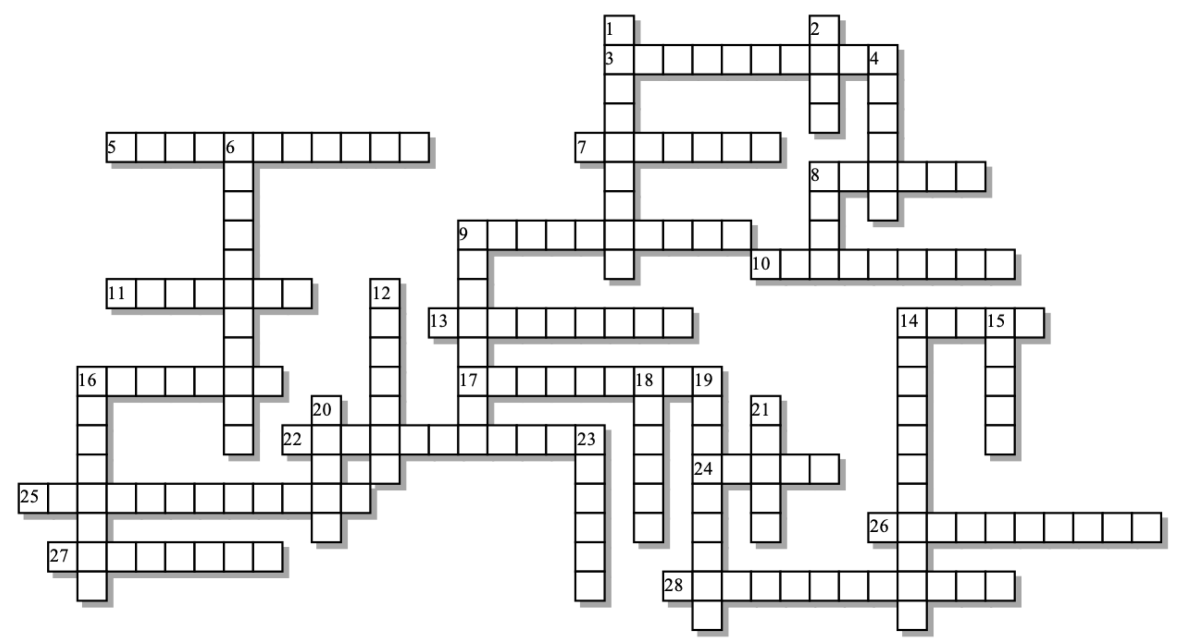
Across: | Down:
3 - If you can count the number of individuals with a _________ recessive phenotype, you can figure out a lot about a gene pool's structure. "  5 - Selection against the extremes of a trait in a population.  7 - The ________ effect is when a small number of individuals with unusual alleles give rise to a new population.  8 - Mating in genetically stable populations must be  9 - Selection against the average trait in a population  10 - Allele ________ is how common an allele is in a gene pool.  11 - This kind of selection occurs when one phenotype leaves more offspring than other phenotypes  13 - Loss of genetic ____________ is associated with genetic drift.  14 - Genetic ___________ is a change in allele frequencies caused by random events  16 - If you're a heterozygote for sickle cell, you have a better chance of surviving this disease  17 - Heterozygote ___________ is one explanation for the persistence of harmful recessive alleles in gene pools.  22 - Individuals are selected. Only ______________ evolve.  24 - For a population to be genetically stable, it must be  25 - 2pq is the frequency of individuals who are _________.  26 - A population _________ is when a population suffers huge mortality, and a few, random survivors give rise to a new population."  27 - The H-W principle states that if five conditions are met, allele frequencies will remain  28 - The gene pool of ___________ populations, like specific breeds of dogs or cattle, will have many fixed alleles. |  | 1 - Natural selection can only act on an organism's ________________  2 - All the alleles for all the genes in a population make up a population's gene __________  4 - A mutation with no effect on the phenotype  6 - Populations that are genetically stable will have no _____________ or emigration  8 - It's possible for a dominant allele to be extremely _________  9 - The allele for Huntington's is an example of a harmful _________ allele that persists in the human gene pool.  12 - _______ recessive alleles, because they can hide out in heterozygotes, don't get selected out of gene pools.  14 - In a graph of a quantifiable trait in a population, this type of selection pushes the average to the left or right.  15 - If there's only one allele for a gene locus, then that allele is  16 - Random change in DNA that brings new alleles into gene pools.  18 - An alternative form of a gene  19 - Change in allele frequencies in a population is  20 - The spot on a chromosome where you find a gene  21 - First part of the name of the most important equation in population genetics.  23 - This kind of selection occurs when one phenotype in one sex gets more matings than other phenotypes.

Word bank: Hardy, advantage, allele, bottleneck, constant, directional, disruptive, diversity, domesticated, dominant, drift, evolution, fixed, founder, frequency, harmful, heterozygous, homozygous, immigration, large, locus, malaria, mutation, natural, phenotype, pool, populations, random, rare, sexual, silent, stabilizing

