Name: _____________________ Period: _____ Date: _________________

sciencemusicvideos Animal Development and Cell Specialization, Student Learning Guide

Getting to the tutorials.
- Go to www.sciencemusicvideos.com; Use the College Bio, AP Bio, or Learning Guide Menus to find “Animal Developement”

Tutorial 1: Animal Development 1
1. Read the Introduction. ☐
2. Read “Major processes and milestones.” ☐
3. Read “Some Highlights of Embryonic Development.” ☐
4. Take the Quiz: “Development, Key Patterns and Processes.”
Defining the terms: From memory (if possible), write out definitions of the following terms:
- Determination
- Differentiation
- Morphogenesis
- Blastula
- Endoderm
- Ectoderm
- Mesoderm

Describing the processes: From memory (if possible), write out descriptions of the following processes:
- Cleavage
- Gastrulation
- Morphogenesis

Tutorial 2: Principles of Animal Development, Part 1
1. Read the Introduction. ☐
2 Read Principle # 1. ☐
3. Read Principle # 2. ☐
4. Read Principle # 3. ☐
5. Take the quiz: “Genomic Equivalence, Determination, and Differentiation”
SUMMARIZE, In your own words, explain genomic equivalence.

Imaginative Science Writing: A cloned frog meets a cloned sheep at a café. They tell each other their origin stories. In the space below these two diagrams, write out what they say,
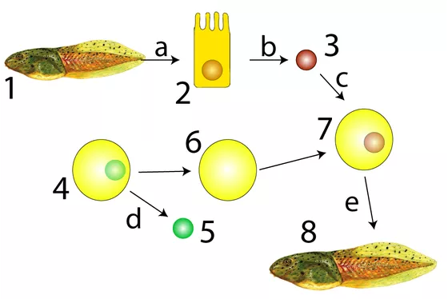 | 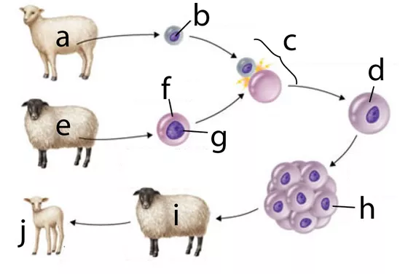

SUMMARIZE: Explain what this diagram says about genes, gene expression, determination, and differentiation. Write small.
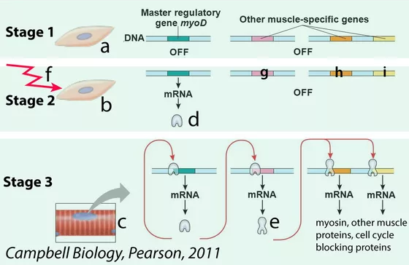

6. Read Principle # 4. ☐
7. Read Principle # 5. ☐
8. Take the quiz: “Cytoplasmic Influences and Induction”
Explain it! In the space to the right of the diagram, explain how cytoplasmic determination works.
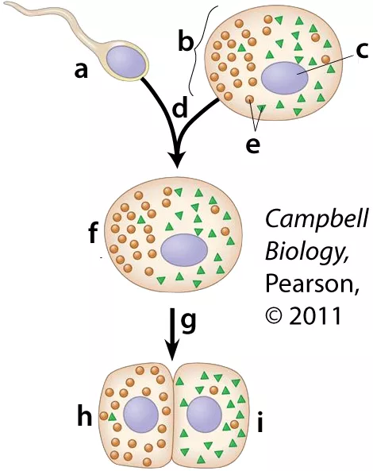

IMAGINATIVE SCIENCE WRITING
In genetics lab, you meet a bicoid mutant fly. It only has its abdominal segments. It’s barely alive. While it still has time, explain to it why it was born without a head.

Make a key for the diagram below
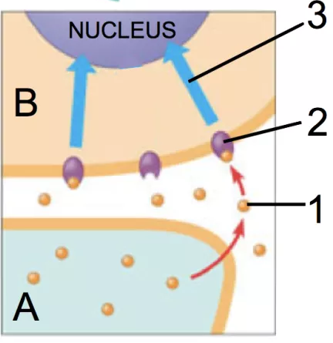 | A
 | B
 | 1
 | 2
 | 3

Explain what happened in the Spemann-Mangold Experiment:
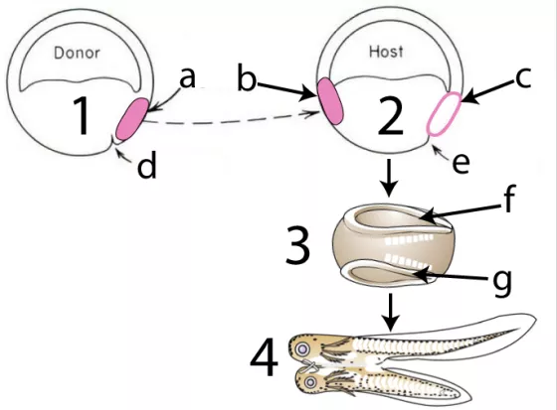

Tutorial 3: Principles of Animal Development, Part 2
1. Read the Introduction. ☐
2 Read Principle # 6. ☐
3. Read Principle # 7. ☐
4. Take the quiz: “Morphogenetic Gradients and Apoptosis”

SYNTHESIZE IT!” As cells develop, one of the key questions they have to answer is “what should I be when I grow up?” Then answer is often answered by the question “Where am I?” Use Lewis Wolpert’s “French Flag Model” to explain how cells answer both questions.
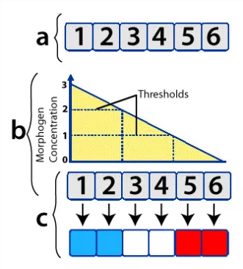

Now use the French flag model to explain what happened in the experiment below, and why:
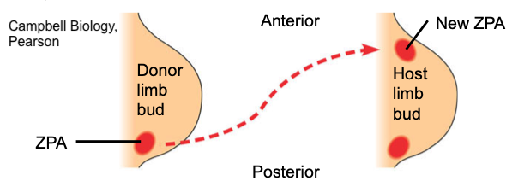

And now use the French Flag model to explain vulva development in C. elegans
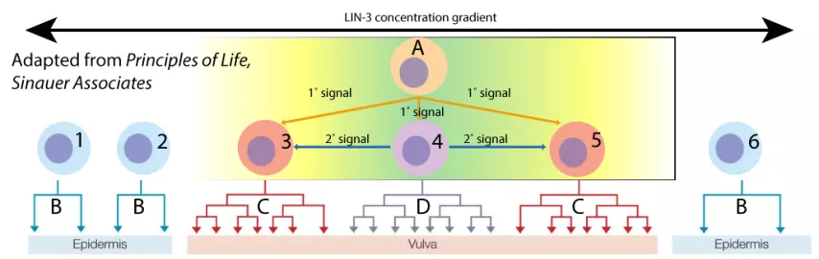

Explain why apoptosis is important in development:
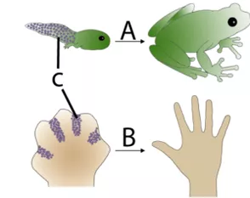

Explain how apoptosis occurs (and doesn’t occur) in C. elegans: Write small in the space to the right of the diagram.
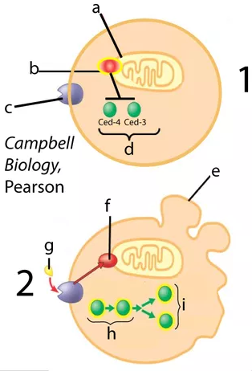

5. Read Principle # 8. ☐
6. Read Principle # 9. ☐
7. Take the quiz, “Genetic Hierarchies, Homeotic Genes.”
EXPLAIN IT. Without worrying about the names of specific genes, use the space to the right of the diagram below to explain how a hierarchical cascade of gene activations brings about segmentation in drosophila.

Explain what homeotic genes are, how they work, and why they’re evolutionarily significant.
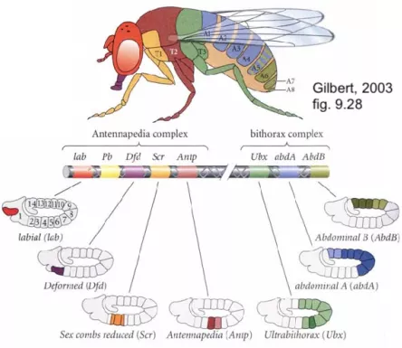

sciencemusicvideos.com | Name:________________________
Animal Development
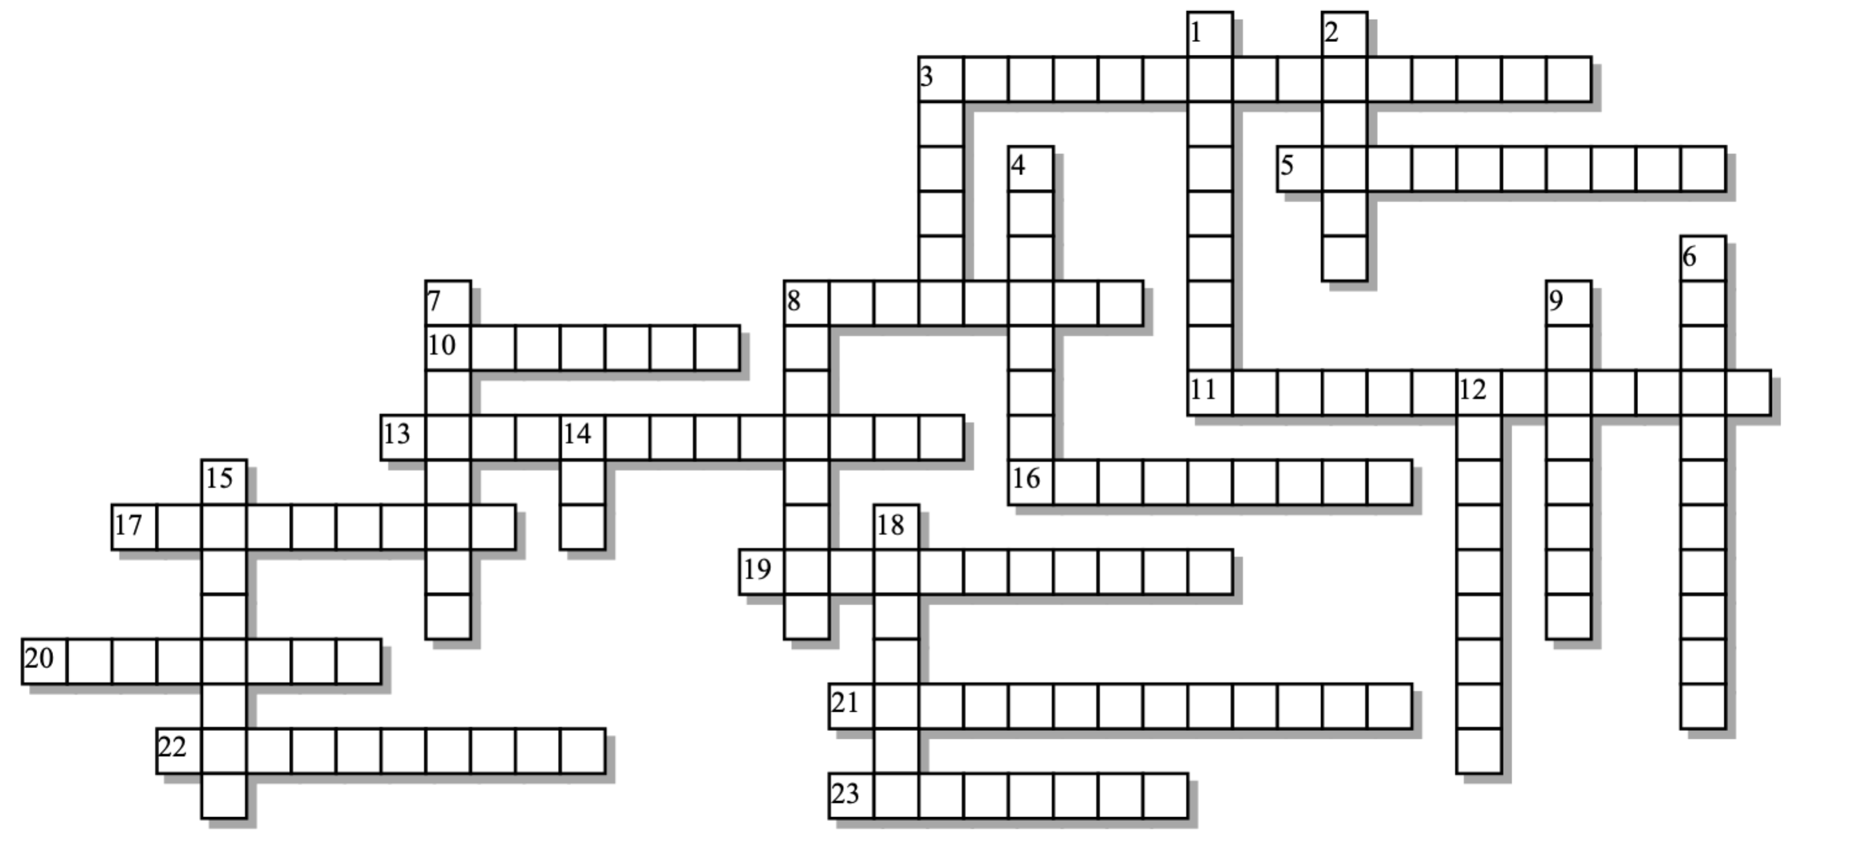

Across: | Down:
3 - Expressing the tissue-specific proteins that are identified with a specific tissue type  5 - Gradients of morphogens can give cells important _________________ information.  8 - This type of mutation might put a leg on the head, instead of an antenna.  10 - John Gurdon's and Ian Wilmut's way of proving genomic equivalence  11 - Genetic commitment to a certain fate, without differentiation  13 - Creating the three dimensional shape of the organism  16 - A type of programmed cell death that's essential in development  17 - In the long course of evolution, genes that control body development have been highly ______________.  19 - The DNA binding motif that's found in Hox proteins.  20 - Develops into the skeleton, muscles, kidney, heart, etc.  21 - Most morphogens are ____________ factors.  22 - The genus of the fly that's been a key model organism in development  23 - A series of early cell divisions that results in many small cells | 1 - At hierarchical cascade of gene interactions is required to create Drosophila's _________ body plan.  2 - An important maternal effect gene. Without this type of mRNA, flies won't develop heads.  3 - What cells usually don't do once they become highly specialized  4 - The embryonic stage with three primary germ layers  6 - This kind of heterogeneity in an egg is one of the first things that makes developing cells different.  7 - Develops into the skin and nervous system  8 - The 180 nucleotide sequence found in all Hox genes.  9 - An early embryonic stage that consists of a fluid billed ball of cells  12 - When one cell causes changes in another cell  14 - Genes that control segmentation in flies and chordates  15 - Develops into the gut  18 - A rule of development is to lay down genes for _____________ features first
Possible Answers:
Drosophila, Ectoderm, Endoderm, Gastrula, Hox, Mesoderm, apoptosis, bicoid, blastula, cleavage, cloning, conserved, cytoplasmic, determination, differentiation, divide, general, homeobox, homeodomain, homeotic, induction, morphogenesis, positional, segmented, transcription

