Name: _____________________ Period: _____ Date: _________________

Biological Macromolecules (Biochemistry), Student Learning Guide
Getting to the tutorials.
- Go to www.sciencemusicvideos.com; Use the College Bio, AP Bio, or Learning Guide Menus to find “Biological Macromolecules/Introductory Biochemistry”
- Start with “Biochemistry 1. Monomers and Polymers”

Tutorial 1. Biochemistry 1: Monomers and Polymers
1. Read “We’re all built from the same stuff…” and check the box below when you’re done. ☐
2. Read “Monomers and Polymers” and check the box below when you’re done. ☐
3 and 4. Read about “Dehydration Synthesis” and “Hydrolysis.” ☐
5. Take the Quiz: Monomers and Polymers and the Four Families. ☐
REFLECT: In the space below, write down the four or five most important things you’ve learned in this section. How are you going to remember them?

Continue to “Biochemistry 2: Carbohydrates
Tutorial 2. Biochemistry 2: Carbohydrates
1. Read the introduction, “More about Monomers…” and check the box below when you’re done. ☐
2. Complete the Interactive Concept Map ☐
3. Read about carbohydrates, stopping at the first interactive question. Before clicking, write down what these three monosaccharides have in common.

Based on the feedback, modify your answer.

What does carbohydrate mean?

4. Read about “Carbon numbering and directionality” ☐
What’s the connection between directionality and dehydration synthesis?

In the space on the left below, sketch what you would think that glucose 6 phosphate looks like. In the right, modify your sketch based on the feedback you’ve received

In the space on the left below, sketch what you would think that glyceraldehyde-3-phosphate looks like. In the right, modify your sketch based on the feedback you’ve received

5. Read “a few monosaccharides to know” ☐
Reflect: write just a few words about
- Glucose:
- Fructose:
- Deoxyribose:
- Ribose:
- Glyceraldehyde:

6. Take the quiz “Monosaccharides: Checking Understanding
☐
7. Read the introduction to “Part 2, Disaccharides” ☐
Write the empirical formula for a disaccharide:
__________________
What are disaccharides generally used for?

Read about maltose and sucrose ☐
Before you read about lactose and lactose intolerance, write down what you know about it.

Now that you’ve read about lactose intolerance, write a brief summary of what it is, how it evolved, and how it can be treated.

8. Take the quiz, “Disaccharides, Checking Understanding.” ☐
9. Read the introduction to polysaccharides, and then read about starch and glycogen. ☐
How is amylose different from amylopectin?

How is glycogen similar to starch? How is it different?

Continue reading about cellulose. Why can’t we digest cellulose in a way that releases its glucose monomers for energy?

How is it that some animals, like cows and termites, can digest cellulose for energy?

10. Take the quiz, “Carbohydrates, Checking Understanding” ☐
REFLECT: If you had to choose the five most important thing to remember about carbohydrates, what would they be. List and briefly describe them below.
a)
b)
c)
d)
e)

Tutorial 3. Biochemistry 3: Lipids
1. Complete the interactive concept map “The Four Types of Lipids.” ☐
2. Read “Lipids are hydrophobic.” ☐
Explain/summarize: why are lipids hydrophobic?

3a. Read “The functions of Fats and Oils” ☐
Summarize the functions of fats below:

3b. Read “Fats and Oils are both Triglycerides…” ☐
From memory: write definitions of these key terms:
- Triglyceride

- Saturated fatty acid

- Unsaturated fatty acid

Now, explain why saturated fats are solid at room temperature, and unsaturated fats are liquid.

3c. Read “Saturated Fats, Trans fats, and Cardiovascular Health” ☐
How do cis-fatty acids and trans-fatty acids differ?

4. Take the quiz “Fats and Oils, Checking Understanding.” ☐
5. Follow the link to the tutorial about phospholipids, and read “Phospholipids and the Lipid Bilayer.” ☐
In the space below, briefly explain how phospholipids interact with water, and how that leads to the formation of phospholipid bilayers.

6. Click the link to return to “Lipids.” Read about steroids down to the first question (“find the difference between testosterone and the steroid molecule below.”) Write down your answer.

Adjust your answer as needed.

Read the rest of the section about steroids. In the space below, write down two things about steroids that you want to remember.

7. Read about waxes☐
8. Take the quiz, “Lipids, Checking Understanding.”☐
REFLECT: In the space below and on the next column, write down the four most important things that everyone should know about lipids
a)

b)

c)

d)
Continue to “Biochemistry 4, Proteins”
Tutorial 4. Biochemistry 4: Proteins
1. Read “The Functions of Proteins,” and complete the interactive table. ☐
2a. Read “2a: Amino Acids.” ☐
2b. Read “2b: Peptide Bonds.” ☐
Copy the diagram showing a dipeptide (it’s the one under the text that says “here’s what happens...” In your diagram, label the peptide bond, the amino group on the left, and the carboxyl group on the right.

2c. Read “2c. Polypeptides.” ☐
What’s a “residue?”

Very briefly, what’s causes the red blood cells of people with sickle cell anemia to sickle?

3. Take the quiz “Amino Acids, Peptide Bonds, and Polypeptides: Checking Understanding.” ☐
4a. Read “4a. Proteins are Specific and Dynamic,” and watch the video “The inner life of the Cell.” In the space below, write a brief summary of the key idea of this section.

4b. Read “4b. Primary Structure. ☐
4c. Read “4c. Secondary Structure. ☐
4d. Read “4d. Tertiary Structure. ☐
Briefly summarize what each level of structure is about:
a) Primary:

b) Secondary:

c)Tertiary:

4e. Read “4e. Quaternary Structure ☐
Briefly summarize.

4f. Read “4f. The Dynamic Nature of Proteins.” ☐
Briefly summarize.

5. Read “Denaturation.” ☐
Briefly summarize.

6. Take the Proteins Quiz ☐
PULL IT ALL TOGETHER. What are proteins? Why are they important? What’s their structure? Fill the space below with your answers. Write small.

Tutorial 5. Nucleic Acids Overview
1a. Read “1a. DNA Overview.” ☐
What’s the connection between heredity, genes, and DNA?

1b. Read “1b. RNA Overview.” ☐
Describe RNA’s two functions in living things.

2. Read “The Monomers of Nucleic Acids are Nucleotides.” ☐
Task 1: Create a key to the diagram below
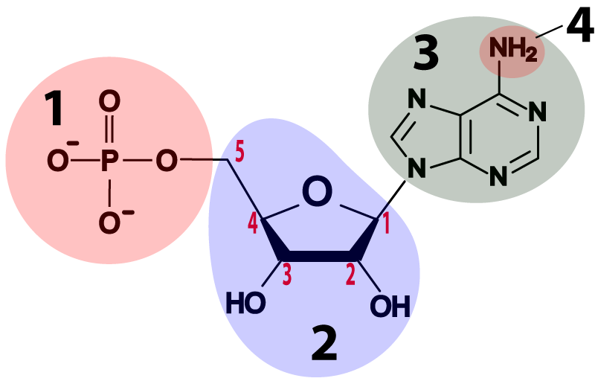 | 1.  2.  3.  4.

3. Take the “DNA, RNA, and Nucleotides” Quiz ☐
4. Read “DNA and RNA Structure ☐
5 . Take the “Nucleotides” Quiz
SUMMARIZING TASK 1: Using the terms hydrogen bond, sugar-phosphate bond, nucleotide, complementary, antiparallel (and other terms as needed)describe the structure of DNA.

SUMMARIZING TASK 2: Imaginative Science Writing
DNA and RNA meet each other at a party. They’re trying to figure out if they’re related to one another, so they talk about how they’re similar, and how they’re different. Imagine what they would say to one another, and write it down in the space below.

Tutorial 6. Biochemistry Review
1. Take the “Biochemistry Flashcards.” Read the question, and then, either mentally or out loud, recite the answer to yourself. Then check my sample response. If you think that you answered well, then click “Got it.” If you need more practice (because you mentally drew a blank, or had what you felt was an insufficient answer), then study the sample response, and click the “Need more practice” button. Keep working until you can respond to all of the prompts fluently and accurately . Check the box below when you’re at a good level of mastery for these flashcards. ☐
2. Take the “Biochemistry Cumulative quiz.” ☐

SUMMATIVE REFLECTION: What are living things made of? Set a timer for five minutes. Write small. Fill the space below with everything that you remember about biochemistry.
sciencemusicvideos Biology | Name:________________________
Biochemistry Crossword 1
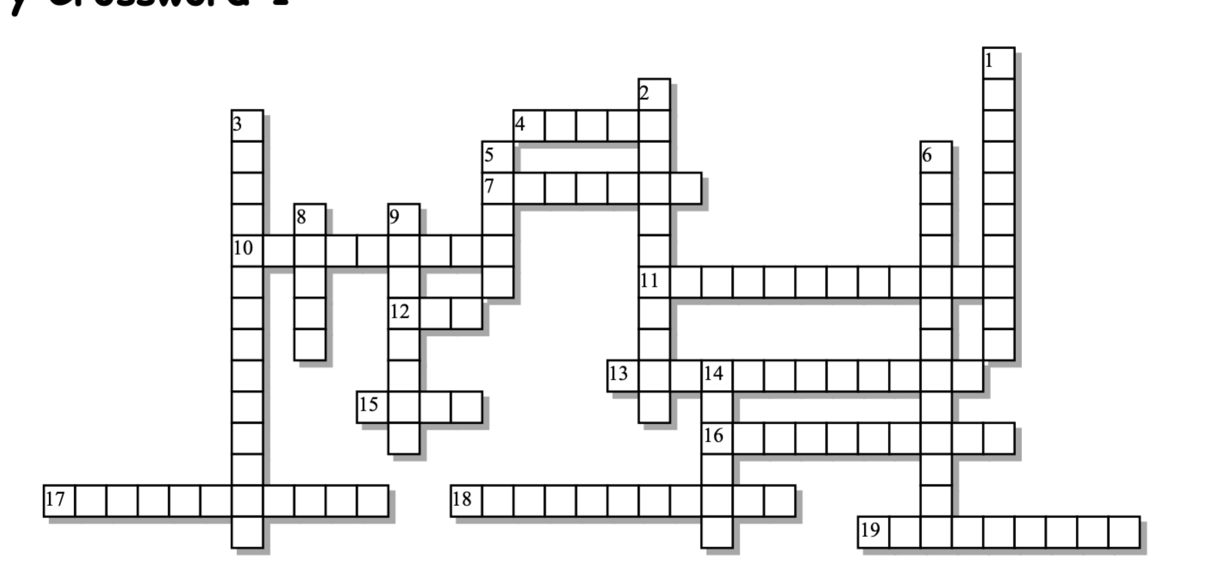
\
Across: | Down:
4 - This acid is an important building block of fats and oils  7 - Glucose and fructose are structural __________ of one another.  10 - A carbohydrate polymer that you can't digest for energy.  11 - Most of a fatty acid is a long chain ____________, making that part of the molecule non-polar  12 - When hydrogens are on the same side of a double bond.  13 - A sweet combination of two carbohydrate monomers  15 - The number of calories in each gram of carbohydrate  16 - Most adult mammals are lactose  17 - A type of steroid that plays a key role in stabilizing cell membranes  18 - This kind of synthesis is how monomers become polymers  19 - This kind of bridge is an important tertiary interaction involved in protein folding | 1 - How polymers become monomers  2 - Lipids have large ______________ regions. Means "water fearing."  3 - Because of ____________, enzymes can add monomers to only one end of a polymer  5 - Cellulose is an important source of this in the diet  6 - sugars and their polymers make up this biomolecule family  8 - This kind of helix is one of two secondary protein structures  9 - This three carbon alcohol hooks on to three fatty acids to make a triglyceride  14 - An amino acid with a carboxyl group in its side chain will be
Possible Answers:
acidic, alpha, carbohydrates, cellulose, cholesterol, cis, dehydration, directionality, disaccharide, disulfide, fatty, fiber, four, glycerol, hydrocarbons, hydrolysis, hydrophobic, intolerant, isomer

sciencemusicvideos Biology | Name:________________________
Biochemistry Crossword 2
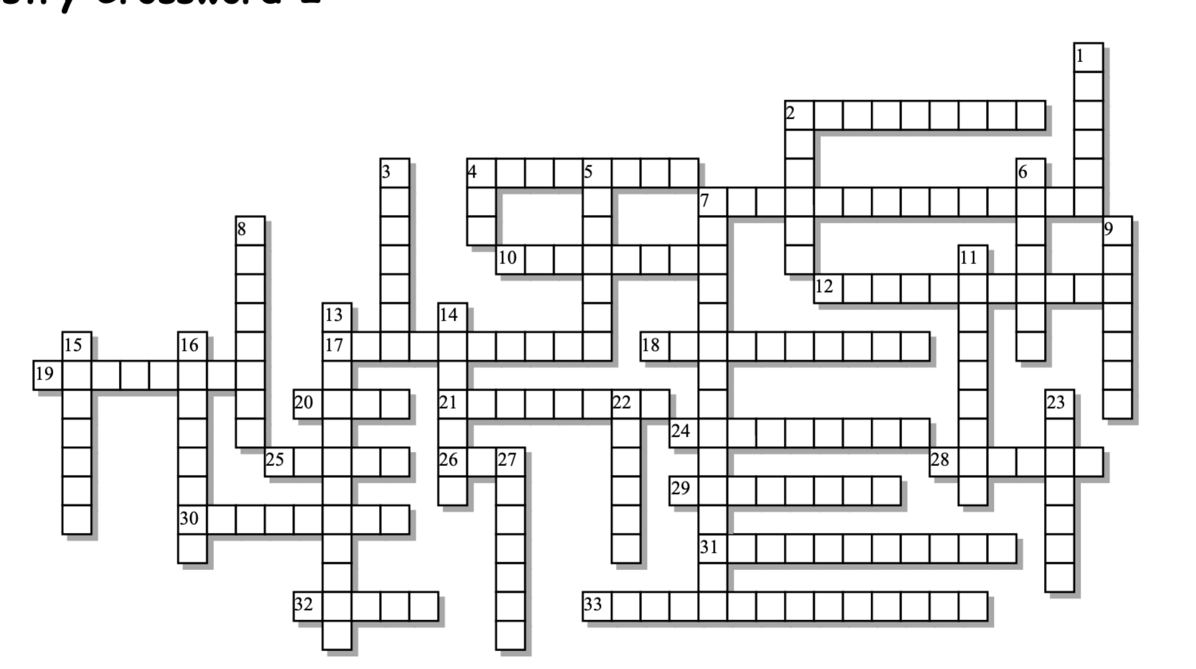

Across: | Down:
2 - A fatty acid with no double bonds  4 - The particle in the cell that follows genetic instructions to synthesize proteins  7 - Most of the molecules of life can be described as  10 - The kind of bond that connects complementary bases in nucleic acids  12 - A chain of amino acids  17 - The monomer of nucleic acids  18 - A level of structure that emerges when folded polypeptides interact  19 - Sugars and phosphates form the _______________ of a nucleic acid strand.  20 - The number of calories/gram in fats and oils  21 - A level of protein folding characterized by interactions between side chains  24 - This functional group is key part of a nucleotide, and also in the head of the key molecule in membranes.  25 - The function of a protein is determined by its  26 - In all organisms, genes are made out of ______.  28 - This base substitutes for thymine in RNA, and is complementary to adenine.  29 - Life's action molecule. Also, the most diverse type of biomolecule  30 - A kind of mammal that, with the help of bacteria, can break cellulose into glucose for energy  31 - The sugar in DNA  32 - DNA's three dimensional shape is a double _________.  33 - A carbohydrate polymer | 1 - A family of mostly hydrophobic biomolecules.  2 - A high energy polysaccharide synthesized by plants  3 - These acids store and transmit genetic information  4 - This nucleic acid brings information from the nucleus to the cytoplasm and can also act catalytically (like an enzyme).  5 - A disaccharide synthesized by sugar cane  6 - This shape emerges from hydrogen bonds between parallel parts of a polypeptide chain  7 - Glucose, fructose, and other carbohydrate building blocks are  8 - The units that make up polymers.  9 - A type of lipid that includes hormones like testosterone and estrogen  11 - A level of protein folding that results from interactions between carbonyl and amino groups in a polypeptide chain  13 - In a DNA molecule, the two strands are ______________.  14 - These bonds hold proteins together  15 - The disaccharide in milk  16 - DNA, proteins, starch, and glycogen are  22 - The sugar in RNA  23 - The linear sequence of amino acids in a protein makes up its ___________ structure  27 - Binds with thymine
Possible Answers: DNA, RNA, adenine, antiparallel, backbone, deoxyribose, helix, hydrogen, lactose, lipids, macromolecules, monomers, monosaccharides, nine, nucleic, nucleotide, peptide, phosphate, pleated, polymers, polypeptide, polysaccharide, primary, proteins, quaternary, ribose, ribosome, ruminant, saturated, secondary, shape, starch, steroid, sucrose, tertiary, uracil

