Name: _____________________ Period: _____ Date: _________________

sciencemusicvideos Biotechnology and Genetic Engineering, Student Learning Guide
Getting to the tutorials.
- Go to www.sciencemusicvideos.com; Use the College Bio, AP Bio, or Learning Guide Menus to find “Biotechnology and Genetic Engineering”

Tutorial 1: Genetic Engineering
1. Read the “Overview: What is Genetic Engineering?” ☐
2a. Complete the Quiz, “Genetic Engineering Overview.” ☐
2b. Create a key to the diagram below: ☐
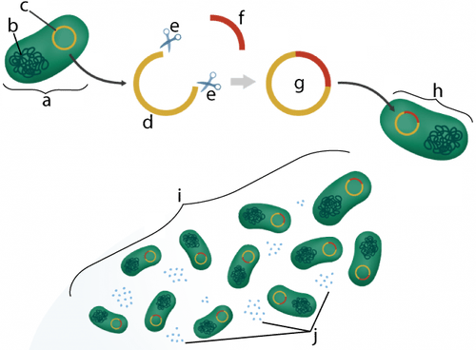

a.
b.
c.
d.
e.
f.
g.
h.
i.
j.
3. Read “The Biology of Insulin and Type 1 Diabetes.” ☐
4a. Complete the quiz: “Diabetes and Insulin.” ☐
4b. At the top of the next column, create a key to the diagram below ☐
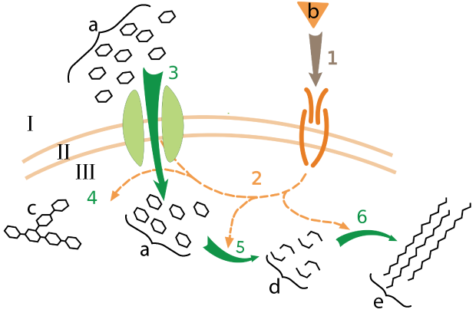

I.
II.
III.
1.
2.
3.
4.
5.
6.
a.
b.
c.
d.
e.

SUMMARIZE: Consolidate what you’ve learned above by responding to the following prompt: How does insulin work, and how is insulin made through genetic engineering? Write small.

5a. Read “Making Recombinant DNA.” Define each of the following terms: ☐
- Restriction endonuclease
- Restriction Site
- Sticky End
- DNA Ligase

5b. In the space below, briefly summarize the two ways that the DNA for human insulin was acquired (so that it could later be inserted into a plasmid).

6. Complete the “Genetic Engineering and Recombinant DNA” Interactive Diagrams. ☐
Checking Understanding: Create a Key to the Diagram below:
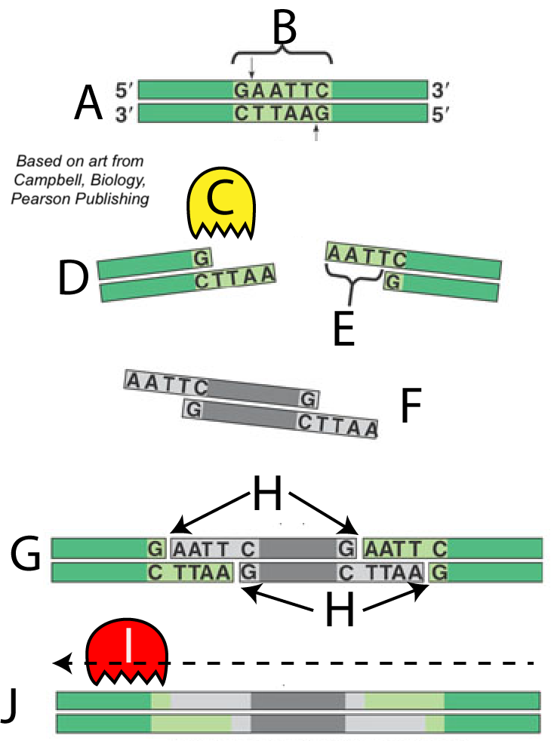 | A.  B.  C.  D.  E.  F.  G.
H.
I.
J.

7. Read “The Genie’s Out of the Bottle.” List the four uses of genetic engineering that are of the most interest to you.

8. Take the Quiz: Genetically Engineered Insulin. ☐
9. SUMMARIZE: Pretend that you’re eating dinner with a friend (or someone in your family). They ask, “What did you learn in school?” You respond: “Oh: I learned something amazing: did you know that you can take a human gene and put it in a bacterial cell to make things like insulin. Here’s how it works....WRITE A DETAILED EXPLANATION BELOW.

Tutorial 2: Polymerase Chain Reaction (PCR)
1. Read the introduction. In the days before PCR, how were genes cloned?

2a. Read “How PCR Works.” As you do, define/describe each of the following processes or components.
- Primer
- Heat resistant DNA Polymerase:
- Denaturation
- Annealing
- Elongation

3. Take the PCR Quiz ☐
Create a key to the diagram below.
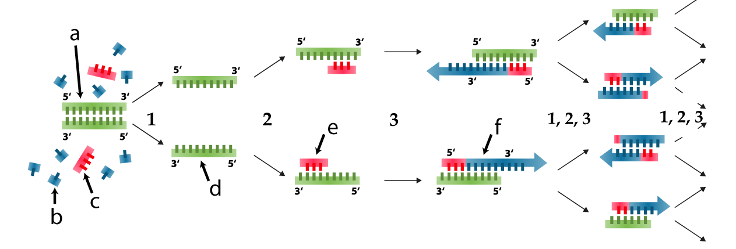
1.
2.
3.
a.
b.
c.
d.
e.
f.
CONSOLIDATION: From memory, write a short paragraph describing how PCR works.

Tutorial 3: DNA Fingerprinting
1. Read the Introduction. What is a DNA fingerprint?

2. Read about RFLPs. ☐
3. Take the RFLPs Quiz. ☐
4. Read about Gel Electrophoresis, and complete the quiz “Results of Electrophoresis” ☐
Checking Understanding:
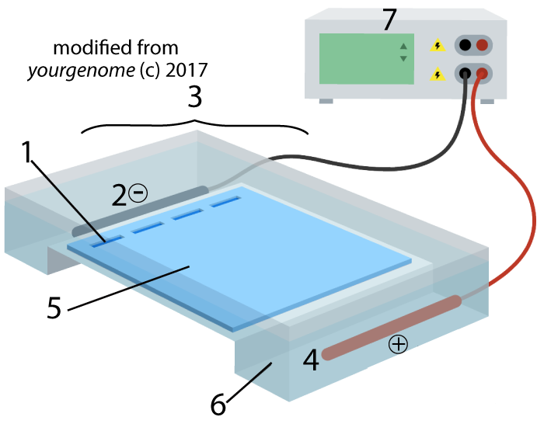Explain how RFLPs can be used to create DNA fingerprints. Make sure | your response includes 1) a definition of what restriction fragments are, 2)  how RFLPS come about, and 3) how gel electrophoresis works. In your explanation, include a description of all the parts of the diagram at left.

5a. Read about RFLPs and Plasmid Analysis, and take the quiz about “Restriction Sites and Restriction Fragments” in Plasmid DNA.” ☐
5b. The image below is from the quiz you just took. To demonstrate your understanding, briefly explain why cutting the pUC23 plasmid with BamHI and EcoRI would result in the pattern shown in “C.”
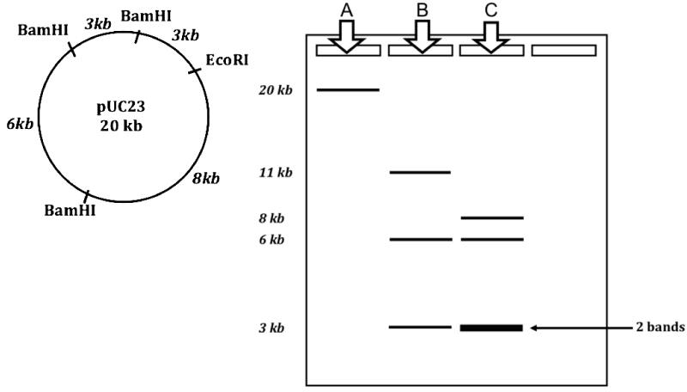

6a. Read about VNTRs and Human DNA Profiling. As you read, explain the diagram below:
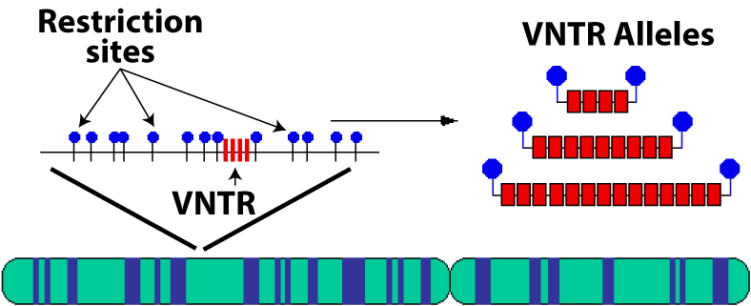

6b. Now, pretend that you’re an expert witness in a legal case where an attorney is trying to establish paternity (fatherhood). If you didn’t know the father’s DNA VNTR profile, how could you reconstruct it from the partial family pedigree data shown below?
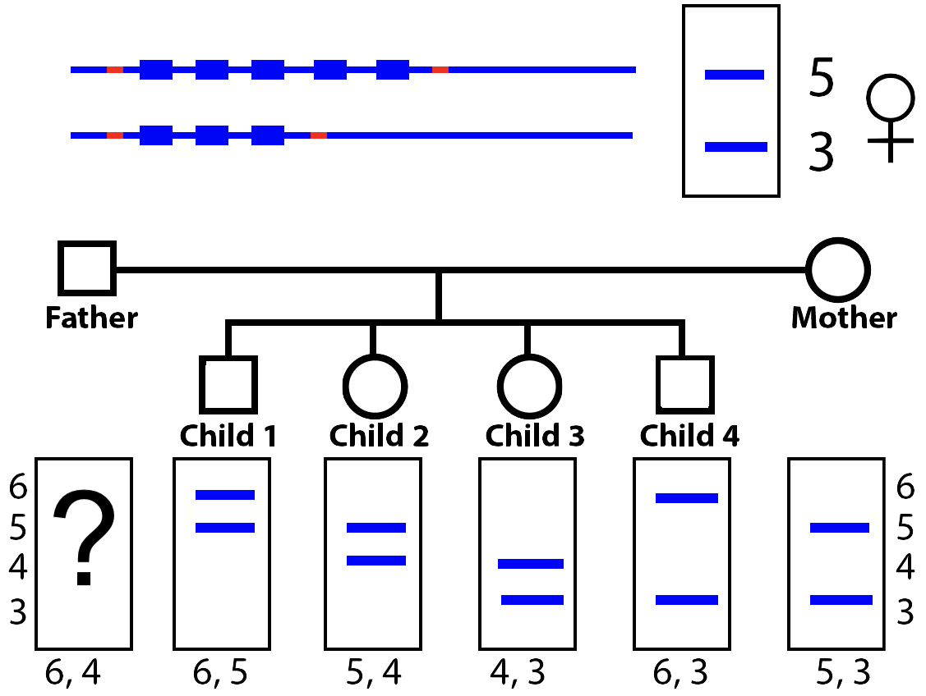

7. Read about STRs. As you read, answer the following questions:
- How are STRs different from VNTRs?
- What is CODIS, and how does CODIS Profiling work?

8. Take the DNA Fingerprinting Quiz ☐
PULLING IT ALL TOGETHER. The image below shows some of the steps involves in the simplest type of DNA fingerprinting, the kind using RFLPs. Write a brief description of how this technology works.
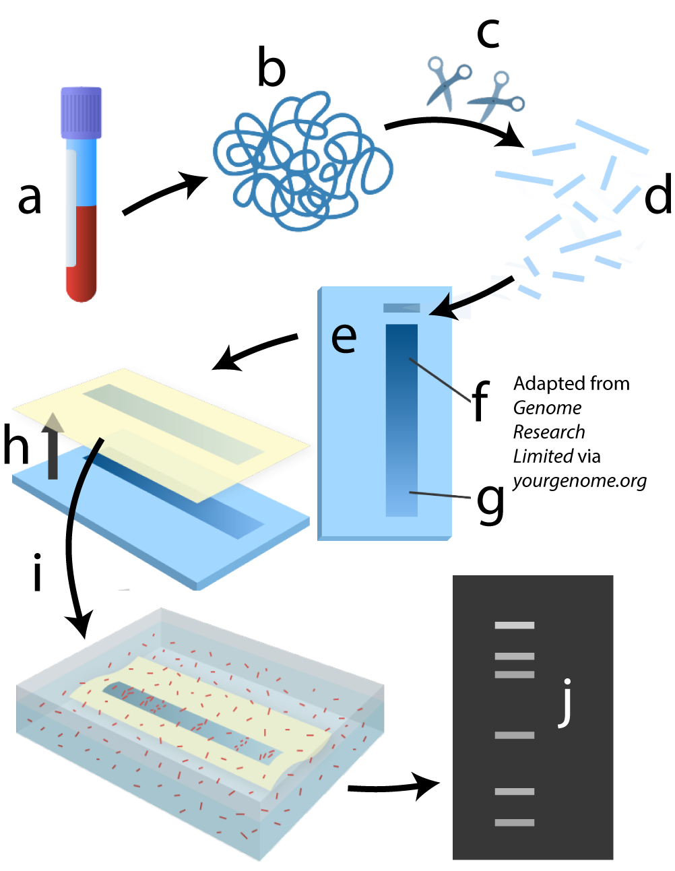

Tutorial 4: Sequencing DNA Using the Sanger Method
1. Read the Introduction. What is sequencing?

2. Read about dideoxynucleotides. ☐
3. Read about how ddnucleotides cause chain termination. ☐
4. Take the Sanger Sequencing Quiz 1. ☐ When you’re done, answer the questions below.
a. What are dideoxynucleotides? Use the diagram below to explain how they’re different from deoxynucleotides, and ribonucleotides.
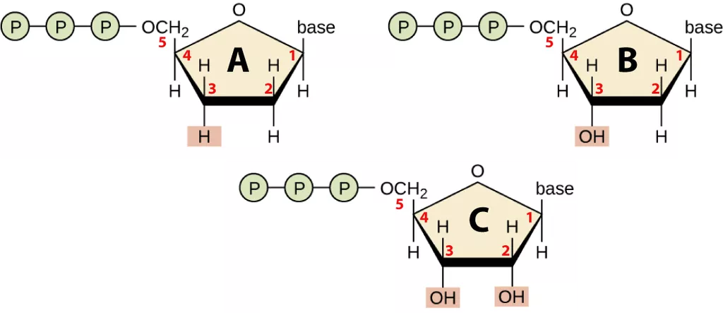

b. What happens if dideoxynucleotides are incorporated into a DNA strand during DNA synthesis. Why?

5. Read about how ddNucleotide chain termination reveals DNA sequences.☐
6a. Take the “Chain Termination: Checking Understanding”
quiz ☐
6b. When you get to the “Summary” question for reaction tube 3 (ddGTP), draw the three reaction products in the space below. Then click “show the answer,” and adjust your answer as needed.
7. Read “Sanger Sequencing Concept 3: Electrophoresis...” You can choose to do the interactive exercises first, or to complete the table below. Just make sure that you complete both.
If you were sequencing 5’CTGACTTCG3′, what would happen in the gel below?
Negative Pole
ddATP well | ddTTP well | ddGTP well | ddCTP well | Fragment Length
 |  |  | _____ | 9
 |  |  | _____ | 8
 |  |  | __ddC_ | 7
 |  |  | _____ | 6
 |  |  | _____ | 5
 |  |  | _____ | 4
 |  |  | _____ | 3
 |  |  | _____ | 2
 |  |  | _ddC_ | 1

8. Complete the “Sanger Sequencing Application Exercise.”☐
9. Read “Sequencing Advances.”☐
SUMMARIZE: Respond to the following. One of your friends in 9th grade biology has just learned about the structure of DNA, and they’re telling you about it. You politely listen, and then say “Did you know that all the DNA in the human genome has been sequenced?” They say “Really: how did they do that?” Explain it to them. Use terms like dideoxynucleotides, electrophoresis, chain termination

Tutorial 5: CRISPR-Cas9
1. Read the Introduction, and answer the following questions:
a. Use the diagram below to explain the gene edit that Dr. He made in two twin girls.
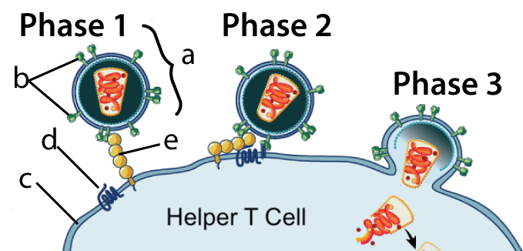

b. Why was the response to Dr. He’s work so negative?

2. Watch the overview video of CRISPR-Cas9. If you’re in a classroom, turn down the volume or, if they’re available and your teacher allows it, use earphones. ☐
3a. Take the CRISPR-Cas9 Video Quiz ☐
3b. SUMMARIZE. Use the space below to offer a preliminary explanation of what CRISPR-Cas9 is, how it works, and why it’s important.

4. Read Understanding CRISPR ☐
5a. Complete the Interactive Diagrams ☐
5b. Create a key to the diagram below:
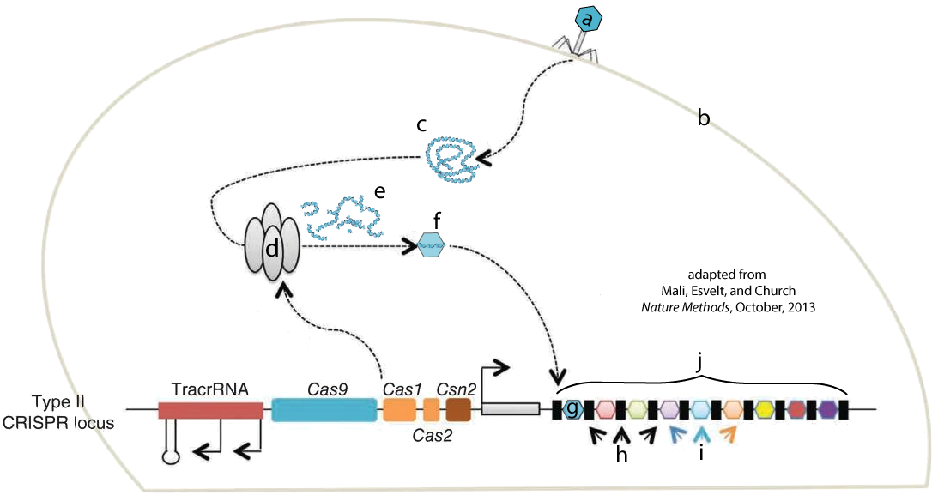
a.
b.
c.
d.
e.
f.
g.
h.
i.
j.

5c. Write a short paragraph explaining steps 1 – 5 of the diagram below. 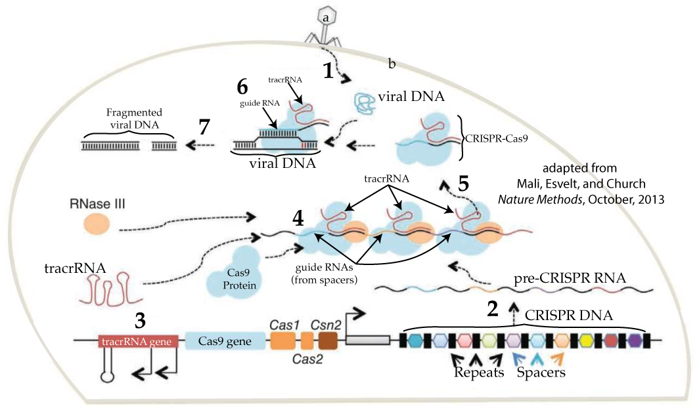

6a. Read “CRISPR-Cas9 Becomes a Genome Editing System.”
6b. Compare and contrast wild type CRISPR Cas9 with the bioengineered form. As you do, explain how CRISPR-Cas9 works.
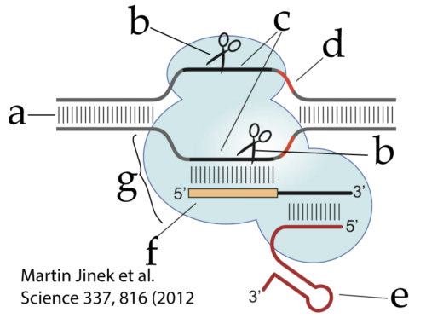 | 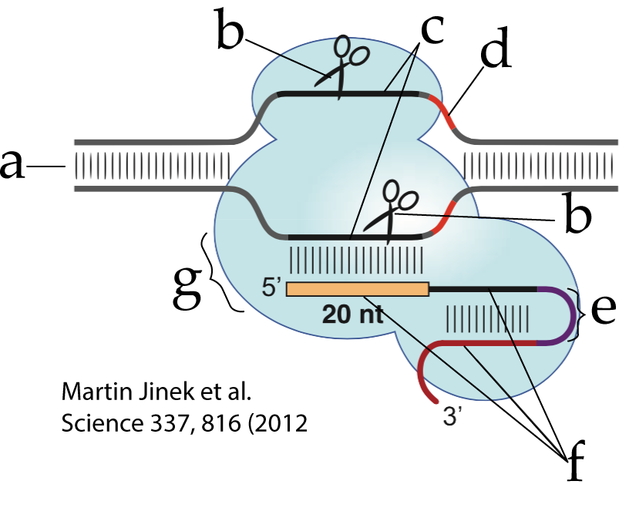

7a. Take the “CRISPR-Cas9 for Genome Editing” Quiz ☐
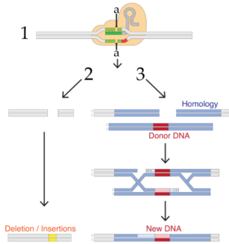
7b. One of the most important things with CRISPR-Cas9 is what happens after it cleaves target DNA. Use this diagram to describe two of the possibilities.

8. Read “Some CRISPR-Cas9 Applications.” Write brief bullet point summaries of three of these, but use the links on the page to learn some details about, and summarize it in some depth, one or two more. Write small.

9. Take the CRISPR-Cas9 Cumulative Quiz. ☐
10. Use this diagram to write cumulative summary of how CRISPR-Cas9 works. Write small!
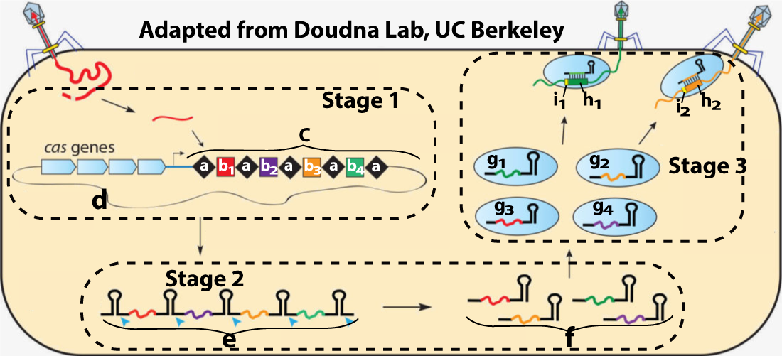

There’s a crossword puzzle on the next page!

sciencemusicvideos | AP Biology | Name:________________________
Genetic Engineering/Biotechnology
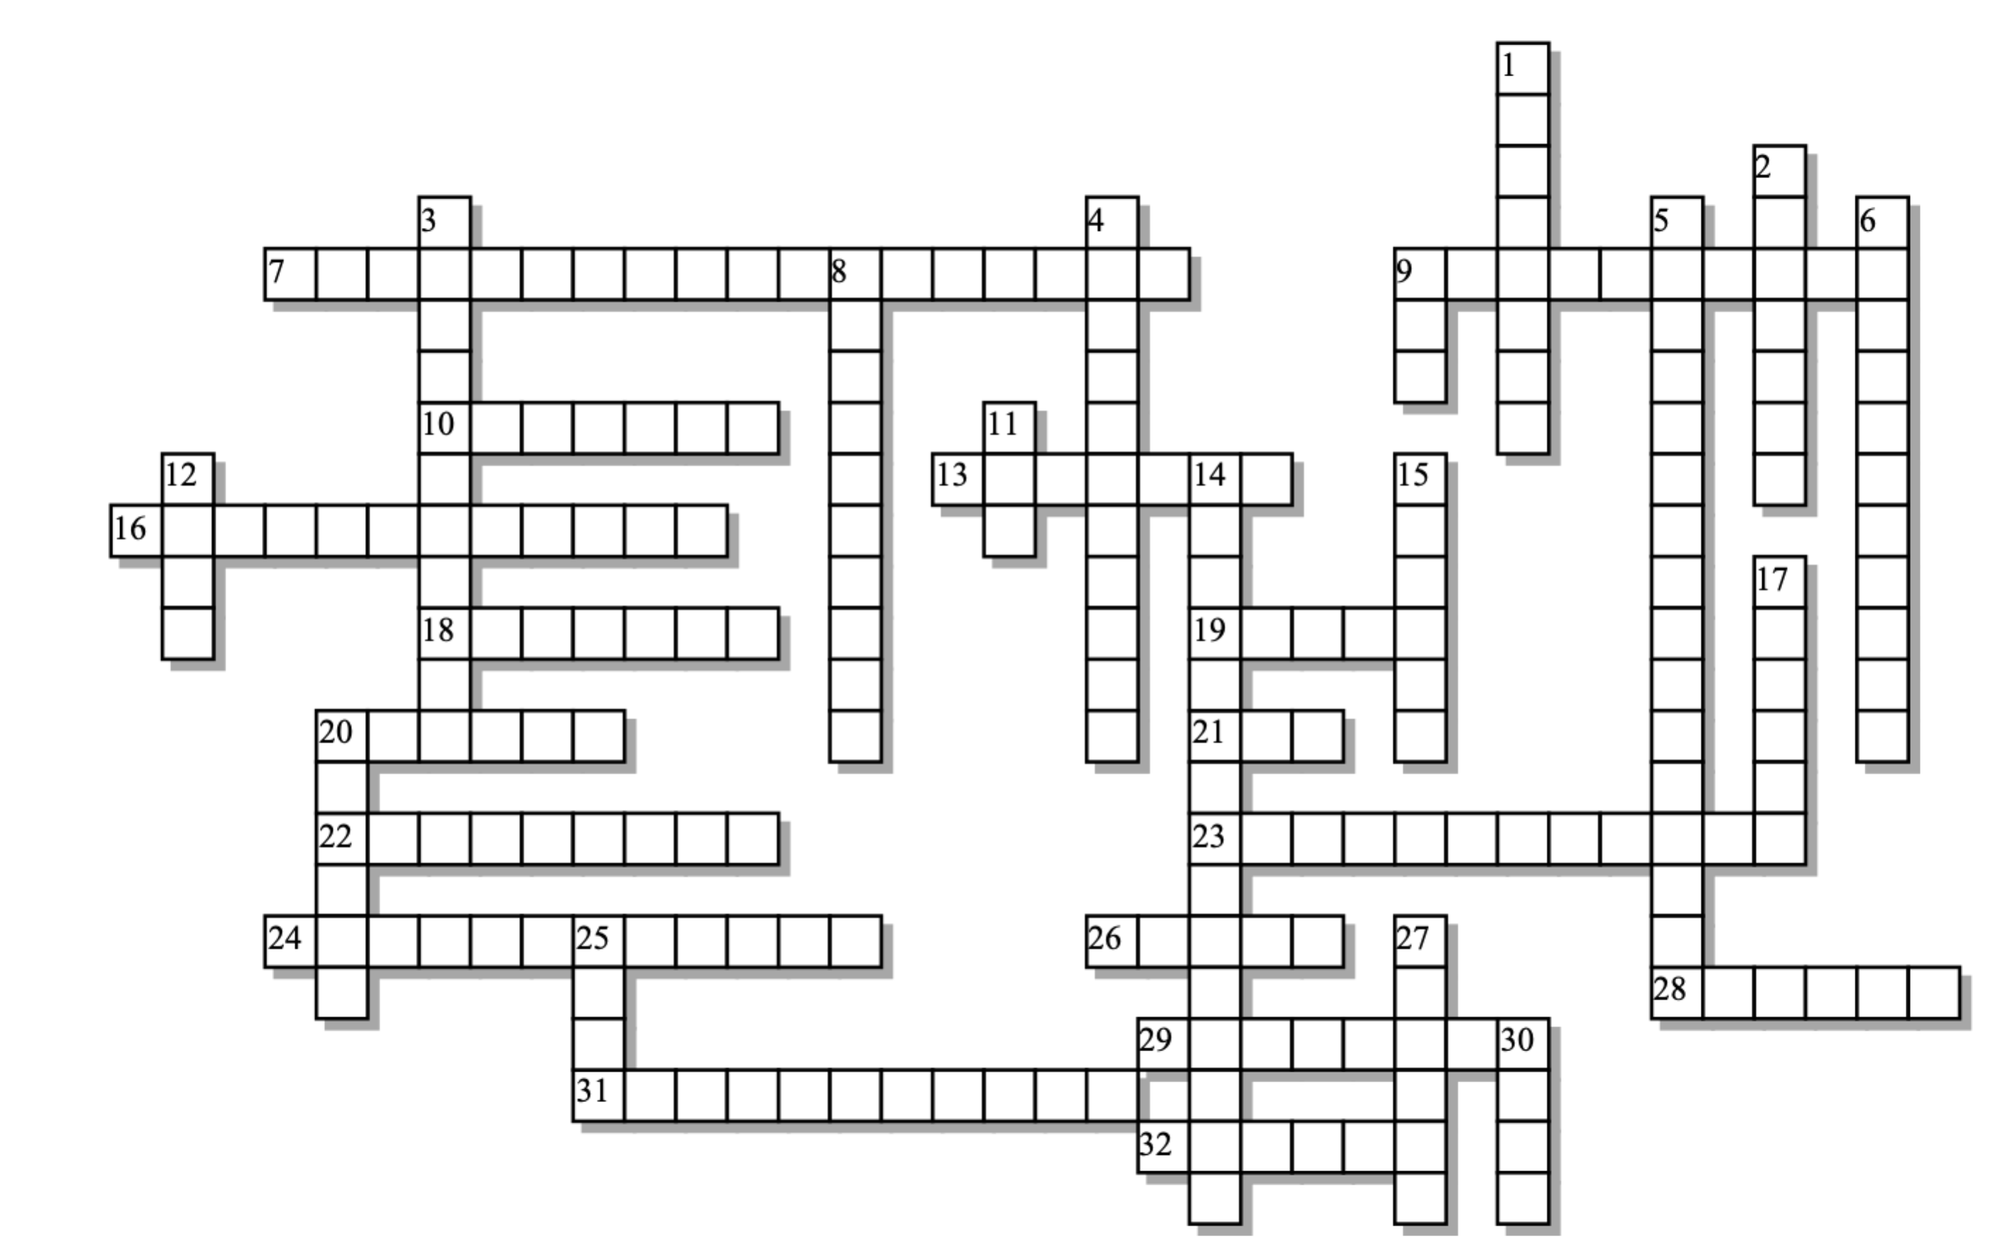

Across: | Down:
7 - A modified nucleotide that's missing an oxygen atom at its 3' carbon.  9 - A DNA synthesizing enzyme used in PCR and sequencing.  10 - The last R in CRISPR stands for ______________.  13 - Each PCR cycle ______________ the amount of DNA.  16 - An enzyme that breaks a nucleic acid into two pieces by breaking a sugar phosphate bond in the middle of the chain.  18 - One of the first commercial applications of genetic engineering was creation of this protein hormone.  19 - The FBI's system for collecting DNA profiling data.  20 - Won the Nobel prize for figuring out a sequencing method that came to have his name.  21 - The type of nucleic acid that associates with Cas9 in the CRISPR system  22 - This step in PCR when the primers bind.  23 - A difference in form is a _____________. In DNA fingerprinting, these result from point mutations.  24 - The first step in PCR is to use heat to separate the strands, a process called ____________.  26 - If you want to _________ millions of copies of DNA, then PCR is the way to go  28 - If DNA is cut in a way that leaves exposed nucleotide bases, it's said to have these kind of ends.  29 - All of those phosphate groups on DNA give it this kind of charge.  31 - The phage DNA that crRNA can recognize is called a ___________.  32 - This enzyme will create a sugar phosphate bond between DNA fragments that have hydrogen bonded to one another. | 1 - __________ directed repair mechanism allows insertion of new genes during a gene editing process  2 - A small circle of DNA outside of the main bacterial chromosome, often with antibiotic resisitance genes.  3 - This kind of enzyme is widely used in genetic engineering. In nature, it restricts viruses from taking over bacterial cells.  4 - This kind of DNA is from a combination of two (or more) sources.  5 - The monomers required for making new DNA.  6 - When DNA polymerase inserts a ddnucleotide into DNA, the result is chain ____________.  8 - The step in PCR when polymerase is at work.  9 - The three letter acronym for a short sequence that tells Cas9 that it's okay to cut this DNA.  11 - A key enzyme used in PCR came from bacteria that live in ______ springs.  12 - The acronym for the differences in repeat numbers found by Alec Jeffreys.  14 - A process by which molecules are separated based on charge and size.  15 - A system that bacteria use to remember the phage that have attacked them  17 - The T in STR and VNTR  20 - Phage DNA that's been inserted into the bacterial genome becomes a __________.  25 - A four letter acronym that describes differences in DNA segments that have been cut by endonucleases.  27 - Short single stranded segments of DNA that bind with known sequences in in the DNA you want to copy.  30 - The CRISPR system allows you to do this to DNA.
Possible Answers: CODIS, CRISPR, PAM, Plasmid, RFLP, RNA, Recombinant, Sanger, VNTR, annealing, clone, denaturation, deoxynucleotides, dideoxynucleotides, doubles, edit, electrophoresis, elongation, endonuclease, homology, hot, insulin, ligase, negative, polymerase, polymorphism, primer, protospacer, repeats, restriction, spacer, sticky, tandem, termination

