Name: _____________________ Period: _____ Date: _________________

sciencemusicvideos: Carbon and Functional Groups
Getting to the tutorials.
- Go to www.sciencemusicvideos.com; Use the College Bio, AP Bio, or Learning Guide Menus to find “Carbon and Functional Groups”
- Start with “1. Carbon the Central Element”
Note from Mr. W: The video in this tutorial incorrectly uses the term “orbitals” to describe “electron energy levels” (also known as “shells” or “orbits.”). So when you hear “orbital,” think “energy level” or “shell.”

Tutorial 1. Carbon, the Central Element
1. Why the molecules of life are built around carbon
1.1. Draw structural and electron distribution models of methane to demonstrate how carbon atoms can form _______ covalent bonds

Methane, Electron Distribution Model | Methane, Structural Formula

1.2. Carbon’s bonding ability allows it to form ___________, ______________, and ______________ molecules.
1.3. Find the coolest looking molecule on this page, and draw it in the space below.

1.4. Speculate: there’s an episode of the old Star Trek series (“Devil in the Dark)” where the crew of the Enterprise has to confront a silicon based form of life. Silicon was a good choice for an alternative basis for life. Why?

2. Take the “Checking Understanding…” Quiz. ☐
Proceed to the next tutorial, “Functional Groups.”
Tutorial 2: Functional Groups
1. What are isomers?

2. What are hydrocarbons?

3. Write a general definition for a “functional group.”

4. As you read, complete the table below:
Name | Structure | Function
Hydroxyl
 | 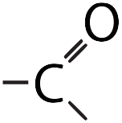
 |  | Makes a molecule acidic (because it can donate _____ to a solution)
 | 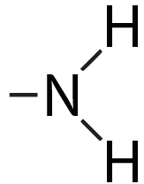
Sulfhydryl
 |  | Important in energy transfer
Methyl
 | 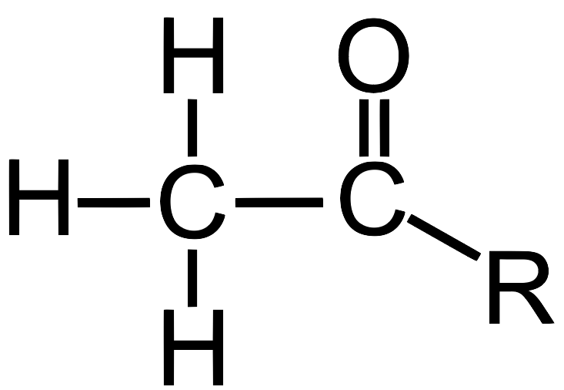

2. Take the quiz “Identifying Functional Groups”
☐
3. Read about “Ionized Functional Groups” and study the table
☐

(continues on opposite side)

4. Read “More about isomers.” Describe each of the three kinds of isomers:
a) Structural Isomers

b) cis-trans isomers

c) enantiomers

5. Take “Another Quiz: Functional groups and isomers”
☐
Carbon and Functional Groups Crossword Puzzle
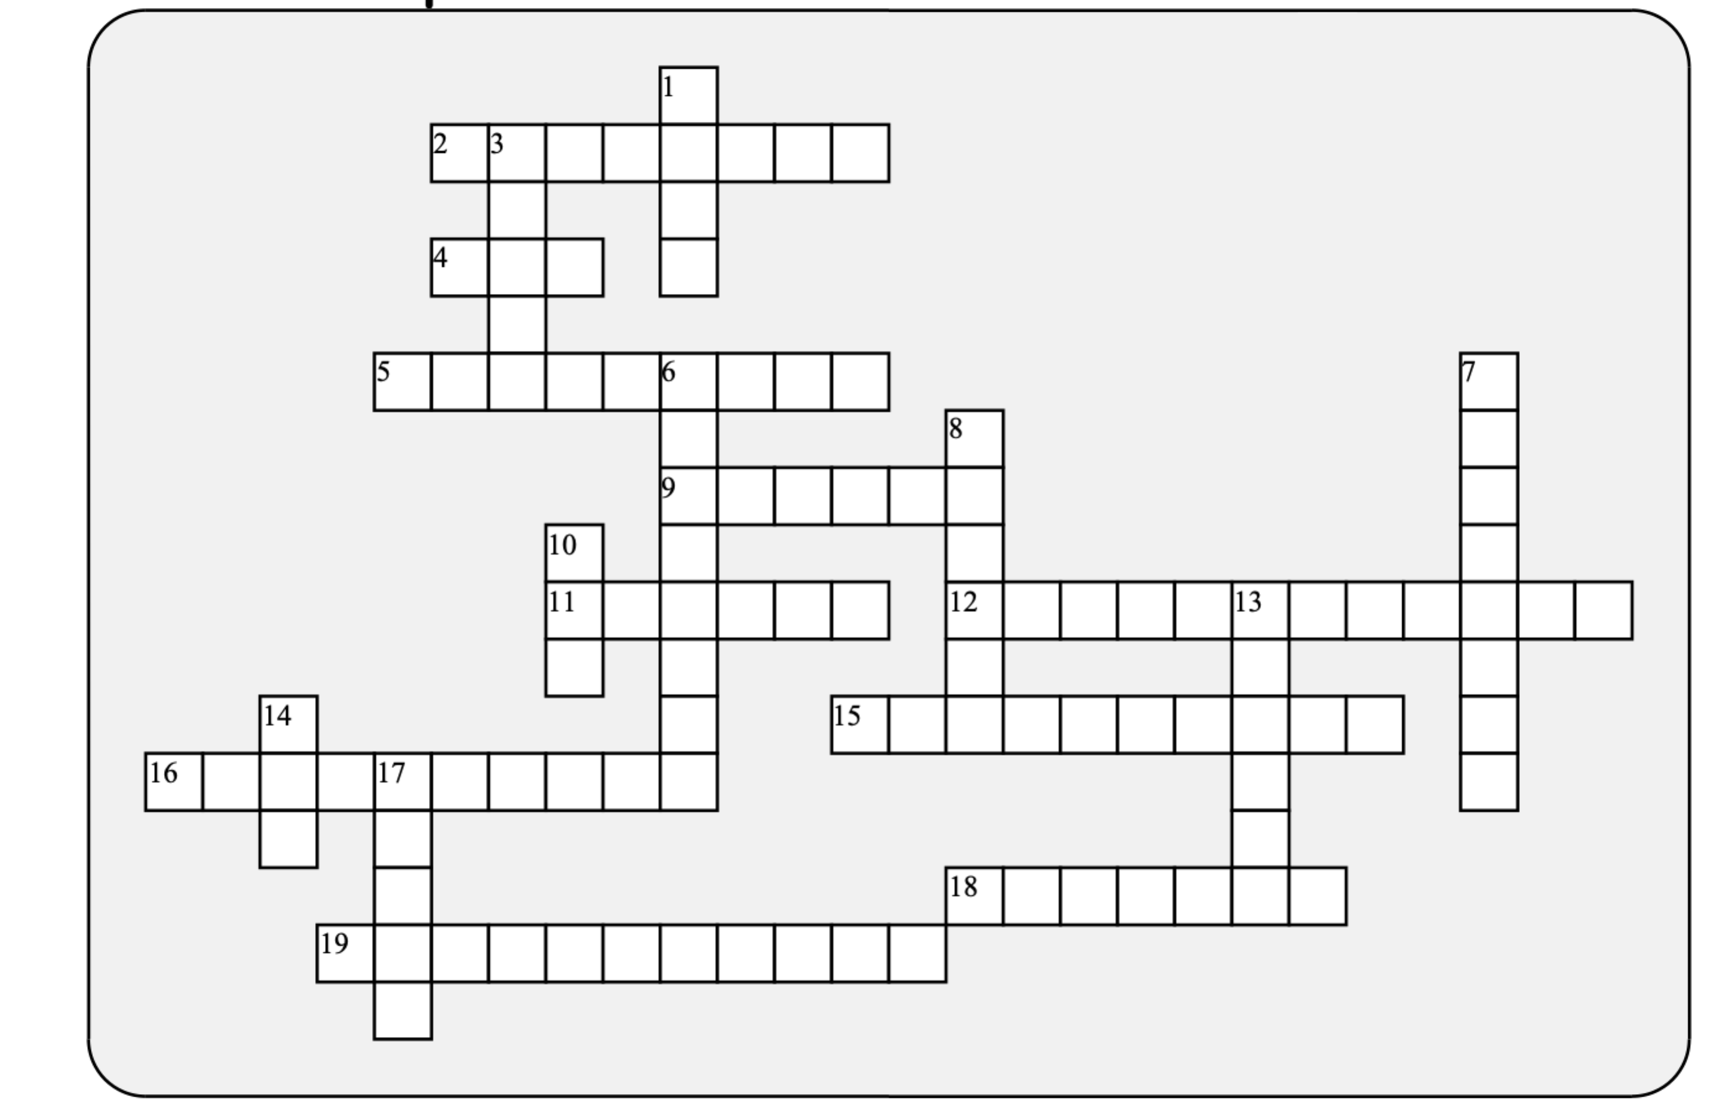

Across: | Down:
2 - This carbon containing functional group makes a molecule weakly acidic.  4 - This configuration has molecular pieces on the same side of a double bond.  5 - A functional group important in energy transfer.  9 - two shared pairs of electrons makes for a ________ bond  11 - same chemical formula but a different arrangement of atoms  12 - energy-rich substances, many of which are fossil fuels  15 - This sulfur containing functional group is responsible for the disulfide bridges that are important in protein structure  16 - These groups of atoms act as a unit  18 - one carbon bonded to four hydrogens  19 - Mirror image isomers | 1 - the number of valence electrons in carbon  3 - This nitrogen containing functional group makes a molecule basic.  6 - A functional groups that's like a water molecule that's missing one hydrogen  7 - This functional group has an oxygen double bonded to a carbon atom, and creating a polar region.  8 - Attaching this functional group can make a molecule non-polar  10 - the number of protons in a carbon nucleus  13 - the central element of life is  14 - When methyl groups are attached to ______, genes can become deactivated  17 - This configuration has molecular pieces on opposing sides of a double bond.

Possible Answers: DNA, amino, carbon, carbonyl, carboxyl, cis, double, enantiomers, four, functional, hydrocarbons, hydroxyl, isomer, methane, methyl, phosphate, six, sulfhydryl, trans

