Name: _____________________ Period: _____ Date: _________

sciencemusicvideos: Cell Structure and Function; Cell Membranes and Osmosis, Student Learning Guide
1 Getting to the tutorials.
- Go to www.sciencemusicvideos.com; Use the College Bio, AP Bio, or Learning Guide Menus to find “Cell Structure and Function”
- Start with “Surface Area, Volume, and Life”

Tutorial 1. Surface Area, Volume, and Life
Note: you’ve already done the lab and watched the video in class. Quickly skim through the reading, and when you’re done, check the box below.
☐
2. Do the “Checking Understanding Quiz.” Make sure you’re logged in to this first quiz. Check the box below when you’re done.
☐
3. Complete the interactive reading.
☐
REFLECT: The surface area: volume ratio has been strongly selected for in the course of evolution. Describe four adaptations in living things that relate to surface area and volume.

Continue to “Introduction to Cells.”
Tutorial 2: Introduction to Cells
1. Complete “Interactive Reading 1: Introducing Cells.”
☐
REFLECT: What are three things worth remembering from this interactive passage?

2. Complete “Interactive Reading 2: Eukaryotic Cells, The Cell Theory…”
☐
a. How are eukaryotic and prokaryotic cells different?

b. Why aren’t viruses classified as prokaryotes?

3. Complete “Flashcards: Some Cell Related vocabulary.”
☐
4. Study the diagrams and read the text in the “Viewing Cells: A Virtual Microscope Lab.” Note that whether you’ve done this lab or not, this will be a useful review
☐
5. Complete the “Basic Cell Parts and Cell Concepts Quiz”
☐
REFLECT: Spend three minutes filling up the space below with whatever you remember about the terms you’ve encountered in this tutorial (prokaryotic, eukaryotic, unicellular, multicellular, plant cell, animal cell) and the various cell parts you’ve met.

Continue to “Animal Cells: Parts and Functions”

Tutorial 3:Animal Cells: Parts and Functions
1. Complete the “Interactive Reading: A guided tour of an animal cell”
☐
2. Complete the “Cells Parts and Functions: Fill-in-the-blanks”
☐
3. Complete the “Animal Cell Parts Quiz.”
☐
CHECKING UNDERSTANDING: With as few words as possible, list the name and function of each of the numbered parts below.
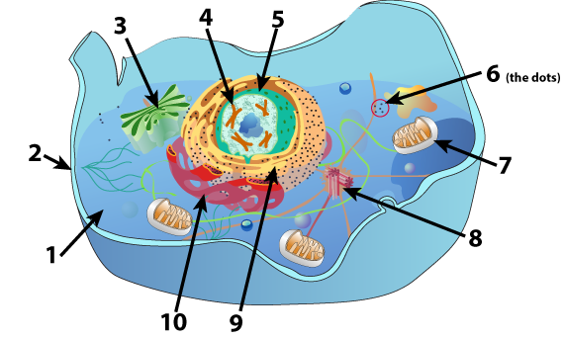

# | Name | Function
1
2
3
4
5
6
7
8
9
10

Continue to “Plant cell parts and functions”
Tutorial 4: Plant Cell Parts and Functions
1. Read “A guide to plant cell organelles”
☐
2. Complete the “Matching: Labeling Plant Cell Parts and Functions.”
☐
3. Complete the Quiz, “Plant Cell Parts”
☐
CHECKING UNDERSTANDING: With as few words as possible, list the name and function of each of the numbered parts below. For parts that are also in animal cells, feel free to write “see animal cell” for the function.
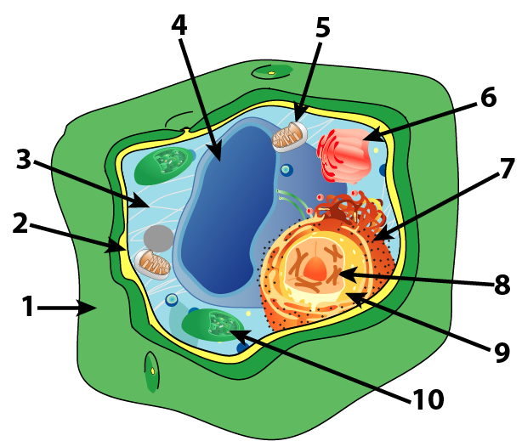

# | Name | Function
1
2
3
4
5
6
7
8
9
10

Continue to “The Endomembrane System”
Tutorial 5: The Endomembrane System
1. Read “How a B cell mobilizes to release antibodies”
☐
SUMMARIZE: Why would a B cell become filled with ER and Golgi as it mobilizes for antibody production?

2. Take the quiz, “Checking Understanding, the Endomembrane System.”
☐
3. Complete the interactive reading “Introducing Lysosomes.”
☐
SUMMARIZE: Describe how an amoeba engulfs and digests its prey.

4. Complete the interactive table “Putting hydrolytic enzymes into a lysosome.”
☐
Write the five steps below
1.
2.
3.
4.
5.

CHECKING UNDERSTANDING: complete the table below the diagram, indicating each of its parts and functions
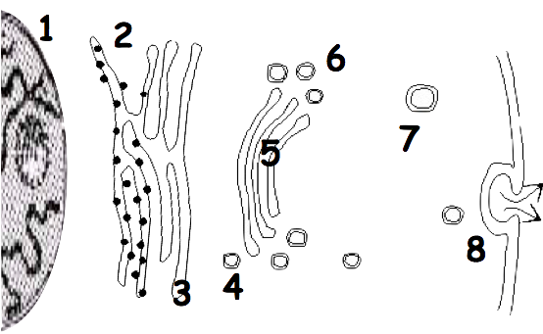
# | Name | Function
1
2
3
4
5
6
7
8

5. Take the quiz: The Endomembrane System, the Whole Shebang.
☐
CHECKING UNDERSTANDING: complete the table below the diagram, indicating each of its parts and functions
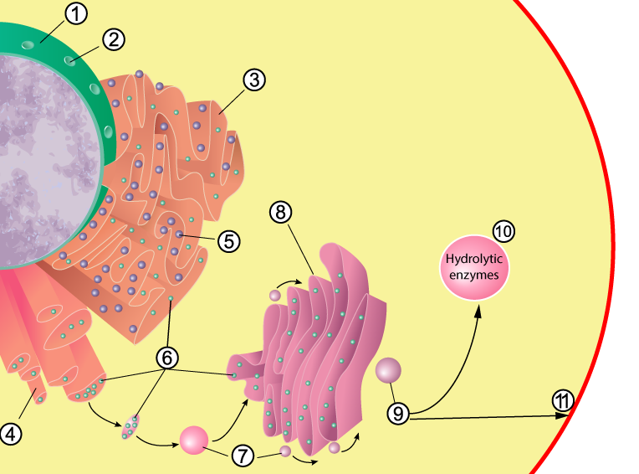
# | Name | Function
1
2
3
4
5
6
7
8
9
10
11
MORE CHECKING UNDERSTANDING: Briefly describe how a cell can package a hydrolytic enzyme inside a lysosome

MORE CHECKING UNDERSTANDING: Briefly describe how a B cell synthesizes an antibody and then releases it from the cells.

Continue to “The Evolution of Cellular Compartmentalization.”

Tutorial 6: The Evolution of Cellular Compartmentalization
1. Read “Cellular Compartmentalization” ☐
2. Read “Compartmentalization is present only in domain Eukarya” ☐
SUMMARIZE:
- What’s the advantage of cellular compartmentalization?

- What are the three domains of life? Summarize the key features of each one? How are the three domains related to one another?

3. Read “Eukaryotes arose through Endosymbiosis” ☐
SUMMARIZE:
- What is endosymbiosis?

- What’s are the two organelles that are thought to be endosymbionts, and what’s the evidence for that?

4. Read “Two Models for the Evolution of Endosymbiosis and Compartmentalization” ☐
TASK 1: 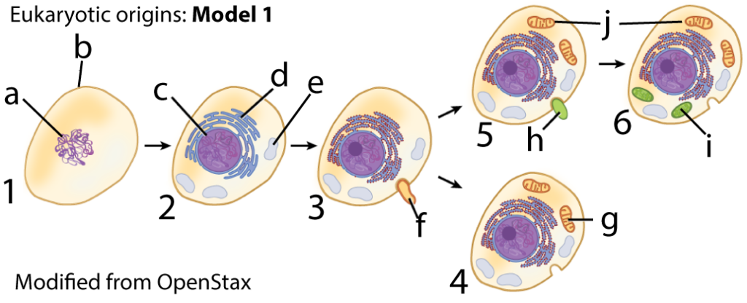
Describe what’s happening in steps 1 – 6 above. As you do, create a key to the diagram.

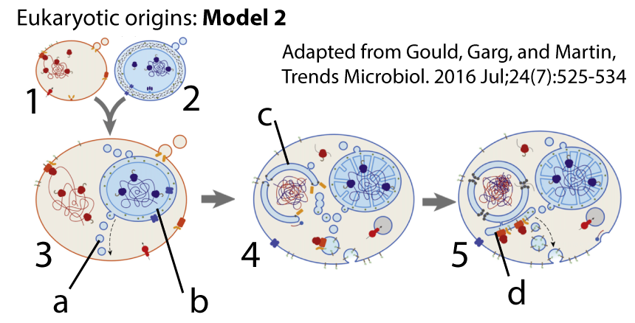
Describe what’s happening in steps 1 – 5 above. As you do, create a key to the diagram.

5. Take the “Checking Understanding” Quiz: ☐
CUMULATIVE SUMMARY:
Using the diagram below to stimulate your thinking, explain the how compartmentalization evolved in the eukaryotes?
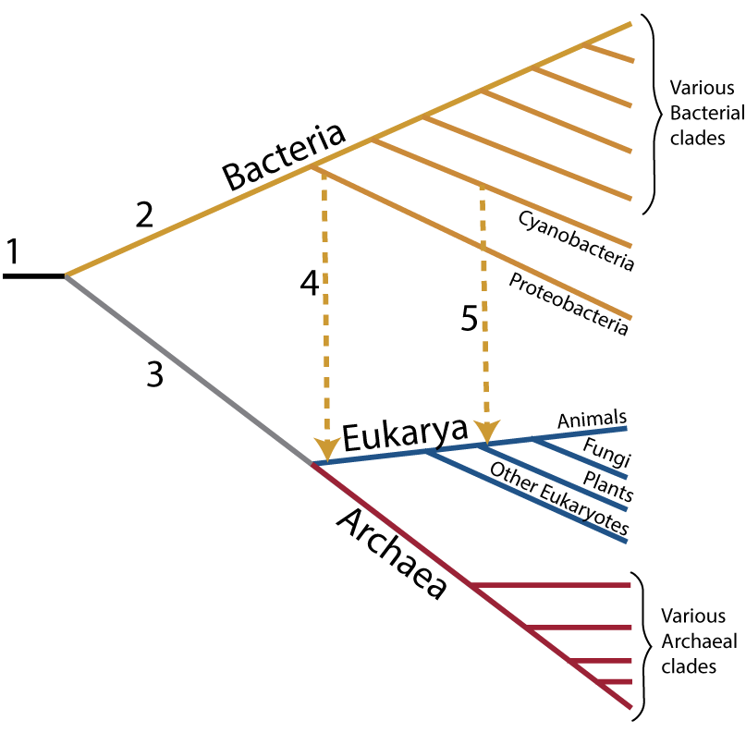

sciencemusicvideos | Biology | Name:________________________
Cell Structure and Function Crossword
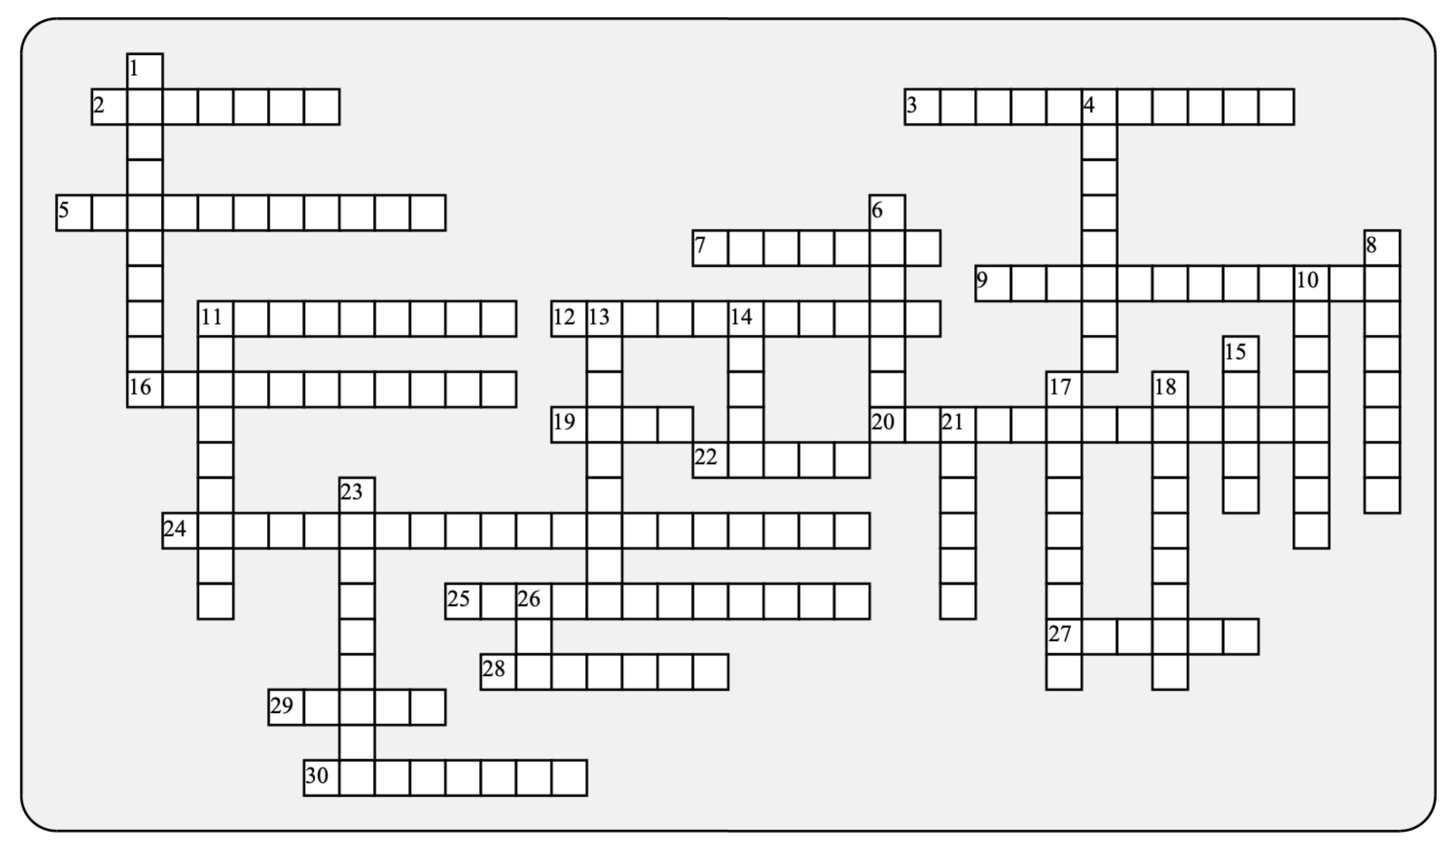

Across: | Down:
2 - The DNA-containing cellular control center  3 - An organism composed of only one cell.  5 - DNA is packaged into one or more  7 - The domain that's most closely related to eukarya  9 - These organelles take in food from the cytoplasm and convert it into ATP  11 - Creates the spindle that separates chromosomes during cell division.  12 - The simplest, most ancient type of cells are ____________  16 - A photosynthetic organelle  19 - Flat structures have a very ______ surface area to volume ratio.  20 - How eukaryotic cells came to arise  22 - The E.R. that contains ribosomes  24 - A feature found only in eukaryotic cells.  25 - Collectively, the ER, golgi, and lysosomes make up the ___________ system  27 - The E.R. that synthesizes lipids  28 - A huge, central ________ stores water and dissolved solutes in plant cells.  29 - The function of this complex of flattened sacs is to package and modify proteins  30 - The selectively permeable boundary surrounding a cell. | 1 - Nucleated cells with internal organelles  4 - An organelle with hydrolytic enzymes  6 - A bubble of membrane that's used for transport from one organelle to another.  8 - Two organelles, both involved with energy, were once free-living ______________.  10 - A protein factory  11 - This polysaccharide makes up cell walls  13 - The network of channels just outside of the nucleus is the endoplasmic  14 - Many biological adaptations relate to the surface area to volume _______.  15 - According to the cell theory, cells are the _________ units of life  17 - The area between the membrane and the nucleus.  18 - Organisms maximize surface area in order to increase _________ of molecules or heat.  21 - Both mitochondria and chloroplasts have a ______________ membrane.  23 - A general name for any cell part with a defined function, often surrounded by membrane  26 - Found in both chloroplasts and mitochondria
Possible Answers: Archaea, DNA, Golgi, bacteria, basic, cellulose, centriole, chloroplast, chromosomes, compartmentalization, cytoplasm, diffusion, double, endomembrane, endosymbiosis, eukaryotic, high , lysosome, membrane, mitochondria, nucleus, organelle, prokaryotic, ratio, reticulum, ribosome, rough, smooth, unicellular, vacuole, vesicle

Name: _____________________ Period: _____ Date: _________

sciencemusicvideos Cell Membranes and Osmosis, Student Learning Guide
Getting to the tutorial: Go to www.sciencemusicvideos.com; Use the College Bio, AP Bio, or Learning Guide Menus to find “Cell Structure and Function.“ Start with “Understanding Phospholipids”

Tutorial 1: Understanding Phospholipids
Note: you’ve already done various activities in class related to this material. Quickly skim through the reading, and when you’re done, check the box below.
☐
2. Do the flashcards “The Phospholipid Bilayer.” Make sure you’re logged in to this first activity. Check the box below when you’re done.
☐
3. Take the quiz: “Phospholipids.”
☐
REFLECT: In the space below, draw a sketch of a phospholipid. Then draw a phospholipid bilayer. Then write a few words explaining how a phospholipid bilayer can spontaneously form.

Continue to “Membrane Structure.”
Tutorial 2: Membrane Structure
1. Read “The fluid mosaic model...”
☐
2. Complete the “Cell Membrane Structure” Flashcards
☐
3. Complete the “Cell Membrane Structure” Quiz
☐

REFLECT
Exercise 1: In the space below, write everything you can about the function of
a) Membrane carbohydrates:
b) Cholesterol:

c) Membrane proteins:

Exercise 2: Now, without looking at any diagrams on the web page (or anywhere else), draw your best rendition of a cross section of the membrane. Label as many parts as you can.

Exercise 3: Now, look back at one of the diagrams on the web page, and as needed, correct your diagram. You can do this below or on the original diagram you drew above.

Continue to the next tutorial, “Transport across cell membranes.”
Tutorial 3: Transport Across Cell Membranes
1 and 2: Read the introduction, and the section on “Diffusion.”
☐
Choose a diagram to copy that captures the concept of diffusion, and draw it below.

Complete the following sentence: Whereas simple diffusion involves…
facilitated diffusion…

3. Read about “Active Transport”☐
Complete the following sentence: As opposed to diffusion, which involves…
active transport…

4. Read about “Endocytosis”
☐
5. Read about “Exocytosis”
☐
6. Complete the “Membrane Transport” Flashcards
☐
7. Complete the quiz: “Cell Membrane Transport.”
☐
REFLECT: Spend three minutes filling up the space below with whatever you remember about how things move across membranes.

Continue to “Osmosis 1: Key Concepts”
Tutorial 4: Osmosis Part 1: Key Concepts
1 and 2. Read “A gummy bear mystery” and “Osmosis is the movement of water from hypotonic to hypertonic.
☐
3. Complete the osmosis vocabulary flashcards.
☐

From memory, write out definitions for each of the following terms:
a. hypotonic

b. hypertonic

c. isotonic

c. osmosis

Click the link to “Osmosis 2”
Tutorial 5: Osmosis Part 2: Osmotic Pressure
1, 2, and 3. Read “Osmotic Pressure, ” Animal Cells and Osmosis,” and “Plant Cells and Osmosis.”
☐
4. Take “Osmosis Quiz 1”
☐
5. Take “Osmosis Quiz 2”
☐
CHECKING UNDERSTANDING
a. Assuming that the boundary between solutions 1 and 2 is permeable to water but not the solute, use the space on the right to draw what will happen, and to explain why.
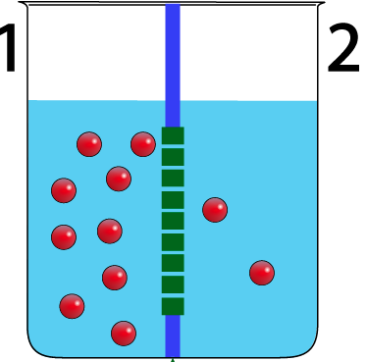
b. Without looking back at the page (unless you need to), sketch and explain what happens to animal cells and plant cells when placed in a hypotonic solution. Why is the outcome different?

c. Without looking back at the page, sketch and compare what happens to animal cells and plant cells when placed in a hypertonic solution.

d. Without looking back at the page, explain why grapes will rot but raisins won’t, and why raisins expand when placed in water

sciencemusicvideos | Biology | Name:________________________
Membranes and Membrane Transport Crossword
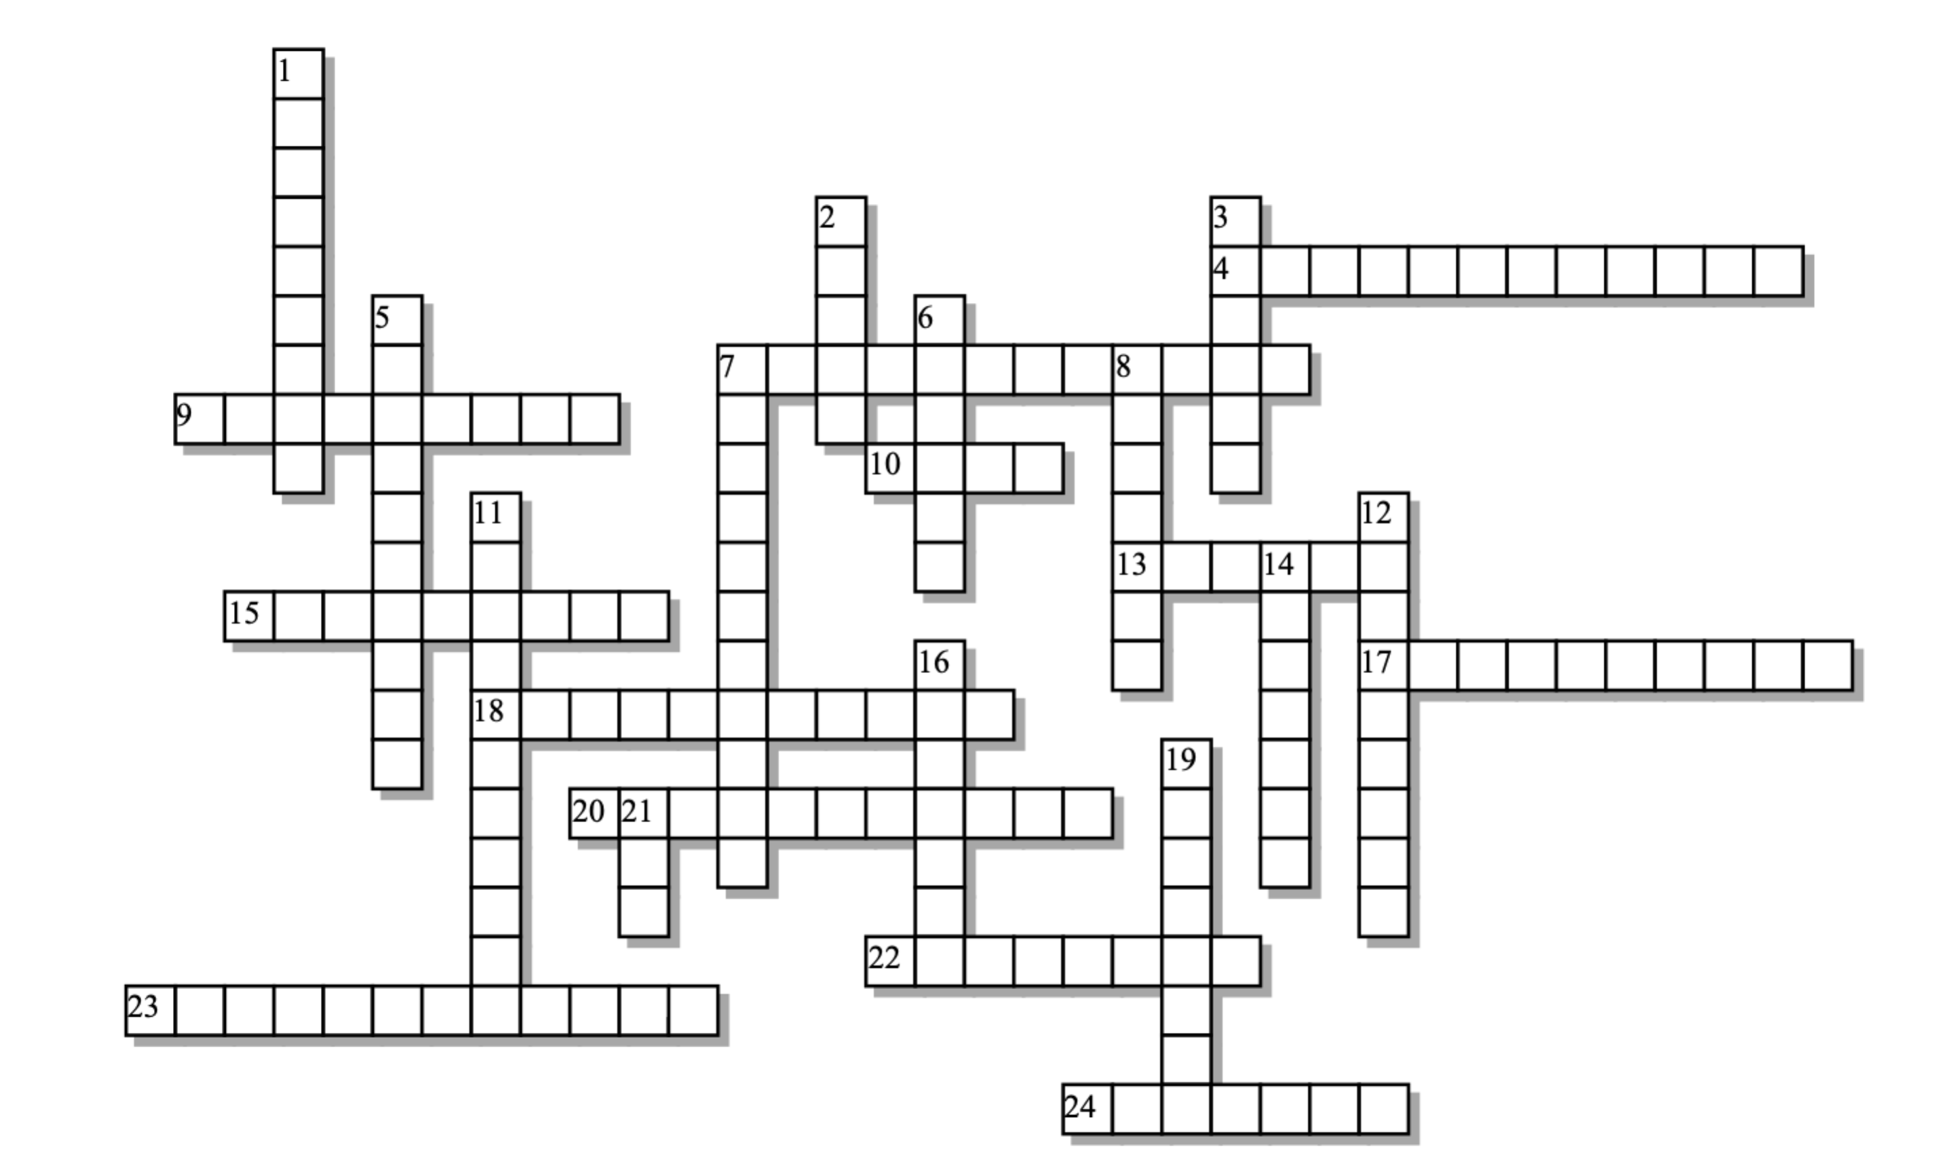

Across: | Down:
4 - This membrane component can act as a marker to the immune system  7 - How white blood cells, or amoebas, surround and engulf their prey  9 - This functional group gives a phospholipid head its negative charge  10 - The _________ of a phospholipid is non-polar  13 - The type of diffusion that occurs across the lipid bilayer  15 - The side with less solute, more water  17 - Fusion of a vesicle with the membrane, followed by dumping the vesicle's contents outside the cell.  18 - When the membrane pinches in, engulfing fluid or particles outside the cell and bringing them inside  20 - The type of diffusion that occurs through a protein channel  22 - Diffusion can be described as movement down a concentration ______________  23 - The key molecule making up the membrane  24 - This type of transport doesn't need any energy from the cell. | 1 - Movement of molecules or heat from higher to lower concentration  2 - The "head" of a phospholipid is  3 - Movement up a concentration gradient is ____________ transport  5 - The side with less water, more solute  6 - The membrane is often described as a fluid ____________.  7 - When the membrane of a plant cell peels away from the wall because of osmosis  8 - Diffusion of water from hypotonic to hypertonic  11 - This molecule helps maintain membrane fluidity  12 - The kind of permeability a membrane has  14 - This amino acid polymer can exceed the weight of the phospholipids in the membrane  16 - The kind of structure that emerges when phospholipids are mixed with water  19 - One function of membrane proteins is to provide ____________ for diffusion  21 - This molecule is often required to power active transport
Possible Answers: ATP, active, bilayer, carbohydrate, channels, cholesterol, diffusion, endocytosis, exocytosis, facilitated, gradient, hypertonic, hypotonic, mosaic, osmosis, passive, phagocytosis, phosphate, phospholipid, plasmolysis, polar, protein, selective, simple, tail

