Name: _____________________ Period: _____ Date: ________

sciencemusicvideos: DNA Structure and Replication
Getting to the tutorials.
- Go to www.sciencemusicvideos.com; Use the College Bio, AP Bio, or Learning Guide Menus to find “DNA Structure and Replication”
- Start with “1. DNA, An Overview”

Tutorial 1: “DNA, an Overview”
1. Read the introduction. Check the box below when you’re finished. ☐
SUMMARIZE
- DNA stands for
- DNA’s functions are

2. Read “Three Key DNA-Related Processes…,”
3. Read “Where DNA is Found…” ☐
4. Take the “DNA Concepts” quiz. ☐
CHECKING UNDERSTANDING:
a. Make a key to the diagram below.
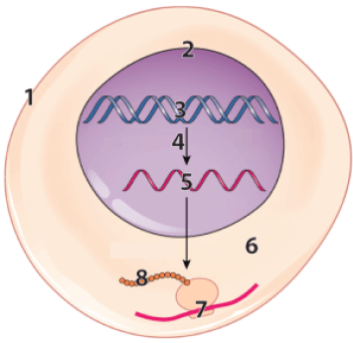 |  | 1
 |  | 2.
 |  | 3.
4
5
6
7
8
b. Describe these three processes
- REPLICATION
- TRANSCRIPTION
- TRANSLATION

Click the link to the next tutorial, “DNA Structure.“
Tutorial 2: “DNA Structure”
1 - 2. Read the Introduction and “Nucleotides are the Monomers of DNA.” ☐
3. Take the Quiz “Checking Understanding: Nucleotides” ☐
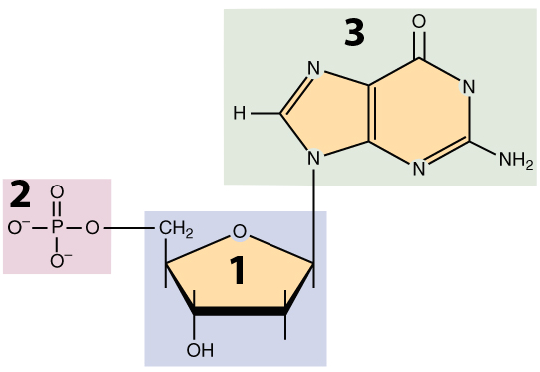 | Create a key to this diagram (without worrying about the specific name of # 3)  1.  2.  3.
4. Read “Sugar-phosphate bonds form the backbone..” ☐
5. Read “The two strands of DNA are held…” ☐
6. Complete the “Base Pair/Hydrogen Bond Practice.” ☐
7. Read “The Double Helix: Final Points.” ☐
8. Take the “DNA Structure” Quiz ☐
CHECKING UNDERSTANDING: DNA Structure
Create a key to this diagram. Note that “9” is guanine (and knowing that, you can figure out the other three bases).
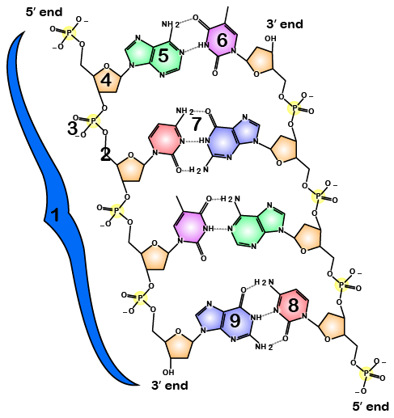 | 1.  2.  3.  4.  5.  6.  7.  8.  9. Guanine
REFLECT: What are the three most important things to remember about DNA’s structure. Write small.

CHECKING UNDERSTANDING: DNA’s dimensions
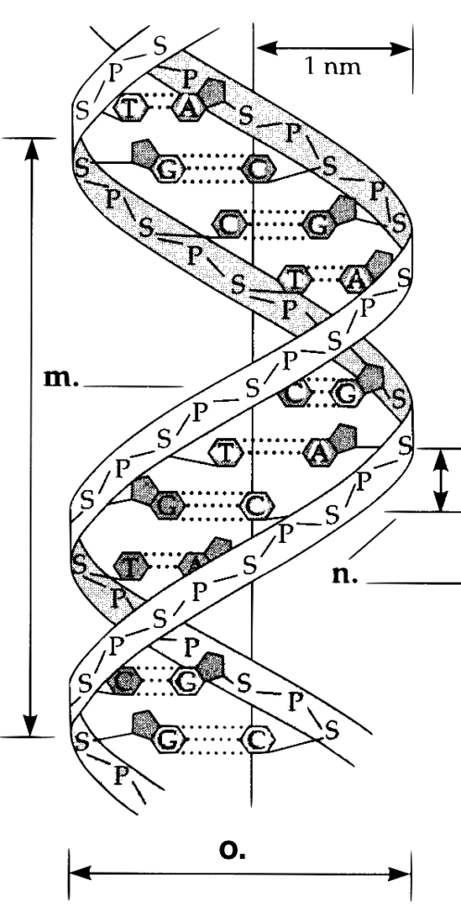 | m. ____ nm (distance between 10 base pairs (one “wavelength”)  n. _____nm (distance between each base pair  o. _____ nm (DNA’s diameter)  Image source: Study guide for Campbell, Biology.

Click the link to “DNA Replication,“ the next tutorial.

Tutorial 3: “DNA Replication”
1 - 2. Read the Introduction and “Replication Means Copying DNA” ☐
3. Read “During DNA Replication, Each Strand Serves…” ☐
4. Take the quiz “Checking Understanding: DNA Replication (the big picture)” ☐
SUMMARIZE
Explain, on a big picture level, how the DNA molecule below could be replicated into two identical daughter strands. Use terms like template, complementary, base-pairing, hydrogen bonds, and sugar-phosphate bonds in your answer (and add other terms as needed).

5. Read “How DNA Replication Occurs in Cells.” ☐
6. Watch the amazing HHMI video “And Here’s What it Really Looks Like” ☐
7. Take the very long quiz “DNA Replication (with some DNA structure review” ☐
CHECKING UNDERSTANDING
Exercise 1: Make a key to this diagram
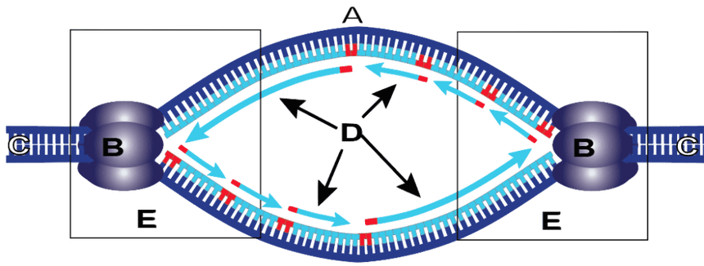
A
B
C
D
E
Exercise 2: Complete the sentence below this diagram: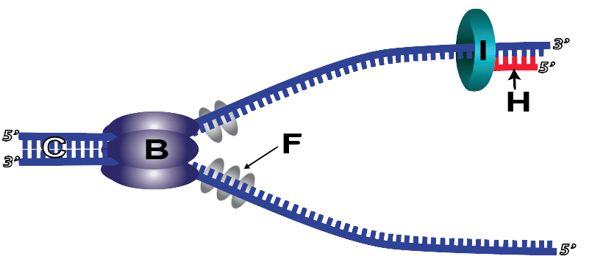
What’s happening above is

Exercise 3: Using the diagram below, explain how DNA Replication works. Feel free to use the top of the next page. In your explanation, describe any new items you haven’t already referenced above.
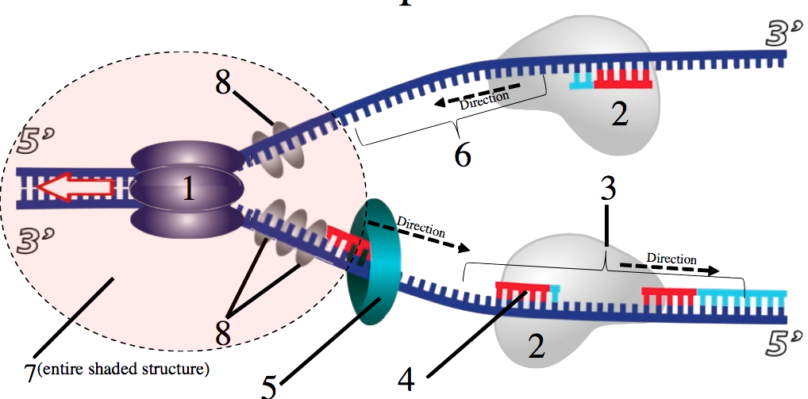

(My explanation of DNA replication, continued)

Biology | sciencemusicvideos | Name:________________________
DNA Structure and Replication Crossword, part 1
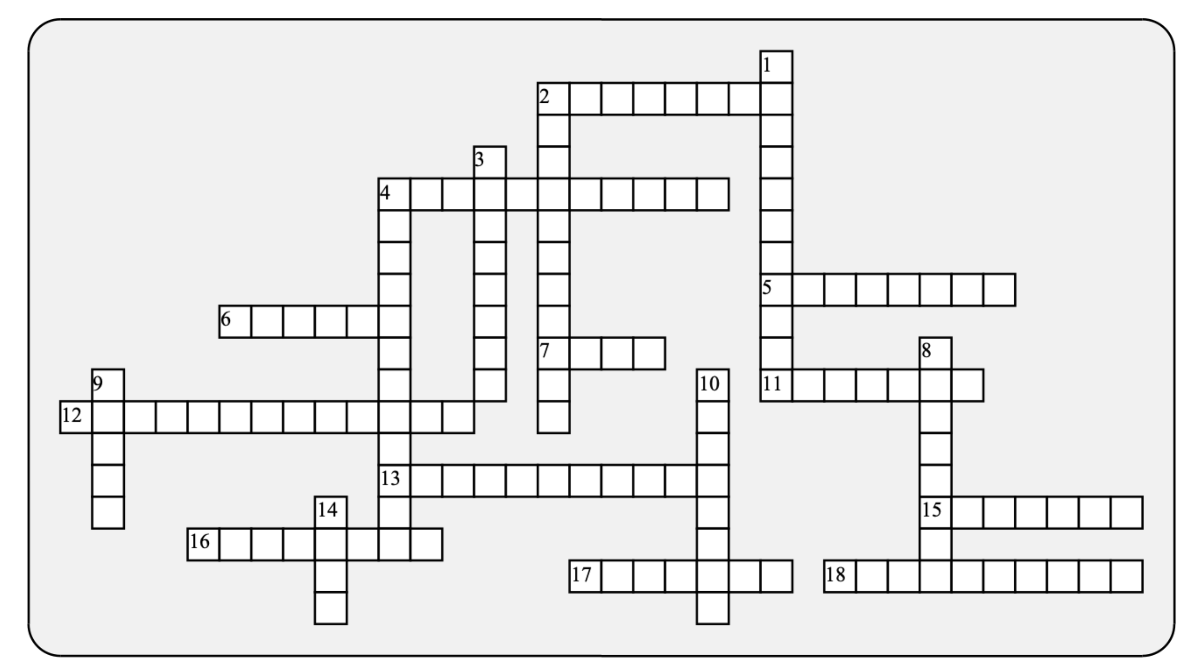

Across: | Down:
2 - The one-ring base that complements guanine.  4 - DNA, in eukaryotes, is mostly found in long, linear ________________.  5 - This part of DNA is made of alternating sugars and phosphates.  6 - A pair or replication forks creates a replication ___________.  7 - DNA's complementary bases fit together only when in an ______-parallel orientation.  11 - All the DNA building proteins that end in -ase are _____________.  12 - The paired bases in DNA are _____________ to one another.  13 - This biological theme, more than any other, is connected to DNA.  15 - The two-ring base that complements thymine.  16 - Bonds that are individually weak, but collectively strong enough to hold the two strands together.  17 - The strand where the direction of synthesis moves away from the opening fork.  18 - The kind of information that DNA transmits. | 1 - The sugar in DNA.  2 - A photosynthesizing organelle with its own DNA.  3 - The strong, electron-sharing bonds within a single strand of DNA.  4 - Since each new double helix has one old and one new strand, DNA replication is said to be semi-___________.  8 - The enzyme that breaks apart the double helix  9 - "DNA makes RNA makes protein" is molecular biology's central ___________.  10 - Cheated by death of a Nobel Prize, her analysis of crystallized DNA was an essential clue to DNA's structure.  14 - A utensil: also the site of the action during replication.
Possible Answers: Dogma, Franklin, Hydrogen, adenine, anti, backbone, bubble, chloroplast, chromosomes, complementary, conservative, covalent, cytosine, deoxyribose, enzymes, fork, helicase, hereditary, information, lagging

Biology | sciencemusicvideos | Name:________________________
DNA Structure and Replication 2
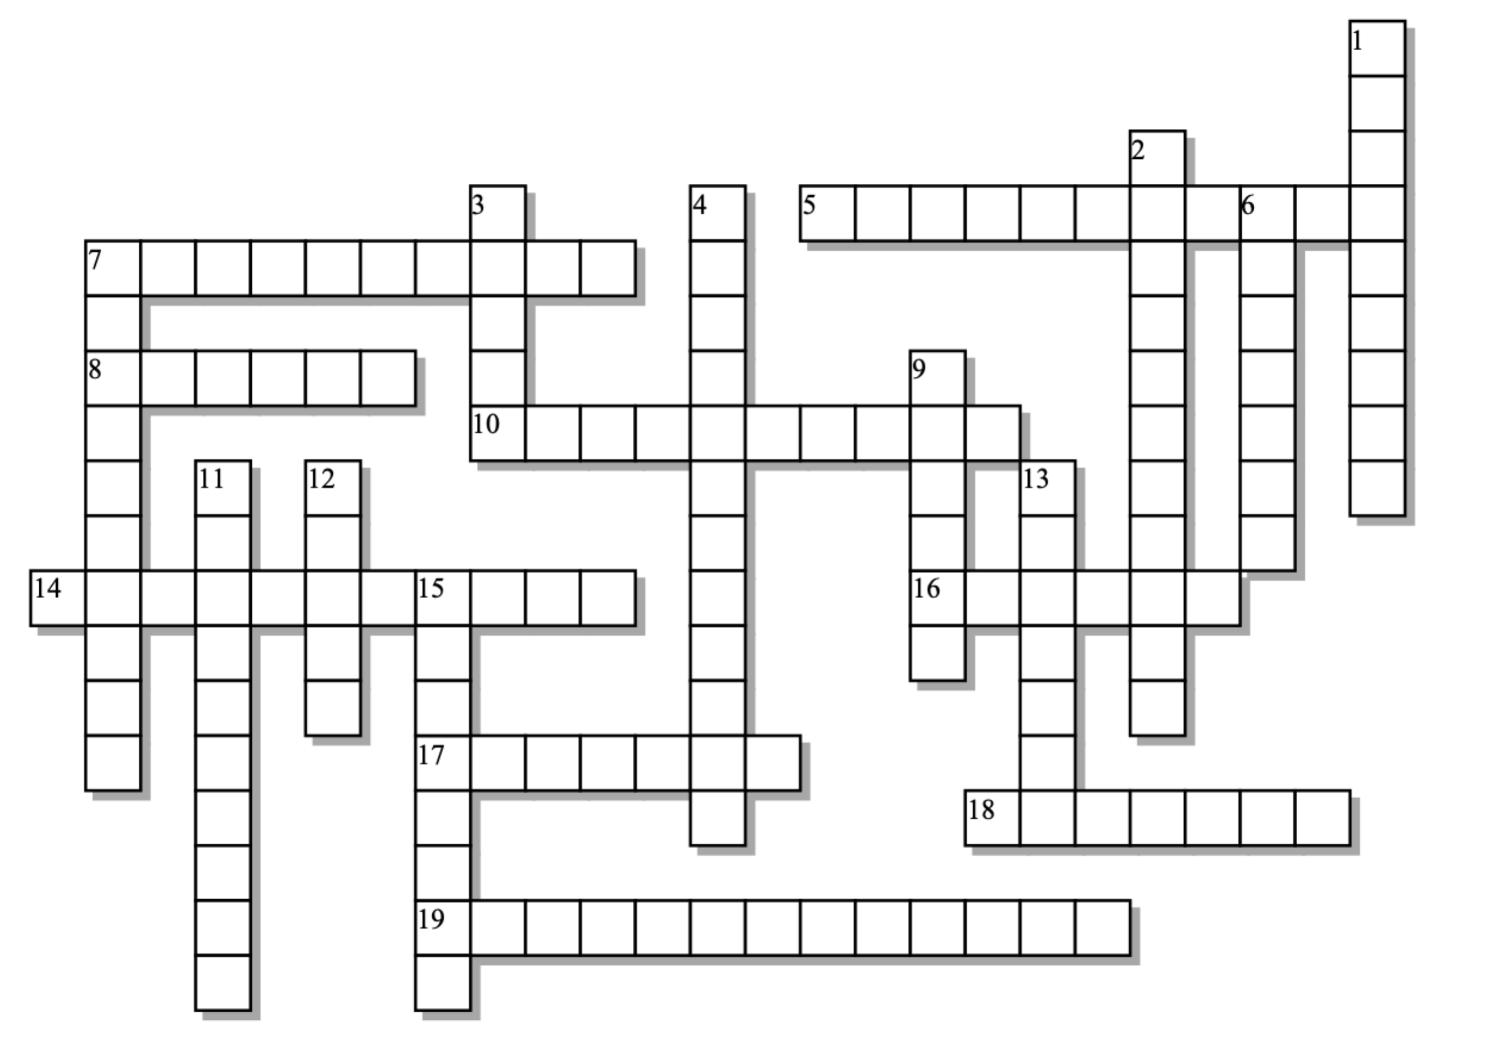

Across: | Down:
5 - The unique, informational part of a nucleotide.  7 - Sounds like an Egyptian monument; also a base with one ring.  8 - The enzyme that creates sugar-phosphate bonds between adjacent Okazaki fragments.  10 - Unlike the bases, sugar and phosphate play a _________role in DNA.  14 - Making protein from RNA.  16 - The spot where replication begins.  17 - A little circle of DNA found in bacterial cells.  18 - On this strand, synthesis of DNA is continuous.  19 - Making RNA from DNA. | 1 - The sour part of the nucleotide thatÕs neither sweet nor bitter.  2 - Making DNA from DNA.  3 - These infectious particles inject their DNA into other organisms (including us).  4 - An ATP secreting organelle that has its own DNA.  6 - The fragments formed on the lagging strand.  7 - The key enzyme in DNA synthesis.  9 - Along with Crick, one of the two famous discoverers of DNAÕs structure.  11 - DNA is so skinny: merely two __________ in diameter.  12 - The shape of DNA is a double ________.  13 - An enzyme that lays down a short stretch of RNA to give polymerase a place to begin.  15 - During replication, each strand acts as a _____ for creation of a new strand.
Possible Answers:
Helix, Ligase, Mitochondria, Nanometers, Nitrogenous, Okazaki, Origin, Phosphate, Plasmid, Polymerase, Primase, Pyrimidine, Replication, Structural, Template, Transcription, Translation, Virus, Watson, leading

