Name: _____________________ Period: _____ Date: _________________

Ecosystems, Student Learning Guide
Getting to the tutorials.
- Go to www.sciencemusicvideos.com; Use the College Bio, AP Bio, or Learning Guide Menus to find “Ecosystems” (AP Bio Topic 8.2)

I. Tutorial 1: The Carbon Cycle
1. Read the Introduction, “Ecosystems and Biogeochemical Cycles,” and complete the interactive table, “Biotic v. Abiotic Ecosystem Components.” ☐
2. Complete the “Ecology and Biogeochemical Cycles” Flashcards ☐
Checking Mastery: From memory, write out definitions for the following terms.
Ecosystem
Biotic
Abiotic
Biogeochemical cycle

3. Read “The Basic Carbon Cycle:...” and complete the interactive diagram. ☐
4. Read “Death and Decomposition...” and complete the interactive diagram. ☐
5. Read “Fossil Fuel Formation, Extraction...” and complete the interactive diagram. ☐
6. Watch the Carbon Cycle Music Video, and complete the interactive Lyrics. ☐
7. Take the “Carbon Cycle, Cumulative Quiz” ☐
Checking Mastery
Task 1: From memory, write out definitions for the following terms
carbon fixation
producer
consumer
decomposer
Task 2: Depending on its effect on atmospheric CO₂, write “increases CO₂” or “decreases CO₂ “for each of the following:
photosynthesis
decomposition
respiration
combustion
Fossil fuel formation

Task 3: Make a key to the diagram below
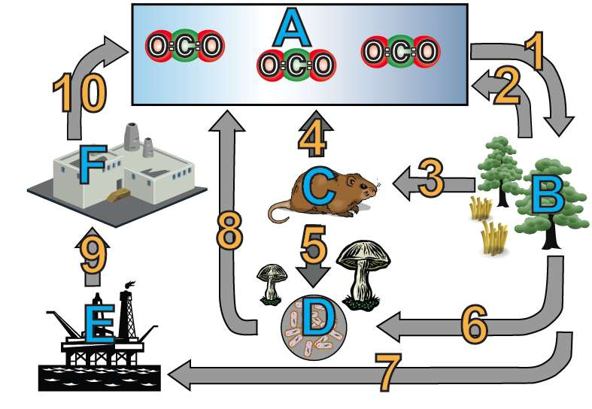
A. |  | 3.
B. |  | 4.
C. |  | 5.
D. |  | 6.
E. |  | 7.
F. |  | 8.
1. |  | 9.
2. |  | 10.

Task 4: Imaginative Science Writing
Pretend that you’re a carbon atom in a molecule of CO₂ up in the air. In the space below, describe how you move through the carbon cycle. Describe at least four journeys that you might take.

Continue to Tutorial 2: The Nitrogen Cycle
Tutorial 2: The Nitrogen Cycle
1. Read the Introduction ☐
2. Read “The Nitrogen Cycle: The Details” ☐
3. Take the quiz “Nitrogen Cycle: Checking Understanding.”
Mastering the terms
Write a short description of each of the following. Include what the process does, and who does it.
- Nitrogen fixation
- Nitrification
- Ammonification
- Assimilation
- Denitrification
Checking Understanding:
Create a key to the diagram below
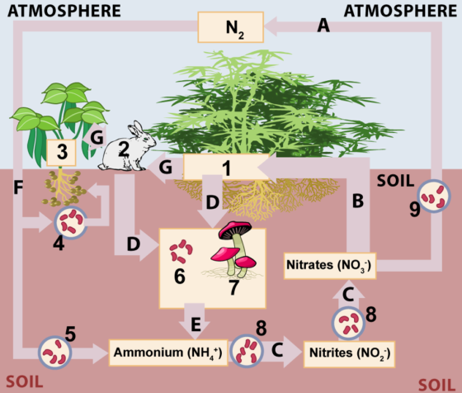
A |  | 2
B |  | 3
C |  | 4
D |  | 5
E |  | 6
F |  | 7
G |  | 8
1 |  | 9

4. Read “The Nitrogen Cycle in Practice” and take the “Applying Your Understanding of the Nitrogen Cycle Quiz.” ☐

Imaginative Science Writing
Pretend that you're an atom of nitrogen in a nitrogen molecule up in the air. Describe what happens to you as you make several loops through the Nitrogen cycle.

Click the link to the next tutorial.

Tutorial 3: Food Chains and Food Webs
1 and 2. Read the Introduction and “Getting Matter and Energy.” ☐
3. Read about “Food Chains,” and take the short quiz that follows. ☐
4. Read “Food Webs.” ☐
5. Read “Other Ways of Getting Food.” ☐
6. Complete the “Food Chains, Food Webs” Flashcards. ☐
7. Take the “Food Chains, Food Webs...” Quiz. ☐
Make a key to the diagram below
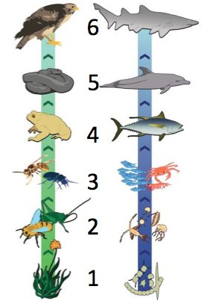

Define each of the following terms
Term | Definition/Description
Food chain
Food web
Producer
Primary consumer
Herbivore
Autotroph
Heterotroph
Secondary consumer
Carnivore
Predator
Trophic level
Omnivore
Decomposer
Scavenger
Parasite

Continue to the next tutorial
Tutorial 4: Trophic Levels and Energy Pyramids
1 and 2. Read the Introduction and the “Thought Experiment...” ☐
Make your prediction: To support the largest possible crew, we should eat as ……. . My reasoning is as follows:

Continue to Trophic Levels and Energy Pyramids, part 2
1 and 2. Read the introduction and “The Easy Math of...” As you read, complete all the interactive diagrams. ☐
3. Read “Understanding the 10% Rule.” As you read, complete the quiz “The 10% rule in Action.”☐
4. Read “Ecological Pyramids.” ☐
5. Take the “Ecological Pyramids” Quiz. ☐
6. Complete the “Biological Magnification” Interactive Reading. ☐
7. Read the “Concluding Thoughts” and watch the “Food Chain Song” music video. If you’re in a classroom, use ear buds (or check with your teacher) before playing the video. ☐
8. Complete the “Trophic Levels and Energy Pyramids” Quiz ☐
Checking Understanding 1: Explain the 10% rule. Make sure your explanation includes the underlying reasons for the rule.

Checking Understanding 2: Explain what biological magnification is, and how it works.
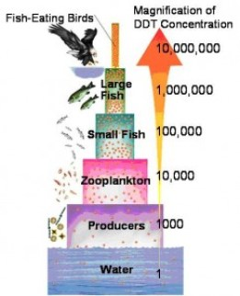

Checking Understanding 3: An important book about ecology is entitled Why Big Fierce Animals Are Rare. Use what you’ve learned about trophic levels to explain why.

sciencemusicvideos | Biology | Name:________________________
Ecosystems Crossword
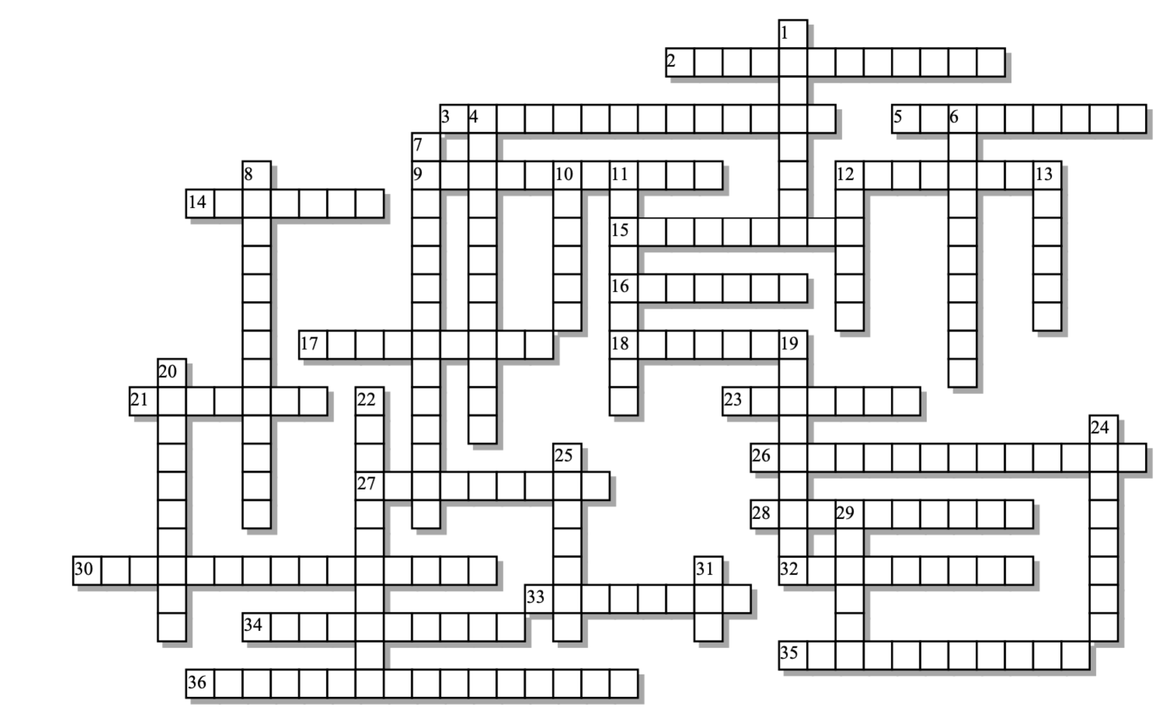

Across: | Down:
2 - When plants absorb nitrates and nitrites from the soil, incorporating them into organic molecules  3 - How carbon fixation happens  5 - Eats the dead things it finds  9 - The win-win relationship between nitrogen fixers and their hosts  12 - Taking the atoms in a gas and putting them into organic molecules (or a form that can be absorbed)  14 - This level of consumer eats plants.  15 - Organisms that eat producers, or eat animals that eat producers  16 - The root swellings where nitrogen fixing bacteria live  17 - Another word for a primary consumer  18 - Describes all the non-living parts of an ecosystem  21 - The amount of living matter in an ecosystem  23 - The loss of energy between trophic levels is the basis for a __________ of energy.  26 - Cycles that move matter between an ecosystem's biotic and abiotic components  27 - Organisms that trap the sun's energy and convert it into chemical energy  28 - Burning a fuel.  30 - Returns nitrogen to the atmosphere  32 - All the living organisms in a community, plus the abiotic components in the environment.  33 - The gas that makes up 78% of the atmosphere.  34 - The energy that sustains ecosystems eventually _________ as heat.  35 - Take dead organic matter and break it down into simpler molecules that reenter biogeochemical cycles  36 - When persistent pollutants (often metals or lipid-soluble compounds) increase in concentration in higher trophic levels. | 1 - Eats everything.  4 - Organisms that get their energy and matter by consuming other organisms.  6 - Self-feeders  7 - What happens to the proteins and nucleic acids in living organisms as they're decomposed.  8 - Oxidizing ammonia into nitrites and nitrates  10 - A family of nitrogen fixing plants  11 - Carnivores that eat herbivores are __________ consumers.  12 - These fuels, which once were parts of plants, provide most of our energy.  13 - The percentage of useable energy that is lost between trophic levels  19 - A meat-eating consumer of herbivores or higher level consumers  20 - Combustion of fossil fuels is causingclimate ____________.  22 - A cellular process that returns carbon dioxide to the atmosphere  24 - Preys on a larger, living host  25 - The level an organism feeds at  29 - Describes all the living parts of an ecosystem  31 - The interconnected food chains in an ecosystem create a food _______.

Possible Answers: abiotic, ammonification, assimilation, autotrophs, biogeochemical, biomagnification, biomass, biotic, carnivore, combustion, consumers, decomposers, denitrification, disruption, dissipates, ecosystem, fixation, fossil, herbivore, heterotrophs, legume, mutualistic, ninety, nitrification, nitrogen, nodules, omnivore, parasite, photosynthesis, primary, producers, pyramid, respiration, scavenger, secondary, trophic , web
Food Chains
Lyrics by Glenn Wolkenfeld, © 1989
Sung to the tune of The Ballad of Jed Clampett (also known as The Beverly Hillbillies Song)
Oh, a nuclear reaction happens deep inside the sun,
Where hydrogen atoms are fused into helium
Then their heat and light is radiated into space,
In 90 million miles it shines upon the Earth's face.
For every hundred calories that shine out from the sun,
The calories that green plants trap will number only one,
But every single calorie in oceans, hills, and plains,
Will serve as a foundation for a living food chain.
At the bottom of a food chain are producers like green plants
Whose cells make food from sunlight making use of chloroplasts,
It happens in the pines and flowers on your windowsill,
'Cause every single green plant's got a little chlorophyll.
Well the next step in a food chain is a primary consumer,
An herbivoric cow or vegetarian baby boomer,
A primary consumer spends its mealtimes eating plants,
It might be a buffalo or might be an ant.
Each level in a food chain yields only ten percent
Of the former level's energy you might ask where it went
There are bones and leaves you can't digest that really make a dent
And don't ignore the weighty cost of metabolic rent.
So if your plants are yielding 'bout a hundred calories,
Your yield will only be ten in the birdies and the bees.
And seven hundred calories in algae in the sea
In primary consumers it will yield you seventy.
Some other ways of getting food are really out of sight.
You could be a predator or be a parasite,
A predator eats meat a parasite eats your insides,
And if you're a decomposer you will eat me when I die!
And if you know this about food chains you can really take the cake,
When energy goes through it doesn't last, it dissipates,
But nutrients in food chains meet a very different fate,
They recycle and they circulate forever, ain't that great?
Just remember there's no beings in this world that live alone
Populations form communities where all do make their homes
Though your niche may be determining the role that you are playing.
Every creature live or dead is in a food chain.

Carbon Cycle
View it at www.sciencemusicvideos.com
Glenn Wolkenfeld © 2014

I’m a carbon atom in a CO₂ up in the air,
(In the air, in the air)
Floating with the oxygen and nitrogen up there
(Nitrogen and oxygen up there)

And there I’m gonna be until I’m sucked into a tree
(Into the leaves, of a tree)
Photosynthesis captures me,
(Puts me in the leaves of a tree)

Fixed into the leaves I’m in a new situation
(Now I’m in a solid in a plant location)
‘Cause photosynthesis does carbon fixation
(Carbon fixation)

CHORUS
Carbon cycle, moving me around
Gaseous in the air, solid on the ground,
Carbon cycle going 'round and 'round
(Going 'round and 'round and round)

I might be fixed into a tree, or herb or weed or shrubbery,
(Or maybe an algae, floating in the sea)
But after CO₂ in a producer’s where I’ll be
(Producer’s where I’ll be)

Formerly a gas, now I’m solid carbohydrate,
(Leaves and bark and fruit and wood are mostly carbohydrates)
Or possibly a grain of rice on someone’s dinner plate,
(Someone’s dinner plate)

Then maybe I’ll be eaten by a deer or mouse or bird,
(Chewed up by a goat or by a buffalo herd)
After being swallowed I could be dropped as a turd,
(Dropped down as a turd)

\CHORUS

In a plant or animal, I might get respired,
(For energy I’ll get respired)
CO₂’s released, and oxygen’s required
(Oxygen’s required)

Or possibly who carries me will fall dead to the ground,
(On to the soil on the ground)
Decomposers break me down as CO₂ comes out,
CO₂ comes out.

Decomposition, respiration put me in the air
(Carbon dioxide in the air)
With the clouds and nitrogen and oxygen up there
(Nitrogen and oxygen up there)

CHORUS
Or maybe I fall to the ground, no oxygen around,
Logs and leaves accumulate, pound by pound,
Makes me into fossil fuels deep under the ground,
(Deep under the ground)

They mine the coal, and oil and gas; combust me in machines
(CO₂ emitted from machines)
And now the CO₂’s at levels no one’s ever seen.
No one’s ever seen!

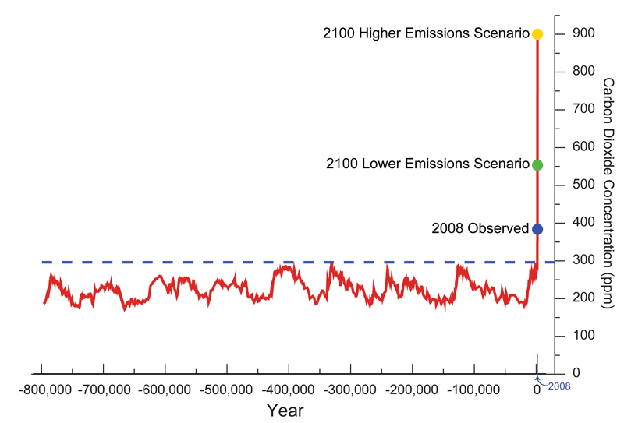 | 