Name: _____________________ Period: _____ Date: ________

sciencemusicvideos: Enzymes and Enzyme Regulation
Getting to the tutorials.
- Go to www.sciencemusicvideos.com; Use the College Bio, AP Bio, or Learning Guide Menus to find “Enzymes and Enzyme Regulation”
- Start with “Enzymes Tutorial”

Enzymes tutorial, Part 1
1. Read the introduction. Check the box below when you’re finished.
☐
In the space below , summarize the effect of amylase on starch.

What are enzymes?

2. Complete the interactive reading: Enzymes and Activation Energy. Check the box when you’re done. As you read, answer the following questions.
☐
a. A catalyst is…

b. Enzymes speed reactions by

c. Complete the key for the diagram below:
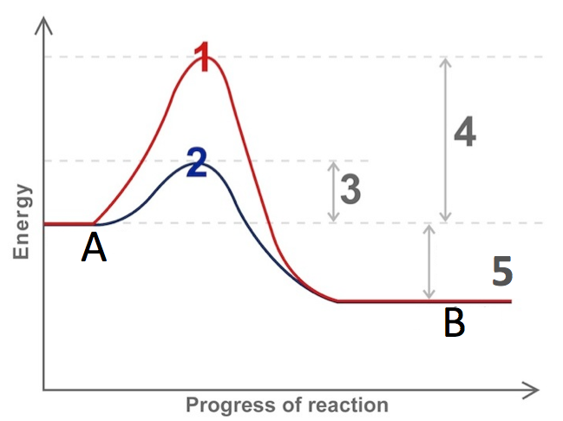
A:
B:
1:
2: Course of reaction with an enzyme
3:
4: Activation energy without an enzyme
5:

3. Complete the interactive reading: “Enzymes and Substrates.” Check the box when you’re done.
☐

a. What’s a substrate?

b. Make a key for the diagram below:
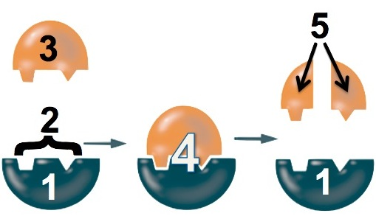
1.
2.
3.
4.
5.
c. What is the “lock and key” model of enzyme action?

d. What is the “induced fit” model of enzyme action.

4. Complete the interactive reading: “Enzymes and their Environment.” Check the box when you’re done.
☐
a. What is denaturation?

b. Use denaturation and optimum to explain the two graphs below:
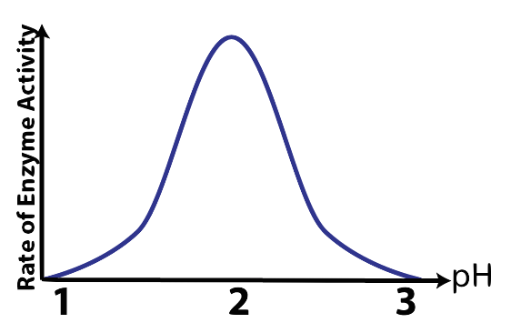 | 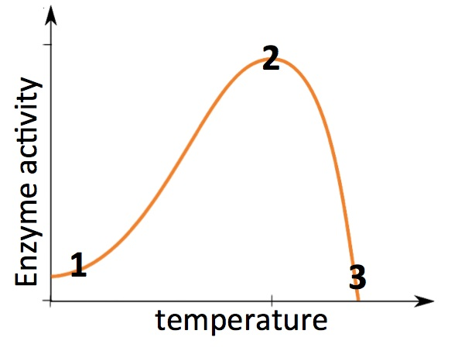

5. Complete the enzymes flashcards. Check the box when you’re done.
☐
6. Take the enzymes quiz. Check the box when you’re done.
☐
7. Complete the Enzymes, Interactive Lyrics. Check the box when you’re done.
☐
PRACTICE RECALLING WHAT YOU KNOW. In the space below, write down everything you’ve learned so far about enzymes.

Enzymes
Glenn Wolkenfeld © 2012
They’re the protein catalysts in every organism: ENZYMES!
Through enzymatic action your metabolism’s driven: ENZYMES!
In staphylococcus, jellyfish, tarantulas and trees,
They lower activation energy
Enzymes, in you and me now, ENZYMES!

You got ‘em in your cells where they do cellular digestion: ENZYMES!
You got ‘em in your mouth and in your stomach and intestines: ENZYMES!
The thing an enzyme acts upon is called a substrate.
They fit like lock and key with complementary shape
Enzymes, speed up reaction rates: ENZYMES!

An enzyme binds its substrate at its active site: ENZYMES!
Bound together in a complex where they snuggle so tight: ENZYMES!
New bonds will form and break due to the active site’s chemistry
Reactants become products, it’s the enzyme’s specialty,
Product gets release enzyme repeats its action readily: ENZYMES!

Like any molecule an enzyme’s shape defines its function: ENZYMES!
Environmental change that changes shape leads to malfunction: ENZYMES!
Every enzyme has a pH where it catalyzes best,
a pH change will set enzyme activity to rest.
Enzymes are so sensitive they’re easily upset: ENZYMES!

More heat until a certain point increases their efficiency: ENZYMES!
But too much heat denatures them destroying their activity: ENZYMES!
That’s why a fever running high’s a dangerous situation,
All that heat can alter enzymatic conformation.
Keep it 98.6 for enzyme optimization: ENZYMES!

Enzymes in saliva will break starch into glucose: ENZYMES!
If you lack the enzyme lactase then you won’t enjoy milk lactose: ENZYMES!
Tay-sachs, galactosemia and PKU disease,
All caused by inherited enzyme deficiencies
ENZYMES, they’re what everybody needs: ENZYMES!
Name:______________________________________ Period: ____________

Enzymes tutorial, Part 2 (Enzyme Inhibition and Regulation
Access this biology180.com tutorial by going to the AP Biology Menu, then Module 9, Energy and Enzymes, then the “Enzyme Inhibition and Regulation Tutorial.”

1. Read the introduction and the section on Enzyme Inhibition. . Check the box below when you’re finished.
☐
In the space below , summarize the difference between competitive and non-competitive inhibition.

Take the “Enzyme Inhibition” Quiz.
☐
CONSOLIDATING YOUR LEARNING
Make a key to the diagram below. Try to do this without looking at the page. Then go back and check your work.
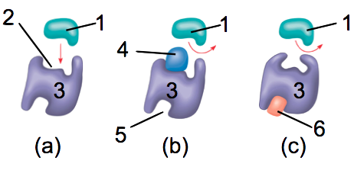
a:
b:
c:
1:
2:
3:
4:
5:
6:

2. Read the section on enzyme regulation. Check the box when you’re done.
☐

Briefly define the following terms:
- Metabolic pathway:
- Feedback inhibition:
- Intermediate compound
- Feedback inhibition
- Allosteric site
- Allosteric inhibitor
- Allosteric activator
Take the “Enzyme Regulation” Quiz.
☐
Make a key to the diagram below: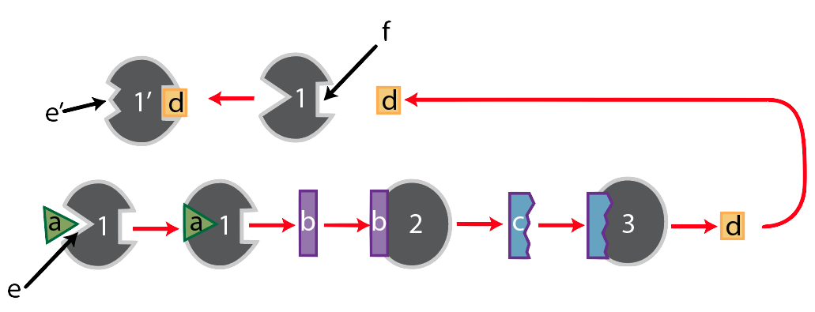
1:
1’:
2:
3:
a:
b:
c:
d:
e:
e’:
f:

Reflect: how are allosteric inhibition and non-competitive inhibition similar? How do they differ?

Biology | sciencemusicvideos.com | Name:________________________

Enzymes!
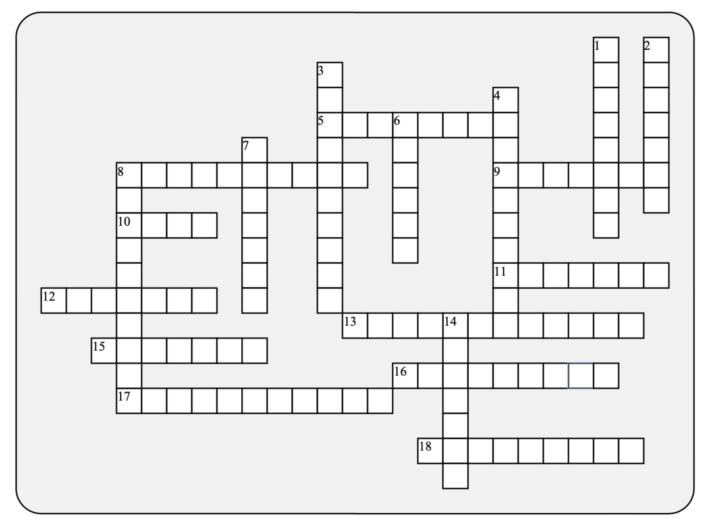

Across: | Down:
5 - Too much heat can __________ an enzyme  8 - Enzymes work by lowering ___________ energy  9 - An enzyme required for digesting starch  10 - Enzymes fit substrates like a key fits a  11 - The changed shape an enzyme acquires after binding its substrate is known as _______ fit  12 - The class of macromolecule that most enzymes belong to  13 - The three dimensional shape of an enzyme is known as its  15 - Measuring the appearance of ________ is one way to measure the rate of enzyme activity.  16 - The name of substances that speed up a chemical reaction without being changed by that reaction  17 - The kind of inhibition that occurs when an inhibitor blocks the active site.  18 - The thing an enzyme acts upon | 1 - Inhibition that involves the product of a pathway interfering with one of the pathway's enzymes  2 - They're the protein catalysts in every organism  3 - __________ enzymes break polymers into monomers  4 - Enzymatic action drives your ______________.  6 - The __________site is where an enzyme binds with its substrate  7 - An enzyme required for digesting milk sugar  8 - A binding site away from the active site that can change the shape of the active site.  14 - Every enzyme has a pH ____________ where it operates most efficiently
Possible Answers:
Activation, Enzymes, Induced, active, allosteric, amylase, catalysts, competitive, conformation, denature, feedback, hydrolytic, lactase, lock, metabolism, optimum, product, protein, substrate

