Name: _____________________ Period: _____ Date: _________________

sciencemusicvideos Eukaryotic Gene Regulation and Expression, Student Learning Guide
Getting to the tutorials.
- Go to www.sciencemusicvideos.com; Use the College Bio, AP Bio, or Learning Guide Menus to find “Eukaryotic Gene Regulation and Expression.”

Tutorial 1: Eukaryotic Gene Expression: an Introduction
1. Read the introduction. In terms of the genes they express, how are a pancreas cell, an eye-lens cell, and a nerve cell similar and different?

b. What is genomic equivalence?

2. Study the diagram and table “Eukaryotic Gene Regulation: The Big Picture.” Quiz yourself until you can confidently name every part. ☐
3. Read “Gene Regulation through DNA/Chromatin Packaging.” ☐
4. Take the quiz: “Euchromatin, Heterochromatin, Methylation, Acetylation.” ☐
a. In terms of appearance, structure, and function, compare and contrast euchromatin and heterochromatin.

b. Complete the following: whereas methylation ...
acetylation________________________________
c. Make a key to the diagram below.
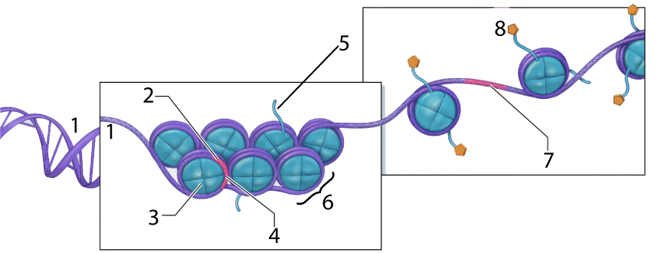

1
2 | A gene
3
4 | A gene that can’t be ________________
5
6.
7. | A gene that can be ________________
8.
5. Read about heterochromatin, Barr Bodies, and Tortoiseshell cats (and watch the short video). ☐
6. Take the quiz: “Barr Bodies, Female Mosaicism, and Heterochromatin.” ☐
APPLICATION: You’re sitting around with a few friends and a calico/tortoiseshell cat walks by. One of your friends says “I’ve heard that male calicos/tortoiseshells are exceedingly rare. I wonder why.”
You take a deep breath and say, “Let me explain it to you.” Write your explanation below. Make sure you use the terms Barr body, female mosaicism, gene expression, heterochromatin, and heterozygote in your answer.

7. Read about Epigenetics (the excerpt from Nessa Carey’s article “Beyond DNA,” from Natural History Magazine © 2012).
a. List three amazing things from this article.

b. The article points out that because of epigenetics, identical twins aren’t phenotypically and behaviorally identical. But male identical twins are more similar than female identical twins. Look over what you learned in this page, and in the tiny space below, speculate about why that is.

Continue to Tutorial 2: “Regulation of Transcription...”
Tutorial 2: Regulation of Transcription
1. Read the Introduction. ☐
2. Complete checking for understanding quiz: “Transcription and the Transcription initiation complex.” ☐
a. Create a key for this image. When needed, add functions.
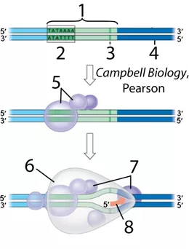 | 1.  2.  3.  4.  5.  6.  7.  8.
3. Read “Eukaryotic Transcription Factors and Control of Gene Expression” ☐
4. Take the quiz: “Eukaryotic Gene Structure and Transcriptional Control.” ☐
A. Know the Parts: Make a key for this diagram:
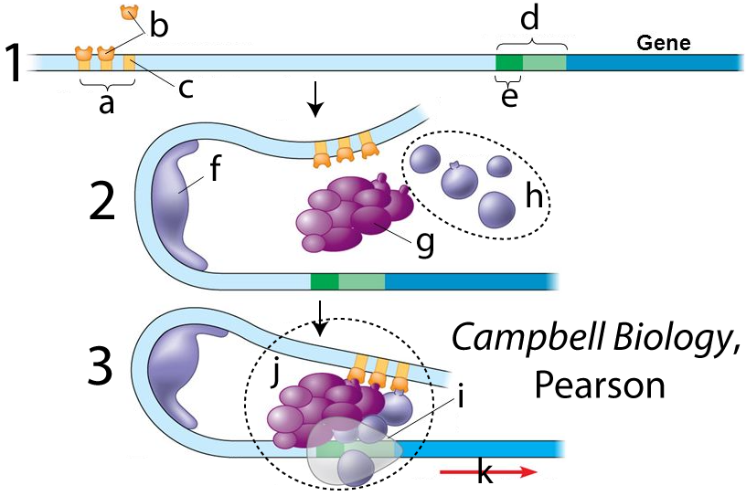 |  | a.  b.
c.
d.
e
f.
g.
h.
i.
j.
k.
B. Explain it! In the space below, describe what needs to happen in order for a eukaryotic gene to be transcribed.

5. Read “Activators, Cell Specialization, and Coordinated Control” ☐
6. Take the Quiz “Activators, Cell Specialization, and Coordinated Control (and everything else..)” ☐
Explain it (1). In the space to the right and below this diagram, explain how combinatorial control of gene expression works.
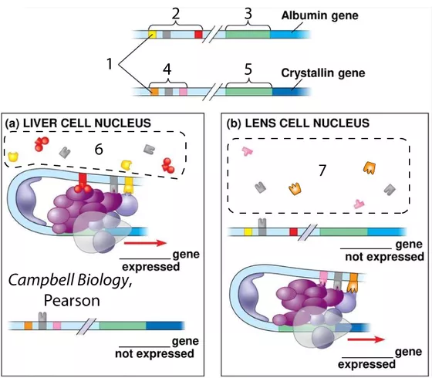

Explain it (2). Explain how signals can coordinate the simultaneous expression of multiple genes.
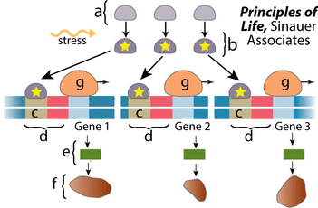

Explain it (3). Explain how steroid hormones control gene expression (write to the right of the image below).
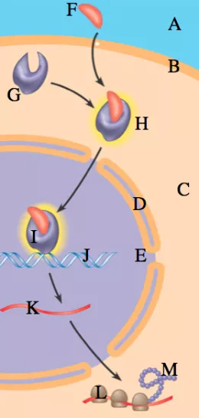

Follow the link to the next tutorial
Tutorial 3: Post Transcriptional Eukaryotic Gene Regulation.
1. Read the Introduction. ☐
2. Read “Alternative Splicing...” ☐
3. Read “Regulation of translation by miRNAs...” ☐
4. Take the quiz: “Alternative Splicing and RNA interference.” ☐
Explain it: Use the image below to explain alternative splicing.

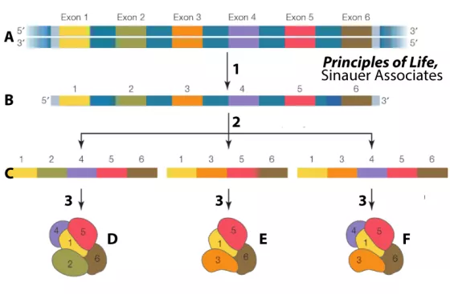

Explain it: Use the image below to explain RNA interference.
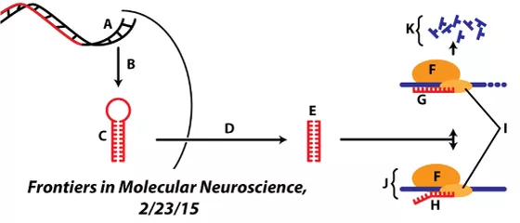

5. Read “Regulation of Translation by Proteins.” ☐
Create a key to this diagram about ferritin protein regulation.
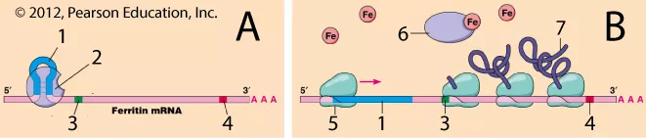
1.
2.
3.
4.
5.
6.
7.

Now, create a key to this diagram about regulation of production of the transferrin receptor.
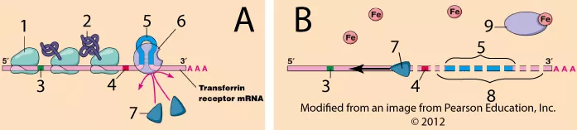
1.
2.
3.
4.
5.
6.
7.
8.
9.
Now, pull what you’ve learned together by writing a short paragraph explaining how cells regulate their cytoplasmic iron concentration.
Ferritin Regulation
Transferrin Regulation
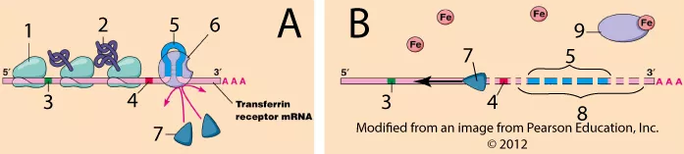

Finally, create a key to this diagram about proteasomes and protein degradation.
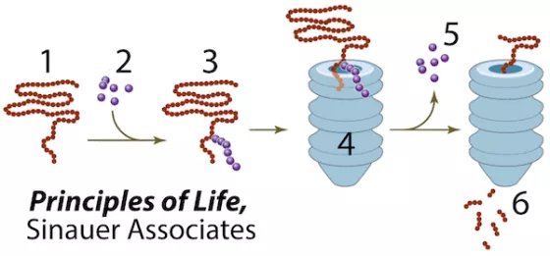
1.
2.
3.
4.
5.
6.

7. Take the Eukaryotic Gene Regulation Cumulative Quiz

CUMULATIVE SUMMARY
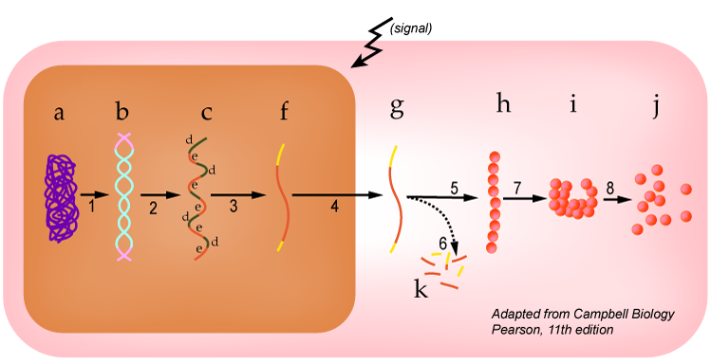
Use the image above to explain control of gene expression in eukaryotes. In your explanation, cover each structure (letters) and each process (numbers).

sciencemusicvideos|Biology | Name:________________________
Eukaryotic Gene Expression and Regulation
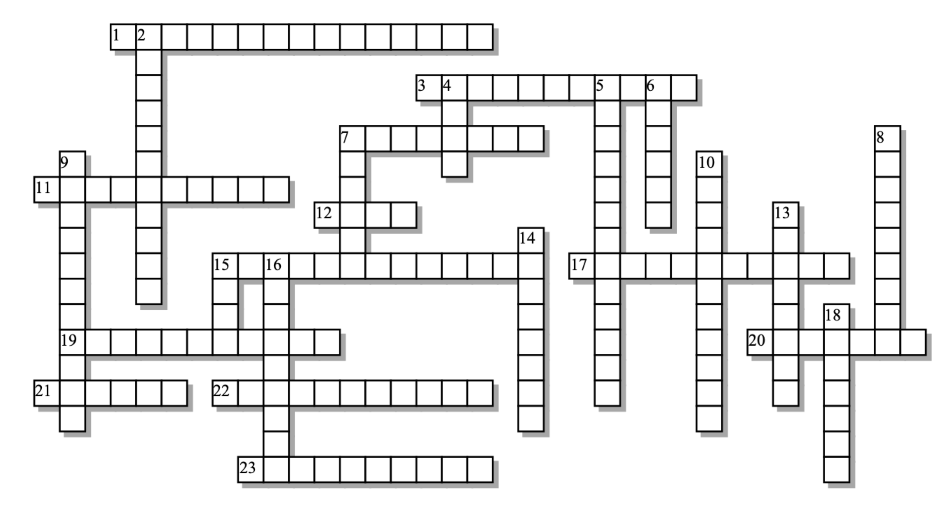

Across: | Down:
1 - Densely packed DNA, not available for transcription.  3 - Chemical modification of chromatin that shuts down gene expression.  7 - The kind of RNA responsible for RNA interference  11 - The functional unit of DNA packaging  12 - A type of chromosomal body found in every somatic cell of a female.  15 - For RNA polymerase to bind, __________ factors must be in place.  17 - Almost all cells in a multicellular organism are ___________ equivalent  19 - Chemical modification of chromatin that makes genes available for transcription.  20 - The kind of protein that DNA wraps around  21 - Control elements far away from the promoter  22 - miRNAs, through various mechanisms, block ________________.  23 - A large protein complex that digests proteins that have been tagged for destruction. | 2 - Heritable changes that involve DNA, but not its sequence of nucleotides  4 - An expressed sequence of DNA  5 - Female cat coloration pattern resulting from X inactivation  6 - Gene regulation system used by prokaryotes, but not eukaryotes  7 - Because of X-inactivation, every female mammal is a cellular ________  8 - A protein that's used to tag other proteins for destruction.  9 - Loosely packed DNA, available for transcription  10 - It's the _______________ of activators that determines what genes get expressed.  13 - Through alternative __________, one gene can code for multiple proteins.  14 - A group of control elements makes up an ___________  15 - A sequence near the promoter that tells RNA polymerase where to bind.  16 - These regulatory proteins bind with enhancers AND with transcription factors or mediator proteins  18 - The kind of hormone that binds with a cytoplasmic receptor, forming a transcription factor.
Possible Answers:
Barr, Enhancer, TATA, Tortoiseshell, acetylation, activator, combination, distal, epigenetics, euchromatin, exon, genomically, heterochromatin, histone, methylation, microRNA, mosaic, nucleosome, operon, proteasome, splicing, steroid, transcription, translation, ubiquitin

