Name: _____________________ Period: _____ Date: _________________

Module 27: Immune System, Student Learning Guide
Instructions:
1. Work in pairs (share a computer).
2. Make sure that you log in for the first quiz so that you get credit.
3. Go to www.sciencemusicvideos.com. Select the AP Biology Menu. Then select “Module 27: The Immune System”

Tutorial 1: Non-Specific (Innate) Immunity
Introduction. Read “It’s a Dangerous World.” ☐
Summarize: What’s a pathogen?

What are some of the threats that multicellular organisms (like you and me) face?

1. Read “A Layered Defense System,” and complete the interactive diagram. ☐
Briefly describe the three lines of defense:

2. Read about “Defense Layer 1: The Outer Barriers”
As you do, describe or define the following:
Term | Definition or description
Epidermis
Resident flora
mucous membranes
lysozyme

3. Read about “Defense Layer 2: Non-Specific (Innate) Immunity.” As you do, answer the questions below.
Overview. Why is defense layer 2 non-specific and innate?

3a.1. What do phagocytes do?

3a.2. What does sentinel mean?

3a.3. What’s a leukocyte?

3b.1. Create a key to the diagram below:
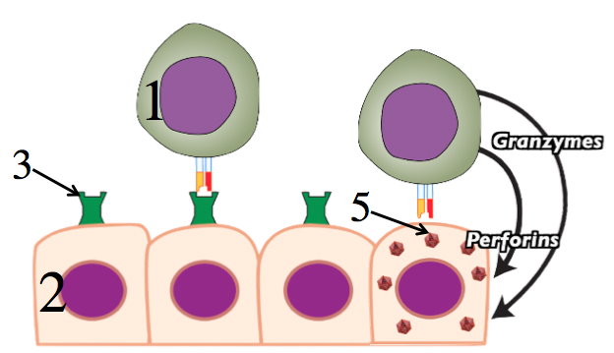

1
2
3
4
5
3b.2. Explain how natural killer cells use the MHC protein system to know which cells to attack.

3b.3. Explain how natural killer cells destroy their targets.

3c. Using the diagram below, explain how interferons work.
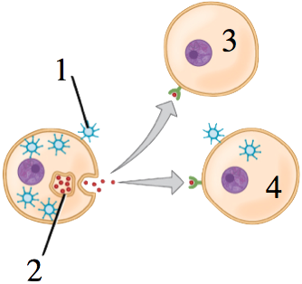

3d. Explain how complement works.

3e. Using the diagram below, explain how the inflammatory response works.
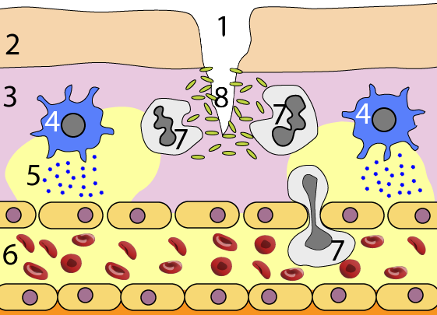

3f. Describe how fever works.

4. Take the Quiz, “Non-Specific Responses: Checking Understanding:” ☐
5. If you haven’t already done so, watch the “Immune System 1: Non-Specific (Innate) Responses Song.” Afterwards, complete the interactive lyrics ☐

SUMMARIZING: Fill in the blanks in the diagram below. Then fill the space below the diagram with a description of our body’s first two lines of defense. Write small.
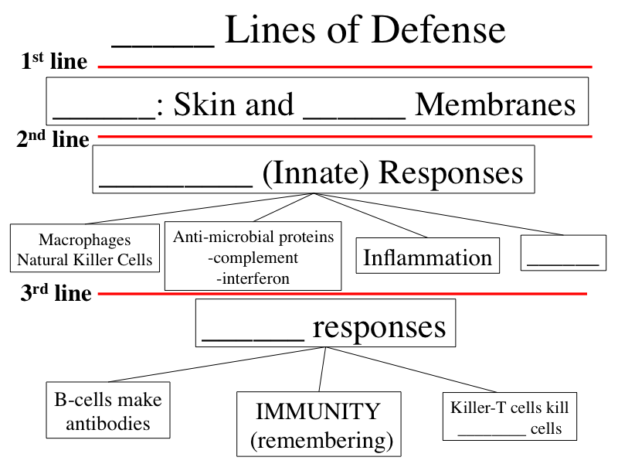

II. ADAPTIVE/ACQUIRED IMMUNITY: Follow the link to “Immune System 2: Overview...”
1. Complete the “Immune System: Review and Preview Quiz.” ☐
2. Read “Specificity and Clonal Selection. ☐
3. Take the “Antibody Specificity and Clonal Selection” Quiz ☐
From memory, try to make a key for this diagram:
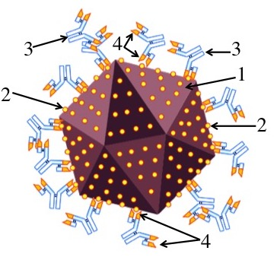 | 1.  2.  3.  4.

Make a key for this diagram:
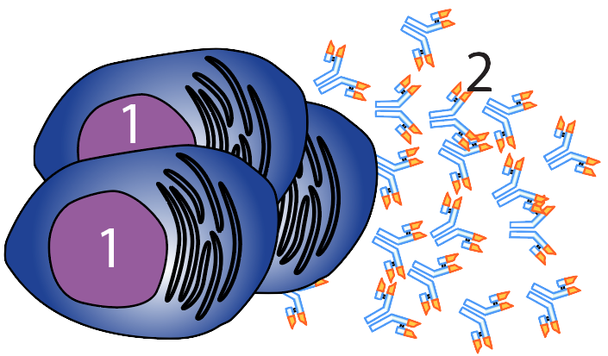 | 1.  2.
SUMMARIZE: What is specific about the specific immune response? Why is the “custom tailoring” analogy for this specificity incorrect?

Now make a key for this diagram, and, in the space below the key, write an explanation of “clonal selection.”
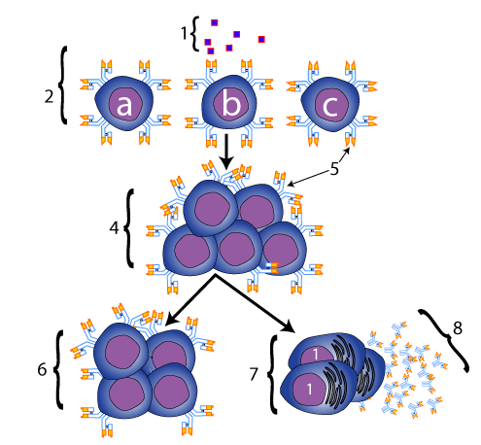
1.
2.
3.
4.
5.
6.
7.
8.
Clonal selection is

4. Read “Antibody Structure and Generating Antibody Diversity.” ☐
5. Take the Quiz “Antibody Structure and Antibody Diversity.” ☐

Make a key for this diagram:
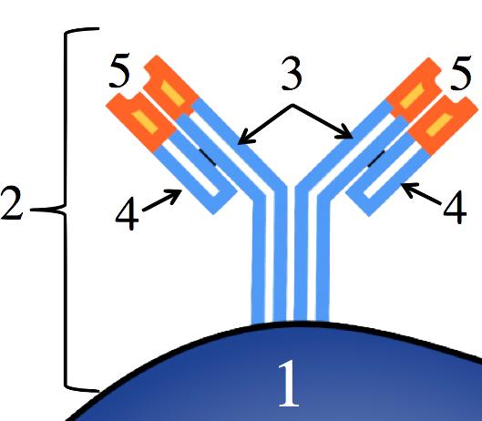 | 1.  2.  3.  4.  5
Using the diagram below, describe the steps involved in generating antibody diversity
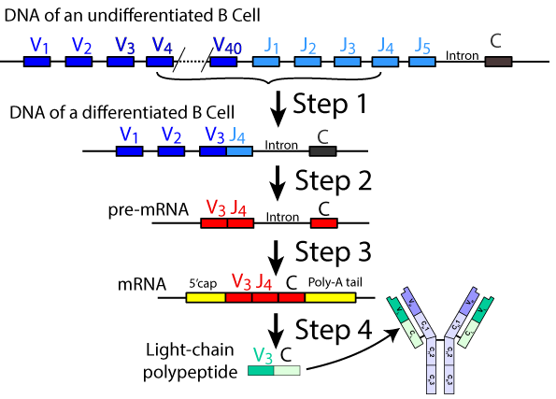
1.
2.
3.
4.
In the space below, write (from memory) a brief summary of how antibody diversity is generated. Write small.

Follow the link to the next tutorial, “The Humoral Response.”
III. Immune System 3: The Humoral Response.”
1. Read the Introduction. ☐
2. Read “The humoral response begins with...” ☐
3. Read “Phagocytes present antigen to helper...” ☐

Summarize what you’ve read by creating a key to the diagrams below.
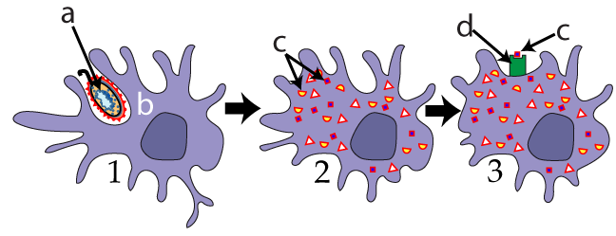
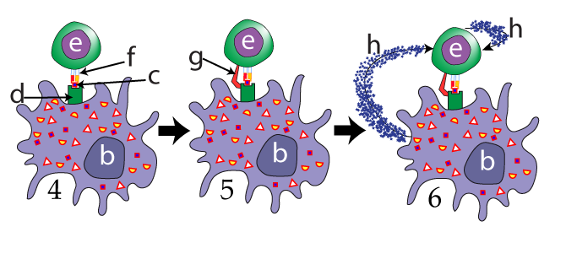
a.
b.
c.
d.
e.
f.
g.
h.
1.
2.
3.
4.
5.
6.

4. Read “Helper T Cells activate B cells, which become...” ☐
5. Complete the interactive table, “The Humoral Response.” ☐

Checking understanding: Explain what’s happening in the diagram below. Lay out your explanation as a sequence of events: First...Second...Next...etc. Write small.
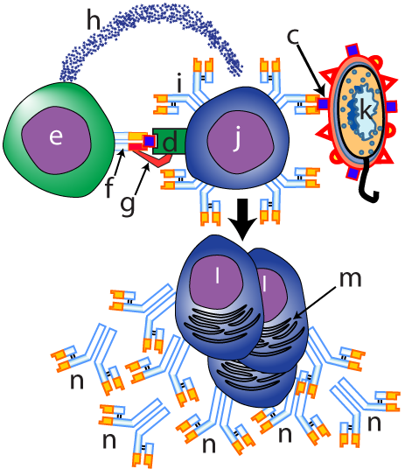

6. Read “Antibodies help neutralize pathogens...” ☐
7. Complete the quiz, “The Humoral Response: Checking Understanding.” ☐
More Checking Understanding: Describe the three ways that antibodies can neutralize pathogens.

Follow the link to “Cell Mediated Immunity and Immunological Memory” (Immune System 4).
IV. Immune System 4: The Cell Mediated Response..”
1. Read the introduction. ☐
2. Read “Killer T Cells (AKA Cytotoxic T cells) use ...” ☐
3. Read “Mobilizing Killer Ts” ☐
4. Take the “The Cell Mediated Response” quiz. ☐
Checking Understanding
In the space below, explain what’s happening in these diagrams.
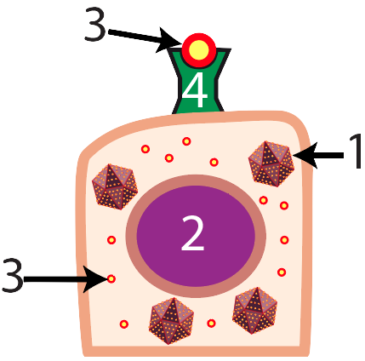 | 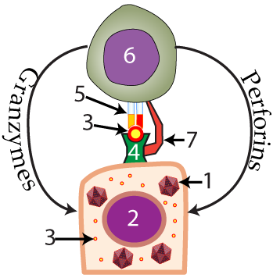

Now, using the diagram below, explain how cytotoxic T cells get activated.
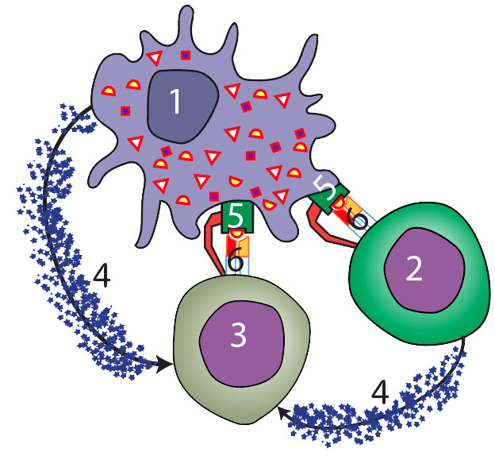

5. Read “Immunological Memory.” ☐
6. Read “Primary and Secondary Immunity.” ☐
7. Read “Vaccinations and Passive Immunity.” ☐
8. Take the “Specific Immunity (the Whole Shebang)” quiz. ☐
Checking Understanding:
Make a key to the diagram below.
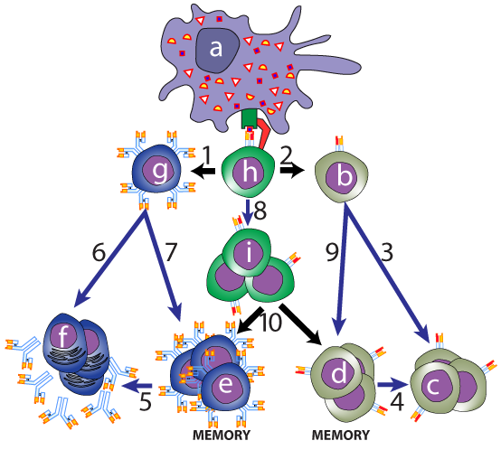

a. |  | 2.
b. |  | 3.
c. |  | 4.
d. |  | 5.
e. |  | 6.
f. |  | 7.
g. |  | 8.
h. |  | 9.
1. |  | 10.

And now explain what’s happening in this graph.
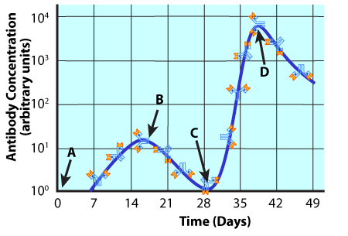

Complete this sentence: Passive immunity is different from active immunity because...

9. Complete “Immune System Part 2: Interactive Lyrics” ☐

Mariah’s Immune System Adventure

Instructions: Read each of the passages below. Fill in the blanks with the choices below, which can be used once or more than once. Write your answers on the right side so that you can continue to use this as a study sheet.

Part 1: The Three Lines of Defense  When Mariah woke up, she knew she was in for trouble. Her throat hurt, and she felt feverish. Her swollen throat was an example of __1__, part of the body’s __2__ line of defense. Obviously, some kind of disease causing __3__ had made it past the __4__, line of defense: the skin and __5__.  Mariah told her father, Reggie, about how she was feeling. Reggie took her temperature; the thermometer read 38.5 C. __6__is also part of the __7__ immune response. Reggie asked Mariah if her glands were swollen. Mariah nodded yes, but also corrected her father: “Those swellings aren’t glands, Dad. We learned in biology that those are actually __8__.”  Fearing strep throat, Reggie drove Mariah over to the local clinic to see what was causing Mariah’s symptoms. The nurse gave Mariah a strep test: the result was negative. “It looks like it’s a viral infection” said the nurse. “That means that I can’t prescribe any __9__: they’re only effective against __10__. All you can do is head home and try to get some rest. | - ________________  - ________________  - ________________  - ________________  - ________________  - ________________  - ________________  - ________________  - ________________  - ________________

- antibiotics
- bacteria
- fever
- first
- inflammation
- lymph nodes
- mucus membranes
- non-specific
- pathogen
- secondary

Part 2: The Battle, part 1  Mariah went home and got into bed. Within her body, a battle was occurring.  At the site of the infection, large white blood cells called __1__ had swallowed the virus. After digesting it, they displayed pieces of it on their __2__. Those pieces of the pathogen, which will soon elicit an immune response, are called __3__.  Some of these macrophages died at the site of the infection, resulting in __4__. But other macrophages wandered back to __5__nodes, where they presented the antigen to the generals of the immune system army, the __6__cell. The Helper T cell now activates a cell that will produce antibodies, also known as a __7__. The B-cell that gets activated has a special attribute: it has a membrane __8__that is __9__in shape to the antigen.  Once the B-cell is activated, it __10__many copies of itself. Some of these clones become __11__cells, which release antibodies into the bloodstream. These antibodies will bind with __12__on the invading virus, making it impossible for the virus to __13__other cells. Attachment of antibodies also makes it easier for __14__white blood cells to swallow up the virus.  Other B cells will stay in Mariah’s lymph nodes for the rest of her life. These are __15__B cells, and they are the basis for __16__. | 1. _______________  2. _______________  3. _______________  4. _______________  5. _______________  6. _______________  7. _______________  8. _______________  9. _______________  10. _______________  11. _______________  12. _______________  13. _______________  14. _______________  15. _______________  16. _______________

- antigen
- antigen
- B-cell
- clones
- complementary
- Helper-T
- immunity
- invade
- lymph
- macrophages
- membranes
- Memory
- phagocytic
- plasma
- pus
- receptor

Part 3: The Battle, Part 2  The battle is not quite over. From her studies of biology, Mariah knew that viruses are not independent __1__. A virus, in fact, is little more than __2__surrounded by a protein __3__. Viruses lack a membrane and __4__. They’re really like __5__that take over cells. For Mariah, that meant that any infected cells would be churning out new __6__: they’d have to be stopped.  The creation of antibodies in the __7__response was not enough to meet this threat. Rather, what’s needed is the __8__response. In this response, helper T-cells activate __9__, which have __10__that match with the pathogen’s __11__. These Killer-T cells will move through the blood and tissues. When they meet body cells displaying the __12__antigen, they’ll kill the __13__cells. | 1. _______________  2. _______________  3. _______________  4. _______________  5. _______________  6. _______________  7. _______________  8. _______________  9. _______________  10. _______________  11. _______________  12. _______________  13. _______________

- antigen.
- cell-mediated
- cells
- coat
- cytoplasm
- Genes
- humoral
- infected
- Killer-T cells
- pirates
- receptors
- viral
- viruses

Part 4: After the Battle  Three months later, Mariah went to a party. Her classmate, Isabel, coughed while telling a story. Isabel was in the early stages of the same infection that Mariah had suffered. Tiny droplets of virus-containing fluid were forced into the air, some of which went into Mariah’s nose. While most of these viruses were trapped in the __1__ lining Mariah’s nasal passages and destroyed by __2__, some virus managed to drip back to the site of the previous infection.  This time, the story unfolded quite differently. Because of her previous infection, Mariah possessed a large clone of __3__cells. After a macrophage captures some of the invader, it quickly finds these memory cells. The __4__quickly start producing antibodies, which immediately __5__the virus. The Killer T cells sweep into action, destroying the few __6__cells, preventing them from producing more __7__. Before Mariah feels any symptoms, this __8__has been defeated. | 1. _______________  2. _______________  3. _______________  4. _______________  5. _______________  6. _______________  7. _______________  8. ________________

- B cells
- enzymes
- infected
- memory B and T
- mucus
- neutralize
- pathogen
- viruses

Part 5: Earlier in life  The events above are very similar to what happened –in an artificial way—when Mariah had a series of injections or __1__. These injections involved weakened forms of the __2__, or even just a bit of __3__. Without causing any significant symptoms, these antigens stimulated the formation of clones of __4__. And with these cells present in __5__nodes around Mariah’s body, she now has __6__to several common diseases. | 1. _______________  2. _______________  3. _______________  4. _______________  5. _______________  6. _______________

- antigen
- immunity
- lymph
- memory cells
- pathogen
- vaccination

Immune System Crossword sciencemusicvideos|AP Biology
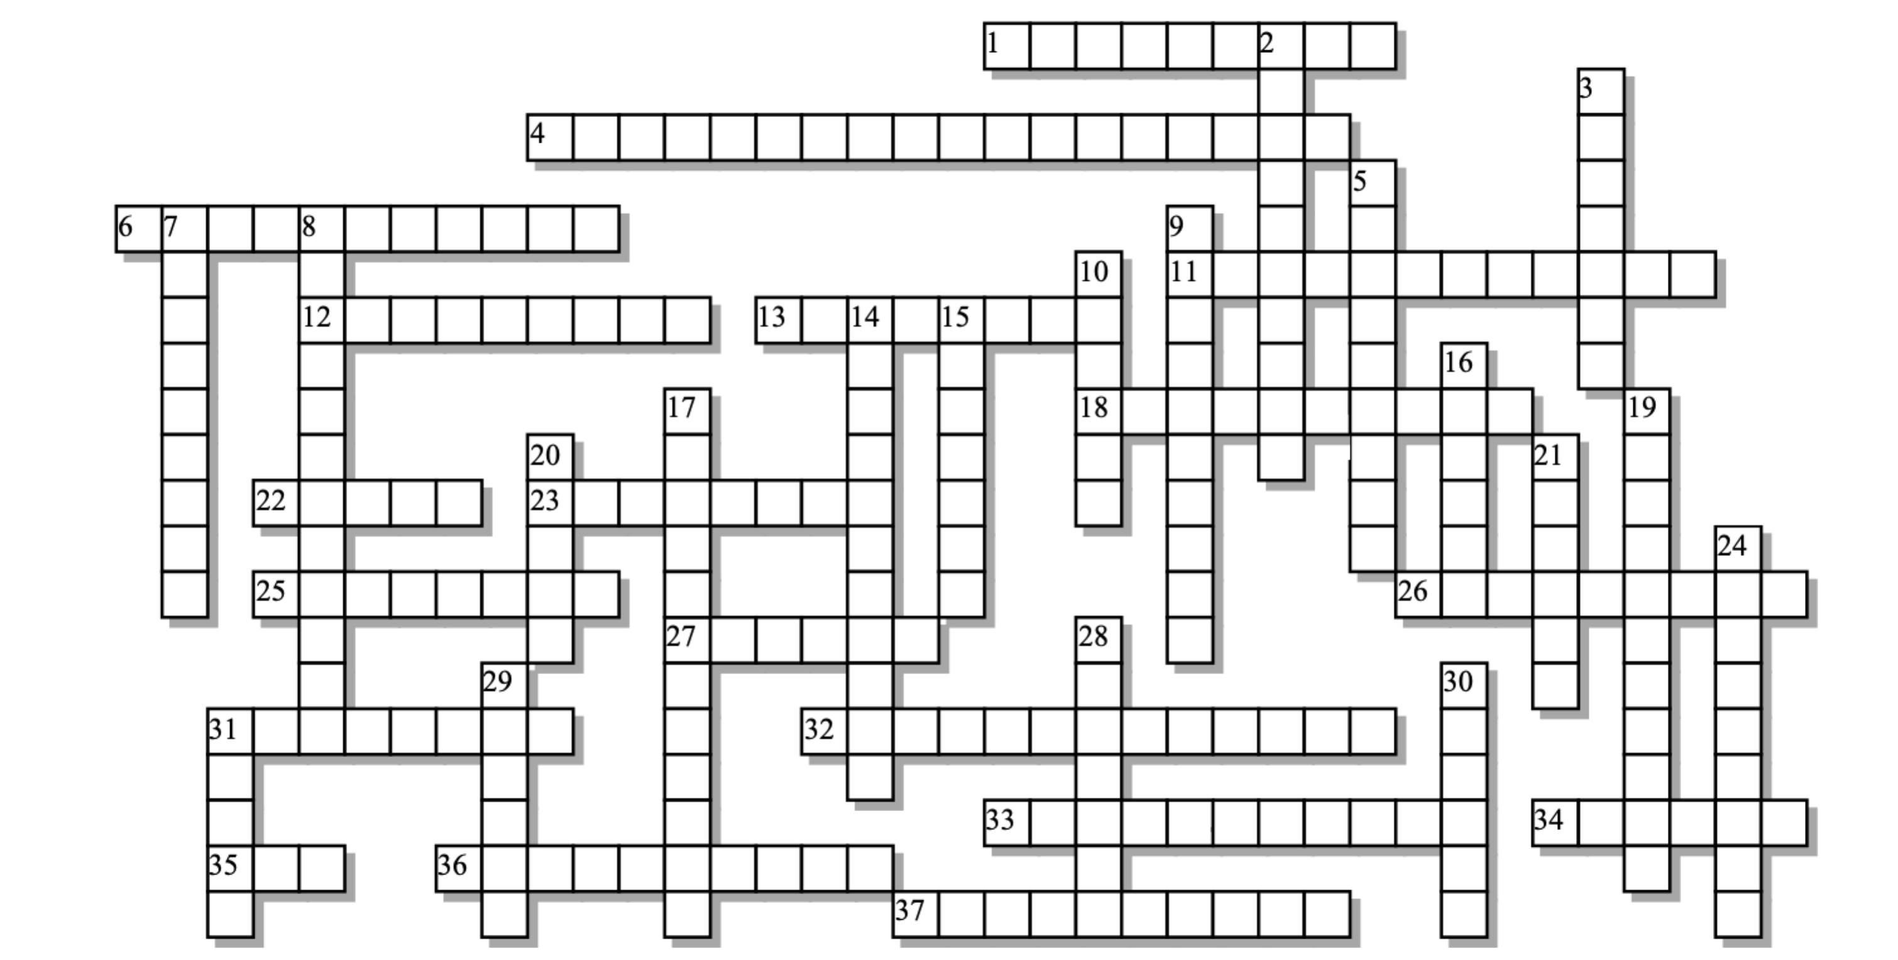

Across: | Down:
1 - T cell secretions that blow holes in target cell membranes  4 - These proteins are used to display antigen.  6 - Viruses that can't bind with their targets because they're covered with antibodies have been  11 - The redness and swelling that are part of the non-specific responses.  12 - These T cells are specific assassins that attack virus-infected and pre-cancerous cells.  13 - Antibodies have constant and ____________ regions  18 - General name for sentinel cells that find and engulf pathogens  22 - The kind of pathogen that requires the cell-mediated response  23 - We don't tailor-make antibodies; their diverse shapes are pre-___________  25 - A disease-causing agent  26 - These molecules act as messages that induce immune cells to clone themselves.  27 - Immune responses that we're born with  31 - An anti-microbial enzyme in tears and saliva  32 - Antibodies (and T cell receptors) work because their binding sites are __________ to an antigen.  33 - This is the clade that evolved the specific immune response  34 - The type of selection that's key to the specific immune response.  35 - Results from the accumulation of dead white blood cells.  36 - Proteins that bind with and neutralize pathogens  37 - A team of proteins that can attack bacterial cell membranes | 2 - A substance secreted by virus-infected cells that tells their neighbors to resist infection  3 - The type of immunity that results when you receive antibodies from an outside source.  5 - T cell secretions that induce apoptosis in infected cells.  7 - The outermost layer of our body's outermost barrier.  8 - Enzymes that recombine DNA segments in a way that amplifies antibody diversity  9 - Molecules released by mast cells that promote swelling and allow phagocytes to reach an infected area.  10 - This T cell is the general of the immune system army.  14 - The first step of the specific immune response involves ___________ of a pathogen.  15 - A molecular part of a pathogen that elicits an immune response.  16 - These B and T cells result from previous infections, and help to quickly fight of new infections  17 - Marking a pathogen for phagocytosis  19 - Medical induction of immunological memory  20 - A heat-related sign that our bodies are fighting an infection.  21 - These membranes line our orifices  24 - You develop this type of immunity by immunologically remembering previous infections.  28 - This part of the specific response involves B cells that secrete antibodies.  29 - The system that fights of pathogens  30 - A B cell that matures becomes an antibody-secreting ________ cell.  31 - These nodes are the immune system's command centers.
Possible Answers: Plasma, antibodies, antigen, clonal, complement, complementary, cytokines, cytotoxic, epidermis, existing, fever, granzymes, helper, histamines, histocompatibility, humoral, immune, inflammation, innate, interferon, lymph, lysozyme, memory , mucous, neutralized, opsonization, passive, pathogen, perforins, phagocytes, pus, recognition, recombinases, secondary, vaccination, variable, vertebrates, virus

