Name: ______________________________ Period: _____ Date: ________

sciencemusicvideos Meiosis, Sex Determination, Nondisjunction and Chromosomal Variations: Student Learning Guide
Getting to the tutorials:
- Go to www.sciencemusicvideos.com; Use the College Bio, AP Bio, or Learning Guide Menus to find “Meiosis ...”

Tutorial 1. Meiosis: Basic Concepts
1. Read the introduction. Check this box when you’re finished. ☐
Define meiosis:

2. Read “Understanding Chromosome Number.”☐
3. Work on the “Key Meiosis Terms” Flashcards until you can recite the answer to each card with confidence. ☐
4. Take the quiz, “Basic Concepts of Meiosis.” ☐

CHECKING UNDERSTANDING: Define each of the following terms. Try to do this from memory, and then go back and use the webpage to perfect your definitions.
Diploid:
Haploid:
Homologous chromosomes:
Allele:
Germ cell:
Gamete:
Somatic cell:

CHECKING UNDERSTANDING:
Why should you care about meiosis? Why is it important? Fill the space below with your best answer (knowing that your answer might improve as you learn more).

Click the link to “Meiosis Part 2: Meiosis 1 v. Meiosis 2”
Tutorial 2. Meiosis 1 v. Meiosis 2
1 and 2. Read the Introduction, then continue reading “Haploid Cells, Diploid Cells, and the Life Cycle…” ☐
3. Take the Quiz: “The Life Cycle of Sexually Reproducing Organisms” ☐
CHECKING UNDERSTANDING: Create a key to the diagram below
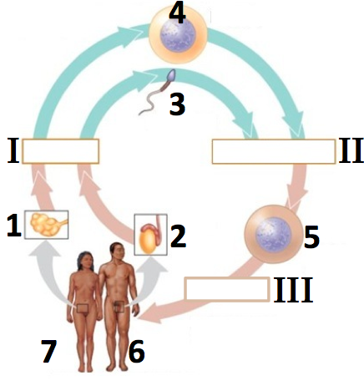 |  | 1.
 |  | 2.
 |  | 3.
 |  | 4.
 |  | 5.
 |  | 6.
 |  | 7.
I
II
III
4. Read “Meiosis Involves Two Cell Divisions” ☐
5. Take the Quiz: “Meiosis 1 v. Meiosis 2” ☐
6. Take the Quiz: “Comparing Mitosis and Meiosis” ☐
CHECKING UNDERSTANDING: Compare and contrast meiosis and mitosis. Write small, and fill the space below. You’ll have a chance to do this again later, so just do your best.

MORE CHECKING UNDERSTANDING: In as much detail as possible, explain what’s happening in the diagram below. As you do, use terms like haploid, diploid, meiosis I, meiosis II, homologous pairs, sister chromatids, etc.
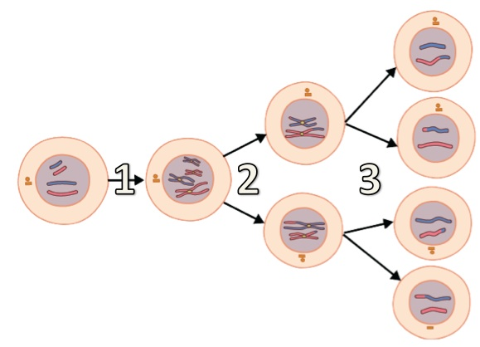

Click the link to Tutorial 3: “How Meiosis Creates Variation”

Tutorial 3. How Meiosis Creates Variation
SPECULATE: Before continuing, consider this: siblings inherit their genes from the same parents. But siblings can be quite different. Based on what you know about meiosis (and biology in general) use the space below to explain how you think this might work.

1. Read “Understanding Independent Assortment.” ☐
ACTIVITY: Given the three pairs of homologous chromosomes shown below, how many chromosomally distinct gametes could this organism create? Then check your answer and correct what you wrote as needed.
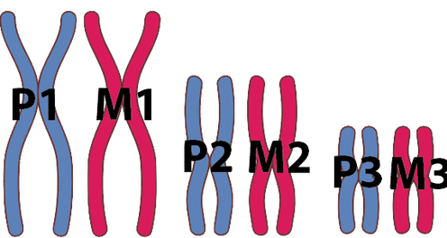

CHECKING UNDERSTANDING: What is independent assortment, and how does it ensure that siblings are different from one another?

2. Read “Crossing Over.” ☐
3. Take the Quiz: “Meiosis and Variation.” ☐
CHECKING UNDERSTANDING: What is crossing over, and how does it contribute to the variation that meiosis creates?

4. Read “Meiosis: The Whole Shebang.” ☐
5. Take the Quiz: “Phases of Meiosis.” ☐

Meiosis! Lyrics
View and listen at www.sciencemusicvideos.com/meiosis

6. Carefully read the lyrics to Meiosis!
Check this box when you’re finished. ☐

Meiosis: it’s how we make sex cells, or gametes
The sperm cells or egg cells performing the feat
Of moving genes forward, in eukaryotes like orchids and bees.
Meiosis doesn’t happen in all cells of the body
There’s just a few cells that have this hobby
I’m talking ‘bout germ cells in testes and ovaries,
Germ cells are diploid and what that means,
Is that the chromosomes are paired up in teams
In each pair one’s from your dad, one’s from your mother,
And when you line up the chromosomes it’s suddenly clear
How each is a member of a coupled pair,
Homologous pairs, each a homologue of the other.
In humans, the diploid number’s forty six,
And a key trick that happens in meiosis
Is dividing that number in half to 23
And that single set of chromosomes has its own name
It’s called “haploid” in this meiotic game.
So diploid to haploid’s a key meiotic strategy.

CHORUS
Meiosis, makes eggs and sperm
It’s the same in the robin as it is in the worm.
Makes haploid gametes with recombination,
Meiosis creates variation!

In interphase I meiosis starts,
It’s the DNA replication part
An evolutionary relic of its origin,
‘Cause meiosis evolved from mitosis you see,
So each process starts identically
Replicating chromosomes into two sister chromatids.

In Prophase I chromosomes coil up, and homologous pairs pair up,
Forming tetrads, each with chromatids four.
A chiasma’s the spot where the chromatids link
And synapsis is the name for the whole darn thing,
And crossing over is what this whole process is for.

See the homologues aren’t identical twins-- no way!
They’re not the same DNA
The genes are the same but the alleles might take different forms,
So during synapsis alleles can cross over,
Between homologues, and when it’s all over,
There are gene combinations that have never been seen before.
CHORUS

Another meiotic variety creator,
Is metaphase one with homologues at the equator,
Cause how each pair lines up is random and independent,
So in one pair facing north might be the maternal,
In the next one it might be the paternal,
It’s a one in two shot, it’s called independent assortment.

So two pairs divide up in four distinct ways,
It’s two to the number of pairs, you could say.
So think ‘bout us humans with 23 homologous pairs
Two to the 23rd power is a number so great,
Is 8 million, three eighty eight thousand, six-oh-eight
That’s why metaphase one is a variety creating affair.

And now connect this assortment with recombination,
Note that what we’ve got during gamete creation.
Is sperm and egg cells that are absolutely unique
So if you ever wondered why sisters or brothers
Can be so different from one another
Just remember these meiotic recombining techniques
BRIDGE
And if meiosis had never evolved
The book of life would be a different tome.
Cause if it wasn’t for meiosis
All offspring would be clones!
Metaphase one: homologues at the equator
Anaphase one: they say “see you later”
It’s like Mom and Dad splitting up and setting up new homes.
Two nuclei form in telophase one,
Then cytokinesis-meiosis one is done,
We’ve got two haploid daughters, still with doubled chromosomes.

Now things are simpler in part two of meiosis
Essentially it’s like just mitosis,
You just need to pull those sister chromatids apart,
They line up in the center in metaphase two
Anaphase pulls them apart we’re almost through,
Telophase then cytokinesis, we’re at the last part.
CHORUS

7. Complete these questions about meiosis:
- What’s the difference between a somatic cell and a gamete?

- What’s the difference between a haploid cell and a diploid cell?

- Give an example of a cell in your body that’s diploid.

- Give an example of a cell in your body that’s haploid

- What’s the difference between asexual and sexual reproduction?

- Give an example of a species that reproduces asexually.

- List three examples of species that reproduce sexually.

- What would happen if gametes carried the diploid number of chromosomes, instead of the haploid number of chromosomes?

- Meiosis is sometimes called reduction division. Why?

- What’s the difference between meiosis I and meiosis II? What gets separated in each?

- During what meiotic phase are paired homologous chromosomes pulled to the middle of the cell?

- When do paired, homologous chromosomes separate?

- What happens during telophase I?

- After meiosis I, are the daughter cells haploid or diploid? Why?

- After meiosis I, are the chromosomes still doubled?

- What gets separated during anaphase II?

- For every cell that starts meiosis, how many gametes could theoretically result?

- What happens during meiosis that does not happen during mitosis?

More questions comparing mitosis and meiosis
- What happens before both mitosis and meiosis?

- During anaphase of mitosis, what gets pulled apart?

- What gets pulled apart during anaphase 1 of meiosis?

- Which process (meiosis or mitosis) results in haploid cells?

- Which process (meiosis or mitosis) results in diploid cells?
- Which process (meiosis or mitosis) generates genetic variation? How?

SUMMARIZING: Explain the process of meiosis:
You can do so by creating a detailed key to the diagram below, or writing a few paragraphs explaining the process. Whatever your approach, make sure that you explain what’s happening in each part. Also, make sure you use terms like haploid, diploid, independent assortment, synapsis, homologous pair, sister chromatid, crossing over, gamete, germ cell, DNA replication, etc.
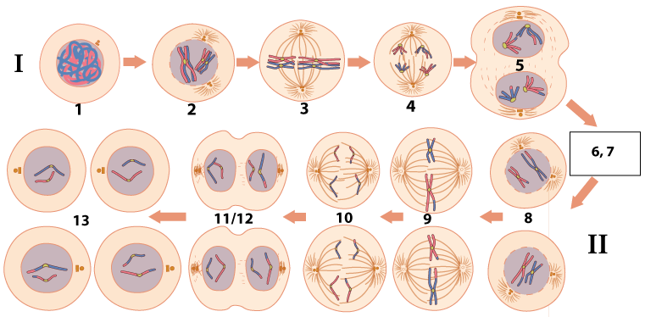

Click the link to “Sex Determination, Nondisjunction, and Chromosomal Variation.”

Tutorial 4. Sex Determination, Nondisjunction, and Chromosomal Variation
1. Read the Introduction. Check this box when you’re finished. ☐
2. Complete the section on Sex Determination, including the reading and the interactive activities. ☐
3. Read “Learning about sex determination in some non-mammalian animals.” Follow each link, and quickly scan the webpages so you can write short descriptions of how these other forms of sex determination work. Notice that I gave you very little space, so keep these descriptions short (and write small).
Sex Determination Method | How it works
Temperature dependent
Z-W
Haplodiploidy
4. Take the “Human Sex Determination Quiz” ☐

CHECKING UNDERSTANDING: Your very sharp (real or imaginary) 11 year old cousin learns that you’re taking AP Bio. They ask you what you’ve learned. You tell them that you’ve learned about how sex is determined. They say, “Oh, really? How?” Explain it to them.

5. Read about Down Syndrome and Maternal Age.
Study the data table, and before clicking “Click to see the answer,” write down the correlation, and speculate about the underlying biology of the correlation. Hint: it has something to do with meiosis!

6. Read the section on “Nondisjunction.” ☐
7. Take the Quiz: “Nondisjunction: Checking Understanding.” ☐
CHECKING UNDERSTANDING: Write a paragraph explaining what’s happening in the diagram below. Make sure to cover each lettered cell, and each number.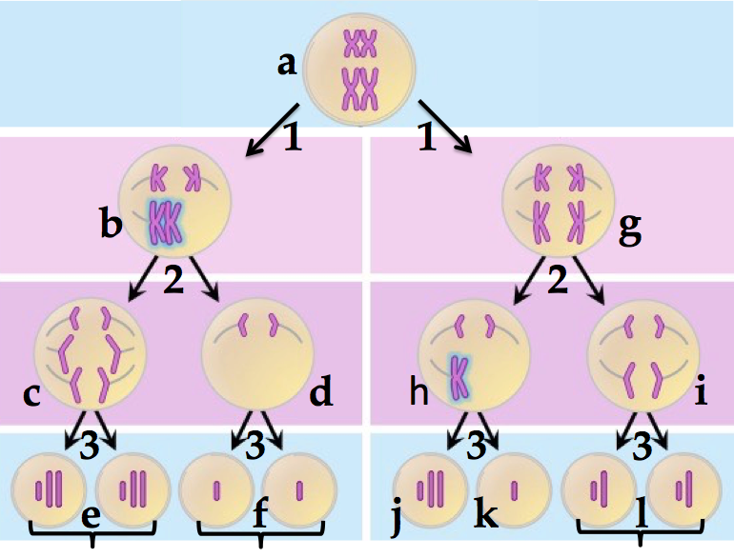

8. Read “Nondisjunction, Down Syndrome, and other Chromosomal Variations ☐

Follow the links to learn about Trisomy 18, Turner Syndrome, Klinefelter Syndrome, and XYY Syndrome. Quickly scan these webpages so you can write short descriptions of each one. Notice that I gave you very little space, so keep these descriptions short (and write small).
Syndrome | Description
Trisomy 18
Turner Syndrome
Klinefelter Syndrome
XYY Syndrome

9. Take the “Sex determination, Nondisjunction, and Chromosomal Variation Quiz.” ☐

CHECKING UNDERSTANDING: Pretend that you’re a genetic counselor (an increasingly important profession). A couple has learned that their yet to be born child has [insert one of the conditions above]. They want to know how this happened, and what they can expect. Use the space below to explain to them how nondisjunction happens, and what they can expect for their son or daughter. Use the space below, and the space in the next column.

Click the link to the “Meiosis Cumulative Quiz.”

Part 5. Meiosis Cumulative Quizzes
1. Complete the interactive lyrics for the Meiosis Song: ☐
2. Take the “Meiosis Cumulative Quiz.”☐

Meiosis: Pulling it all together. You’re talking to a real or imaginary older relative who says to you: “Biology! I never could understand why it was important to learn about mitosis and meiosis. What is that all about, anyway?”
Use the space below to explain what it’s all about, and why it’s important.

Biology | sciencemusicvideos | Name:________________________
Meiosis Crossword
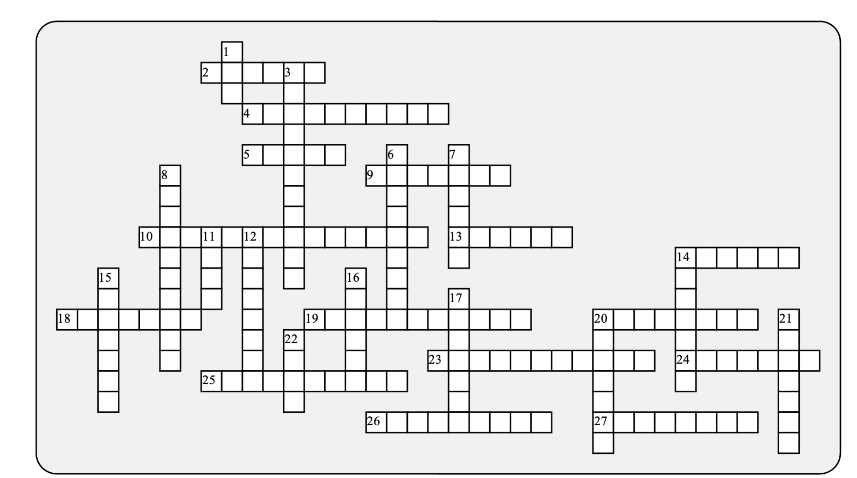

Across: | Down:
2 - A fertilized egg  4 - Matched in form and information; this term is also used in evolutionary biology  5 - The male gamete  9 - Along with fruit flies, these animals have an XY sex determination system  10 - When homologues or sister chromatids don't separate  13 - The four chromatid structure found during prophase 1  14 - A female with a single X chromosome has _______ syndrome  18 - Having two sets of chromosomes  19 - XXY causes ___________ syndrome  20 - ______ over leads to creation of new, recombinant chromosomes  23 - DNA _____ precedes the cell divisions of meiosis  24 - Meiosis 2 is very similar to ___________.  25 - Independent ___________ mixes up maternal and paternal chromosomes  26 - All the chromosomes except the sex chromosomes  27 - Missing a chromosome | 1 - A male with an extra Y chromosome has _____ syndrome  3 - In some reptiles, this environmental factor determines sex  6 - An image that shows chromosomes sorted by size and banding pattern.  7 - A general name for a sex cell  8 - Sister ___________ are split apart during meiosis 2  11 - Trisomy 21 causes _________ syndrome  12 - The fusion of chromsome pairs during prophase 1  14 - Having an extra chromosome  15 - Having one set of chromosomes  16 - The gametes created during meiosis are genetically ________  17 - Alternative versions of genes  20 - The spot where the chromatids link  21 - The special kind of cell division that creates haploid gametes  22 - Only ______ cells go through meiosis
Possible Answers: Alleles, Assortment, Chiasma, Chromatids, Crossing, Diploid, Down, Gamete, Germ, Haploid, Homologous, Karyotype, Klinefelter, Mammals, Mitosis, Monosomy, Replication, Sperm, Synapsis, Temperature, Tetrad, Trisomy, Turner, XYY, autosomes, meiosis, nondisjunction, unique, zygote

