Name: _____________________ Period: _____ Date: _________________

sciencemusicvideos Photosynthesis, Student Learning Guide
Getting to the tutorials.
- Go to www.sciencemusicvideos.com; Use the College Bio, AP Bio, or Learning Guide Menus to find “Photosynthesis”

Tutorial 1: Introduction
1. Complete the Interactive Diagram, “Photosynthesis Inputs and Outputs,” and read the text below the diagram. ☐
2. Read “Photosynthesis is an endergonic redox reaction.” ☐
3. Take the quiz “Photosynthesis: the Big Picture.” ☐
SUMMARIZING: Use the diagram below to write a summary of this section. Don’t just write a key: also connect what’s below to concepts like entropy, carbon fixation, oxidation, and reduction.
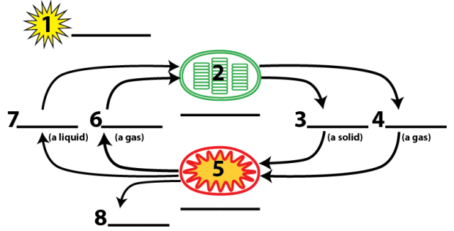

Continue to Tutorial 2: The Two Phases of Photosynthesis
1. Read the “Introduction.” What’s the connection between endosymbiosis and photosynthesis?

2. Read “Leaves.” ☐
3. Read “Chloroplasts ☐
4. Read about how “...Photosynthesis occurs in two Phases.” ☐
5. Take the Quiz: “The Two Phases of Photosynthesis.”
Checking Understanding
Describe the two phases of photosynthesis

Making Connections. In the space below, list the inputs of photosynthesis, and describe where they come in. Then list the outputs, and describe where they come out.
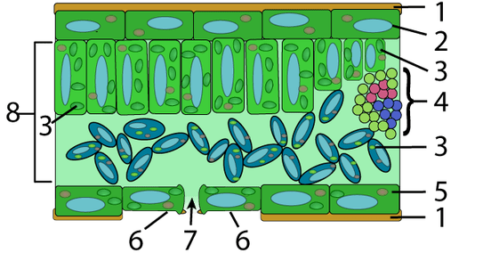
Inputs:

Outputs:

Now list a few ways that the structure of a leaf is adapted to its function.

Make a key to the diagram below:
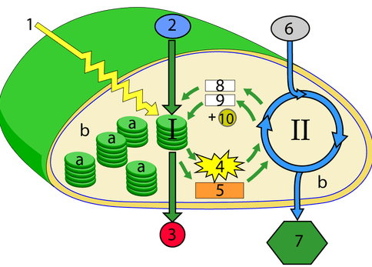
I.
II.
a.
b.
1.
2.
3.
4.
5.
6.
7.
8.
9.
10.

Continue to Tutorial 3: Light and Pigments
1. Read the introduction ☐
2. Read “Understanding Light.” ☐
3. Read “Chlorophyll: the Key Photosynthetic Pigment.” ☐
4. Read “Absorption and Action Spectra,” ☐
5. Take the Quiz “Photosynthesis: Light and Pigments,” ☐
SYNTHESIZING
The diagram below shows the absorption spectrum for Chlorophyll a, Chlorophyll b, and Carotenoids.
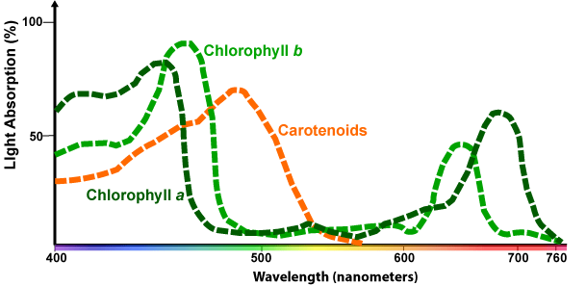

This diagram shows the action spectrum for photosynthesis.
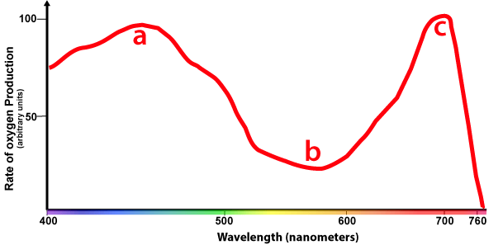

In the space below, describe what each diagram on the previous column means, and how they’re related.

You’re at the hardware store to buy grow-lights for a school project. All they have are blue, green, and red lights. Which two colors do you buy, and why? Be sure to relate your answer to the previous question.

6. Complete the Interactive Lyrics for “The Light Reactions Part 1.” ☐

Continue to Tutorial 4: The Light Reactions
1. Read the introduction ☐
2. Read “Chlorophyll, Photoexcitation, and Photosystems.” ☐
3. Read “In Non-Cyclic Electron Flow...” ☐
4. Take the Quiz: “Photoexcitation, Photosystems, and Non-Cyclic Electron Flow.” ☐
Checking understanding
Describe how the diagram on the left is related to the one on the right. As you do, explain each numbered part in each diagram. Write small.
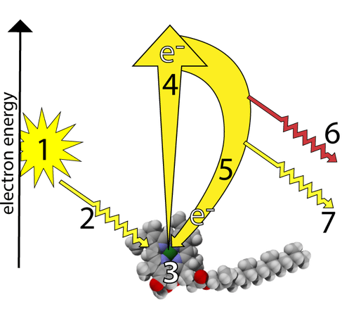 | 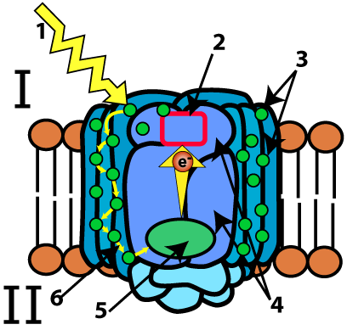

In the space below the diagram, explain how non-cyclic electron flow creates ATP and NADPH.
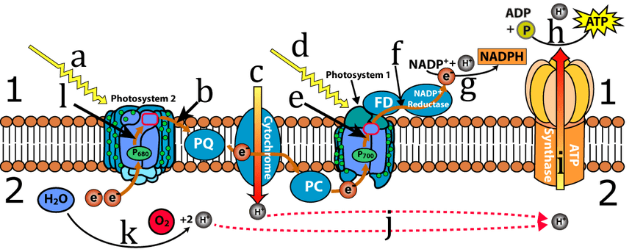

5. Read “The Z Scheme” ☐
6. Take the quiz, “The Z-Scheme.” ☐
7. Read “Cyclic Electron Flow...” ☐
8. Complete the “Cyclic Electron Flow...” interactive diagram. ☐
9. Take the “Light Reactions” Quiz.” ☐
Checking Understanding
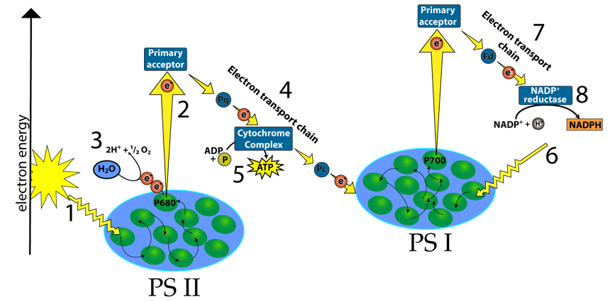
Explain the Z scheme:

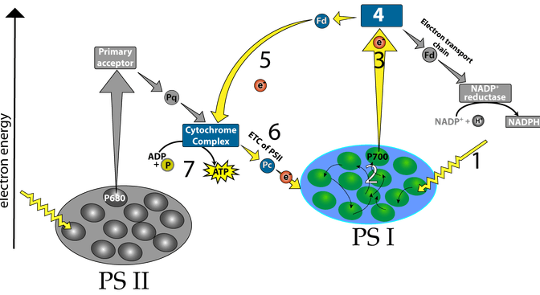
Explain cyclic electron flow:

Continue to Tutorial 5: The Calvin Cycle
1. Read the introduction. ☐
2. Read “The Calvin Cycle.” ☐
3. The “The Calvin Cycle” Quiz. ☐
Checking Understanding
In the space below this diagram, explain how the Calvin cycle works.
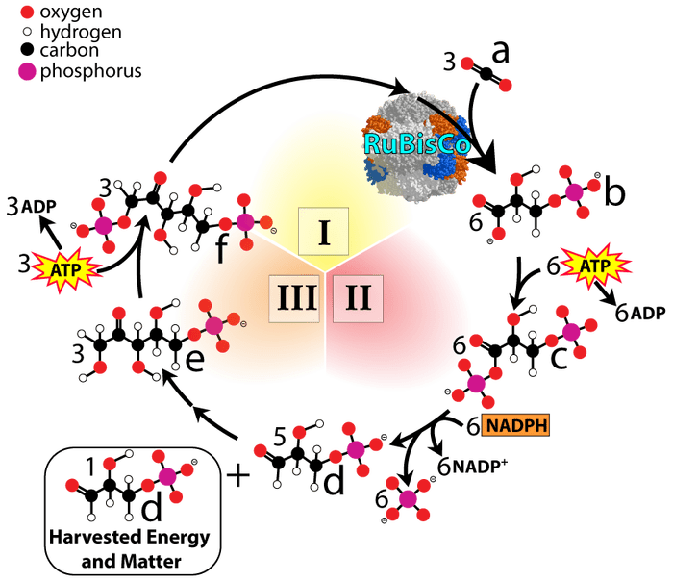

Explain why the reactions of the Calvin cycle require that chloroplasts switch back and forth between non-cyclic and cyclic electron flow during the light reactions.

Comparing Calvin and Krebs
Pretend that it's the World Biology Cycling Championship. The two finalists are the Calvin Cycle and the Krebs cycle. You're a reporter doing pre-game analysis. Write a paragraph comparing and contrasting Krebs and Calvin.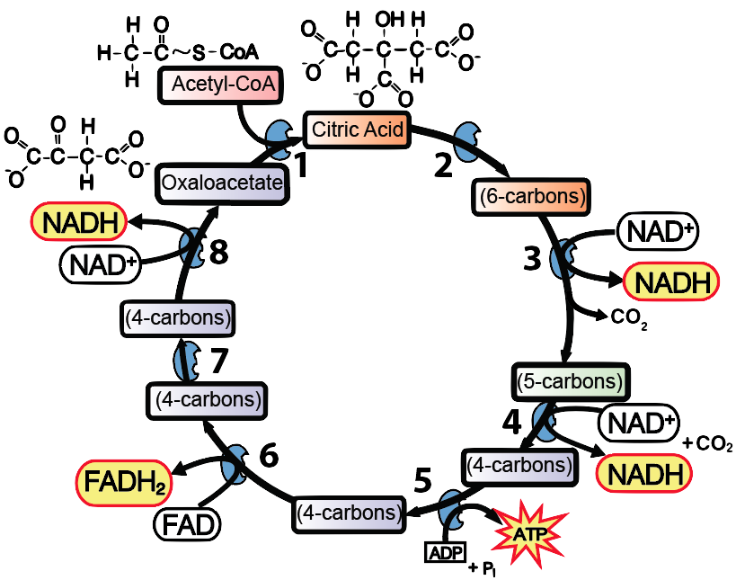

4.Take the Quiz, “Making Connections Between Photosynthesis and Cellular Respiration.” ☐
Create a key to the diagram below.
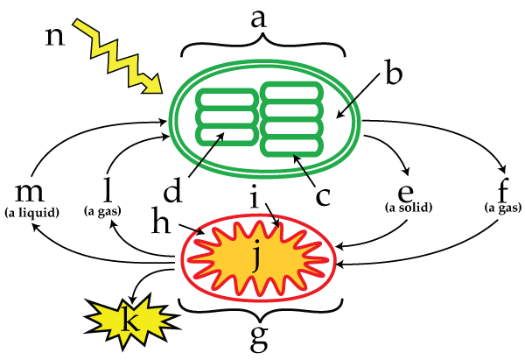 |  | a.  b.  c.  d.  e.  f.  g.  h.  i.
j.
k.
l.
m.

CULMINATING SYNTHESIS: Comparing ATP synthesis during photosynthesis and cellular respiration.
Diagram A below shows a close-up depiction of structures and processes in the inner and outer membranes of a mitochondrion. Diagram B shows structures and processes in the thylakoid membrane. In the space below the diagrams and the right column, compare how ATP is produced in the light reactions with how it is produced in mitochondria.

A. The Mitochondrial inner and outer membranes
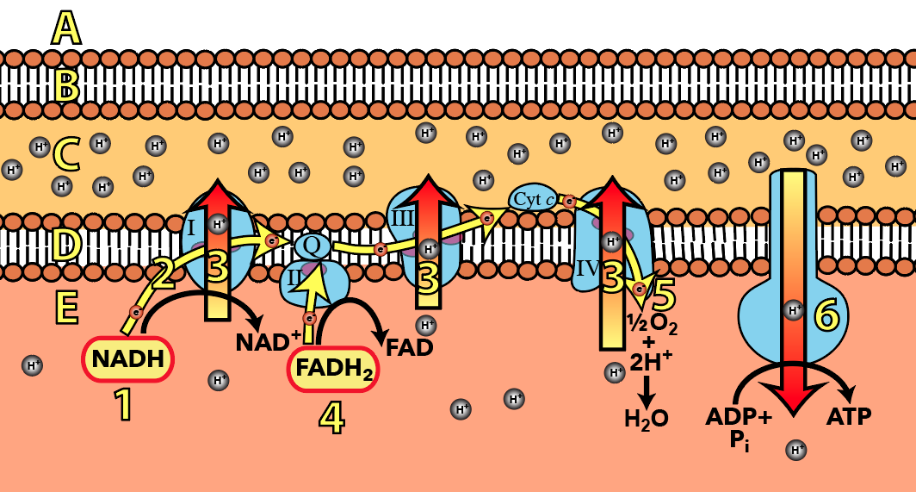

B. The Thylakoid Membrane

Photosynthesis sciencemusicvideos|Biology
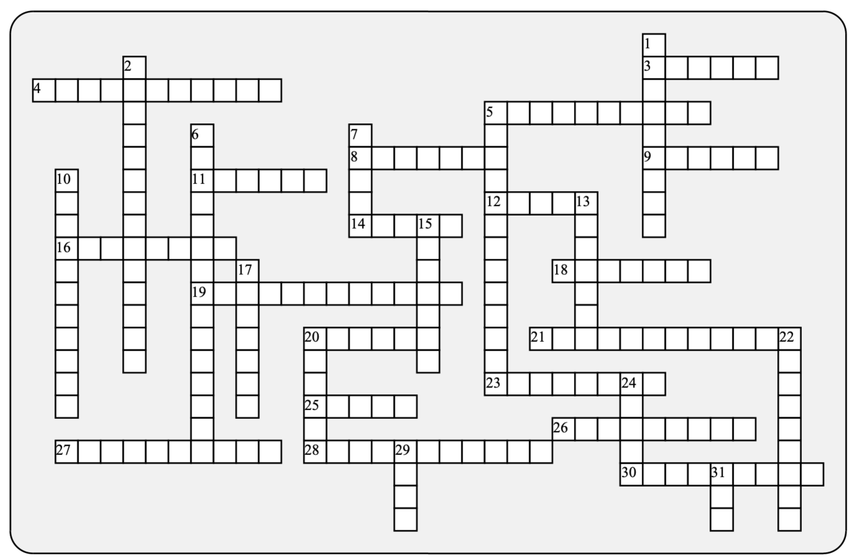

Across: | Down:
3 - The spectrum that tells you how much photosynthesis occurs at various light frequencies.  4 - This kind of diffusion returns protons from the thylakoid space to the stroma.  5 - As far as energy goes, this term describes photosynthesis  8 - In the Calvin cycle, carbon dioxide is  9 - In a chloroplast, this is equivalent to the cytosol, or the mitochondrial matrix  11 - When water is split, this gas is released.  12 - The kind of energy that powers photosynthesis. Also an electricity producing panel.  14 - The reduced electron carrier produced by the light reactions  16 - In the light reactions, water is  18 - Carbon___________ is the source of the carbon in our bodies.  19 - The class of macromolecule produced by photosynthesis  20 - These reactions form a cycle that creates carbohydrates  21 - There are two of these light-trapping, chlorophyll-rich protein complexes in the thylakoid membrane.  23 - In both mitochondria and chloroplasts, you'll find the ATP ________ channel.  25 - These reactions convert light into electricity, and then into short term chemical energy  26 - This enzyme reduces NADP+ into NADPH.  27 - The shorter the ____________, the more energy a photon has.  28 - The key photosynthetic pigment  30 - The little flattened disk that makes the light reactions possible. |  | 1 - The metal in chlorophyll that makes electron flow possible  2 - ___________-3-phosphate is the harvestable product of the Calvin cycle.  5 - Like mitochondria, chloroplasts are _______________ that were once free-living bacteria  6 - What happens to chlorophyll when it's exposed to light.  7 - This color drives the least photosynthesis  10 - The organelle where photosynthesis happens  13 - The enzyme that pulls carbon dioxide into carbohydrates.  15 - Packets of electromagnetic energy that are both particles and waves  17 - What get pumped into the thylakoid space  20 - This type of electron flow creates ATP only.  22 - The _________ of water is responsible for all of the oxygen in our atmosphere.  24 - This pathway makes cyclic electron flow possible.  29 - The five carbon sugar at the start and end of the Calvin cycle  31 - Chloroplasts create this through photophosphorylation.
Possible Answers: ATP, Calvin, Light, NADPH, RUBP, action, carbohydrate, chlorophyll, chloroplast, cyclic, dioxide, endergonic, endosymbionts, facilitated, glyceraldehyde, green, magnesium, oxidized, oxygen, photoexcitation, photons, photosystems, protons, reduced, reductase, rubisco, shunt, solar, splitting, stroma, synthase, thylakoid, wavelength

