Name: _____________________ Period: _____ Date: _________________

sciencemusicvideos Phylogeny and Classification, Student Learning Guide
Getting to the tutorials.
- Go to www.sciencemusicvideos.com; Use the College Bio, AP Bio, or Learning Guide Menus to find “Phylogeny and Classification”

1. Read “Phylogeny shows evolution’s branching pattern.” ☐
2. Take the quiz “Phylogeny Introduction: Checking Understanding.” ☐
SUMMARIZING: Using the phylogenetic tree below, write a paragraph explaining the story of finch evolution on the Galapagos islands. Use terms such as “node,” “clade,” “speciation,” and “common ancestor.”
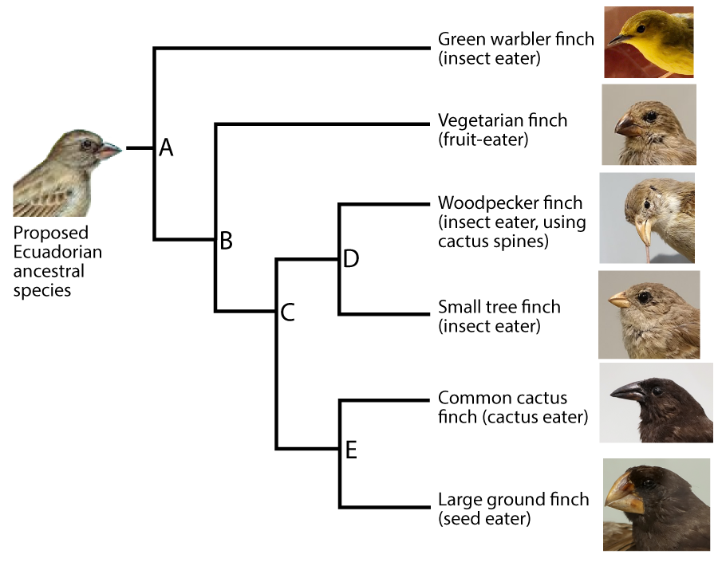

3. Read “Naming and Classifying Species” (both 3a. “Binomial Nomenclature” and 3b. “Classification”☐
4. Take the quiz “Phylogenetic Trees, Binomial Nomenclature, and Classification”
MASTERING THE TERMS: In the space below, define each of the following terms
- Clade
- Node
- Lineage
- Taxon
- Terminal taxon
- Binomial
5. Read “Phylogenetic Trees: A Deeper Look” (sections a, b, and c) ☐
5d. Take the Quiz, “Phylogenetic Trees, Checking Understanding.” ☐

DRAWING DISTINCTIONS: Write a sentence comparing and contrasting each of the following:
a. Ingroup vs. outgroup
b. Clade vs. taxon
c. Taxon vs. category
d. Shared derived features vs. ancestral feature

e. Common names vs. scientific names.

f. Explain, with reference to the diagram below, the difference between a monophyletic, a polyphyletic, and a paraphyletic taxon.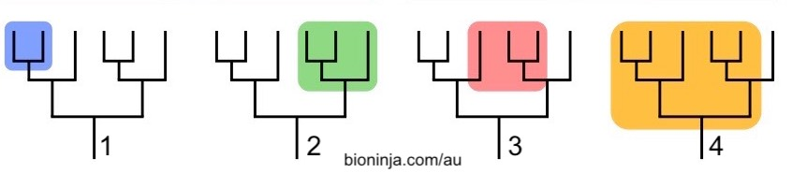

6. Read and complete, “Using Character Tables to Create Phylogenetic Trees (including all the interactive phylogenies in a, b, and c” ☐
7. Read and complete all the quizzes in “Molecular Clocks.”☐
8. Read and complete “Horizontal Gene Transfer”☐
9. Complete the “Phylogeny Cumulative Quiz”☐
Checking Understanding: In the spaces below, answer, define or explain.
1. What’s a character table?

2. What are analogous features? How do they arise? Why must they be avoided in determining phylogeny?

3. Why can shared nucleotide or amino acid sequences be used to determine phylogeny?

4. What are molecular clocks? How are they calibrated?

5. For a given protein or gene, why would you expect sister taxa to have closely matching amino acid and nucleotide sequences?
6. Explain the diagram below (with a particular focus on the tangled web on the bottom).
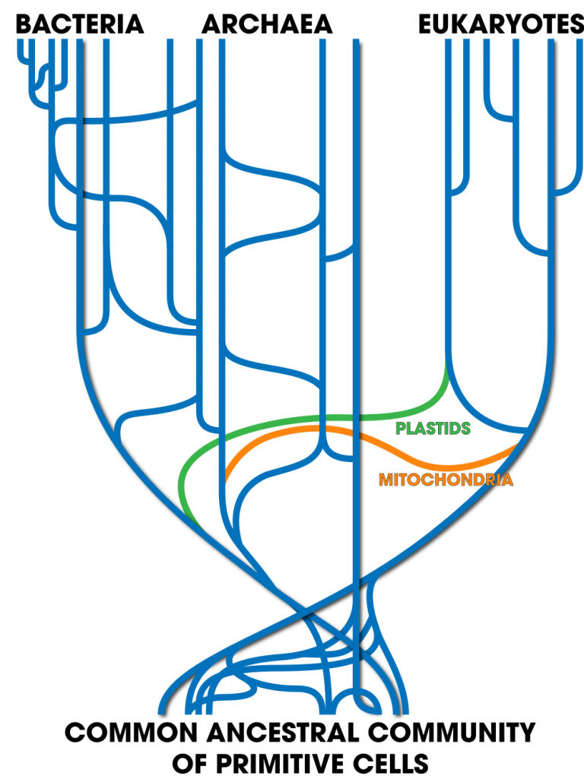

8. You’re talking to a friend, who asks you what you’re learning in biology. You say “about phylogenetic trees.” They say “What are those?” Using the tree below, walk them through how phylogenetic trees work. Make sure your description covers clades, terminal taxa, sister taxa, ancestral traits, shared derived traits, out-groups, in-groups, and other terms as needed.
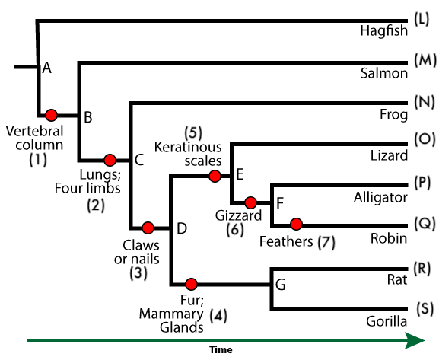

sciencemusicvideos|AP Biology | Name:________________________
Phylogeny and Classification
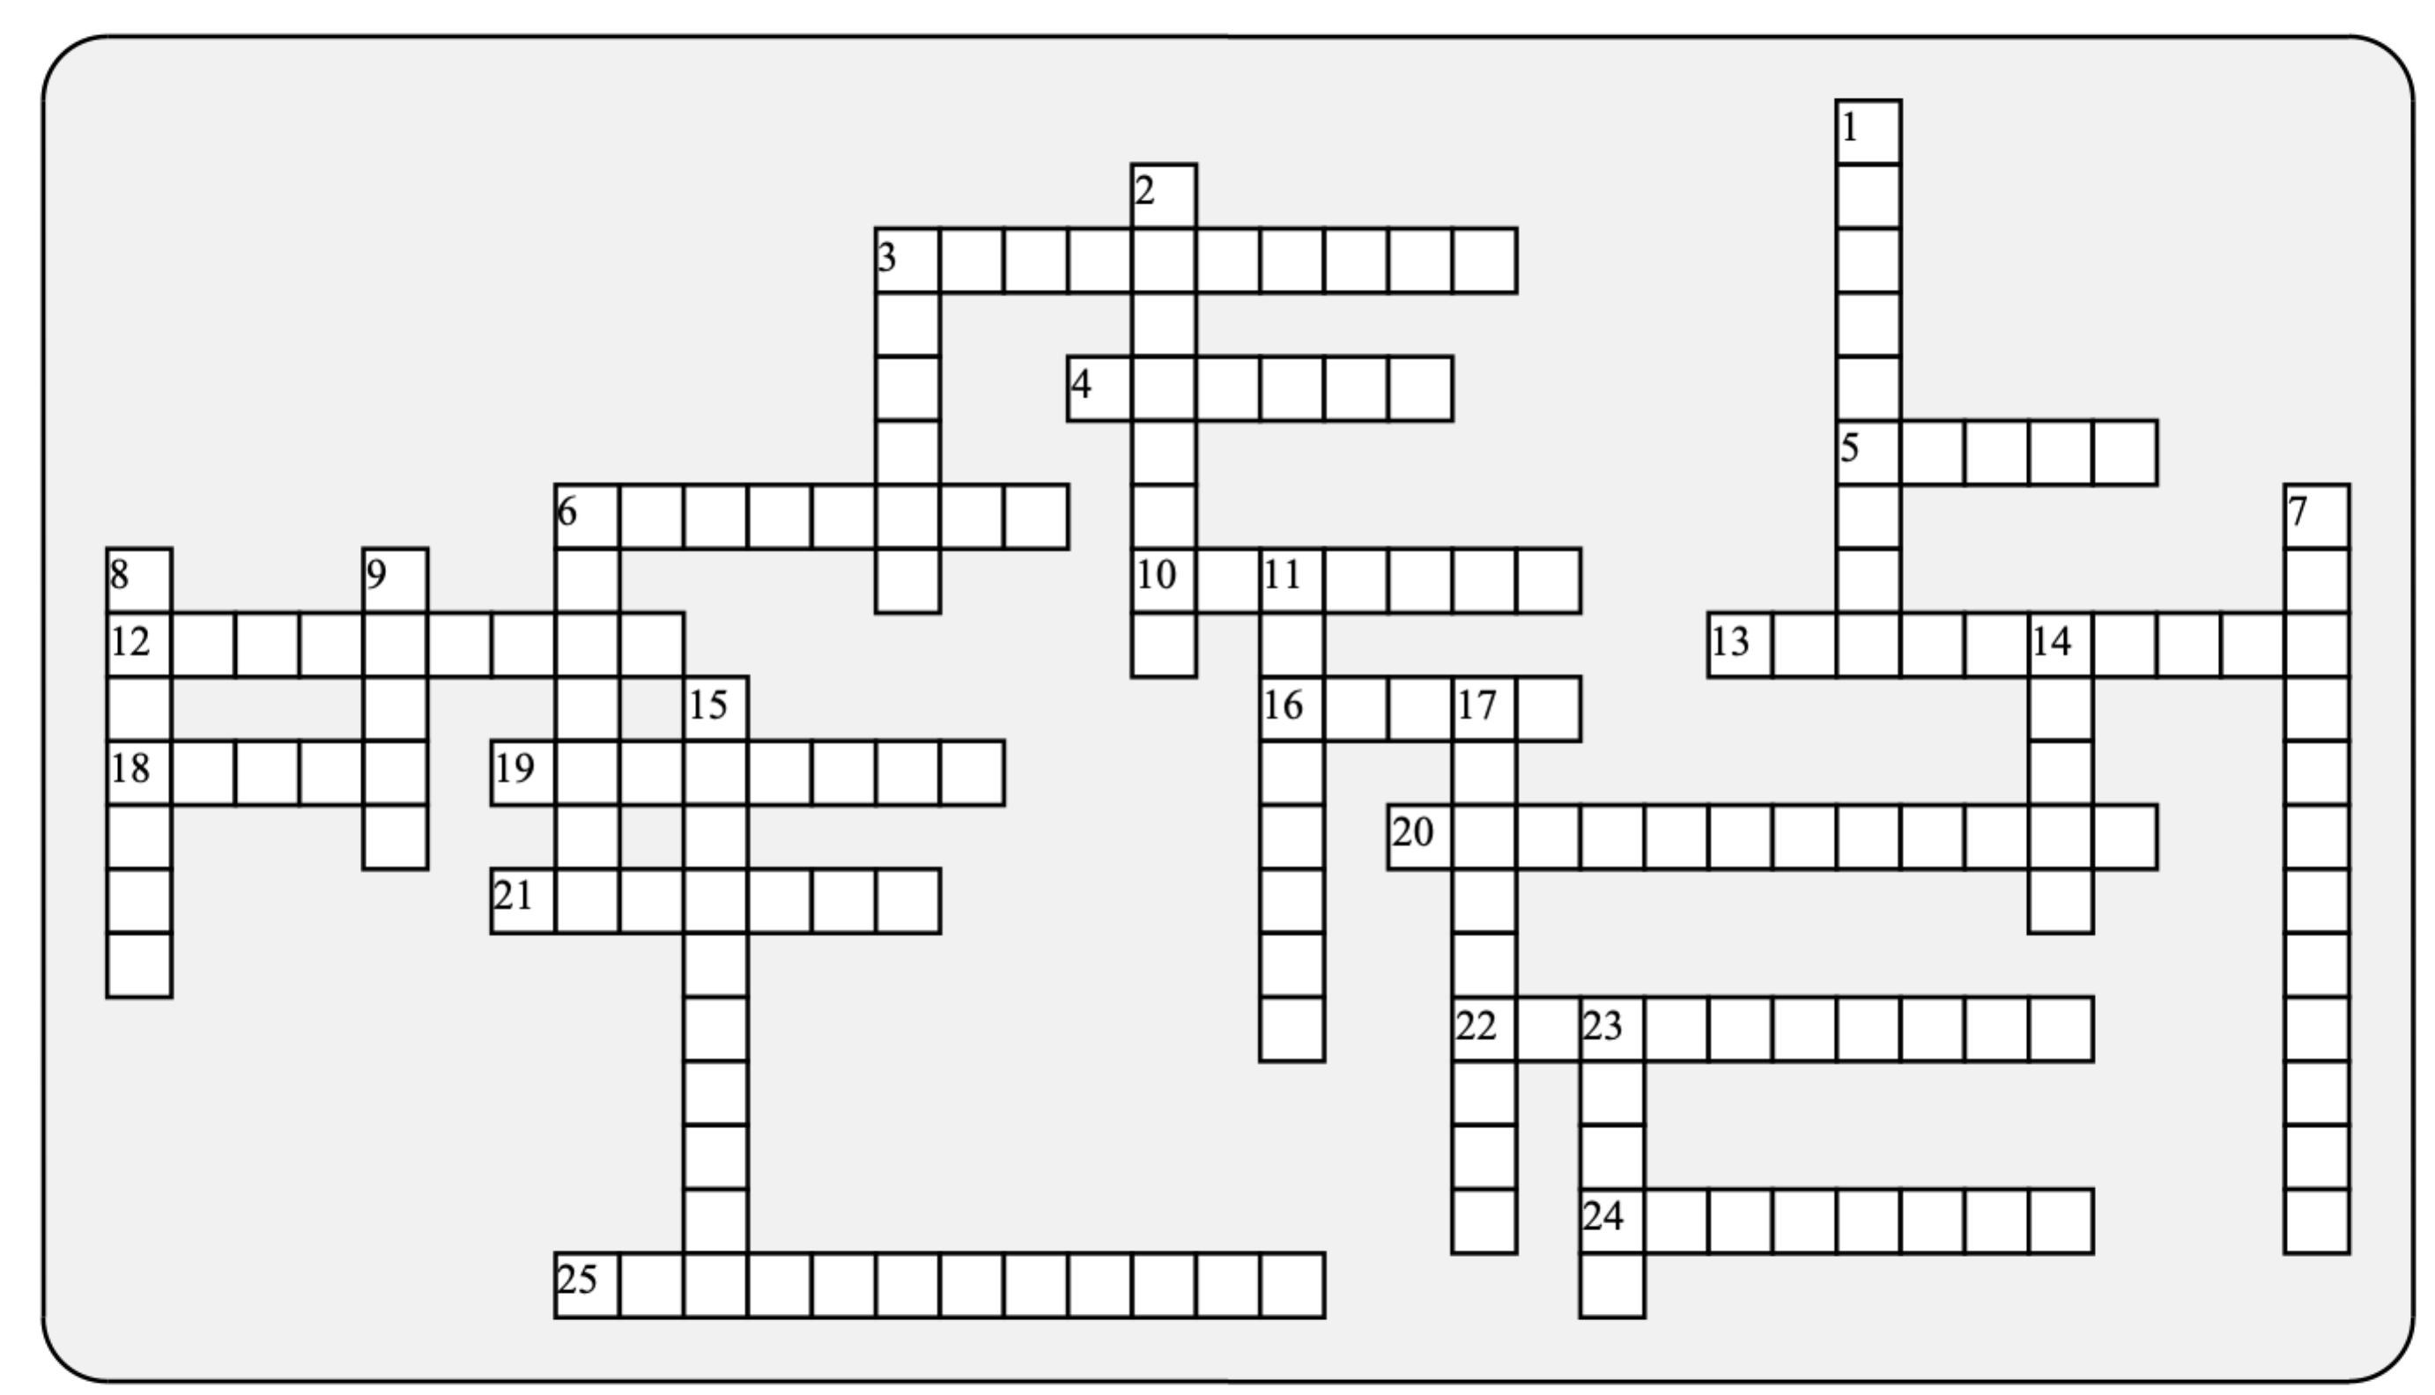

Across: | Down:
3 - The name for the process that occurs at the branch points in a phylogenetic tree.  4 - The most general of the classification categories  5 - The classification category just above species  6 - The scientist who developed the modern science of classification  10 - Avoid this type of character when creating a phylogeny  12 - The study of evolutionary history  13 – An oxygen-carrying protein widely used in determining phylogenetic relationships  16 - If you can calibrate a molecular _________, you can estimate the time of divergence between two species.  18 - A group that consists of a common ancestor, and all of its descendants.  19 - The science of classification is known as ___________.  20 - This kind of taxon excludes some members of its clade.  21 - A feature that unites a clade is a shared ___________ feature.  22 - A protein in the electron transport chain widely used as a molecular clock.  24 - A taxon used to identify the common ancestor of an ingroup.  25 - This kind of taxon includes lineages that spring from separate ancestors. | 1 - A diagram that shows branching evolution, but the branches have no relationship to time.  2 - The two part name given to every species is known as a _____________.  3 - These kind of taxa split off from the same ancestor  6 - A single line of descent within a phylogenetic tree is a ________.  7 - A taxon that's also a clade must be ______________.  8 - A group of organisms that can interbreed to produce fertile offspring  9 - In a phylogenetic tree, the ancestors are located at ___________.  11 - Every clade is united by a single common _____________.  14 - The language used to name species  15 - This type of gene transfer occurs in bacteria, and happened very frequently early in life's history.  17 - Any quantifiable, heritable trait that can be used to determine phylogeny  23 - A named group of organisms.
Possible Answers: Latin, Linnaeus, analogy, ancestor, binomial, character, clade, cladogram, clock, cytochrome, derived, domain, genus, hemoglobin, horizontal, lineage, monophyletic, nodes, outgroup, paraphyletic, phylogeny, polyphyletic, sister, speciation , species, taxon, taxonomy

