Name: _____________________ Period: _____ Date: _________________

Structure of Water and Hydrogen Bonding
Getting to the tutorials.
- Go to www.sciencemusicvideos.com; Use the College Bio, AP Bio, or Student Learning Guide Menus to find “The Structure of Water and Hydrogen Bonding”
- Start with “1. Water Polarity, and Hydrogen Bonds”
Note from Mr. W: The videos in these tutorials incorrectly use the term “orbitals” to describe “electron energy levels” (also known as “shells” or “orbits.”). So when you hear “orbital,” think “energy level” or “shell.”

Tutorial 1: Water, Polarity, and Hydrogen Bonds.
Introduction: Water Makes Life Possible
1. Most of the mass of any living thing is ______________.
2. Astronomically, life only exists where water is found in a ____________ form.

Complete Interactive Reading I.
3. Complete the table below
Water, Electron Distribution Model | Water, Structural Formula

4. Why is water the Mickey Mouse molecule?

Complete Interactive Reading 2: Water and Polarity
5. Add partial positive and partial negative charges to your diagrams of a water molecule above. (δ⁺ and δ⁻ for partial positive and negative, respectively).
6. Explain why water has these partial positive and negative charge.

Complete Interactive Reading 3: Hydrogen Bonding
7. Draw three or four water molecules, showing hydrogen bonding between them.

8. Explain why water is a polar molecule, and why methane is not polar?

9. Explain why water is a liquid at room temperature, while methane is a gas.

10. Take the “Chemistry of Water Quiz.” Check the box when you’re done: ☐

FINAL REFLECTION: Watch the video (up at the top of the page. If you’re in class, use ear buds or headphones). Then, use this space to explain why water is sticky, and the consequences of that stickiness.

Proceed to “The Properties of Water.”
Tutorial 2: The Properties of Water (a virtual lab)
Parts 1 and 2: Introduction and Background.
1. Complete the table below: include partial charges.
Water, structural formula with charges | Alcohol, structural formula with charges
2. Explain: why is water so much more polar than alcohol?

Part 3: Six Observations/Experiments Comparing water and alcohol.
3.1. How is the shape of a drop of water on a penny different from the shape of a drop of alcohol? Explain why it’s different.

3.2. Compare what happens if you try of pile as many drops of water on a penny as you can, and then do the same with alcohol? Why the difference?

3.3. Compare the evaporation speed of water and alcohol. Explain.

3.4. Compare how drops of water and alcohol feel on your skin. Explain.

3.5. Compare what happens when you try to dissolve salt in water with what happens when you try to dissolve salt in alcohol. What’s the difference? Why?

3.6. Compare your attempts to float a paper clip on alcohol and on water? What’s the difference? Why?

4. Use the material in the reading “Five Properties of Water that you should remember” to explain:
a. Why water has a relatively high freezing point.

b. Why ice floats on liquid water (why ice is less dense).

5. Complete the Fill-in-the-Blanks quiz. Check the box when you’re done. ☐

REFLECTION: Watch the video (up at the top of the page). Why is water a stickier molecule than alcohol? How are the properties of each different?

Click the link to “Acids, Bases and the pH scale
Tutorial 3: Acids, Bases and the pH Scale
1 and 2. Read the Introduction, and Solutions, Acids, and Bases. As you read, write down definitions of the following terms:
a. Solution:

b. Solute:

c. Solvent

Take the Quiz: “:Solutions, Acids, and Bases.” Check the box below when you’re done
☐
Take a minute and write a sentence comparing and contrasting acids and bases. Use sentences like this: While bases are …, acids are….Both are similar in that; they differ because….

3. Read “The Chemistry of Acids and Bases…” When you’re done, check the box below
☐
Copy the formula that shows what happens when HCl is dissolved in water.

Copy the formula that shows what happens when NaOH is dissolved in water.

In a single sentence, summarize how the pH scale works.

4. Take the quiz: Acids, Bases and pH. When you’re done, check the box: ☐

Imagine that someone’s asked you to explain how acids and bases are chemically different: write what you’d say in the space below.

5 and 6. Read the section about buffers, and the conclusion
☐
What are buffers? Why are they important?

REFLECT: What are seven (or six or eight) things that everyone should know about acids, bases, the pH scale, and buffers?

sciencemusicvideos | Biology | Name:________________________
Properties of Water, Acids and Bases
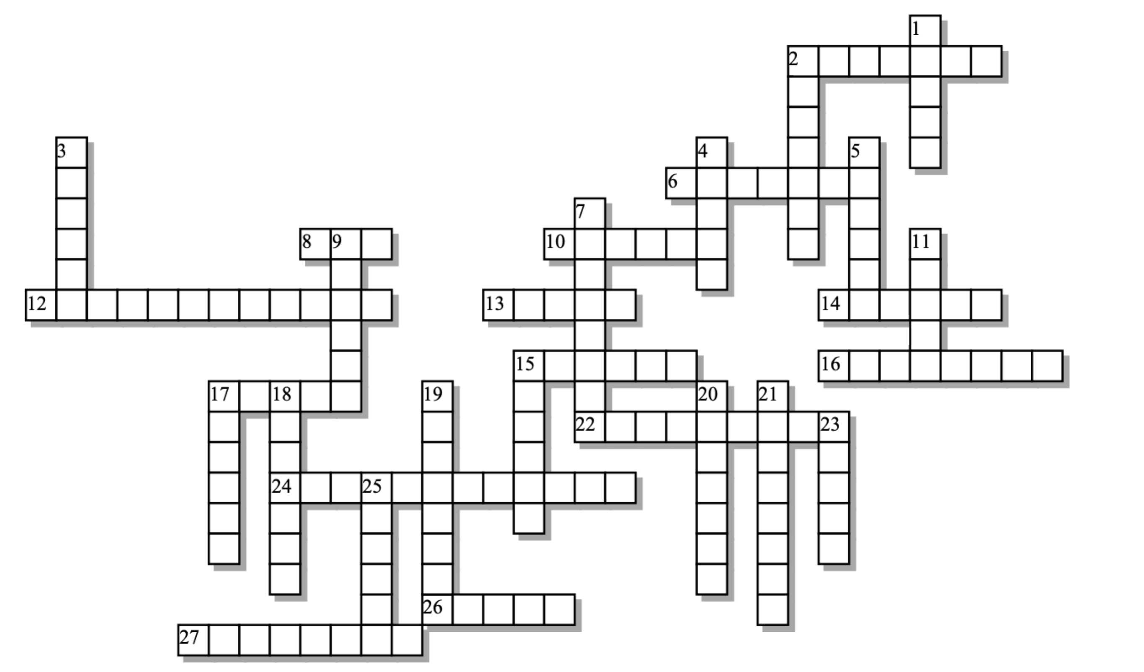

Across: | Down:
2 - Because of hydrogen bonding, water is a great ________ of ionic compounds.  6 - A nonpolar compound found in natural gas  8 - Nonpolar molecules like methane are a _____ at room temperature.  10 - Unlike bases, acids will cause ___________ to dissolve.  12 - The acid in your stomach  13 - A molecule with regions of positive and negative charge is said to be ____.  14 - A hydrogen ion is really just a ____________.  15 - Water's ability to form hydrogen bonds makes it a ________ molecule.  16 - The bond that forms between two water molecules  17 - A solution with more hydroxide ions than hydrogen ions.  22 - In a water molecule, the ________ tend to cluster near the oxygen atom.  24 - Because of hydrogen bonding, water has a high heat of __________.  26 - A planet with lots of water in liquid form  27 - The bonds holding the atoms in a single water molecule together are polar _______ bonds. | 1 - Molecular regions of similar charge will _______ one another.  2 - This type of tension exists on the top of a body of water.  3 - The first name of a cartoon character reminiscent of water  4 - An unusual property of water is that it's less _______ as a solid than as a liquid.  5 - Compared to a covalent bond, a hydrogen bond is much ___________.  7 - A water molecule will have a partially ________ charge near its oxygen atom.  9 - A solution with more hydrogen ions than hydroxide ions  11 - By weight, you're mostly made of _______.  15 - The thing that gets dissolved in a solution  17 - This kind of soda is a weak base  18 - The thing that dissolves the solute is a ___________.  19 - A water molecule will have a partially ______ charge near its hydrogen atoms.  20 - The opposite poles of a polar molecule will _______ one another.  21 - The mutual attraction between water molecules is called ______.  23 - An acid on a cut will ____________.  25 - A water molecule has a single atom of _____.

Possible Answers:
Earth, Mickey, acidic, attract, baking, basic, cohesion, covalent, dense, electrons, gas, hydrochloric, hydrogen, metals, methane, negative, oxygen, polar, positive, proton, repel, solute, solvent, solvent, sticky, sting, surface, vaporization, water, weaker

