Name: _____________________ Period: _____ Date: _________________

Species, Speciation and Extinction, Student Learning Guide
Getting to the tutorials
- Go to www.sciencemusicvideos.com; Use the College Bio, AP Bio, or Learning Guide Menus to find “Species, Speciation and Extinction.”

Tutorial 1: What is a Species?
1 & 2. Read the introduction, and complete the interactive reading. ☐
Why are all dogs members of the same species?

Why isn’t the Bengal cat a species?

From memory, complete this definition of a species:
A group of individuals or populations that share a common _________ ___________, and which is __________ from other groups. All members of a species can ____________ to produce _____________ offspring.

3. Read “Talking about Species, Subspecies, Breeds, and Varieties. “ As you read define the following terms
subspecies
breed

4. Read “What Keeps Species Apart?...” ☐
Speculate: Why don’t grizzly bears breed with black bears?

5. Take the “Reproductive Barriers” Quiz
Checking Understanding:
a. Compare and contrast pre-zygotic and post-zygotic isolating mechanisms.

b. List and briefly describe as many specific reproductive isolating mechanisms as you can. You should be able to list 5 pre-zygotic and 3 post-zygotic mechanisms.

6. Read “The Biological Species Concept. Limitations and Alternatives.” ☐
7. Take the quiz “What is a Species?” ☐
Checking Understanding:
a. Describe the limits to the biological species concepts.

b. Briefly describe these other species concepts:
morphological species
phylogenetic species
chronospecies

Click the link to the next tutorial, “Allopatric speciation.”
Tutorial 2: Allopatric Speciation
1 & 2. Read the introduction, and complete the interactive reading. Start by speculating about how the two Alpheus shrimp species evolved into separate species.

When you’re done, write out an explanation of the allopatric speciation model in the space to the right of the diagram below.
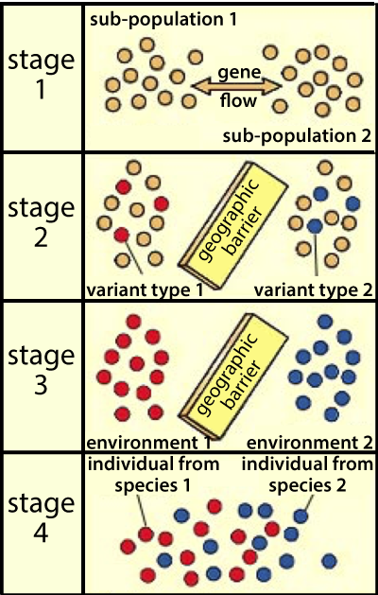

Now, let’s return to the example we started with. Using what you know about allopatric speciation, explain how the two Alpheus shrimp species evolved into separate species.
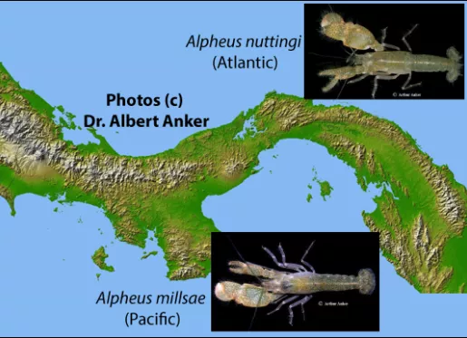

3. Read about “Peripatric Speciation,” and take the Peripatric speciation quiz. When you’re done, use the diagram below to explain how peripatric speciation works.
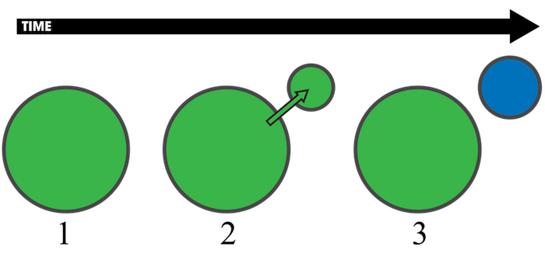
4a. Read about Clines. In the space below the diagram, explain the connection between the height of these yarrow plants and elevation.
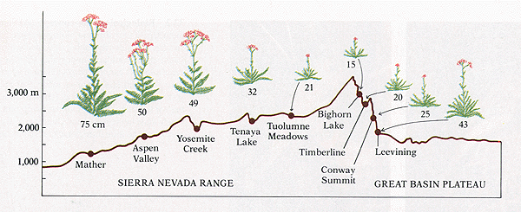

4b. Read about “Parapatric Speciation and Hybrid Zones”
In the space below the diagram, explain 1) the connection between clines, parapatric speciation, and hybrid zones; and 2) how parapatric speciation and allopatric speciation are similar and different.
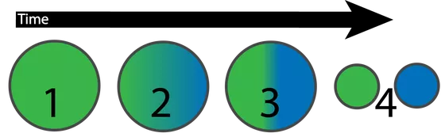

Checking Understanding. Explain the hybrid zone between the two species shown below, and speculate about how it might have evolved.
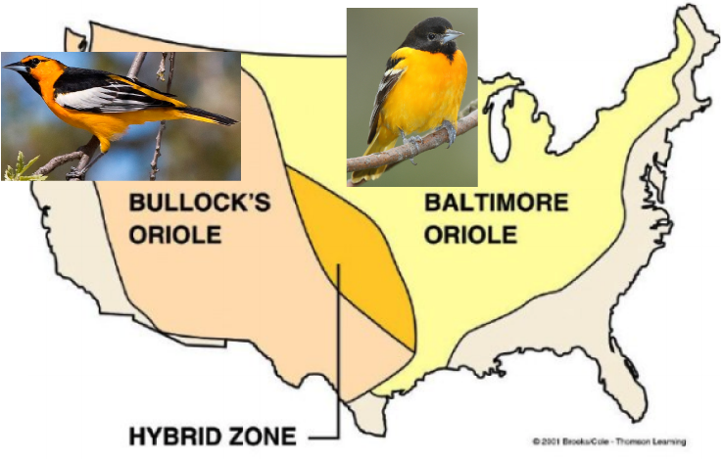

4c. Read about “Ring Species.” ☐
In the space to the right and below the diagram, explain how ring species work. Make sure your explanation includes concepts like reproductive isolation, differentiation, clinal variation, etc.
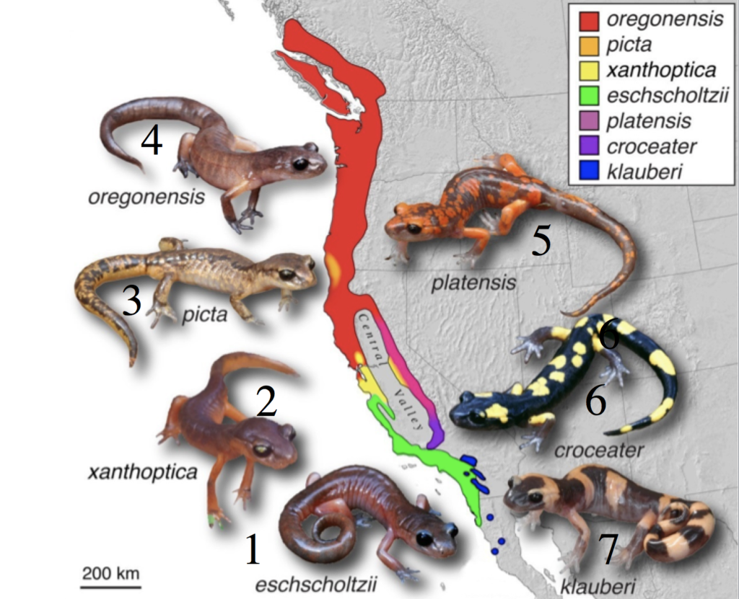

5. Take the “Allopatric Speciation (and its Variations)” quiz.
SYNTHESIZE what you’ve learned.
In the space below, explain how allopatric speciation works, and compare it to peripatric and parapatric speciation. Make sure you include an explanation of clines and hybrid zones.

Follow the link to the next tutorial, “Sympatric Speciation.”
Tutorial 3: Sympatric Speciation
1. Read the introduction. ☐
Explain: How is sympatric speciation different from allopatric speciation?
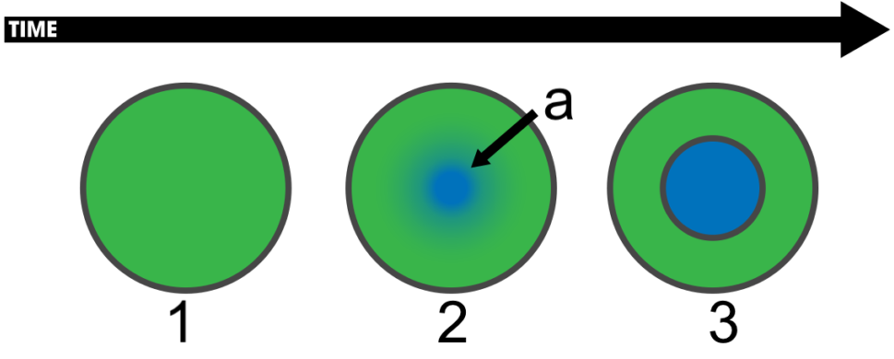

2. Read “In plants, Sympatric Speciation can occur through...”
3. Take the quiz: Polyploidy and Allopolyploidy
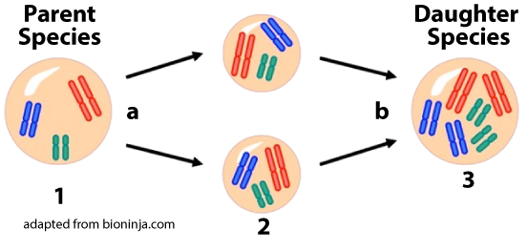
Create a key to the diagram above. The process is called _____________________
1
a
2
b
3

Do the same for this diagram:
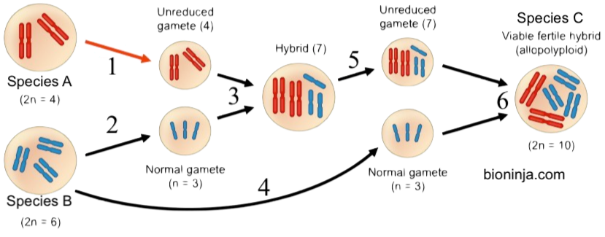
The process is called ______________________
1
2
3
4
5
6
4. Read “Sympatric Speciation in Animals” ☐
5. Take the quiz: Sympatric Speciation ☐
Checking Understanding
Explain how each of the following can bring about sympatric speciation in animals.
a. Sexual selection

b. Disruptive selection

c. Habitat differentiation.

Comparing and Contrasting:
a. Complete the Venn Diagram below
Allopatric Sympatric
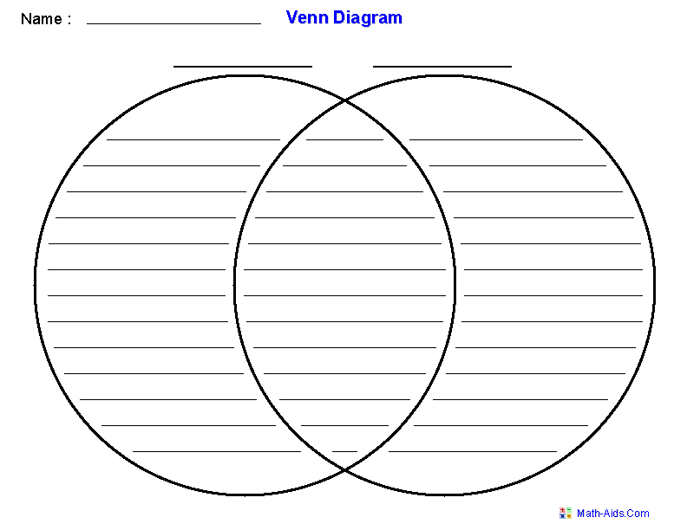
Now, in the space below, write one or two paragraphs comparing and contrasting allopatric and sympatric speciation. Write small.

Click the link for the next tutorial, “Adaptive Radiation.”
Tutorial 4: Adaptive Radiation
1. Read about adaptive radiation ☐
Checking Understanding
a. Explain, on a general level, how adaptive radiation works.

b. Use what you’ve learned about adaptive radiation to explain how, in the hypothetical example below, species “A” could have evolved into 5 descendant species.
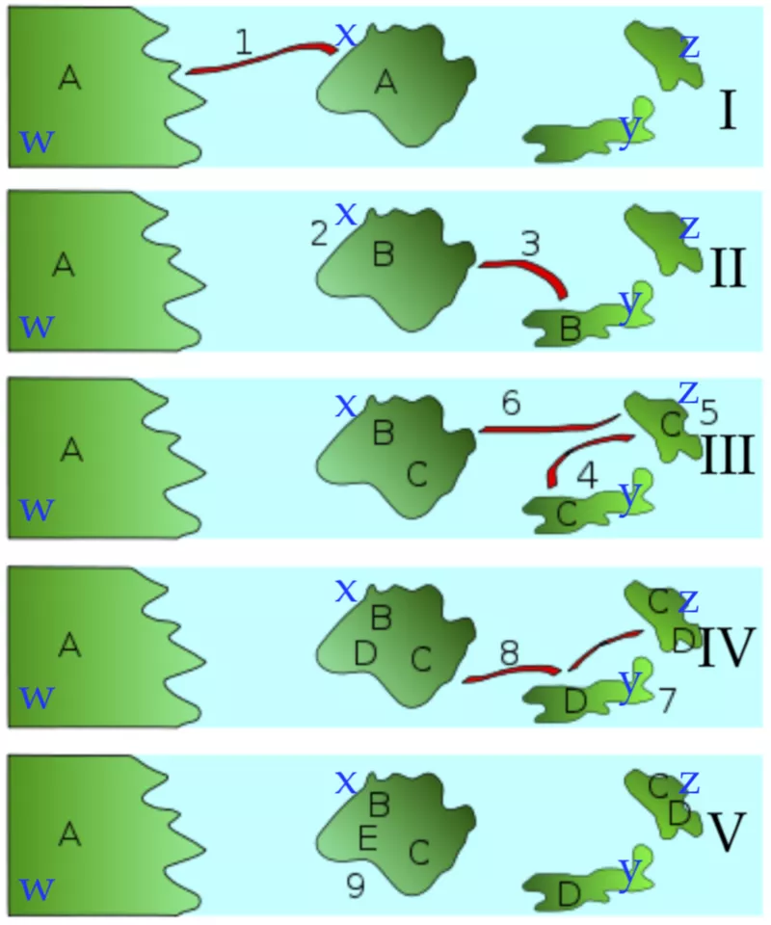

Tutorial 5: Extinction
1. Read the introduction: “Three Extinct Species.”☐
2. Read “Extinction is the Flip Side of Speciation.” ☐
3. Read “The Extinction Vortex” ☐
CONNECT! Explain how the extinction vortex is connected to the idea of genetic drift (covered in a previous module).

4. Read “The background level of extinction.” ☐
5. Read “Mass Extinction” ☐
SUMMARIZE: Imagine that you’re at home, explaining to a younger sibling, cousin, or neighbor about what you learned about mass extinction. Explain what you’ve learned (but make sure not to make it too traumatic). In you explanation, be sure to contrast mass extinction with background level extinction.

6. Read “What Happens After Mass Extinction” ☐
7. Take “Understanding Extinction” Quiz ☐
SUMMARIZING TASK 1; Explain what these diagrams say about what happens before, during, and after a mass extinction.
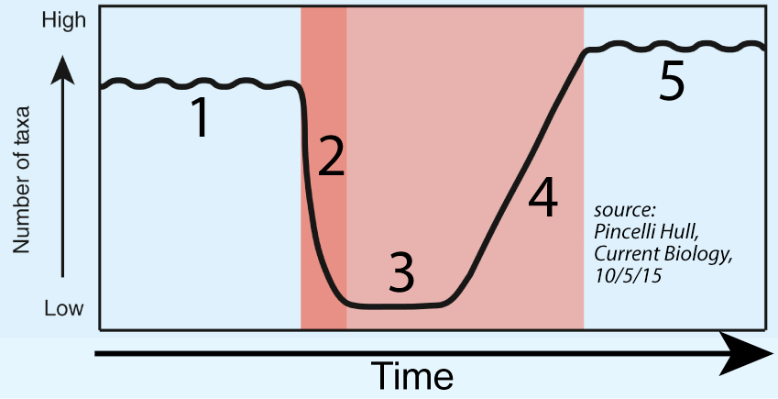 | 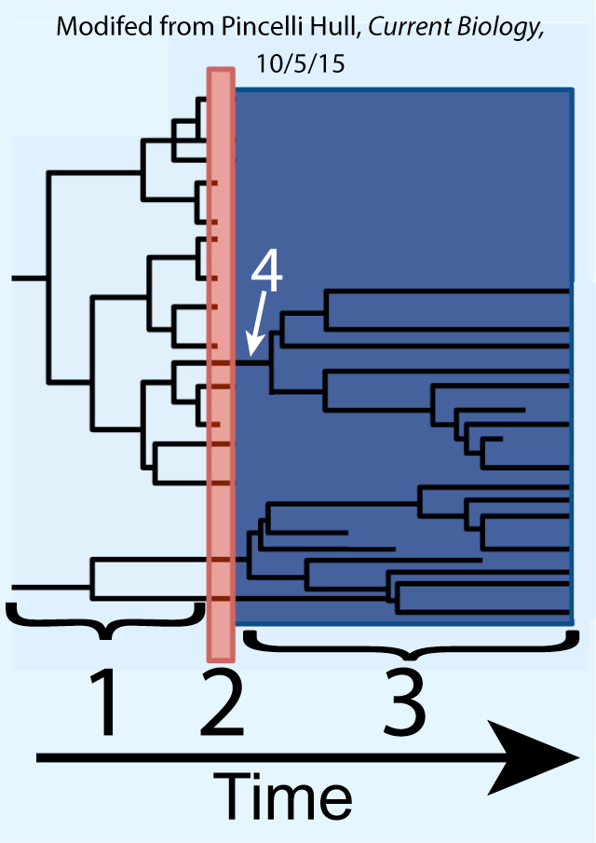

Continue on to the Speciation and Extinction Cumulative Quiz
Tutorial 6. Species, Speciation, and Extinction Cumulative Quiz.
1. Take the Cumulative Quiz.
2. SUMMATIVE REFLECTION ABOUT SPECIATION
According to recent estimates of biodiversity, our planet has 8.7 million species (Nature, August 24, 2011). In the space below, explain how they got there. Use this as an opportunity to test your understanding of 1) what a species is; 2) allopatric speciation, 3) sympatric speciation, 4) adaptive radiation. End with a brief explanation of why extinction happens, and why it’s important in understanding the history of life.
You should have a lot to say. Write small, and fill up the rest of the space below.

sciencemusicvideos.com | Biology | Name:________________________
Species, Speciation, and Extinction
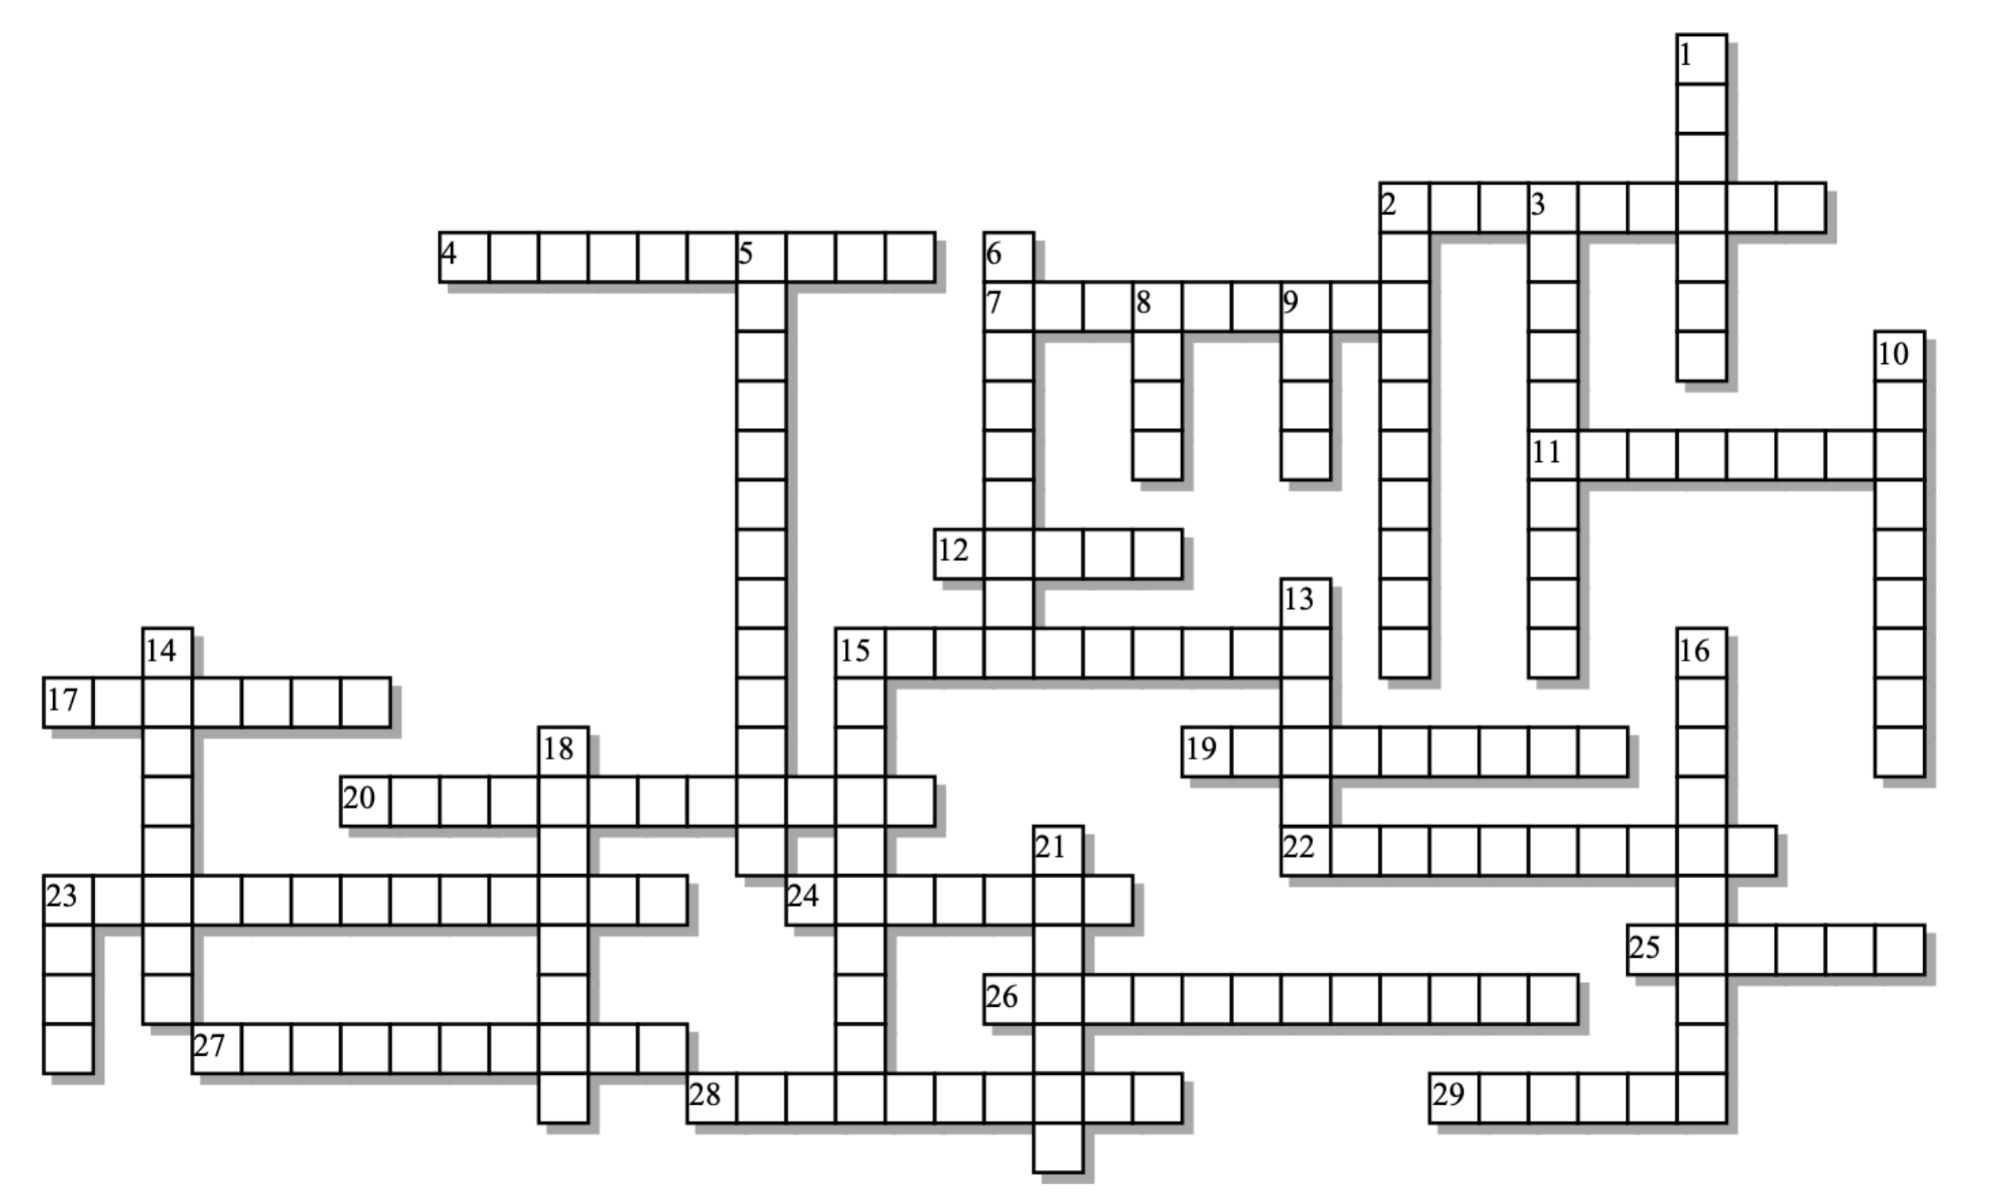

Across: | Down:
2 - The type of barrier in which the first hybrid generation is fine, but the second won't work  4 - A naturally occurring, differentiated group within a species, often connected to a specific geographical area.  7 - Speciation without a geographical barrier  11 - An ___________ impact caused the extinction the dinosaurs  12 - Graded variation in genetic and phenotypic characters along a geographical axis.  15 - A speciation mechanism that involves entire new sets of chromosomes.  17 - A population of interbreeding organisms that is isolated from other such groups  19 - Poodles, Golden Retrievers, and Kerry Blue Terriers are all _____________ of the domestic dog.  20 - The _______ species concept sees species as distinct branches on the tree of life  22 - Selection against the average phenotype that can split a species into two.  23 - A species concept that's very useful with fossil species  24 - Where an organism lives; also a cause of speciation, and a reproductive barrier.  25 - Species in disturbed habitats often enter into an extinction ___.  26 - This kind of isolation is at the heart of the biological species concept  27 - This process directly undoes what speciation does  28 - A burst of ____________ often follows mass extinctions.  29 - This kind of selection involving female choice can lead to speciation in animals. | 1 - Pre-________ barriers prevent closely related species from breeding.  2 - The ___________ extinction rate is about one extinction/million species/year  3 - A speciation process that involves a geographic barrier.  5 - A species that evolves over time into a descendant species.  6 - The biological species concept won't work with species that reproduce this way  8 - One way of thinking about a species is as a distinct, isolated gene _________ .  9 - When a cline folds back on itself, a ______ species can form.  10 - When a species splits into several descendants, it's called adaptive _____________  13 - Between closely related species, there's often this kind of zone.  14 - When two closely related species breed in different seasons, the barrier is  15 - When speciation occurs in a small, subpopulation on the periphery.  16 - If courtship rituals don't elicit the desired response in a partner, the barrier is  18 - Huge _____________eruptions were associated with the "Great Dying."  21 - If sperm won't fertilize egg, then the barrier is  23 - This kind of extinction is associated with planetary disturbances
Possible Answers: allopatric, asexually, asteroid, background, behavioral, breakdown, chronospecies, cline, disruptive, extinction, gametic, habitat, hybrid, mass, morphological, peripatric, phylogenetic, polyploidy, pool, radiation, reproductive, ring, sexual, speciation, species, subspecies, sympatric, temporal, varieties, volcanic, vortex, zygotic

