Name: _____________________ Period: _____ Date: _________________

Transpiration and Water Transport in Plants: Student Learning Guide
Instructions:
1. Work in pairs (share a computer).
2. Go to www.sciencemusicvideos.com. Select the College/AP Biology Menu. Then select “Module 32 Transpiration and Water Transport in Plants.”
3. As you complete the following tasks on the worksheet and on sciencemusicvideos.com, check off the boxes below.

1. Read the introduction. ☐
SPECULATE: How can water get from the water in the soil just outside the roots of a redwood tree all the way to its highest leaves, 100 meters up in the air?

2. Read “Plants and Water.” ☐
3. Read “Water Potential,” and complete the interactive reading.☐
CONSOLIDATING YOUR LEARING:
Task 1: Explain what’s happening in the time sequence below. In your explanation, use the terms water potential, solute potential, hypotonic, and hypertonic.
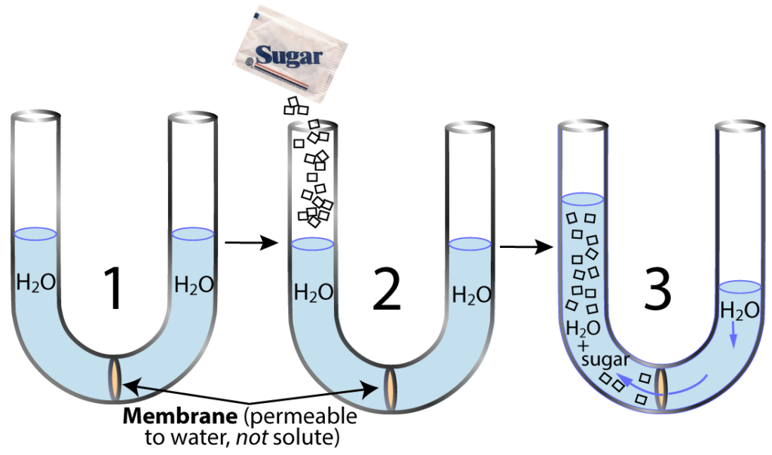

Task 2: Explain what’s happening in the time sequence below. In your explanation, use the terms water potential and pressure potential.
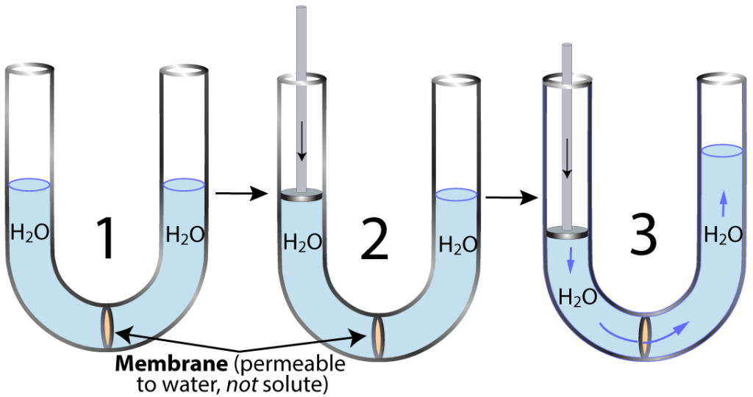

Task 3: Explain why the cell shown below changed shape. Formulate your answer in a quantitative way. Use the terms flaccid, turgor (or turgid), pressure potential, solute potential, and water potential.
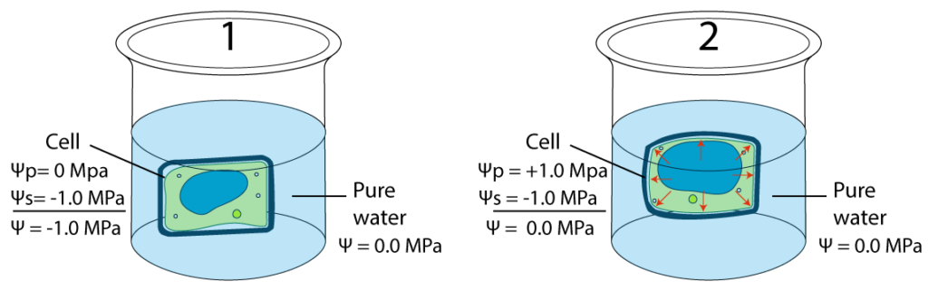

SUMMARIZE: List four reasons why plants need water.

4. Read “Getting Water into the Root.” Note that there’s no sign in for the first quiz.☐
5. Complete the “Getting Water into the Root” Quiz ☐
CHECKING UNDERSTANDING
Task 1: Make a key for the diagram below. Include the name of each part and its function.
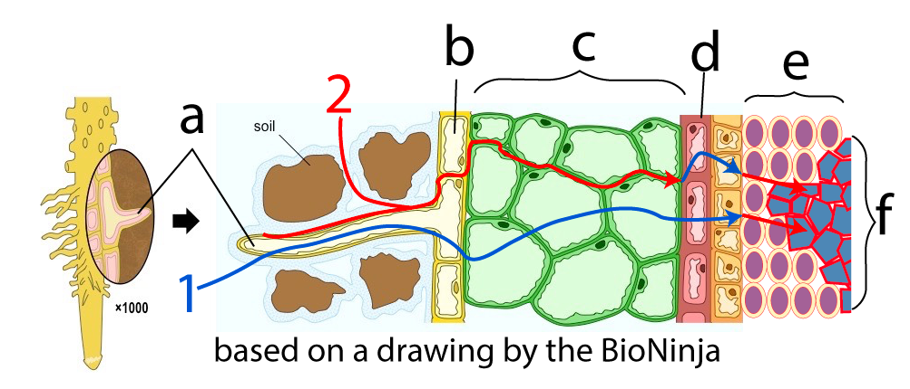
a
b.
c.
d.
e.
f.
Task 2: Explain the difference between pathways 1 and 2.

Task 3: Explain the importance of aquaporins.
Task 4: Using the diagram below, explain how plant roots can transport positive ions (like potassium) and negative ions (like the chloride ion) into the root against their concentration gradient.
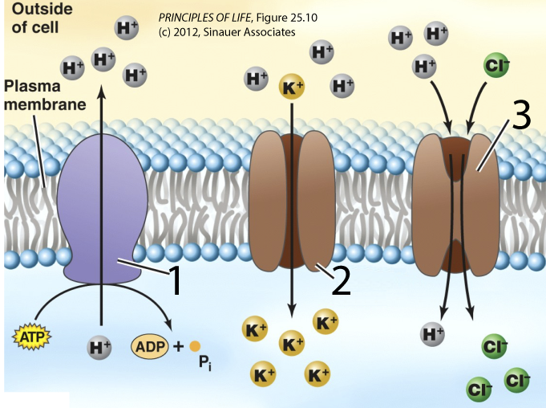

6. Read “From the Root to the Shoot.” ☐
7. Complete the “Transpiration-Cohesion-Tension” Quiz ☐
Checking understanding
Task 1: Make a key for this diagram. Include both the part’s name and (as needed) its function.
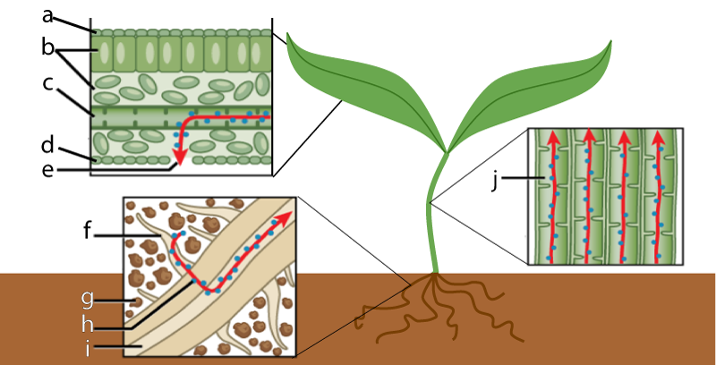

a
b.
c.
d.
e.
f.
g.
h.
i.
j.

Task 2: Use the space to the right and below the following table to explain how the two diagrams below are connected, and to describe how the structures and processes shown connect to water transport in plants.
Diagram 1 | Diagram 2
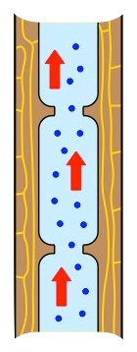 | 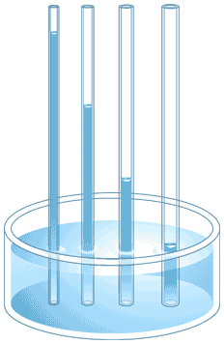

Task 3: Imaginative science writing. Pretend that you’re a water molecules just outside the root of a redwood tree. Explain how you rise to the top. Use this task as an opportunity to demonstrate your understanding of the theory of transpiration-cohesion tension. Write small, and include lots of detail.
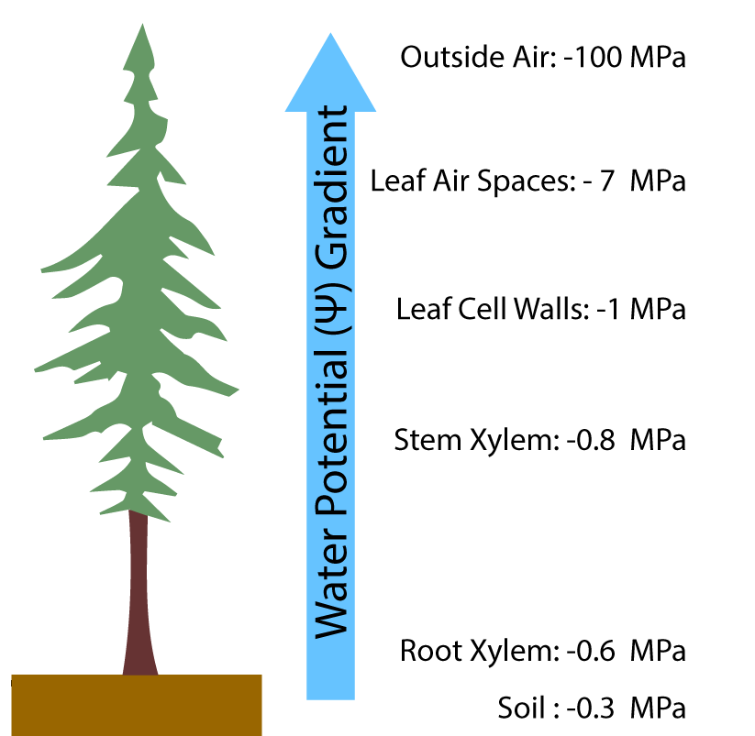

8. “Read Control of Water Loss.” ☐
9. Complete the “Control of Transpiration” Quiz ☐
Checking Understanding
Task 1: With reference to the diagram below, explain how stomata open and close in response to light or darkness.
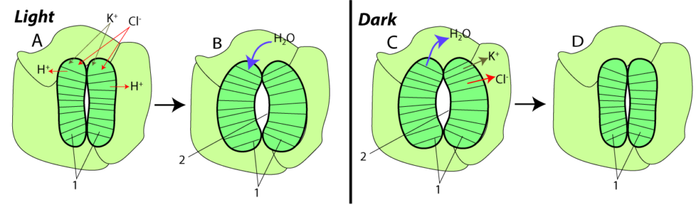

Task 2: Describe four water conserving adaptations found in plants that are adapted to dry conditions.
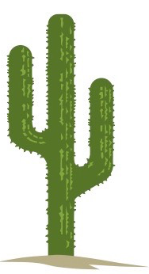

Task 3: In the 1890s, Eduard Strasburger took plant stems, severed them from their roots, and immersed them in basins filled with solutions of the plant poison copper sulfate. During the next two weeks, the copper sulfate rose nearly to the top of the plant, killing all the cells it encountered. During the same time period, the volume of the solution in the container decreased by 30 liters. Explain what happened. Write small.
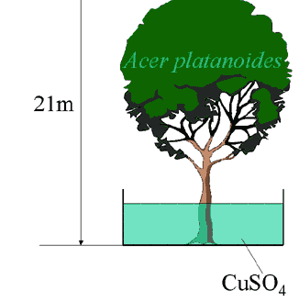

SUMMATIVE TASK: Respond to the following practice FRQ prompt.

Transpiration Experiment: ____/11

A group of students designed an experiment to measure transpiration rates in a particular species of herbaceous plant. Plants were divided into groups and were exposed to the following conditions. | Group I | Room conditions (light, low humidity, 20° C, and little air movement)
 | Group II | Room conditions with increased humidity
 | Group III | Room conditions with increased air movement (fan)
 | Group IV | Room conditions with additional light
The cumulative water loss due to transpiration of water from each plant was measured at 10-minute intervals for 30 minutes. Water loss was expressed as milliliters of water per square centimeter of leaf surface area. The data for all plants in Group I (room conditions) were averaged. The average cumulative water loss by the plants in Group I is presented in the table below.
Average Cumulative Water Loss by the Plants in Group I  Time (minutes) Average Cumulative Water Loss (milliliters H₂O /centimeter²)  10 3.5 x 10⁻⁴  20 7.7 x 10⁻⁴  30 10.6 x 10⁻⁴ | a. Construct and label a graph using the data for Group I. Using the same set of axes, draw and label three additional lines representing the results that you would predict for Groups II, III, and IV.  b. Explain how biological and physical processes are responsible for the differences between each of your predictions and the data for Group I.  c. Explain how the concept of water potential is used to account for the movement of water from the plant stem to the atmosphere during transpiration.

- Graph the results (3 points) | b) (4 points) ______________________  _________________________________  _________________________________  _________________________________  _________________________________  _________________________________  _________________________________  _________________________________  _________________________________  _________________________________  _________________________________  _________________________________  _________________________________  _________________________________  _________________________________  _________________________________  _________________________________  _________________________________  _________________________________

(c) (4 points) _________________________________________________________________________________________________________
___________________________________________________________________________________________________________________
___________________________________________________________________________________________________________________
___________________________________________________________________________________________________________________
___________________________________________________________________________________________________________________
___________________________________________________________________________________________________________________
___________________________________________________________________________________________________________________
___________________________________________________________________________________________________________________
___________________________________________________________________________________________________________________
___________________________________________________________________________________________________________________
___________________________________________________________________________________________________________________
___________________________________________________________________________________________________________________
___________________________________________________________________________________________________________________
___________________________________________________________________________________________________________________
___________________________________________________________________________________________________________________

sciencemusicvideos | AP Biology | Name:________________________
Transpiration and Water Movement in Plants
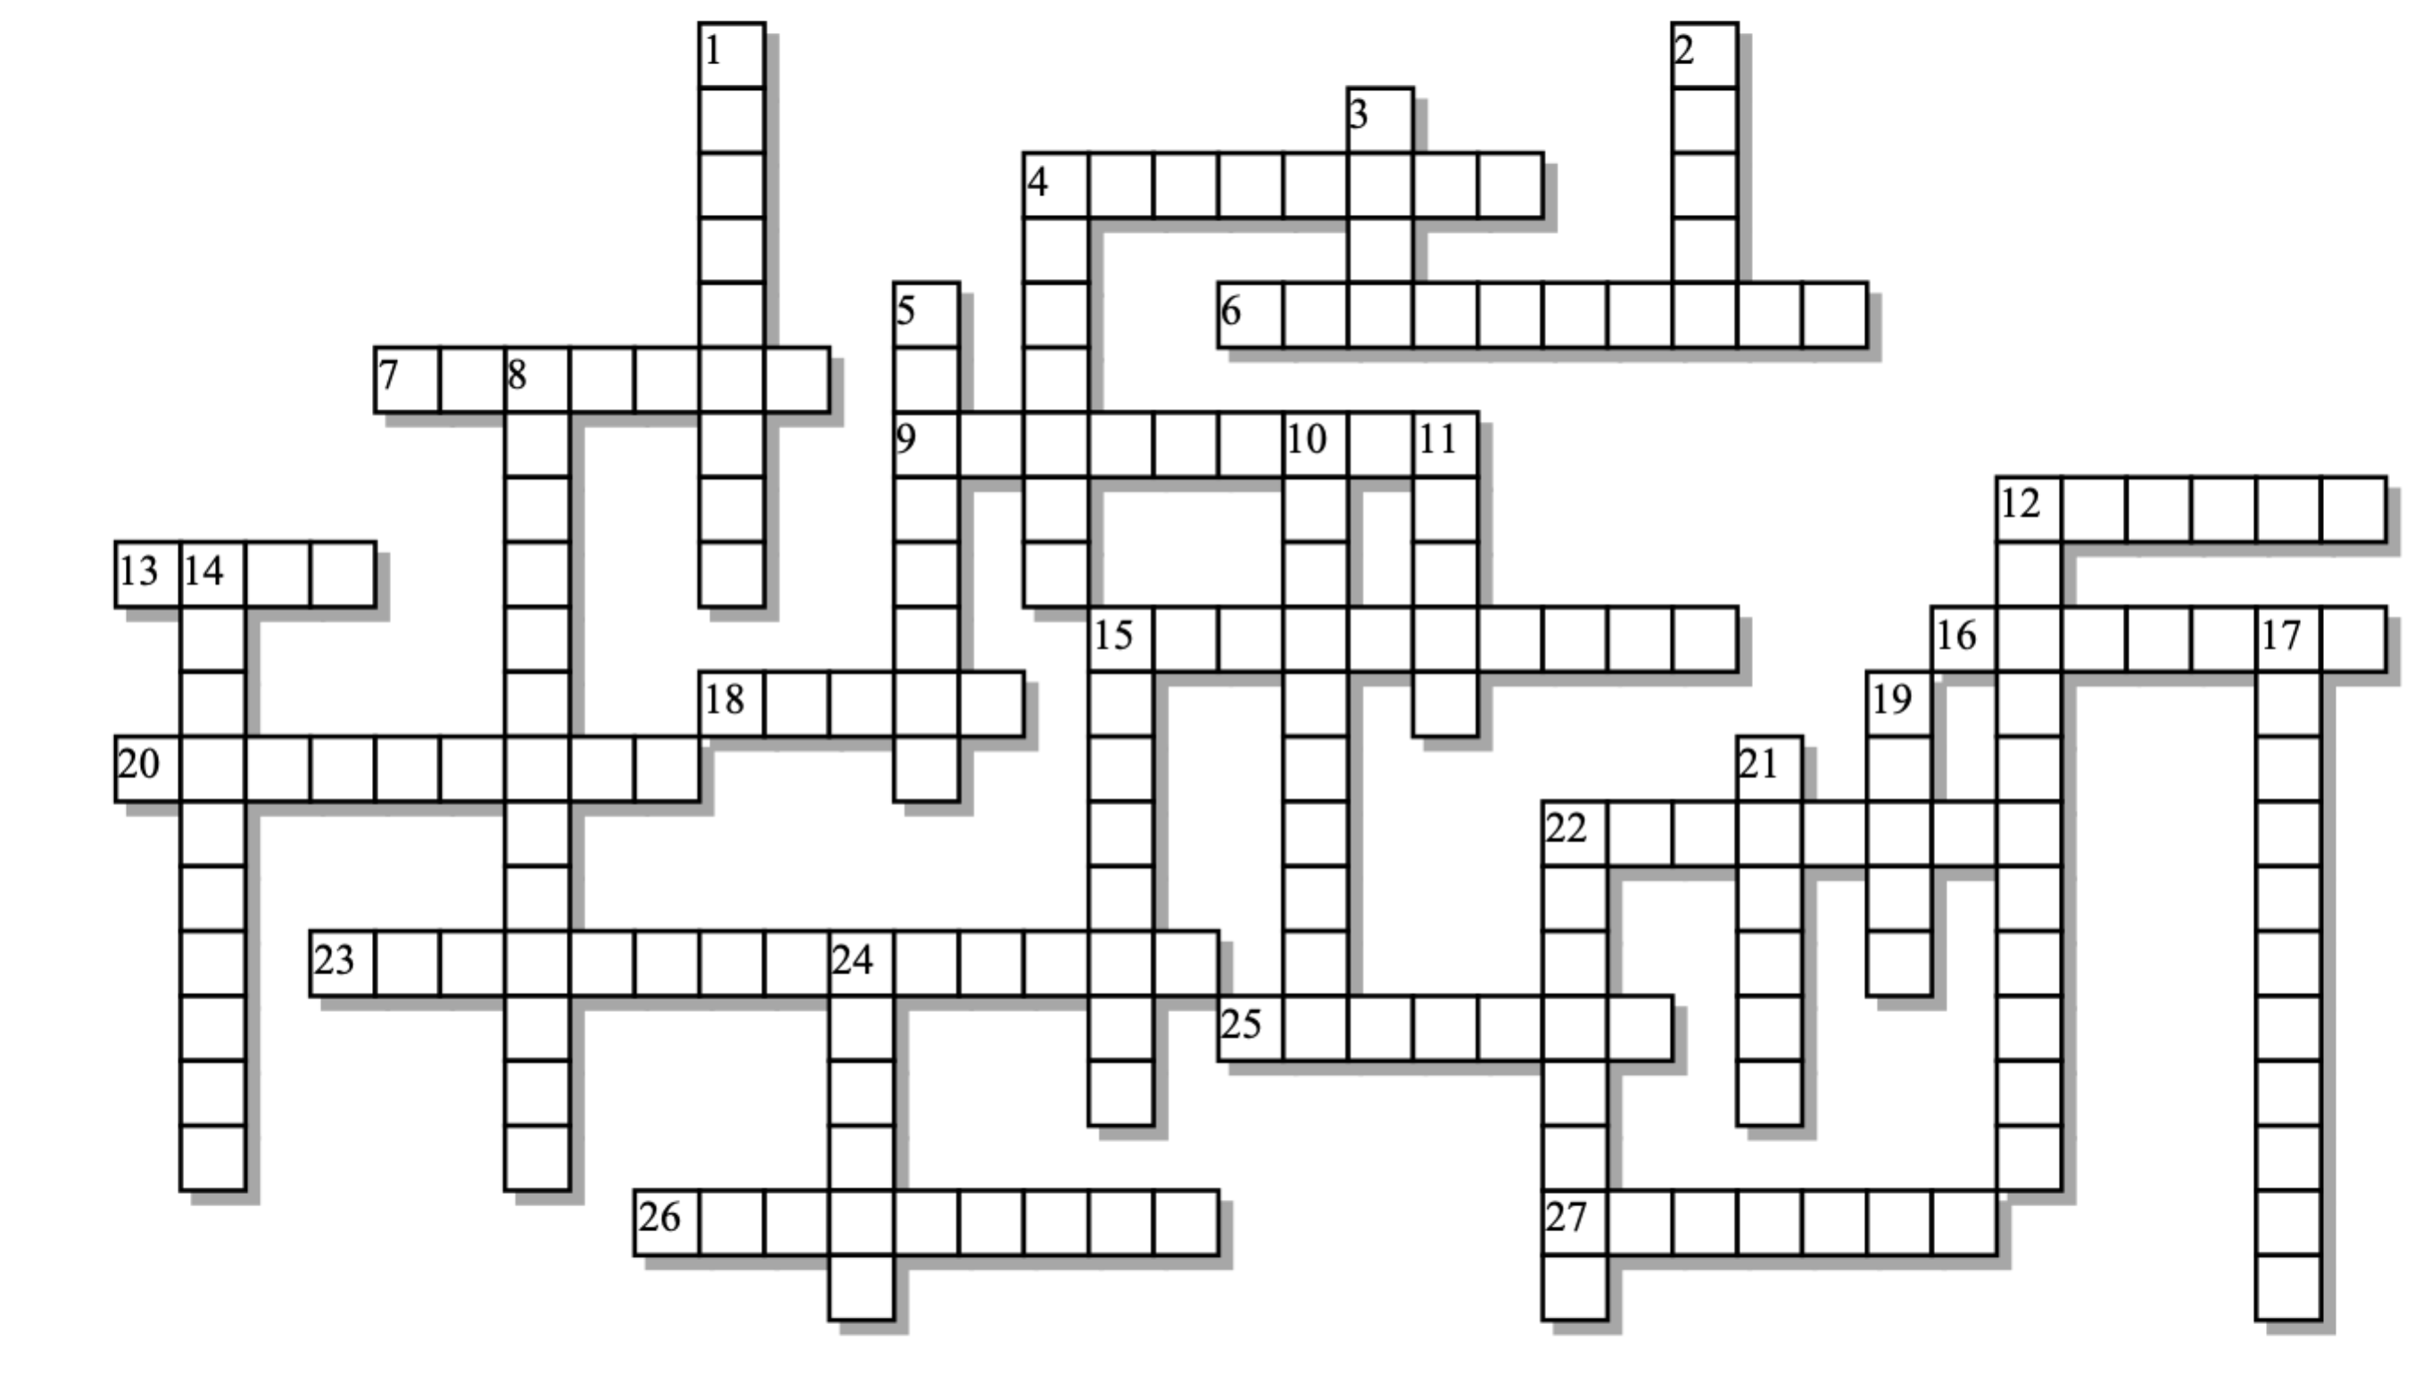

Across: | Down:
4 - Water molecules sticking to other water molecules is an example of _______.  6 - The cell layer around the vascular cylinder  7 - Desert plants have more of a waxy ________ on their exposed parts to reduce water loss.  9 - The outer cell layer of the root  12 - The part of the root that stores food and water.  13 - Movement of charged ______ into guard cells causes osmosis. This causes stomata to open.  15 - Membrane channels for osmosis.  16 - Pores in the lower epidermis of a leaf  18 - Two of these cells create the pores in the lower leaf epidermis  20 - Water always flows from higher water ________ to lower.  22 - If water didn't form these bonds, then water molecules couldn't drag each other up the stem  23 - Consumes less than 1% of the water flowing through a plant  25 - A cell that's in a hypertonic solution will become _______ as it loses water.  26 - A solution with relatively little solute (compared to an adjacent solution)  27 - The opposite of pressure | 1 - This kind of action can drive water about 15 centimeters up a stem  2 - The plant tissue that conducts water  3 - The faster this is, the higher the rate of transpiration  4 - Like perspiration, one function of transpiration is evaporative _________.  5 - Squeezing on a sponge increases this component of water potential, forcing the water out.  8 - Evaporation of water from a plant's leaves.  10 - The unit for measuring water potential  11 - The part of the plant above the root  12 - A channel that couples diffusion of protons to ion flow up a gradient.  14 - Increasing the _________ of a solution makes the water potential lower  15 - When two different things stick together  17 - The higher the ________, the higher the rate of transpiration  19 - Activates proton pumps, causing stomata to open.  21 - These pumps are used by plants to power ion transport.  22 - When this measure of moisture in the atmosphere goes up, transpiration goes down.  24 - This outward pushing, hydrostatic force makes plant cells full and firm
Possible Answers: adhesion, aquaporins, capillary, cohesion, cooling, cortex, cotransport, cuticle, endodermis, epidermis, flaccid, guard, humidity, hydrogen, hypotonic, ions, light, megapascal, osmolarity, photosynthesis, potential, pressure, proton, shoot, stomata, temperature, tension, transpiration, turgor, wind, xylem

