Name: _____________________ Period: _____ Date: ________

sciencemusicvideos Viruses, Student Learning Guide
Getting to the tutorials.
- Go to www.sciencemusicvideos.com; Use the College Bio or Learning Guide Menus to find “Viruses.” If you’re using this as part of an AP Bio class, “Viruses” is in Topic 6.7, “Mutation.”

Tutorial
1. Read the “Introduction.” Check this box when you’re finished. ☐
CHECKING UNDERSTANDING: Viruses are obligate intracellular parasites. Describe in your own words what that means.

2. If you want to, watch Mr. W’s slideshow about viruses. It’ll give you a quick overview of everything that’s to come. If not, jump down to the next section.
3. Read “Viruses are Small and (Relatively) Simple.” ☐
4. Read “The Lytic Cycle,” and take the “Viruses and Lytic Cycle” Quiz: ☐
CREATE A KEY FOR THE DIAGRAM BELOW
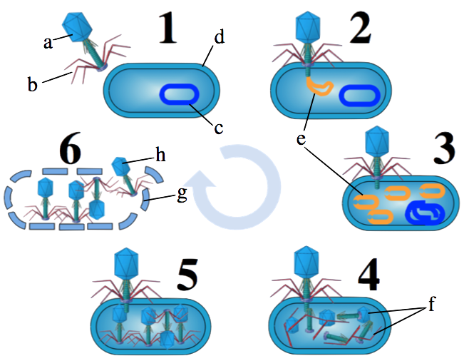
a
b
c
d
e
f
g
h
1
2
3
4
5
6

5. Read “The Lysogenic Cycle,” and complete “Lysogenic Cycle: Interactive Diagram.” ☐
WITHOUT LOOKING AT THE WEBPAGE, CREATE A KEY FOR THE DIAGRAM BELOW:
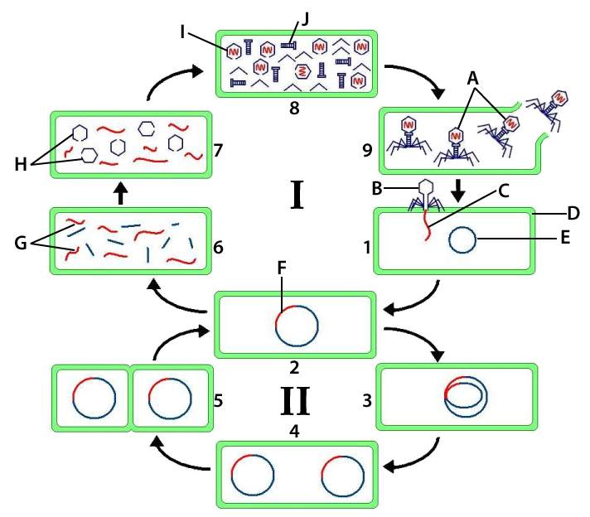
a
b
c
d
e
f
g
h
i
j
I
II
1
2
3
4
5
6
7
8
9

Check your work before proceeding to the next page.
SYNTHESIZING WHAT YOU’VE LEARNED
Write a short paragraph comparing and contrasting the lytic cycle and the lysogenic cycle.

6. Read “HIV Structure and Life Cycle,” and take the “HIV Interactive Diagrams” Quiz. ☐
CREATE A KEY FOR THE DIAGRAM BELOW:
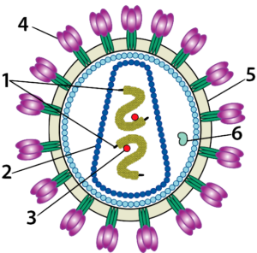 | 1
 | 2
 | 3
 | 4
 | 5
 | 6

CREATE A KEY FOR THIS DIAGRAM :
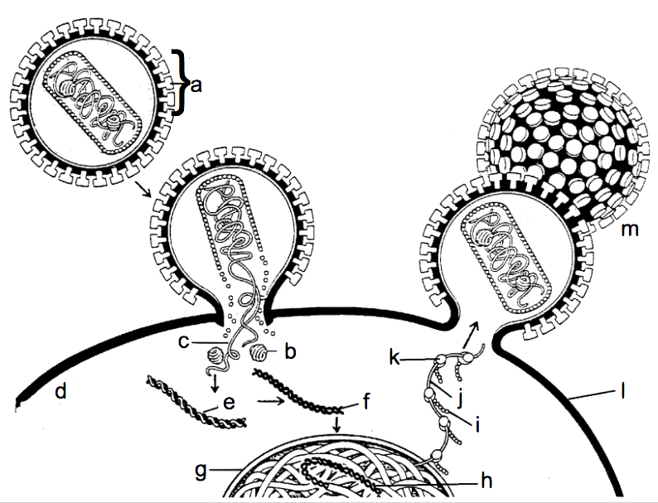
a
b
c
d
e
f
g
h
i
j
k
l
m
SYNTHESIZING WHAT YOU’VE LEARNED
Write a short paragraph describing the life cycle of HIV.

7. Read “Viruses and Variation.“ ☐
CREATE A KEY FOR THIS DIAGRAM:
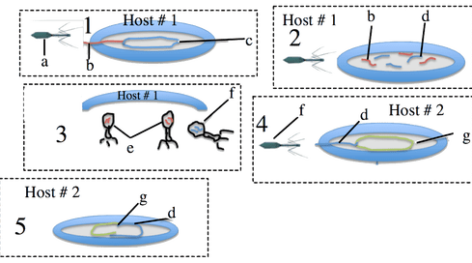
a
b
c
d
e
f
g
1
2
3
4
5
CHECKING UNDERSTANDING: Explain how generalized transduction creates variation in bacteria.

8. Complete: “I’m A Virus: Interactive Lyrics.” ☐
9. Take the “Virus Cumulative Quiz.” ☐

I’m a Virus!
View it at www.sciencemusicvideos.com
Glenn Wolkenfeld © 2012

I’m a virus, an infectious particle,
a nano-thug, a pirate, the genuine article
Ebola, chickenpox, west Nile, influenza,
Yellow fever, AIDS, herpes, SARS, I’m comin’ right at ya
I’m not a cell, not an independent organism,
I don’t even have my own metabolism,
I only reproduce myself by taking over cells,
Then I bust ‘em apart, no wonder you don’t feel well!
My structure is simple, mostly proteins and genes,
Packaged as a sub-micron killing machine,
My capsid’s made of capsomeres that self assemble,
Whenever cells see me they start to tremble,
Inside my capsid is where my genes reside,
I got DNA or RNA on the inside,
And the rest of me is various proteins whose role,
Is assisting in assaulting cells and taking control.
CHORUS
I’m a virus! Gonna use your cells to replicate me
I’m a virus! The death of your cells is the life of me
The lytic cycle shows one method of attack,
I attach to the cell surface, and pierce it like a tack
Inject my genes inside, use my victim’s machinery,
to make my genes and proteins for reproducing more of me.
Step 1, tail fibers grab the membrane or the wall
2: inject my genes, this cell is gonna fall.
3: use the victim’s polymerase and ribosomes,
To synthesize my proteins and replicate my genome.
4: tail piece and capsid self assembly,
5: I’m all together now, look at all my progeny
6 is lysis, I burst that cell apart,
Now I’m looking for more victims I can dearly depart.
CHORUS
Sometimes instead of lysing I lysogenize
Which happens after I inject my genes inside
I slip into your chromosome a thief inside your room
A menacing and silent presence bringer of doom
Integrated in you, your DNA’s my home,
And see what happens when you replicate your chromosomes
Each copy that you copy copies me as well as you,
You might make a million copies, there’s nothin’ you can do
My lurking hiding being’s called a prophage or provirus,
And if you got another name just call us or wire us,
Or write it on papyrus ‘til the moment that I emerge,
from your DNA I’m lytic now a cell destroying scourge.
And suddenly your cells are dying watch me as I lyse them,
I’m a pirate so forget your plans my program now denies them,
Your cells are virus factories they’re making millions more of me
I leave your cells and now I’m free Infecting you’s my destiny
CHORUS
Now meet my associate the virus HIV
Who’s helpless target is the cell called “T”
HIV causes immunodeficiency,
Raising cancer and infection vulnerability
Remember that the T's an essential cell
In the immune system army it's the general
So knocking out the T-cell sets the stage
For cancers, germs and viruses like me to invade!
HIV’s genes are made of RNA,
Outside its capsid's a phospholipid membrane,
A skin stolen from the cell it last dispatched,
studded with proteins that let it attach,
To a protein on the T-cell called CD4
Inducing that cell to open up its door,
Inviting in HIV’s enzymes and core,
That T-cells already done for.
HIV’s a retrovirus it’s next routine,
has to do with transforming its RNA genes
Reverse transcriptase takes its RNA
And reverse transcribes it into DNA
Then this DNA integrates into your chromosomes,
Like a lysogenic prophage in your genome.
This proviral DNA’s transcribed and translated
As new virus genes and proteins get created
And like any virus all those parts will self assemble,
Into new viruses which of course resemble,
the original particle which started the infection,
Acquired by sex, or a needle injection
CHORUS

Biology | sciencemusicvideos | Name:________________________
Viruses
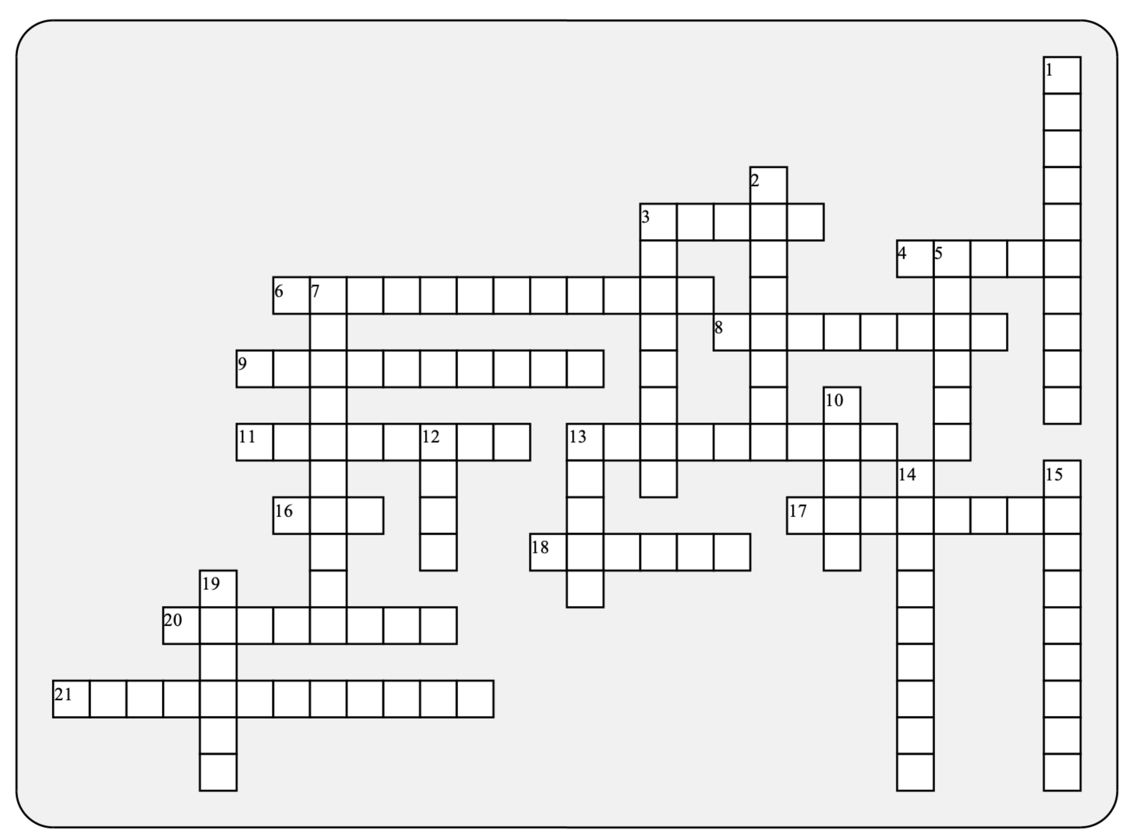\
1

2

3

4
5

6
7

8

9

10

11

12

13

14
15
16

17

18

19

20

21

Across: | Down:
3 - A virus that attacks nerve cells. A famous American president was a victim of it.  4 - A virus that attacks bacteria  6 - Genetic change in bacterial hosts that can be caused by errors during the viral self-assembly process.  8 - Once their parts are built, viruses can self-______________.  9 - Because they lack their own ____________, it's hard to argue that viruses are truly alive.  11 - A viral DNA sequence that's become embedded in a bacterial chromosome.  13 - The viral life cycle where viral genes are incorporated into the host cell's chromosomes.  16 - A virus that causes immunodeficiency  17 - HIV's high rate of __________has kept our immune system from learning to recognize and destroy it.  18 - If a lytic virus had a profession, this would be it.  20 - An organism that lives within a larger host, causing that host harm  21 - Reverse ______________ makes DNA from an RNA template | 1 - A virus will use DNA or RNA ___________ to replicate its genes.  2 - As a virus takes over a cell, it uses this protein-making machine to synthesize viral protein  3 - An enzyme that HIV uses to modify its viral proteins to allow for self assembly of new viruses.  5 - This T cell is like the general of the immune system army, and it's HIV's specific target.  7 - Any virus that violates the central dogma  10 - An infectious, obligate, intracellular parasite  12 - The disease caused by untreated HIV infection.  13 - In this viral life cycle, viruses attack, hijack, and quickly destroy their host cells  14 - A monomer of a capsid  15 - A virus that raged immediately after World War 1, killing more people than the war did.  19 - A virus's protein coat

Possible Answers: AIDS, HIV, Helper, assemble, capsid, capsomere, influenza, lysogenic, lytic, metabolism, mutation, parasite, phage, pirate, polio, polymerase, prophage, protease, retrovirus, ribosome, transciptase, transduction, virus

