Name: _____________________ Period: _____ Date: ________

sciencemusicvideos Cell Communication and Cell Signaling
Getting to the tutorials.
- Go to www.sciencemusicvideos.com; Use the College Bio, AP Bio, or Learning Guide Menus to find “Cell Communication”
- Start with “Introduction to Cell Communication”

1. Introduction to Cell Communication
1. Read the Introduction. Check the box when you’re done.
☐
2. Read “Cell Communication in Bacteria: Quorum Sensing...”☐
3. Read “Cell Communication in Yeast Mating” ☐
4. Take the “Checking Understanding...” Quiz
SUMMARIZING TASK 1: Describe what’s happening in this diagram:
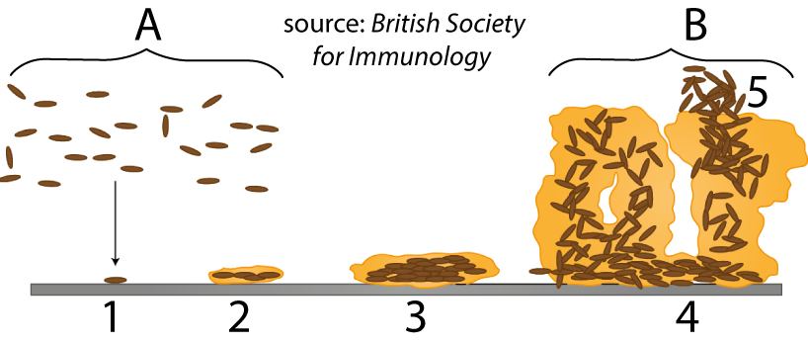

TASK 2: Explain 1) what’s happening in the diagram below, and 2) how this diagram is related to the one above.
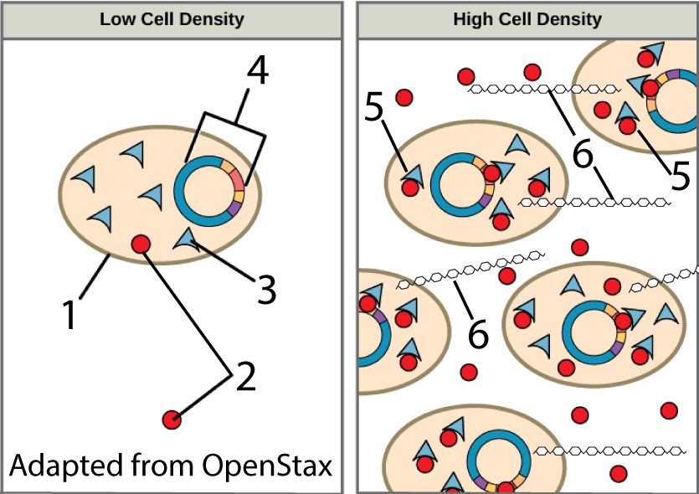

Task 3: You have a younger cousin who’s not certain about the importance of brushing their teeth. With reference to plaque formation, biofilms, and quorum sensing, explain it to them.

Task 4: Explain what’s happening in the diagram below
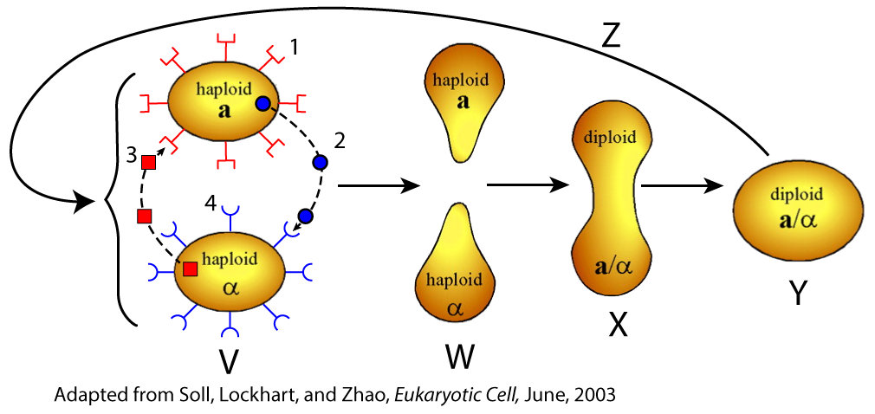

5. Read “Cell Communication in Multicellular Organisms ☐
6. Take the “Cell Communication Overview” Quiz

SUMMARIZING: Use the space to the right of and below the following diagrams to describe how each one relates to cell communication:
Diagram 1:
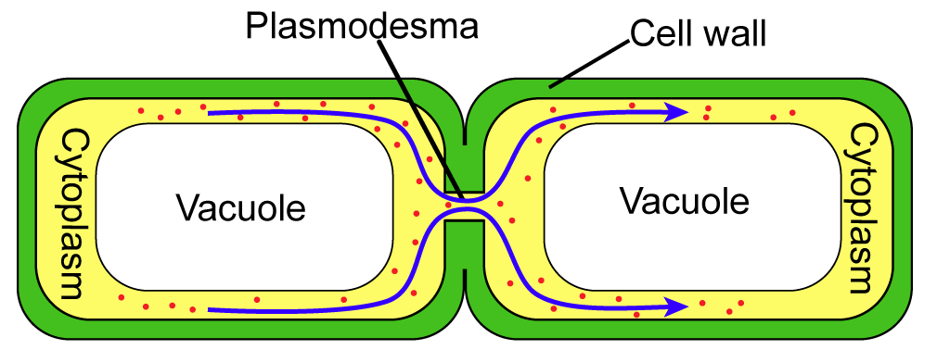

Diagram 2:
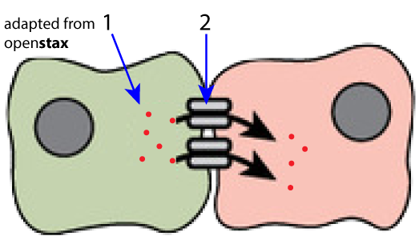

Diagram 3:
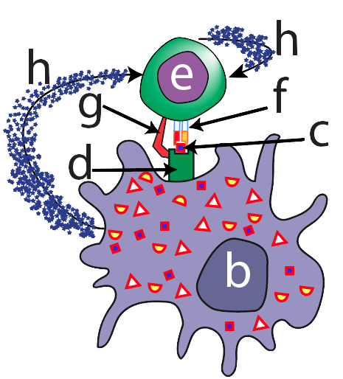

Diagram 4:
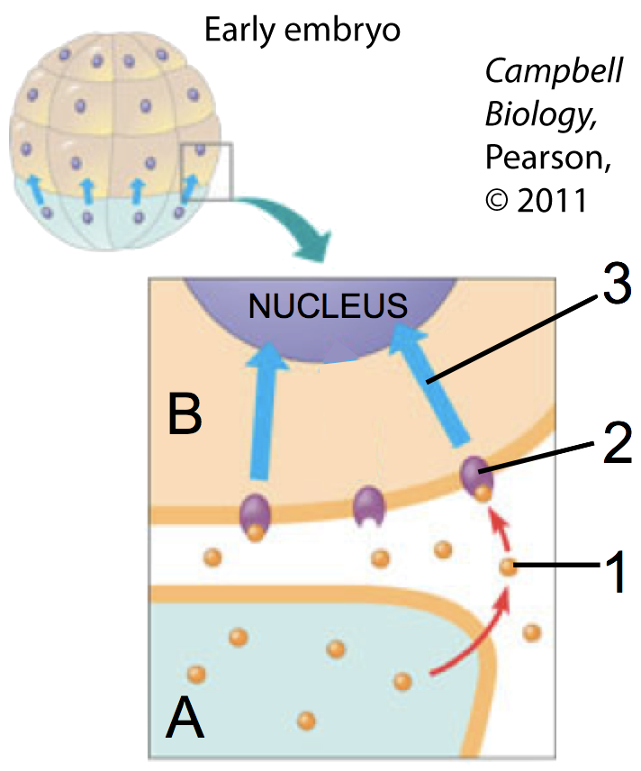

Diagram 5:
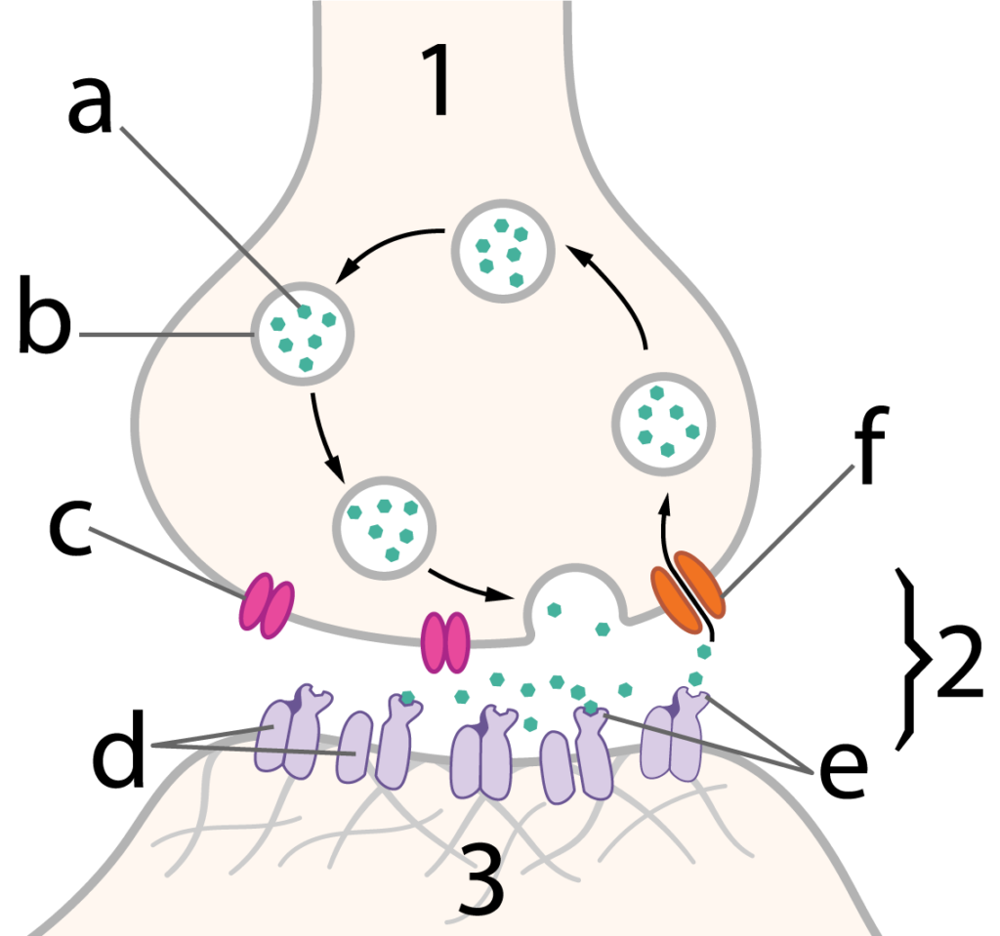

Diagram 6:
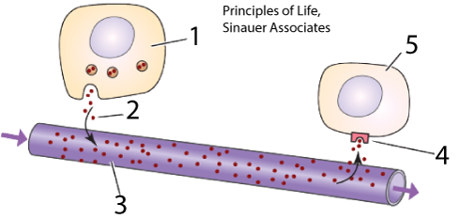

SUMMATIVE SUMMARY:
When you get home after school, someone asks what you learned. You say, “Cell communication.” They say, “Really? How do cells communicate?” Use the space below to let them know. Write small.

Continue to “Cell Signaling.”
2. Cell Signaling: Introduction
1. Read the Introduction. Check the box when you’re done.
☐
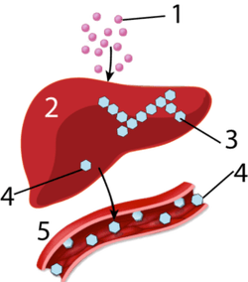 | Create a key to the diagram.  1.  2.  3.  4.  5.
Write a few sentences connecting this diagram to the overall “Fight or Flight” response.

2. Read “Cell Signaling: An Overview.”
☐
3. Take the “Introduction to Cell Signaling and Epinephrine Action” Quiz.
☐
SUMMARIZE. Create a key to the diagram below.
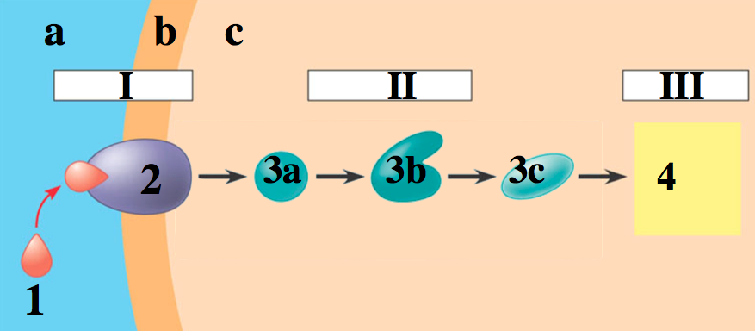 |  | a.
 |  | b.
 |  | c.
I
II
III
1.
2.
3a-3c.
4.

APPLY: Referring to the previous diagram (bottom of the previous column), explain what would be happening in terms of epinephrine, liver cells, and conversion of glycogen to glucose.

Follow the link to “Reception, the Details.”
3: Reception
1. Read the Introduction. Check the box when you’re done. ☐
2. Read about “G-Protein Coupled Receptors.” ☐
3. Take the quiz, “Reception.” ☐
SUMMARIZE: write a description of what’s happening in I, II, III, and IV below. Write small.
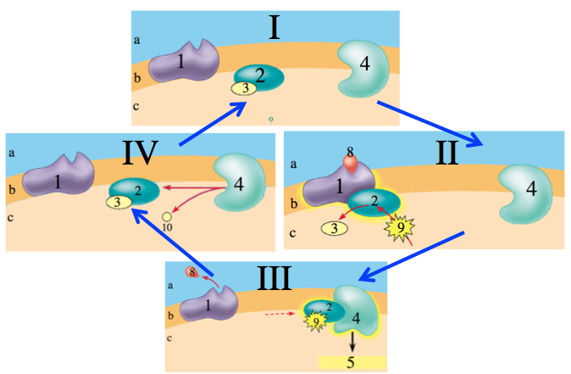

Follow the link to “Signal Transduction.”
4. Signal Transduction
1. Read “Introducing Cyclic AMP, the Second Messenger.” Check the box when you’re done. ☐
2. Take the “Signal Transduction” Quiz.☐
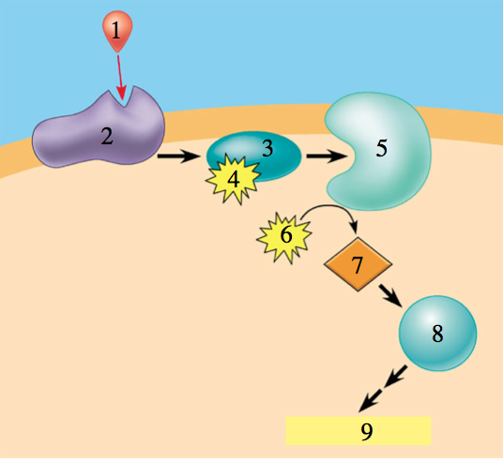
SUMMARIZE: Using our example of epinephrine causing liver cells to convert glycogen into glucose, explain what’s happening in this diagram:

3. Read “Signal Transduction through Phosphorylation Cascades…” ☐
4. Take the Quiz: “Kinases, Phosphorylation Cascades, and Signal Amplification” ☐
EXPLAIN IT! What’s happening in the diagram below?
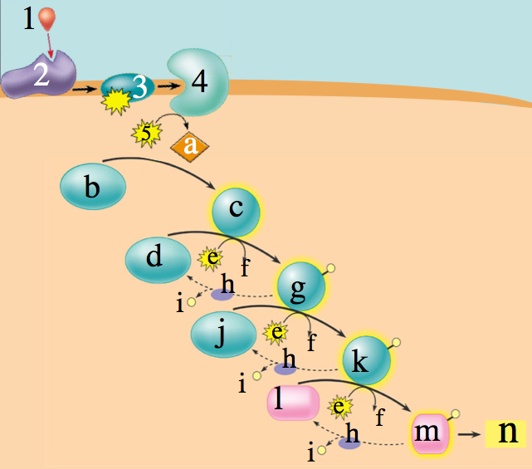

EXPLAIN IT! How can a phosphorylation cascade result in signal amplification?
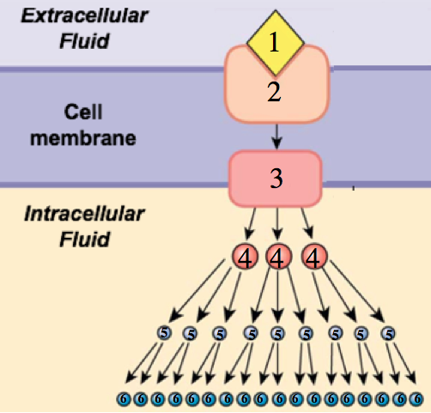

5. Read the Conclusion. ☐
DESCRIBE how epinephrine has different effects in different target tissues.

PULL IT ALL TOGETHER: Explain everything you can about how, as part of the “fight or flight” response, epinephrine induces liver cells to convert glycogen to glucose.

Click the link to “Hormones and Gene Expression.”
5: Hormones and Gene Regulation
1. Read about steroid hormones. Check the box when you’re done. ☐
2. Read about water-soluble hormones that regulate genes. ☐
3. Take the Quiz: “Hormones and Gene Regulation.”
☐
EXPLAIN how steroid hormones (like estrogen) work (use the space to the right of the diagram).
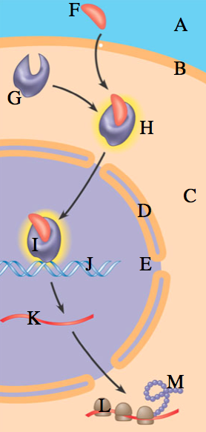

EXPLAIN how protein hormones (like growth hormone) can activate genes:
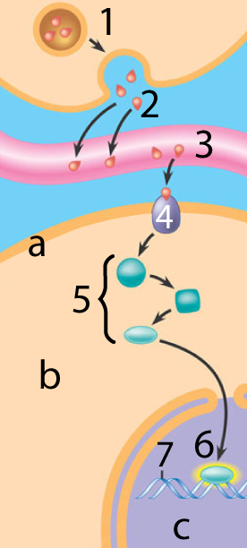

Click the link to the comprehensive quiz about cell signaling
6: Cumulative Quiz
1. If you need to, look over the slideshow ☐
2. Take the cumulative quiz. It’s 62 questions, so leave enough time.
SUMMARY OF SUMMARIES: Flip the page. Look over the questions for the crossword, and then the word bank. Then, respond to the prompt below.
How do cells communicate? Fill the space below with everything you remember about this topic. Write small.

sciencemusicvideos | AP Biology | Name:________________________
Cell Communication
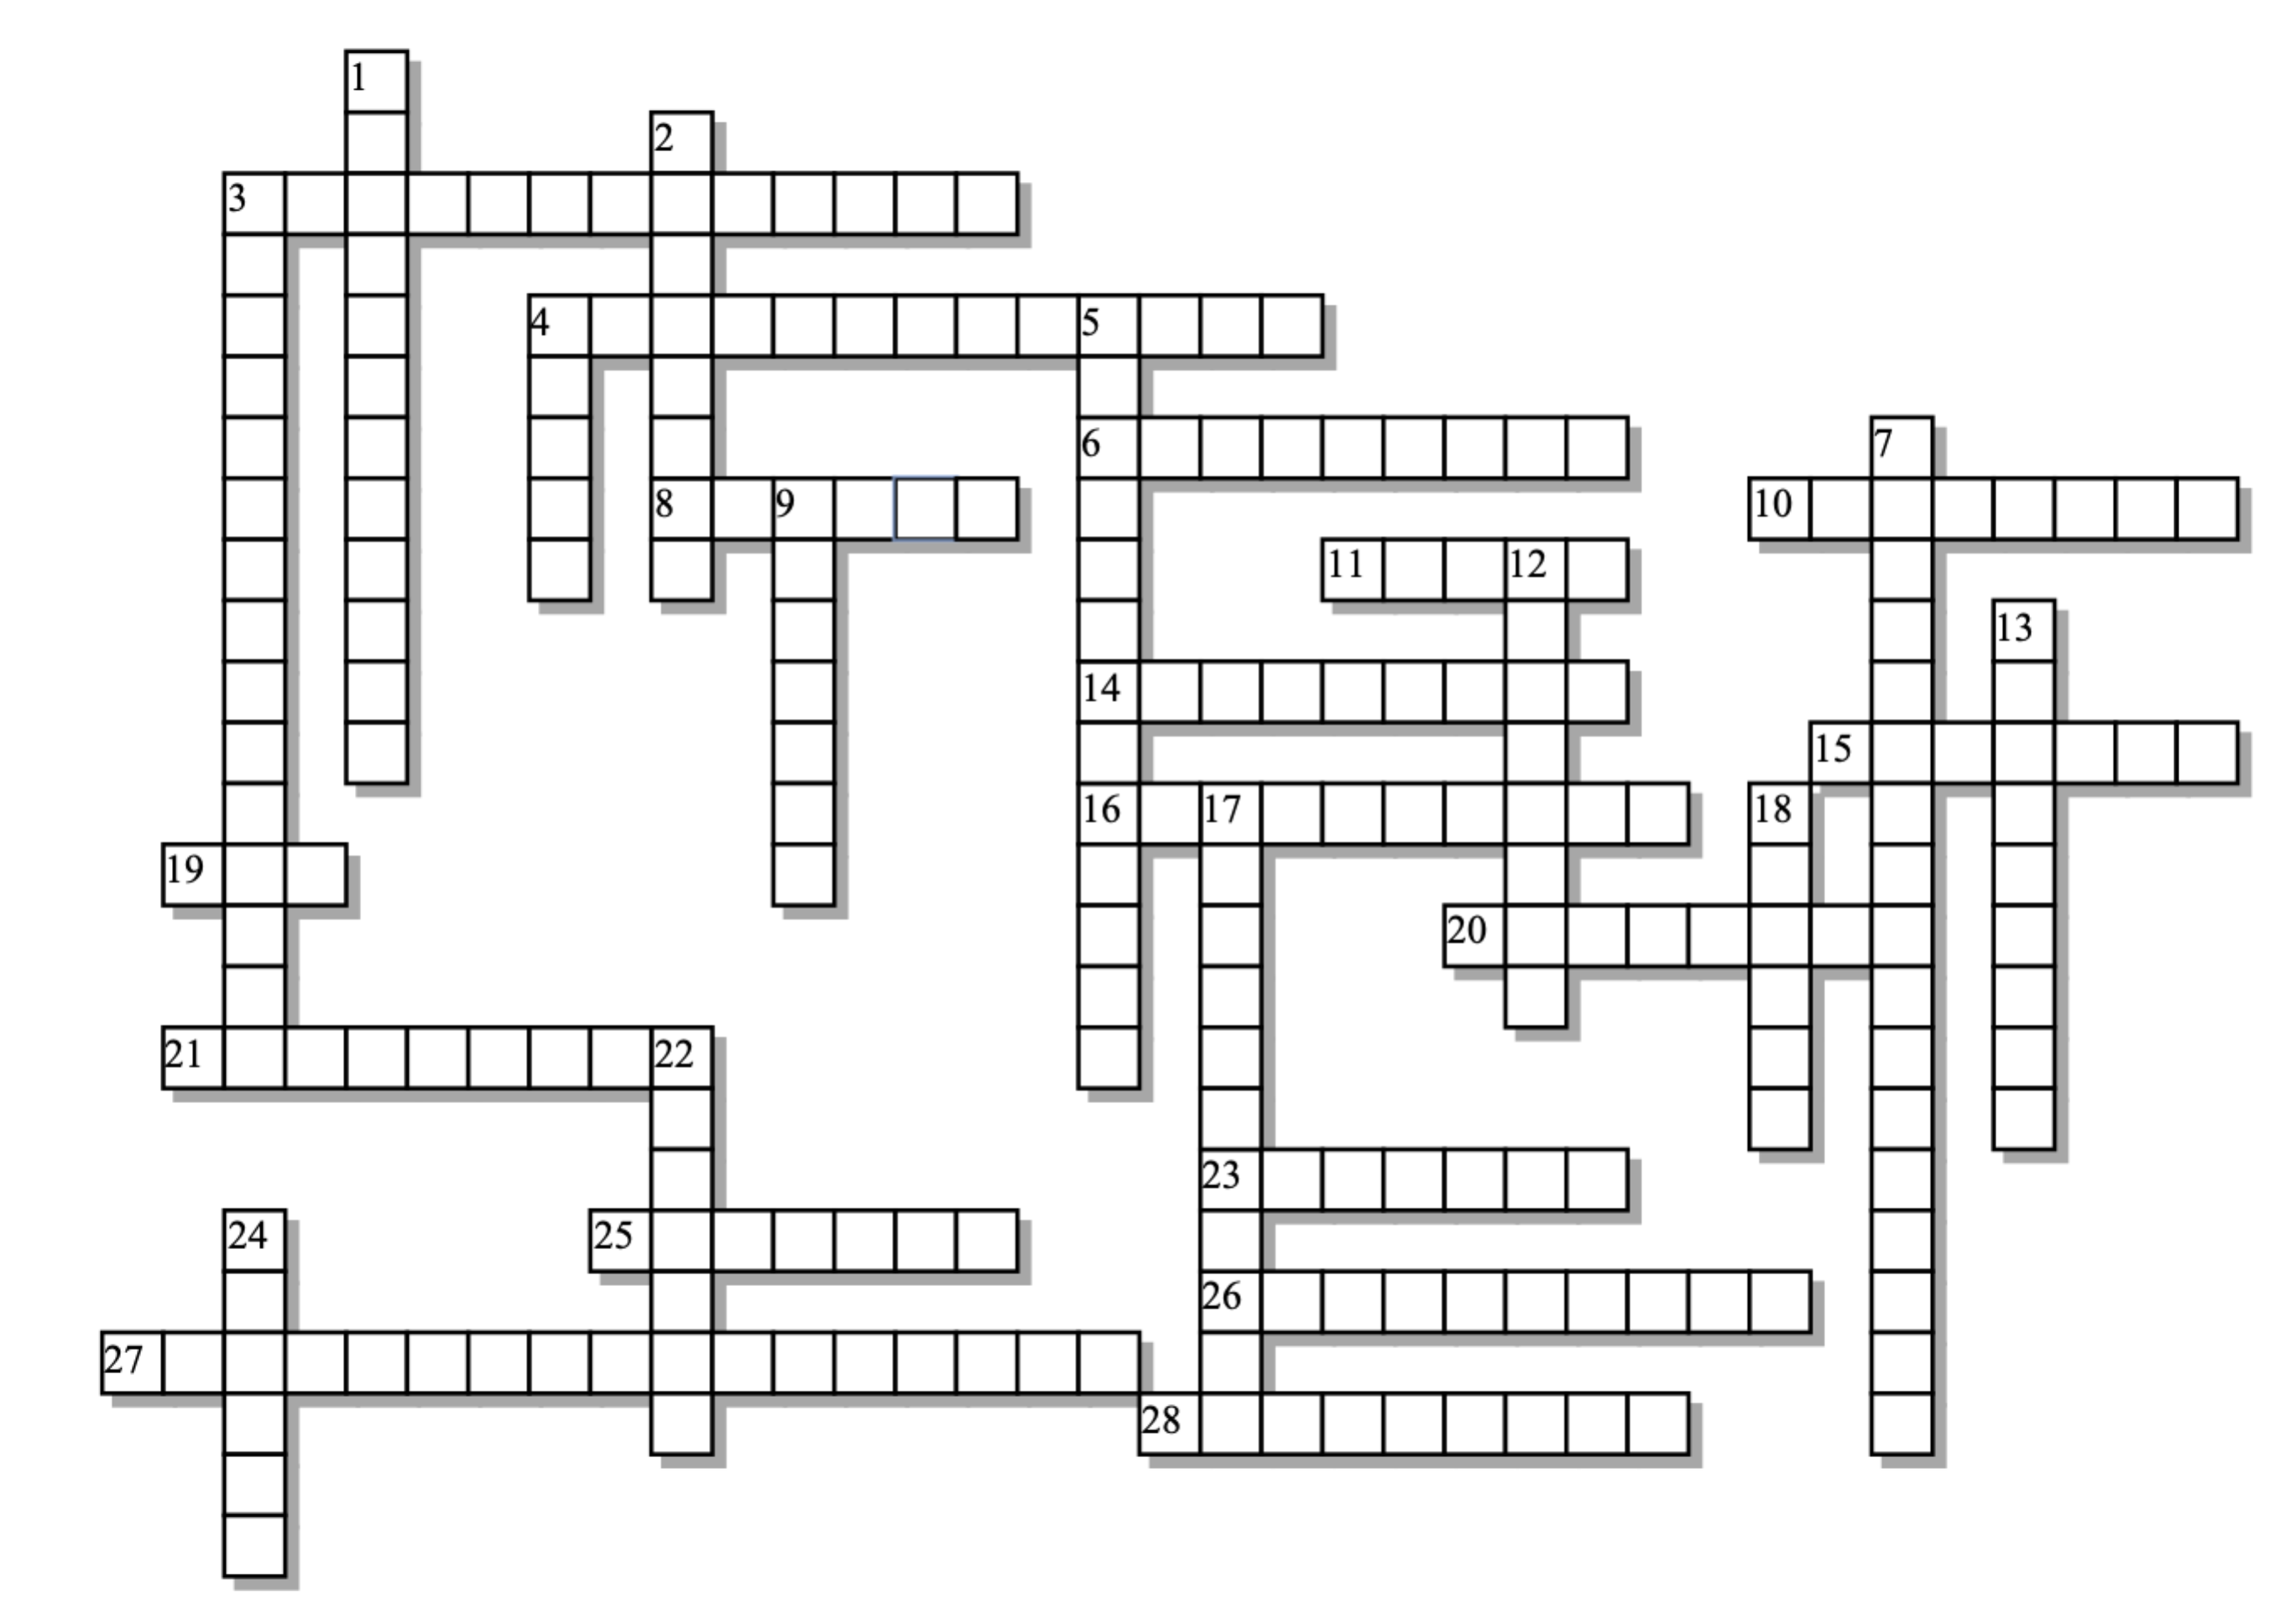

Across: | Down:
3 - Cytoplasmic bridges between adjacent plant cells.  4 - One signal activates millions of enzymes.  6 - When a cell signals itself.  8 - cAMP is this kind of messenger  10 - This kind of muscle gets more blood in response to fighting or fleeing  11 - If a ligand is like this, it won't get through the phospholipid bilayer  14 - Make up about 30% of all human proteins  15 - This kind of hormone binds with cytoplasmic receptors after diffusing through the membrane  16 - Substances produced by one organism that effect the physiology or behavior of others.  19 - Attaches to a G-protein after the receptor binds.  20 - A polysaccharide that can be broken down to glucose when the body needs energy.  21 - Signaling via hormones that move through the blood.  23 - Produced in a gland, diffuses into the blood, and affects only certain target cells.  25 - The last name of the enzyme that creates cyclic AMP  26 - This long, tubular digestive organ gets less blood in response to fighting or fleeing.  27 - Converts cAMP into AMP  28 - This first phase occurs when a ligand binds with a protein that has a complementary shape. | 1 - The process of converting a message into another form.  2 - The last step in cell signaling. The "goal" of the process.  3 - What kinases do to proteins to turn them on.  4 - This kind of helix embeds the G-coupled protein receptor in the membrane.  5 - Once steroids bind with receptors, they form a complex that can promote ____________ of genes.  7 - The local chemical signals sent from a neuron to its target.  9 - A waterfall. Or, when one kinase activates a second, then a third, and so on.  12 - The glands that produce epinephrine  13 - When a cell signals cells that are nearby  17 - A key hormone in the fight or flight response  18 - A general term for something that binds with a receptor  22 - Often the final response of a pathway involves activating _________.  24 - _______ sensing systems involve signals that depend on population density.

Possible Answers: GTP, adrenals, alpha, amplification, autocrine, cascade, cyclase, endocrine, enzymes, epinephrine, glycogen, hormone, intestines, ligand, neurotransmitters, paracrine, pheromones, phosphodiesterase, phosphorylation, plasmodesmata, polar, quorum, reception, receptors, response, second, skeletal, steroid, transcription, transduction

