Name: ______________________________ Period: _____ Date: ________

sciencemusicvideos Evidence for Evolution: Student Learning Guide
Getting to the tutorials:
- Go to www.sciencemusicvideos.com. Use the College Bio, AP Bio, or Learning Guide Menus to find “Evidence for Evolution.”

Tutorial 1. Evidence for Evolution: Claims and Historical Observations
1 and 2. Read the introduction and section 2, “Theory and Hypothesis.”
After the reading, take the “Theory v. Hypothesis” Quiz. Check this box when you’re finished. ☐
3. Read “What claims does the theory of evolution make .”☐
CHECKING UNDERSTANDING: In your own words, explain how the scientific meaning of the word theory is different from the word hypothesis.

SUMMARIZE: In the space below, describe the two claims that evolution makes.

4. Read, “Observations of Evolution in Recent Times.” As you do, complete all of the embedded quizzes and interactive readings. ☐
Extension: If you’re interested (or if it’s assigned by your teacher), read one or more of the suggested readings.
5. Complete the cumulative quiz “Historical Examples of Evolution.”☐
SUMMARIZE: In the space below, write brief summarize of the following. As you do, explain each of the diagrams.
a. Antibiotic resistance in bacteria
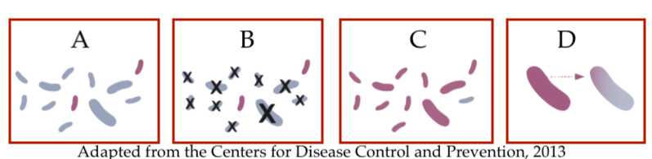

b. Pesticide resistance in Mosquitoes
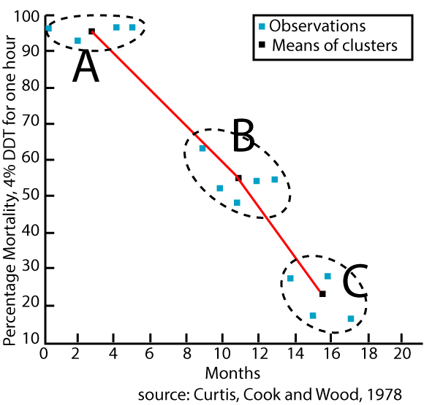

c. Evolution of new phenotypes in the soapberry bug
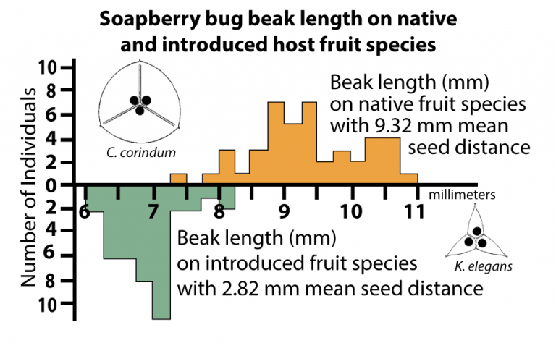

Click the link to Homologous and Vestigial Structures
Tutorial 2. Homologous and Vestigial Structures as Evidence for Evolution
1a. Read “Adaptive radiation results in differentiation.” This includes the interactive reading, “Adaptive radiation and descent with modification.” ☐
1b. Read “Differentiation from a common ancestor results in homologous structures.”
1c. Take the quiz, “Homologous Traits.”
CHECKING UNDERSTANDING: Use the space below to explain the evolutionary biology connected with each of the following diagrams. Create a descriptive title for each image.
Image 1:_________________________________
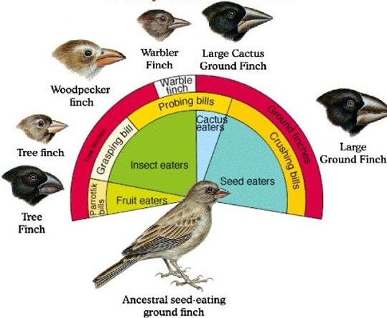

Image 2:_________________________________
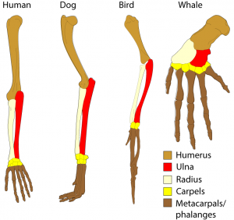

Image 3: _________________________________
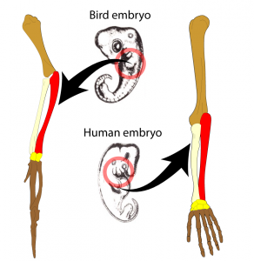

Image 4: _________________________________
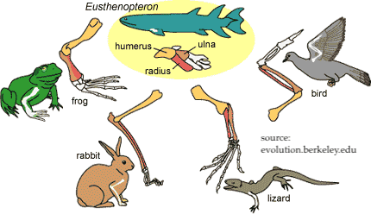

2a. Read “Vestigial Traits, the Case of the Blind Cave Tetra.” ☐
2b. Read “Additional Examples of Vestigial Traits” ☐
2c. Complete the “Vestigial Traits Quiz.”

SUMMARIZING TASK 1: Respond to the prompts below.
- Explain the evolution of blindness in cave fish.

- Explain the evolution of vestigial leg bones in whales.

- Identify two human vestigial traits. In the space below, explain how they evolved.

SUMMARIZING TASK 2: Explain the connection between homologous traits and adaptive radiation.

SUMMARIZING TASK 3: Explain why all vestigial traits are also homologous traits, but why the reverse is not true.

Continue to the next tutorial: The Fossil Record, Biogeography, and Convergent Evolution
Tutorial 3. The Fossil Record and Biogeography
1. Read “How Fossils are Formed.” ☐
2. Read “Knowing the Age of a Fossil.” ☐
3. Read “The Fossil Record as Evidence for Evolution.” ☐
4. Take the quiz “Fossils as Evidence for Evolution.” ☐
CHECKING UNDERSTANDING:
a. Explain how fossils form:
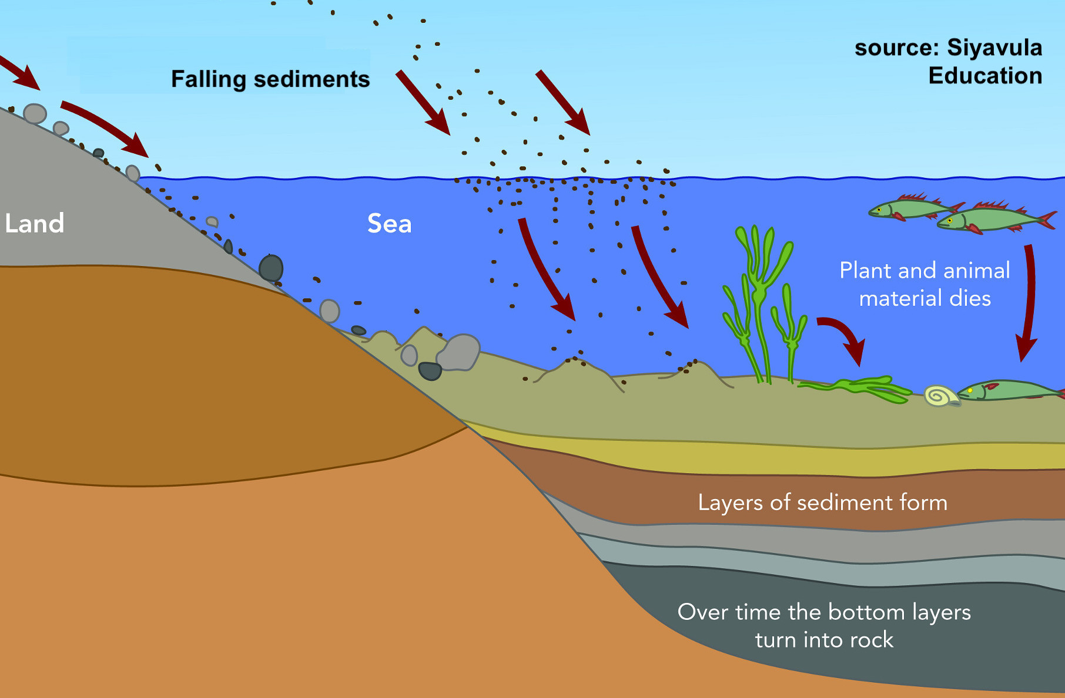

b. Compare and contrast absolute dating and relative dating. In your answer, explain radiometric dating and superposition.
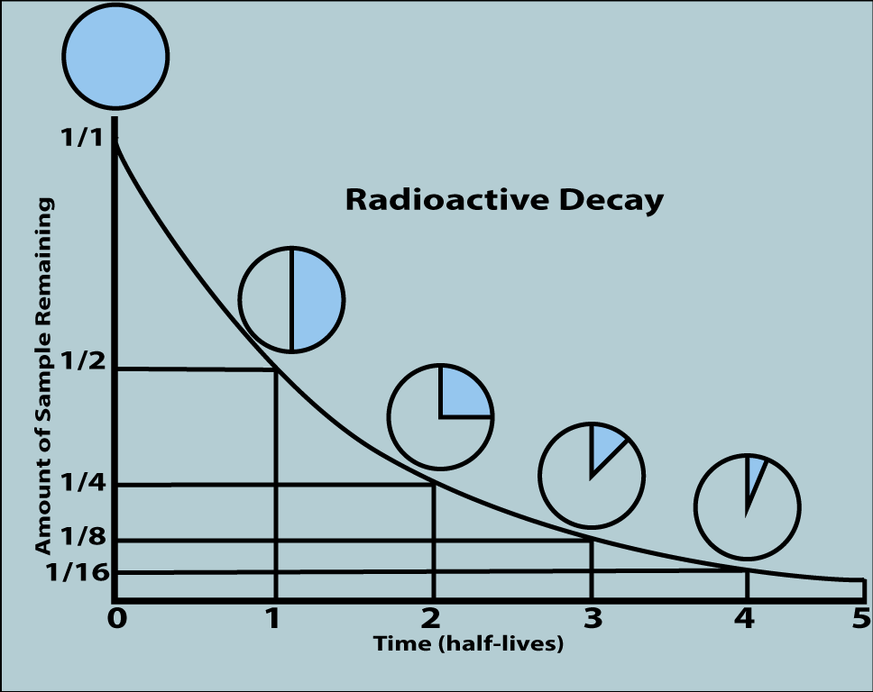 | 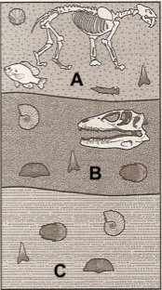

c. Explain how transitional fossils provide evidence for evolution. In your explanation, list 2 specific examples.

5. Read “Biogeography: Convergent Evolution and More Adaptive Radiation.” As you do, complete the “Mystery Succulent” Activity (and read the rest of this passage) ☐
5b. Read “Convergent evolution happens when....” As you do, take the “Homology or Analogy” quiz ☐
SUMMARIZE:
Task 1: Are the wings of bats and birds homologous or analogous? Explain.
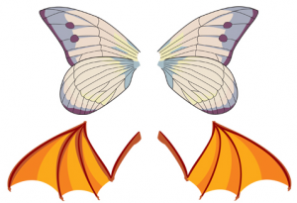

Task 2: Are the forelimbs of humans and dolphins homologous or analogous? Explain

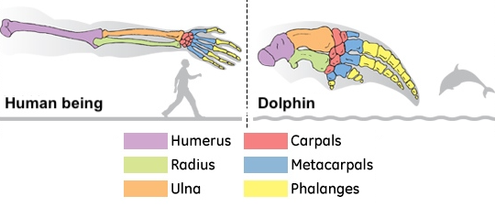
5c. Read “More Biogeography: Life on Oceanic Islands.” This includes the interactive reading, “Explaining the biology of Remote Oceanic Islands.” ☐
6. Take the quiz: Biogeography and Convergent Evolution.”
SUMMARIZE
a. How is life on oceanic islands unique?

b. Explain the evolution of the Hawaiian Honeycreepers
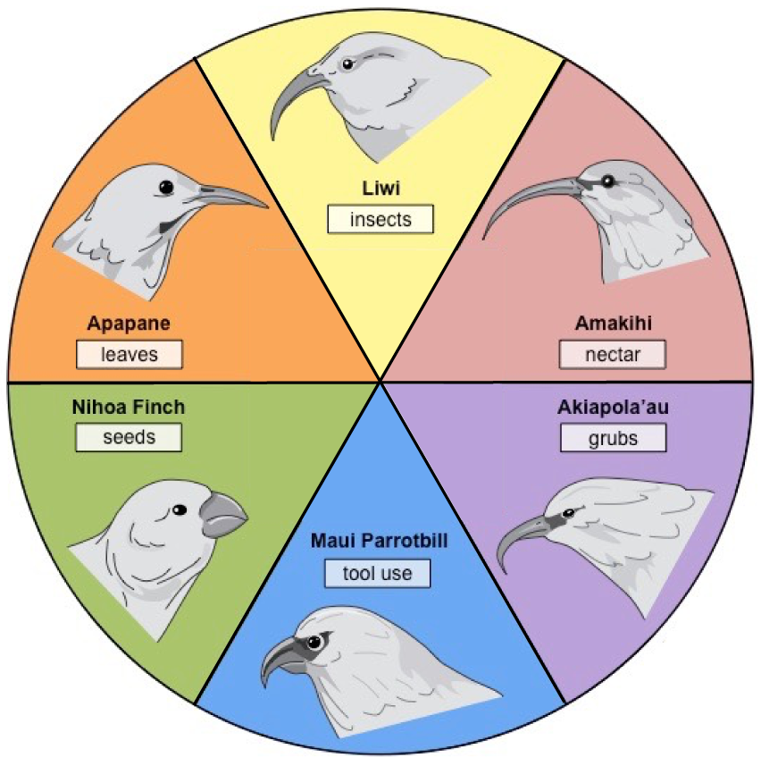

c. Explain how the following concepts connect to island biogeography: adaptive radiation, homology, and descent with modification.

Click the link to “Developmental and Molecular Homologies”
Tutorial 4. Developmental, Molecular, and Genetic Evidence for Evolution
1 and 2. Read the Introduction, then continue reading “Embryology as Evidence for Evolution” ☐
3. Read “Molecular Homologies.” As you do, complete the interactive reading, “Molecular Homologies and Evolution.” ☐
CHECKING UNDERSTANDING:
a. Explain how the diagram below is evidence for evolution. Use the terms adaptive radiation, homologous trait, and vestigial trait in your response.
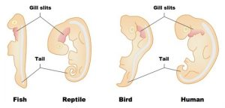

b. Explain how this data about cytochrome c is evidence for evolution.
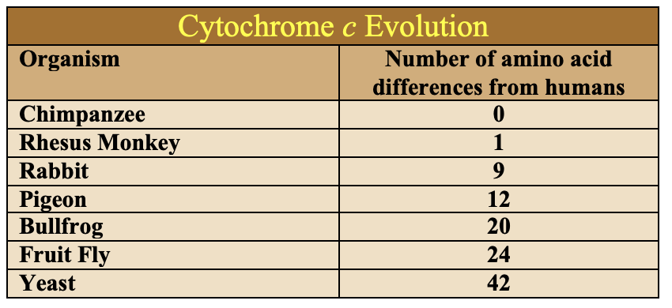

4. Read “Genes can also be homologous and vestigial” ☐
5. Complete the Quiz: “Embryonic and Molecular Evidence for Evolution” ☐
6. Read “The Deepest Homologies.” As you do, complete the quiz, “We’re all Cousins.”☐
CHECKING UNDERSTANDING:
a. Explain how the hox genes, shown below, serve as evidence for evolution.
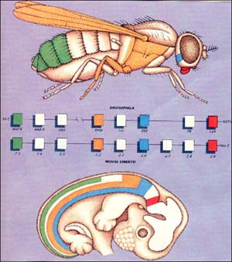

b. List and describe the traits that provide evidence for a common ancestry for all life.

c. List and describe the traits that provide evidence for common ancestry for all eukaryotes.

TUTORIAL 5: CUMULATIVE QUIZ
Follow the link to the “Evidence for Evolution Cumulative Quiz,” and complete the quiz.

SUMMARY OF SUMMARIES: You’re at a park, talking to an acquaintance who says “I don’t believe in evolution. It’s just a theory. There’s no evidence for it.”
What would you say in response. Take your time, and don’t hold back. In your response:
a) Explain what it means for an idea to qualify as a scientific theory.
b) Describe and explain the evidence for evolution. Include a discussion of:
1. Observations of evolution in historical times
2. Homologous and vestigial features
3. Fossils
4. Biogeographical evidence
5. Embryological evidence
6. Molecular evidence
7. Genetic evidence.

Biology | sciencemusicvideos | Name:________________________
Evidence for Evolution
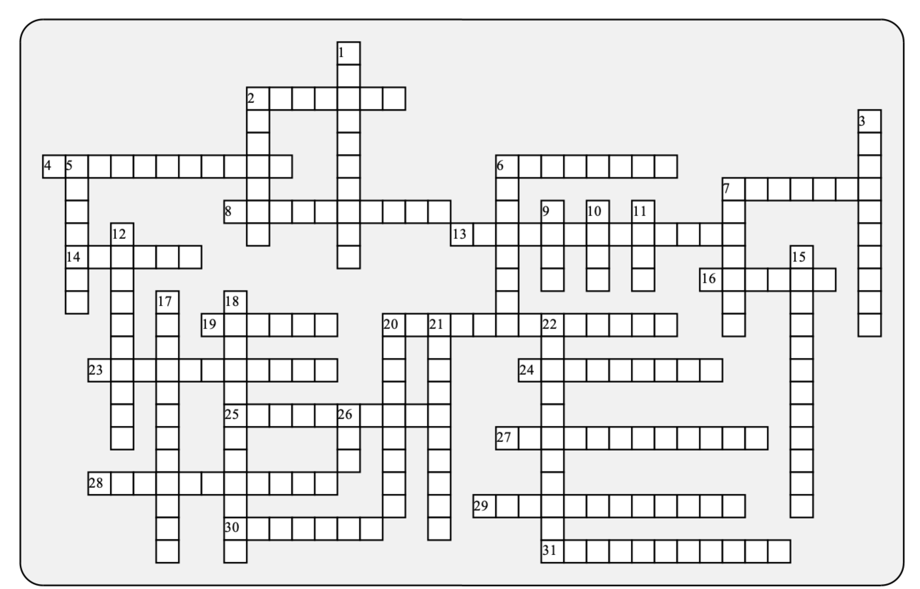

Across: | Down:
2 - The type of species found only in one place. These are very common on islands.  4 - A public health risk has been generated by our overuse of antibiotics in _____________.  6 - One of the deepest ideas of biology: all living things share a common ______________.  7 - Isolated chains of __________ are great places for adaptive radiation.  8 - Bacteria can transfer genes to others in their population through ________gene transfer.  13 - The principle that the older fossils are in the deeper layers of rock.  14 - A well established, tested principle that's supported by a huge body of evidence  16 - A remnant, impression, or trace of an organism from the past that's preserved in the Earth's crust.  19 - The remnant of our tail, which sometimes becomes irritated when we fall on our behinds.  20 - A famous fossil of an early bird  23 - The kind of dating that's based on the half-life of radioactive elements.  24 - ____________traits have lost their original function (and might not have any function at all).  25 - This molecule, part of the electron transport chain, is a great benchmark for evolution.  27 - The study of the distribution of species on our planet.  28 - Many mysteries connected to the distribution of past and present life are solved if one considers this kind of drift.  29 - _________ fossils show an ancestral species in the process of evolving into its descendants.  30 - IIf it looks like a cactus, but it's not, it's probably a _______________.  31 - The only type of rock in which fossils form. | 1 - Structures derived from a common ancestor, often with different functions.  2 - These often show vestigial features that can't be seen in adults.  3 - This kind of fish is rarely found on islands.  5 - Evolution changes a population's ____________ makeup.  6 - This kind of radiation creates new species.  7 - A type of rock that can be used for estimating the age of a nearby fossil.  9 - A bacterial strain that most antibiotics can't stop.  10 - The soapberry bug has quickly evolved new phenotypes as it has adapted to the fruit of new _________ plants.  11 - Tiktaalik is a species that was midway between __________ and tetrapod (four-limbed) vertebrates.  12 - Many insect populations have developed __________ to pesticides.  15 - The endosymbiotic organelle that makes a eukaryote a eukaryote.  17 - Evolution is supported when we see evidence of descent with ___________.  18 - A family of birds that's the Hawaiian version of the Galapagos finch.  20 - Features that share the same function, but aren't the result of common ancestry.  21 - Evolutionary change which results in superficially similar forms evolving independently.  22 - Genes that have lost their function, and are no longer expressed.  26 - Highly conserved genes that control aspects of animal development.

Possible Answers: Archaeopteryx, Embryos, Euphorb, Horizontal, MRSA, adaptive, agriculture, analogous, ancestor, biogeography, coccyx, continental, convergent, cytochrome, endemic, fish, fossil, freshwater, genetic, homologous, honeycreeper, host, hox, igneous, islands, mitochondria, modification, pseudogenes, radiometric, resistance, sedimentary, superposition, theory, transitional, vestigial

