Name: _____________________ Period: _____ Date: _________________

sciencemusicvideos Feedback, Animal Homeostasis, Student Learning Guide
Instructions:
Getting to the tutorials.
- Go to www.sciencemusicvideos.com; Use the College Bio, AP Bio, or Learning Guide Menus to find “Animal Developement”

Tutorial 1: Key Concepts, Thermoregulation
1. Read “Introduction: What is Homeostasis?” ☐
2. Read “Regulators and Conformers” ☐
3. Complete the Quiz: “Homeostasis, Regulating, and Conforming” ☐
Mastering the Terms
Write out definitions for
- Homeostasis:
- Regulator:
- Conformer:
- Ectotherm:
- Poikilotherm:
- Endotherm:

4. Read “Adaptations for Body Temperature Regulation.” ☐
Write brief descriptions of each of the following adaptations:
a. Insulation

b. Evaporative Cooling
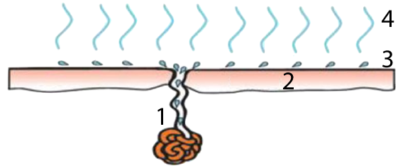
c. Vasodilation and vasoconstriction
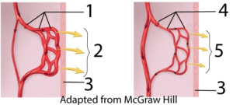
d. Countercurrent exchange
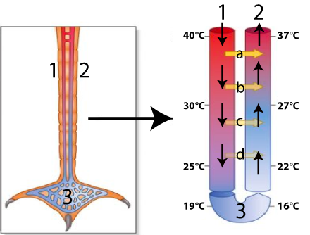
Adapted from All About Birds, Cornell University

e. Thermoregulation related to surface area

f. Behaviors for thermoregulation

5. Read “Body Temperature...is Regulated by Negative Feedback.” ☐
6. Take the quiz, “Homeostasis, Negative Feedback, and Thermoregulation.” ☐
7. Read “Positive Feedback...” ☐

Checking Understanding
a. As a way of demonstrating your understanding about negative feedback and antagonistic effectors, explain how a home heating/cooling system works to maintain a constant temperature. Cover all letters and numbers in the diagram.
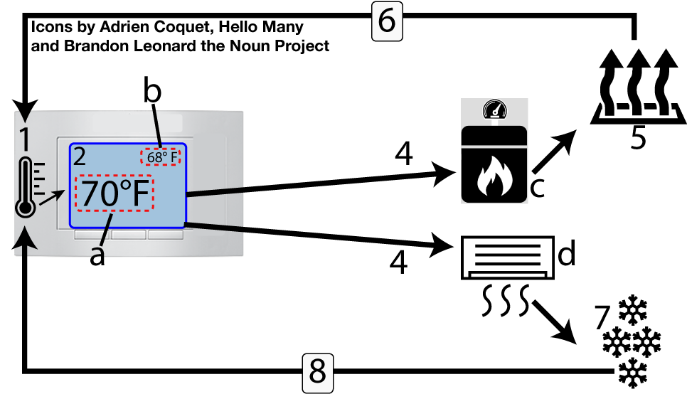

b. Now, explain how the hypothalamus can use heating and cooling mechanisms to maintain body temperature at a homeostatic set point in homeotherms like birds and mammals. Include all parts in the diagram below (even the ones that don’t have a letter, such as the hypothalamus).
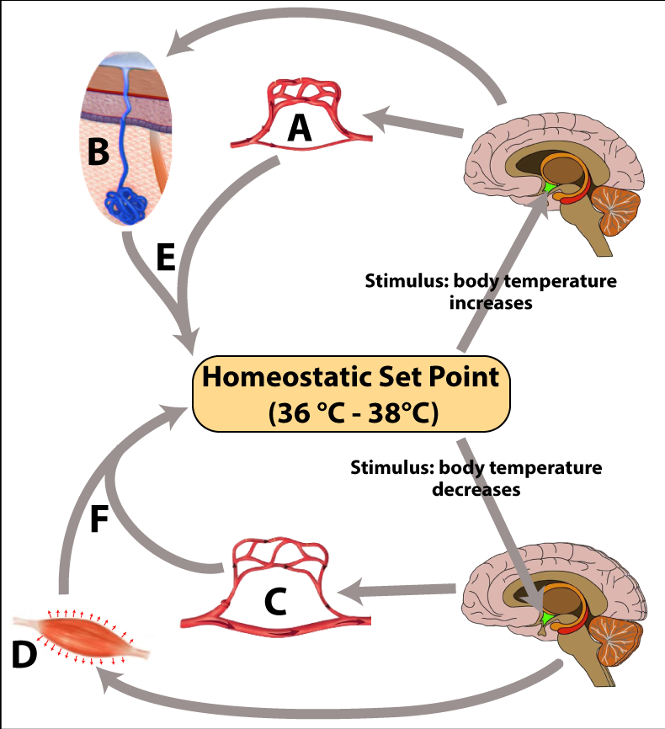

Click the link to continue to the next tutorial.
Tutorial 2: Blood Glucose Regulation
1. Read the introduction: “Regulating Blood Glucose.” ☐
2. Read “Glucose Regulation: Setting the Context.” ☐
Checking Understanding
1. What’s a normal range for blood glucose concentration?

2. What organ controls blood glucose concentration?

3. Most of the pancreas is ____________ tissue, the function of which is to

3. The Beta cells are found in the __________ of ____________. Their function is is to release ___________, which...
4. The alpha cells release ______________, which ...

3. Read “Insulin,” including the two subsections, “3a, Control of Insulin Release,” and “3b, Insulin’s Effect...” ☐
4. Take the quiz, “Insulin, Checking Understanding.” ☐
Checking Understanding
TASK 1: Predict what hormones would be released at points B, C, and D in the graph below. Justify your prediction.
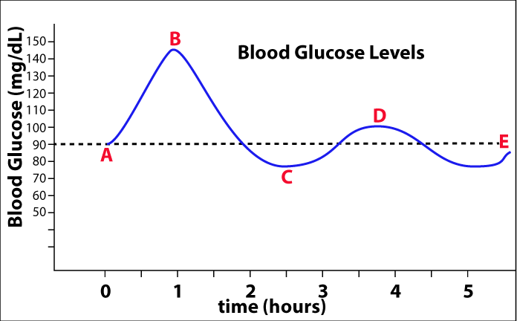

TASK 2: Explain what’s happening in steps 1-8 of the diagram below.
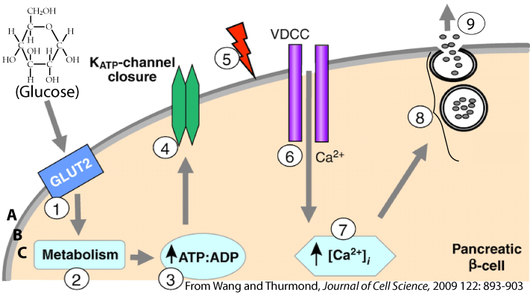

TASK 3: Write a paragraph explaining how insulin effects its target cells. Be sure to explain each part of the diagram (a – j). Write small.
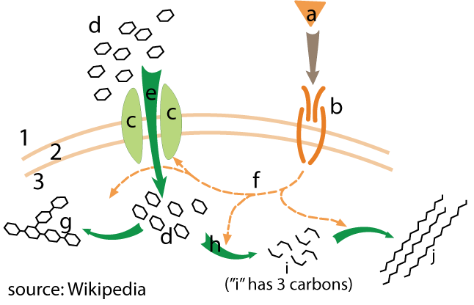

5. Read “Glucagon.” ☐
6. Take the “Insulin and Glucagon” quiz. ☐
Checking Understanding
TASK 1: Use the space to the right of and below the following diagram to explain how the pancreas uses insulin and glucagon to maintain blood glucose homeostasis.
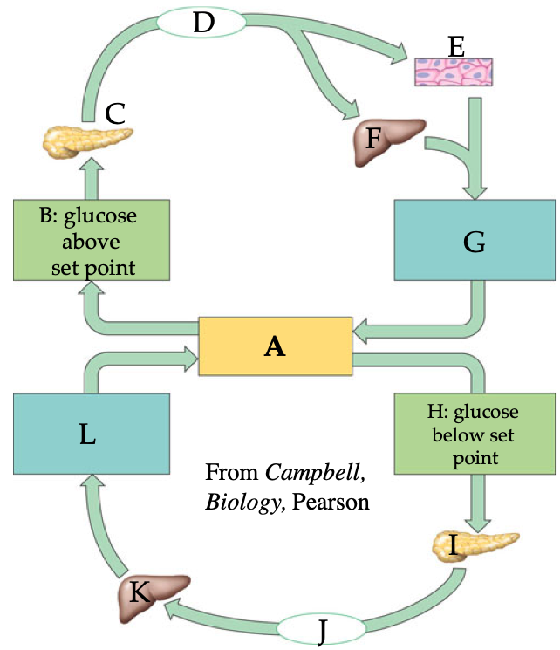

TASK 2: Use the space to the right and below the diagram to explain how glucagon works upon its target cells. Write small.
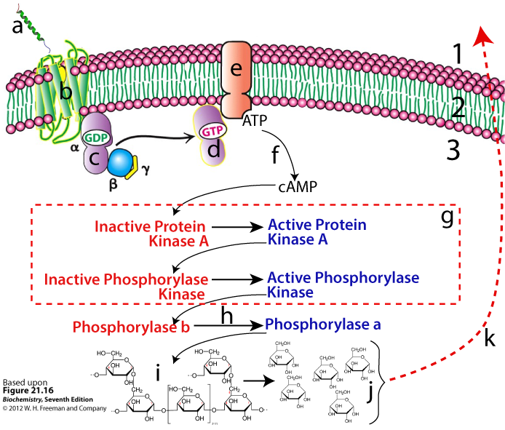

7. Read “Understanding Diabetes.” ☐
8. Take the “Diabetes (and Related Topics)” Quiz ☐
APPLYING WHAT YOU’VE LEARNED
TASK 1 : Imagine that your six year old cousin has just been diagnosed with juvenile diabetes. Talk him or her through the diagram below to explain what happened.:
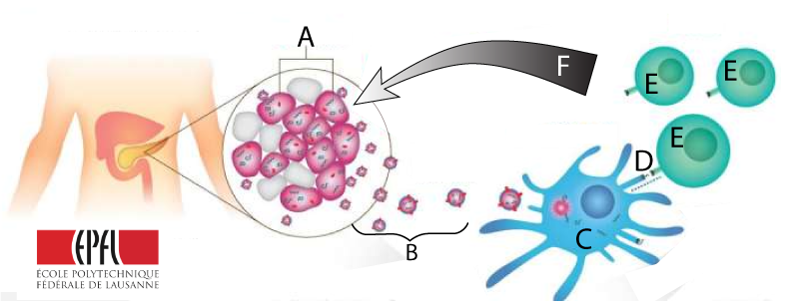

TASK 2: Imagine that your 45 year old uncle or aunt has just been diagnosed with type 2 diabetes. Their biology has become a bit hazy, so sit down with them and walk them through the diagram below.
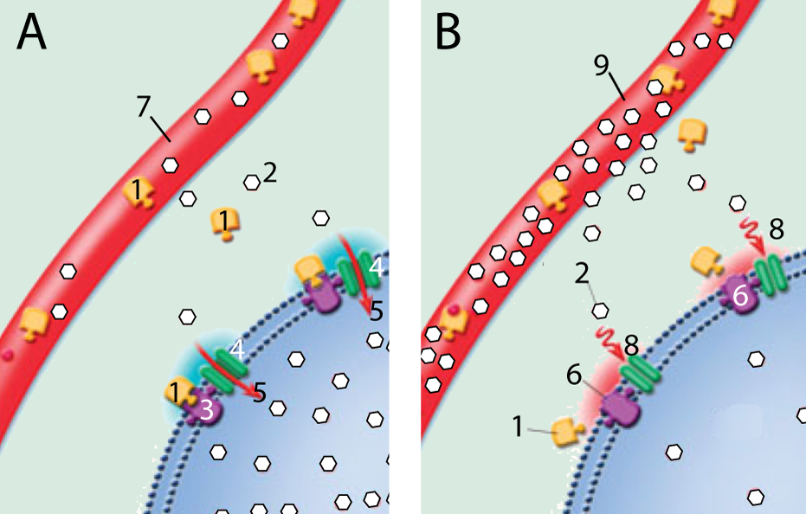

TASK 3: You overhear some friends talking about how a mutual acquaintance was just diagnosed with diabetes (type 1). One friend says, “I’ve never understood why being a diabetic makes you urinate so much. “ Explain it. Write small.
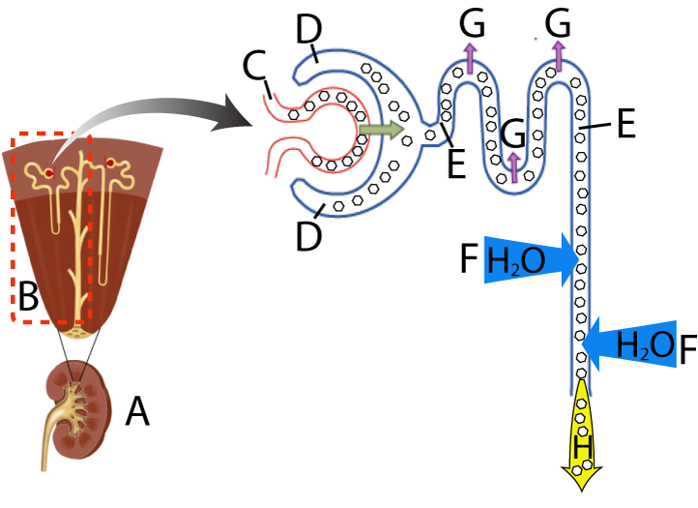

Follow the link to the next tutorial
Tutorial 3: ADH and Osmoregulation
1. Read “ Introduction:: Animal Bodies Need to Provide...”☐
2. Read “Osmoregulation is Controlled by the =...” ☐
CHECKING UNDERSTANDING: You drink a big glass of water. How does that affect your blood’s osmolarity. Explain.

3. Read “ADH Reduces Loss of Water in the Nephron’s Collecting Duct” ☐
4. Take the quiz “ADH and the Nephron Tubule”
Checking Understanding
TASK 1: Create a key for the diagram below.
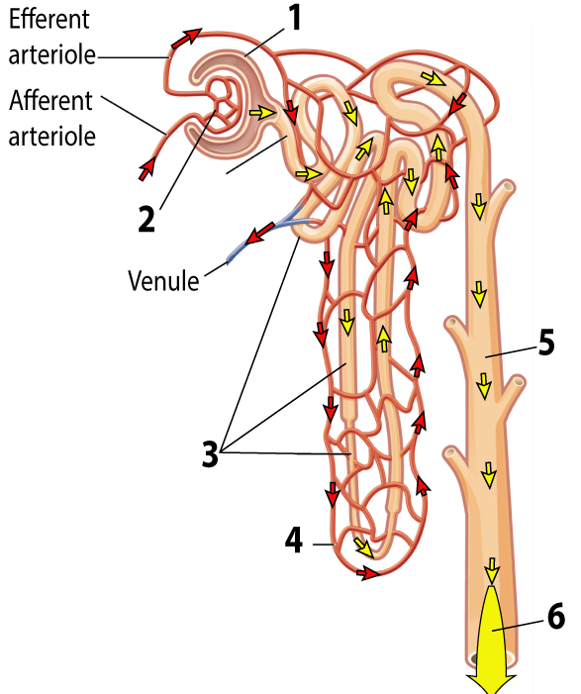 | 1.  2.  3.  4.  5.  6.
TASK 2: Create a key for this diagram
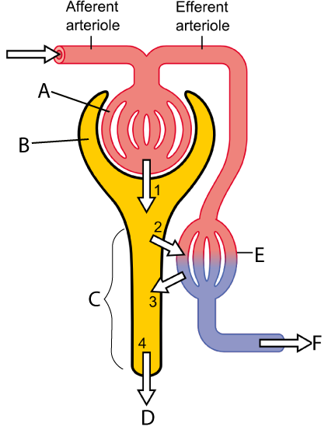 | A.  B.  C.  D.  1.  2.  3.  4.
TASK 3: Using the diagram above, explain how ADH 1) stops blood osmolarity from decreasing, and 2) creates a concentrated, darker urine.
5. Read “Some Final Points about OsmoregulationL Aquaporins, and Thirst.” ☐
6. Take the quiz “ADH and Osmoregulation”
Checking Understanding
TASK 1: Make a key to the diagram below
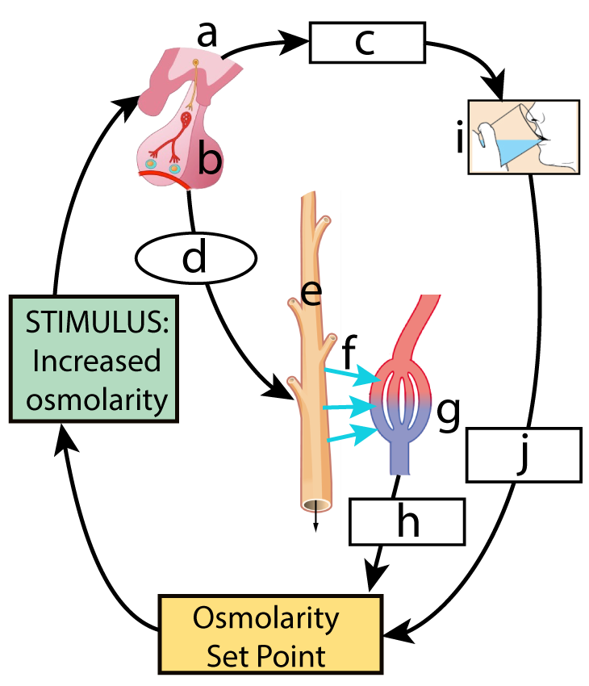 | a.  b.  c.  d.  e.  f.  g.  h.
TASK 2: Using the diagram above, predict what would happen to the volume and color of your urine if you ate a very salty meal. Justify your explanation.

TASK 3: Explain how aquaporins work to alter your blood osmolarity and urine:
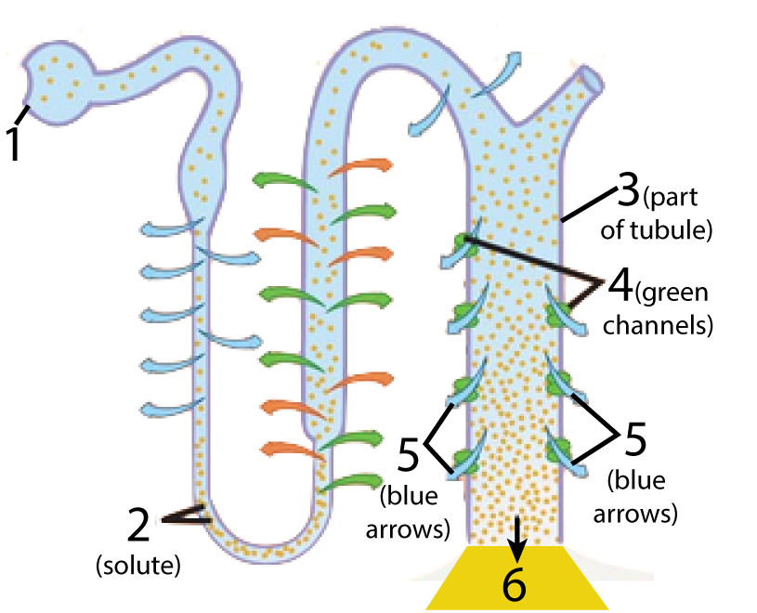

sciencemusicvideos | AP Biology | Name:________________________
Animal Homeostasis: Thermoregulation, Blood Sugar, Osmoregulation
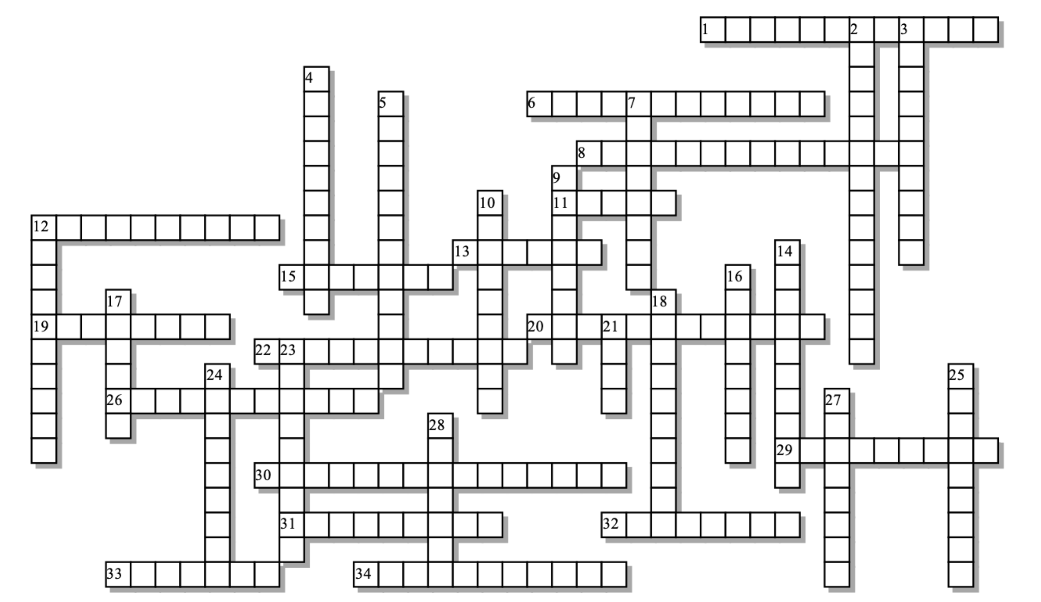
Across: | Down:
1 - A body temperature conformer.  6 - When blood is allowed to flow close to the skin, allowing heat from the blood to radiate out of the body  8 - How arteries and veins are organized to minimize heat loss.  11 - The primary organ that stores glucose as glycogen.  12 - The type 1 form of this sugar-related disease is brought about by an ___________ reaction.  13 - When you eat this polysaccharide, insulin is released.  15 - The hormone that lowers blood glucose levels.  19 - In this kind of feedback system, the output of the system amplifies the system's activity.  20 - One effect of ADH is to create more _______________ urine, which preserves the body's water.  22 - These capillaries reabsorb water from the nephron tubule.  26 - Sweat and panting are forms of ______________ cooling.  29 - An organism that, for a specific physiological variable, works to keep that variable within a narrow, constant range.  30 - This type of cascade mobilizes enzymes in liver cells to convert glycogen to glucose  31 - In the type 2 form of this disease, cells become insulin ____________.  32 - An organ that's both a digestive gland and an endocrine gland that controls blood glucose levels.  33 - The functional unit of the kidney  34 - Maintaining internal stability, even in the face of external change | 2 - The general term for maintenance of the composition of body fluids, especially blood  3 - When your blood is too ________________, ADH is released.  4 - ADH acts by increasing reabsorption from the nephron's ___________ duct  5 - A part of the brain that senses and controls many homeostatic variables, including temperature and osmolarity.  7 - A substance that increases the flow of urine  9 - The hormone that increases blood glucose levels  10 - This gland releases many hormones, including one that acts upon the kidneys for osmoregulation  12 - Protein channels that allow for osmosis  14 - A body temperature regulator  16 - An inability to control blood glucose levels  17 - The key osmoregulatory organ  18 - Blubber and fur are both examples of  21 - Whereas glucagon is the ligand, this is the second messenger.  23 - An organism whose body heat comes from the outside environment  24 - An organism that, for a specific physiological variable, allows that variable to fluctuate with the external environment.  25 - An organism whose body heat is generated internally, from cellular respiration  27 - In this kind of feedback system, the output of the system works to turn the system down (or off).  28 - Elephant and jackrabbit ears provide lots of this kind of area, allowing for effective radiative cooling
Possible Answers: Surface, aquaporins, autoimmune, cAMP, collecting, concentrated, conformer, countercurrent, diabetes, diuretic, ectotherm, endotherm, evaporative, glucagon, homeostasis, homeotherm, hypertonic, hypothalamus, insulation, insulin, kidney, liver, negative, nephron, osmoregulation, pancreas, peritubular, phosphorylation, pituitary, poikilotherm, positive, regulator, resistant, starch, vasodilation

