Name: _____________________ Period: _____ Date: ________

sciencemusicvideos: Mitosis and the Cell cycle
Getting to the tutorials.
- Go to www.sciencemusicvideos.com; Use the College Bio, AP Bio, or Learning Guide Menus to find “Mitosis and the Cell Cycle”
- Start with “Mitosis and the Cell Cycle Quizzes.”

Tutorial 1: Mitosis and Cell Cycle Quizzes
1. If you haven’t already, watch the Mitosis! music video, and then try the Karaoke version. Then complete the interactive lyrics. Check the box below when you’re finished: ☐

2. Take the quiz, “Key Mitosis Concepts.”
☐

CONSOLIDATE: In the space below, briefly explain what’s happening in steps 1 through 4 below.
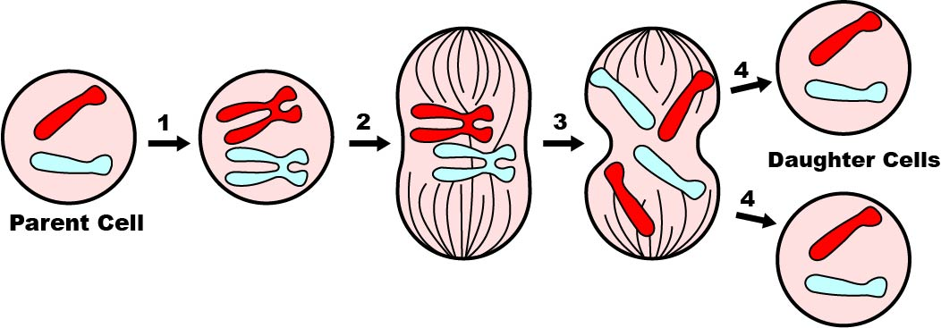

3. Take the quiz “Mechanisms of Mitosis”
☐
Create a key for this diagram
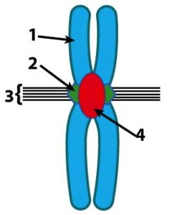

Now create a key for this diagram:
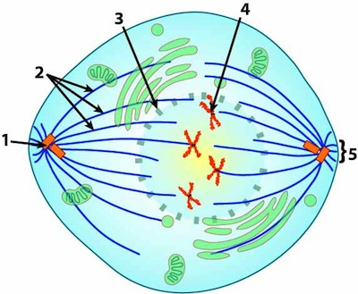 | 1  2.  3.  4.  5.
4-5. Take the quiz “Phases of Mitosis,” and “Another Mitosis Quiz.”☐
SUMMARIZING 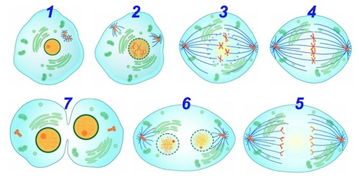
Describe what’s happening in each phase. Write small.

1

2.

3.

4.

5.
6.

7.

6. Take the “Cell Cycle” Quiz. ☐
Make a key for the diagram below. Explain what each numbered phase is called, and what is happening.
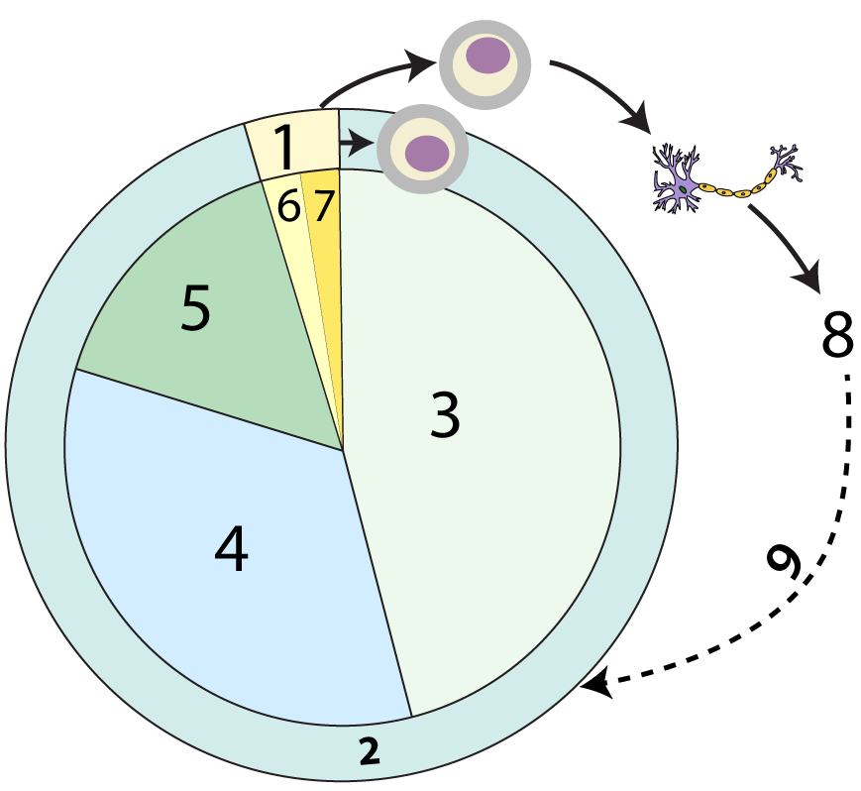 | 1.  2.  3.

4.
5.
6.
7.
8.
9.

PULL IT ALL TOGETHER: Your parents or guardians ask you what you learned in school today. You say “I learned how cells divide.” They say, “Oh really? How?” In the space below, explain it to them. Write small (stopping at the bottom of this column)

Tutorial 2: Regulation of the Cell Cycle
1. Read “Some cells never divide…” ☐
Describe the G₀ phase.

2. Read “It’s about molecular influences…” and take the embedded quiz in this section. ☐
Describe the results of Rao and Johnson’s cell fusion experiments. What did they establish?

3. Read “Cell Cycle Checkpoints” ☐
SUMMARIZE: What are cell cycle checkpoints?

4. Read “Cyclin and Cyclin-Dependent Kinases…” and complete the embedded quizzes in this section.
☐
Explain the functions of:
- Cyclins:

- Cyclin-dependent kinases:

- MPF:

5. Take the “Cell Cycle Regulation” quiz. ☐

Consolidate your learning: explain what’s happening in this diagram, and what it says about cell cycle regulation.
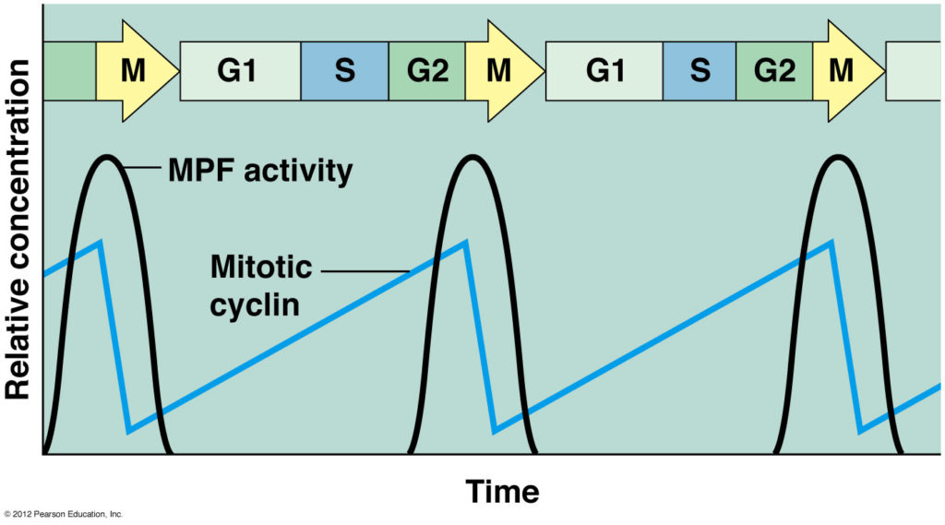

SYNTHESIZE: Write an explanation of what’s happening in this diagram. As you do, make sure you describe the function of each part in the diagram.
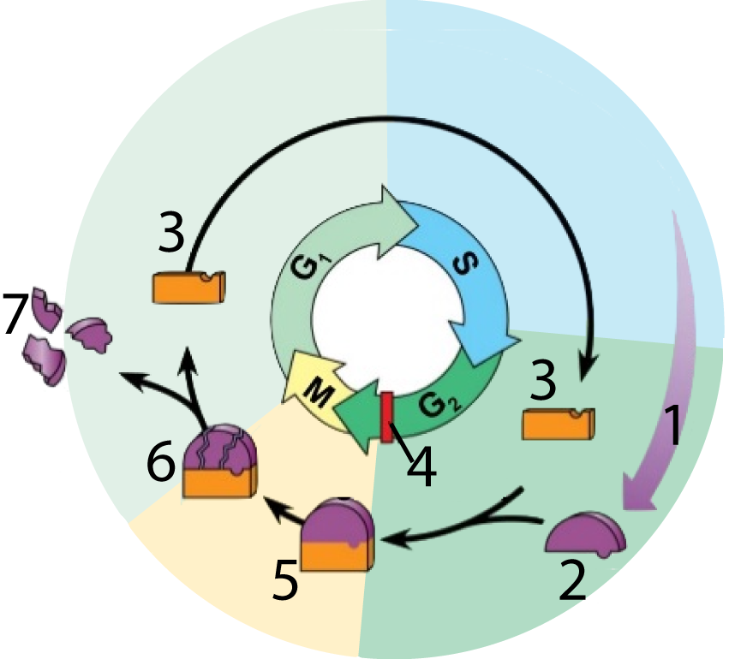

Biology | sciencemusicvideos | Name:________________________

Mitosis and the Cell Cycle Crossword
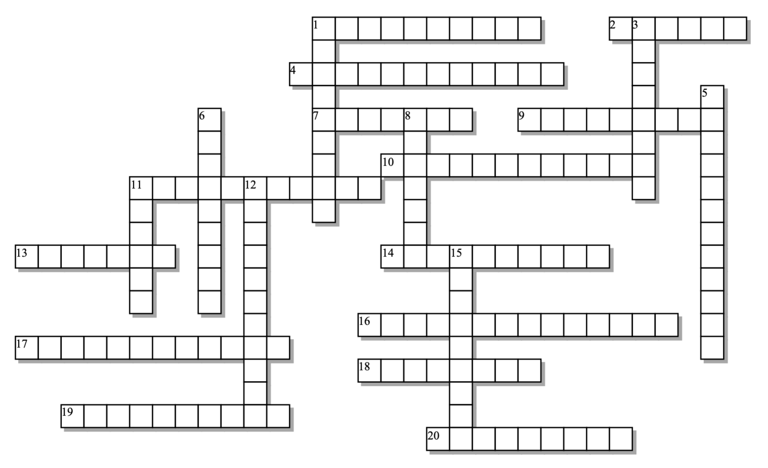
Across: | Down:
1 - The organelle that produces the spindle.  2 - A disease related to excessive cell division.  4 - When the nuclear membrane disintegrates and the centrosomes move apart  7 - Really just division of the nucleus, but sometimes used to refer to all of cell division  9 - When the chromosomes are lined up along the cell equator  10 - What the spindle fibers are made off  11 - ______________ of the genetic material happens during the "S" phase of the cell cycle.  13 - This membrane disintegrates during prometaphase  14 - Connects two chromatids  16 - A ring of this protein fiber is what pulls cells apart during cytokinesis  17 - The "handles" that the spindle fibers use to attach to chromosomes  18 - When the chromosomes condense and the nucleolus disappears  19 - Most of the cell's life is spent in this phase  20 - Vesicles with this polysaccharide are sent to a plant cell's equator to build a new wall to separate the daughter cells. | 1 - A pair of these sisters makes up a doubled chromosome  3 - When the chromosomes are pulled apart  5 - The function of cell division in unicellular organisms  6 - The ribosome factory that disappears during prophase  8 - An array of microtubules that manipulates and later separates the chromosomes  11 - A function of cell division that occurs in response to injury  12 - The moment when one mother cell becomes two daughter cells  15 - Two nuclei are found in one elongated cell during this phase

Possible Answers:
Anaphase, Cytokinesis, Replication, Telophase , cancer, cellulose, centromere, centrosome, chromatid, interphase, kinetochores, metaphase, microfilaments, microtubules, mitosis, nuclear, nucleolus, prometaphase, prophase, repair, reproduction, spindle

