Name: _____________________ Period: _____ Date: _________________

Biology Core Concepts: Student Learning Guide

Content in this module: Key Themes of Biology; Properties of Living Things; Structure Determines Function; Levels of Biological Organization; Scientific Method and Controlled Experiments
Interactive Tutorial Instructions:
- To access quizzes and flashcard decks, you’ll need to have set up an individual account or be registered as part of a class. You can set that up when you get to the first interactive activity (a flashcard deck) below.
- Push yourself toward total mastery, especially on the flashcards. If you don’t know the material on the card, make sure that you click need more practice.
- As you work, use the guide below to check off activities as you complete them.

Finding the tutorial: Go to www.sciencemusicvideos.com. Then use the AP Bio, College Bio, or Learning Guide Menu to find to the “Biology Core Concepts” Menu.”
I. AP Biology Themes and Big Ideas.
1. Complete the reading. When you get to the flashcards, sign in, and do your best. Put a checkmark in the following box when you’re finished.☐
CHECKING UNDERSTANDING:
Write short descriptions of each of biology’s big ideas:
- Evolution
- Systems and system interactions
- Information flow
- Energy and Matter Flow

2. Click the link for “Properties of Living Things.”

II. Properties of Living Things
1. Read the introduction. ☐
2. Complete the interactive reading: “Eight Properties of Living Things.” ☐
3. Complete the “Flashcards: Eight Properties of Living Things.” You and your partner should still be logged in. Repeat these flashcards as many times as you want until your satisfied with your score. Note that all you’re being graded on is completion (so be honest if you can’t define a term, and click “Need More Practice”
4. Complete the “Properties of Living Things” Matching Quiz. ☐
5. TOTAL RECALL
In the space below, without looking at notes or the webpage, try to list as many of the properties of living things as you can. Write small!

6. Click the link for “Structure Determines Function”
III. Structure Determines Function
1. Summarize the introduction.

2a. Describe the structure/function relationship in the needle nose pliers. Check your answer and correct/amend as necessary.

2b. Describe the structure/function relationship in the hand saw. Check your answer and correct/amend as necessary.

2c. Describe the structure/function relationship in the wrench. Check your answer and correct/amend as necessary.

3a and b. Read about the structure/function relationships in the human hand and in human teeth. ☐
3c. Describe the structure/function relationship in the bat’s wings. Check your answer and correct/amend as necessary.

3d. Describe the structure/function relationship in the bat’s ears. Check your answer and correct/amend as necessary.

3e. Describe the structure/function relationship in the talons of a bird. Check your answer and correct/amend as necessary.

3f. Describe the structure/function relationship in the feet of a duck. Check your answer and correct/amend as necessary.

APPLICATION: Use or imagination (or look around your classroom). Describe another structure/function relationship in the biological world.

Click the link for “Levels of Biological organization”

IV. Levels of Biological Organization
1. Read the introduction☐
2. Complete the “Levels of Biological Organization Vocabulary Matching.” ☐
3. complete the “Levels of Biological Organization Flashcards” ☐

Checking Understanding
Label the diagram below.
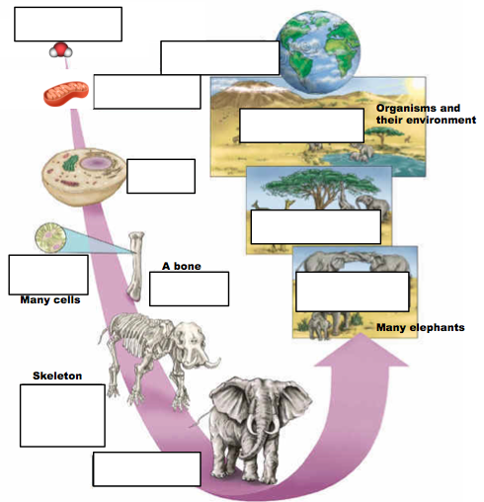
Click the link to proceed to “Understanding Controlled Experiments.”

V. Understanding Controlled Experiments
1. Do the matching activity for an introduction to (or a review of) the steps of the scientific method. Study the list as much as you need to. Check the box below when you are sure you know all the terms. ☐
2. Complete the “Interactive Reading: A case study: The Link Between Cancer and Smoking.” Check the box below when you’re done. ☐
SUMMARIZE: Write a very brief summary of what you learned in this section.

3. Read “Controlled Experiments: General Features. When you finish, take the multiple choice quiz (with the same title). ☐
4. Work on the flashcards that cover the vocabulary about the scientific method and controlled experiments. Be very strict with yourself. Only mark “Got it” if you really understand the term. Otherwise, give yourself more practice. ☐
5. Read “A controlled experiment to test the smoking/cancer connection. Most of this reading is in the form a multiple choice quiz. Click the box when you’re done. ☐
6. Read “What Happened Next” ☐
Write a brief summary of what you learned in this section.

7. Take the quiz entitled “The Scientific Method and Designing Experiments.” ☐
8. Complete the “Scientific Method Song, Interactive Lyrics” ☐
9. Pause and think about what you now understand about how experiments work. This should include everything you know (both from this tutorial, and from prior knowledge). Write your brief summary of your understanding in the space below.

EXTENSION: Once you finish all the work above, please read The Shameful Past: The history of the discovery of the cigarette-lung cancer link. You can find the link under “extra credit…”

Use the space below and on the next column to take notes and to write a short summary (required for credit)

sciencemusicvideos.com | Name:________________________
Biology: Core Concepts
1

2

3

4

5
6
7

8

9

10

11
12

13

14

15

16

17

18

19

20

21

22

Across: | Down:
2 - Dynamic maintenance of optimal internal conditions, despite environmental fluctuation.  3 - An individual living thing.  8 - A structure or behavior that aids in survival or reproduction  11 - In biological systems, structure _____________ function.  13 - All of the living populations in the same area  15 - Living things, from cells to entire organismss, are highly _____________.  16 - A group of connected cells with a common function  17 - Life is sustained by a constant flow of ____________, most of which originates with the Sun.  19 - The study of life  20 - You started life as a single cell. Now you're trillions of cells, exquisitely organized.  21 - Reflexes, learning, and the bending of a vine around a branch are all examples of ___________ to the environment.  22 - Living things are complex __________ with inputs, outputs, boundaries, components, and processes. | 1 - How living things have changed and diversified from earlier forms.  3 - A group of tissues joined as a unit to perform a function  4 - DNA is how genetic _____________ flows from parents to offspring.  5 - A group of atoms, chemically bonded together  6 - This type of selection was first identified and described by Charles Darwin and Alfred Russell Wallace  7 - Whereas energy flows through living systems and dissipates away as heat, the __________ that makes up living things is endlessly recycled.  9 - A group of organisms of the same species, in the same area  10 - A specialized part within a cell  12 - A community of living things, plus the non-living components of the environment  14 - Any group of living things that evolved from a common ancestor will have observable ___________ of structure.  18 - The basic units of life
Possible Answers:
adaptation, biology, cells, community, determines, development, ecosystem, energy, evolution, homeostasis, information, matter, molecule, natural, organ, organelle, organism, organized, population, response, systems, tissue, unity

