Name: _____________________ Period: _____ Date: ________

Cellular Respiration, Student Learning Guide
Getting to the tutorials.
- Go to www.sciencemusicvideos.com; Use the College Bio, AP Bio, or Learning Guide Menus to find “Cellular Respiration”
- Start with “Tutorial 1. ATP.”
Tutorial 1: ATP
1. Read the introduction and take the quiz “ATP is at the Center of Biology.” Check the box below when you’re finished: ☐
In the space below , summarize the three reasons why ATP is a good candidate for the most important biological molecule

2. Read “Releasing chemical energy through combustion.”
☐
Write the equation for combustion of gasoline:

Take the two question quiz: “Checking understanding: Combustion.” ☐
3. Read “In cells, food energy gets transformed into ATP”
☐
4. Read “The ATP/ADP Cycle is how cells release and store energy.” ☐
Create a key to the diagram of ATP below:
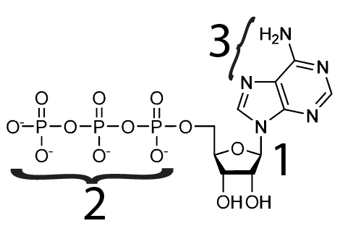 | 1.  2.  3.

Complete this key for the diagram of the ATP/ADP cycle below:
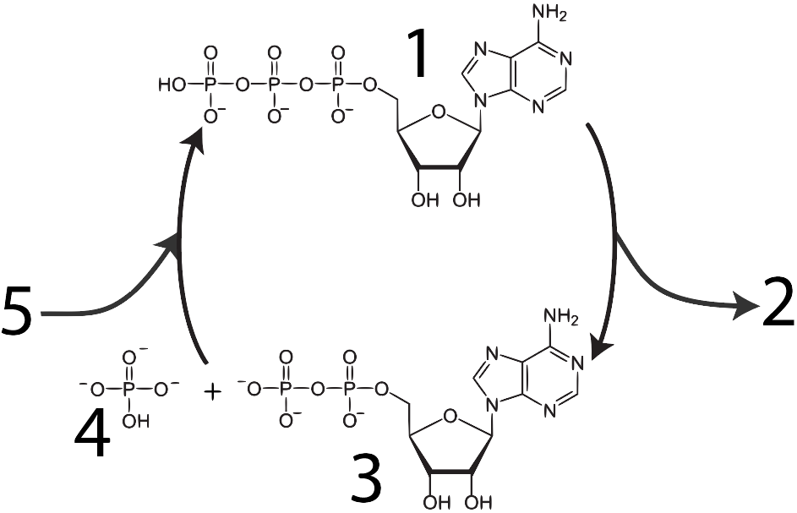 | 1.  2. Energy released for cellular work  3.
4.
5.
REFLECT: Write down three things you want to remember about ATP, ADP, and the cycle that connects them.

Click the link to continue to the “Cellar Respiration Overview.”
Tutorial 2: Cellular Respiration Overview
1. Read the introduction. Check the box below when you’re finished: ☐
Checking Understanding:
1. Why do you need to eat?

2. How efficient is cellular respiration?

2. Read “Where Cellular Respiration Happens: the cellular context: ☐
3. Read “Substrate Level Phosphorylation: ☐
Checking Understanding 1: Take the Cellular Respiration Overview Quiz 1: ☐
More Checking Understanding: Create a key to this diagram.
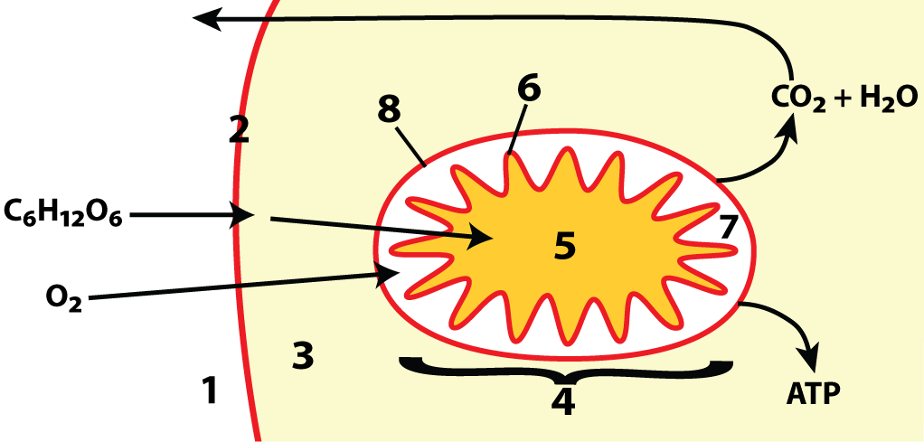
1 |  | 5
2 |  | 6
3 |  | 7
4 |  | 8
Now, create a key for this one
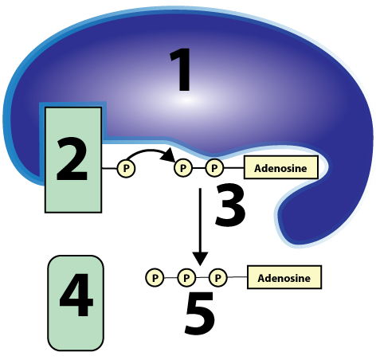 | 1 | ______________________
 | 2
 | 3
 | 4
 | 5
4. Read “Oxidation and reduction reactions…”
☐
Complete the flashcards: “The equation for cellular respiration.” ☐
1. Describe the differences between oxidized and reduced substances.

2. Without looking back at the page, write the formula for cellular respiration

5. Read “The oxidations and reductions in cellular respiration involve electron carriers.”
☐
Without looking at the web page (unless you need to) create a key for the diagram below.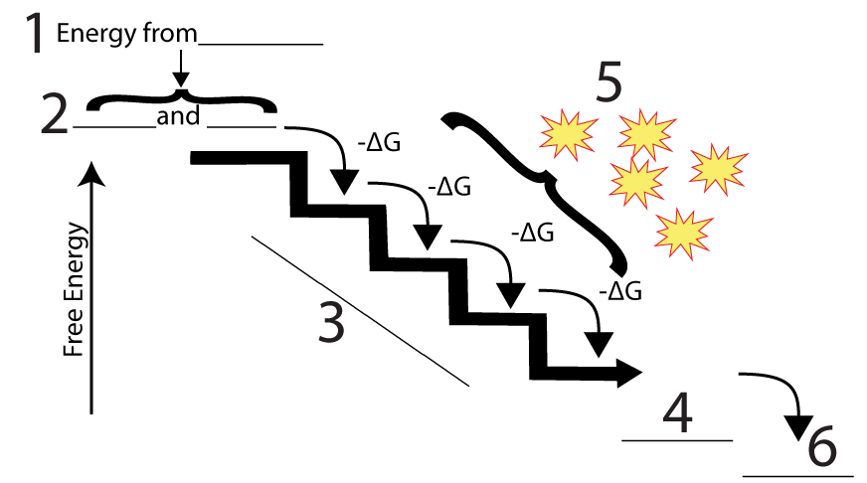
1
2
3
4
5
6
6. Read “Cellular Respiration Occurs in Four Phases.”
☐
7. Take the Quiz “Cellular Respiration Overview: Checking Understanding”
☐
We are just at the beginning of this process. For now, do your best to fill the space below with your current understanding of what happens during cellular respiration. Write small…

Click the link for “Glycolysis,” the next tutorial.
Tutorial 3: Glycolysis
1. Read the introduction, and complete the interactive table “Eight Things to Know about Glycolysis.” When you’re done, study the table for a minute. ☐
2. Read “Glycolysis: A bit more detail”☐
3. Take the “Glycolysis: Checking Understanding” Quiz.
From memory, list the three main phases of glycolysis, and briefly describe what happens during each:
 | Name | What happens
Phase 1
Phase 2
Phase 3
4. Read “The Gross and Net Yield of Glycolysis,” and complete the following table☐
Gross Yield | Net Yield
ATP:  NADH: | ATP:  NADH:
5. Read “What Happens After Glycolysis.” ☐
6. Take the “Glycolysis Fill-in-the-Blanks” Quiz. ☐
7. Complete the “Glycolysis Interactive Lyrics.” ☐
Pretend that in five minutes you’ll be called on to explain everything you know about glycolysis. You’re allowed to fill the space below with notes to help you answer. Fill the space below from memory, and then, as needed, flesh out your notes by referring to material above and on the web page.
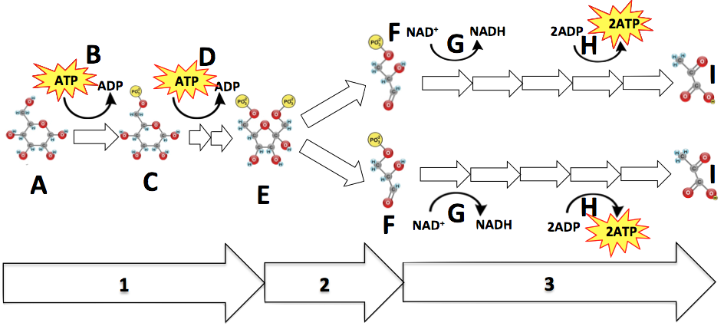

Click the link for “Krebs Cycle and the Link Reaction.”
Tutorial 4: The Krebs Cycle and the Link Reactions
1. Read the introduction:
☐
In terms of transforming food into forms of energy the cell can use, what are the two main “accomplishments” of the link reaction and the Krebs cycle?
First:
Second:

2. Read “The Link Reaction,” and take the “Link Reaction” Quiz. ☐
Create a key for the link reaction diagram below. 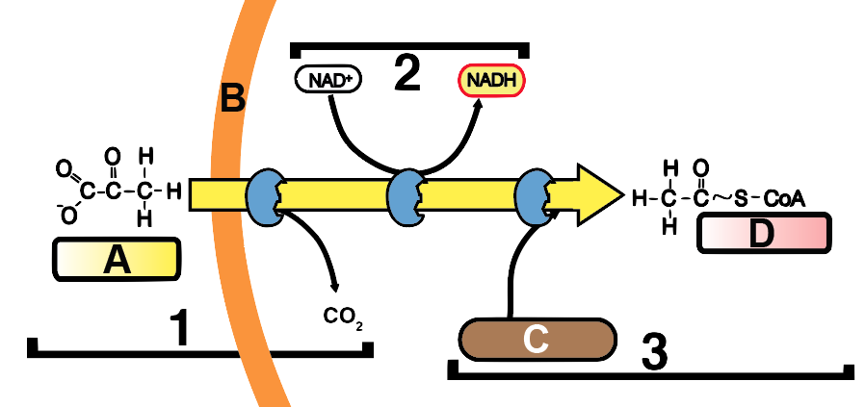
A
B
C
D
1
2
3

3. Read “The Krebs Cycle,” and take the “The Krebs Cycle” Quiz. ☐
4. Complete “The Products of the Krebs Cycle Interactive Diagram.” ☐
5. Complete “The Krebs and Link Reaction Fill in the Blanks Quiz.”☐
6. Complete “The Krebs Cycle Interactive Lyrics.” ☐
Checking understanding/reviewing
a. Think of Krebs as a system. What are this system’s
- Inputs:

- Useful outputs:
- Waste outputs:
b. Where does the Krebs cycle happen?

c. In addition to what’s above, what are two more big picture things to remember about the Krebs Cycle?

d. Working with the diagram. Study the diagram below, and then answer the questions that follow (answers are all numbers from the diagram).
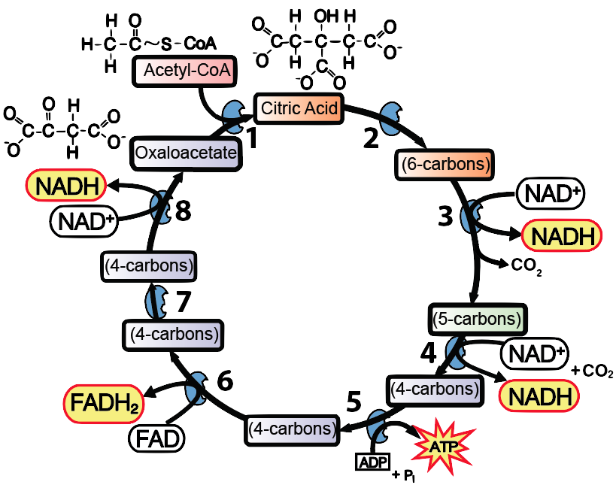
1. Where is reduced food energy entering the cycle?
2. Where are REDOX reactions occurring?
3. Where is carbon leaving the system?
4. Where is the starting compound being recreated?
Proceed to the “Electron transport Chain” tutorial.

Tutorial 5: The Electron Transport Chain
1. Read the introduction: ☐
Before we learn about this last stage of cellular respiration, write down everything you can about the diagram below. Write really small.
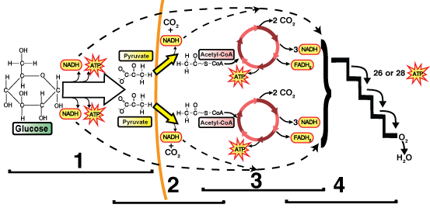

2. Take the “Mitochondria: Structure and Function” Quiz.
☐
3. Read “It starts with pumping protons.”
☐
4. Read “It Ends with Making ATP.”
☐
5. Take the “Electron Transport Chain” Quiz
☐
CHECKING UNDERSTANDING:
Create a key for the diagram below. Try to do this first without looking at the page, then use the page for reference as needed.
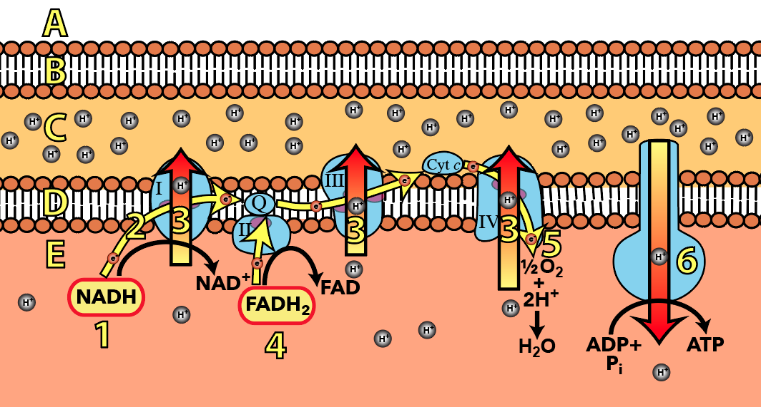

A
B
C
D
E
1
2
3
4
5
6

6. Complete the Interactive Lyrics for the “Electron Transport Chain Song.” ☐
7. Take the “Electron Transport Chain” Fill in the Blanks Quiz. ☐
CHECKING UNDERSTANDING:
Use the space in the next column above to explain the diagram below. Include where the NADH and FADH₂ came from; how their reduced electrons are used; where they go; and how their energy is used to make ATP.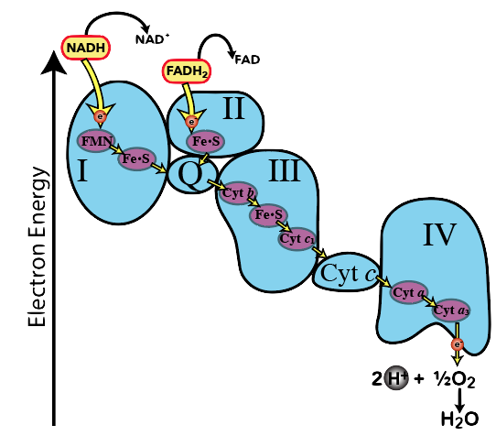

PULLING IT ALL TOGETHER:
Use the space below to explain how cells transfer the energy in a molecule of glucose into the energy of dozens of ATPs. If you need a visual cue, look back at the diagram of cellular respiration at the top of the previous page.

Tutorial 6: Anaerobic Respiration and Fermentation
1. Read the introduction: ☐
2. Read “Aerobic and Anaerobic respiration.”
☐
Summarize:
- How are aerobic and anaerobic respiration different?

- What does fermentation accomplish?

3. Read about alcohol fermentation.
☐
4. Read about lactic acid fermentation.
☐
5. Take the “Anaerobic Respiration and Fermentation Quiz”
☐
CHECKING UNDERSTANDING
a. Start by writing a few lines explaining this diagram
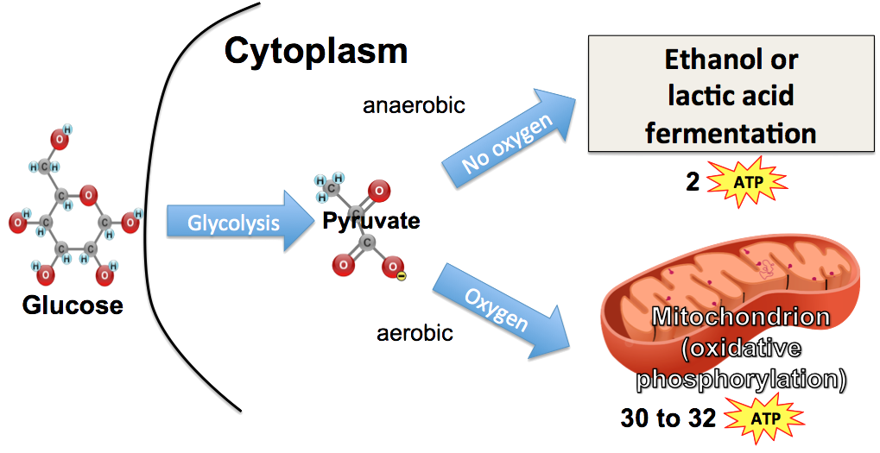

b. Now, make a key for this diagram:
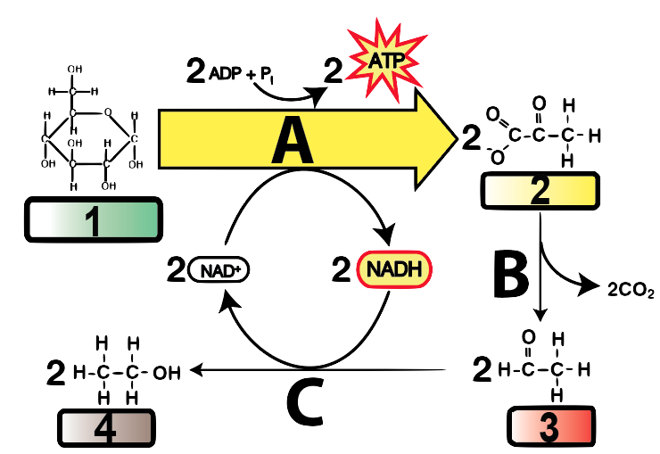
A
B
C
1
2
3
4

c. Now, make a key for this diagram:
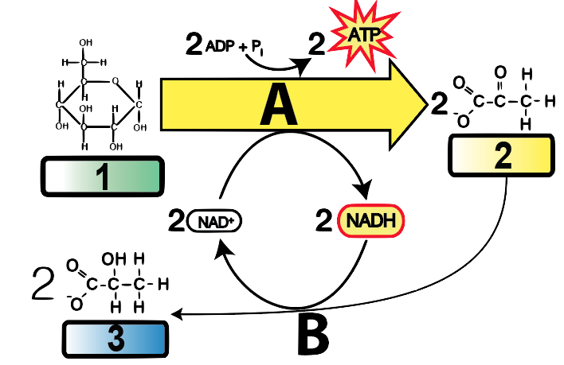
A
B
1
2
3

Biology | sciencemusicvideos | Name:________________________
Cellular Respiration Crossword # 1
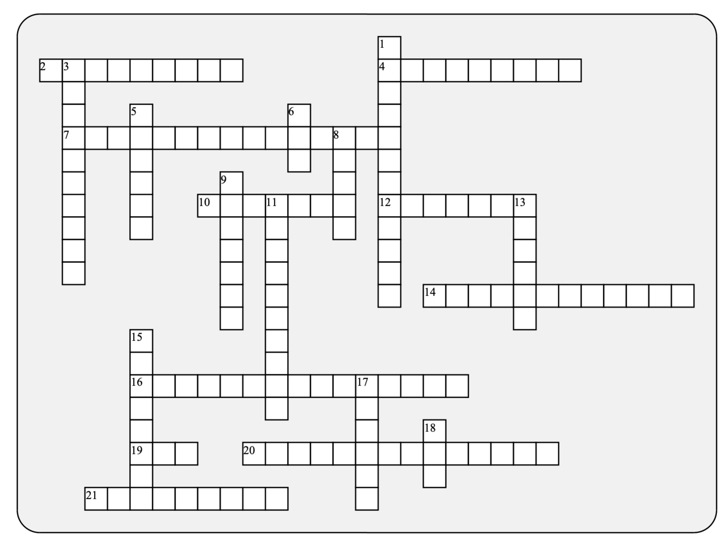

Across: | Down:
2 - How protons move from the intermembrane space to the matrix  4 - The inner membrane uses a flow of ________ to power proton pumps  7 - In the ETC, each electron carrier is more ________ that the one before it  10 - A six carbon molecule that's the starting point for glycolysis.  12 - requiring oxygen  14 - The special name for diffusion of protons through ATP synthase  16 - The gradient across the inner membrane  19 - The moment to moment energy currency of the cell  20 - A phosphorylated form of this molecule occurs after cleavage.  21 - The nitrogenous base in ATP | 1 - Happens when there's not enough oxygen and a cell needs to regenerate NAD+  3 - This phase of glycolysis costs two ATPs  5 - This two carbon group that's attached to a coenzyme is what enters Krebs  6 - This mobile electron carrier gets reduced during the Krebs cycle  8 - The membrane with all of the ETC machinery.  9 - Results from fermentation by yeast  11 - It's equation looks like respiration, but it occurs in one step, releasing a lot of light and heat  13 - A six carbon acidic compound formed at the start of the Krebs cycle  15 - When fructose 1-6 bisphosphate falls apart  17 - Where Krebs happens  18 - If ATP were a charged battery, this would be a dead one
Possible Answers :ADP, ATP, FAD, Investment, Matrix, acetyl, adenosine, aerobic, alcohol, chemiosmosis, citric, cleavage, combustion, diffusion, electrochemical, electronegative, electrons, fermentation, glucose, glyceraldehyde, inner

Biology | sciencemusicvideos | Name:________________________
Cellular Respiration Crossword # 2
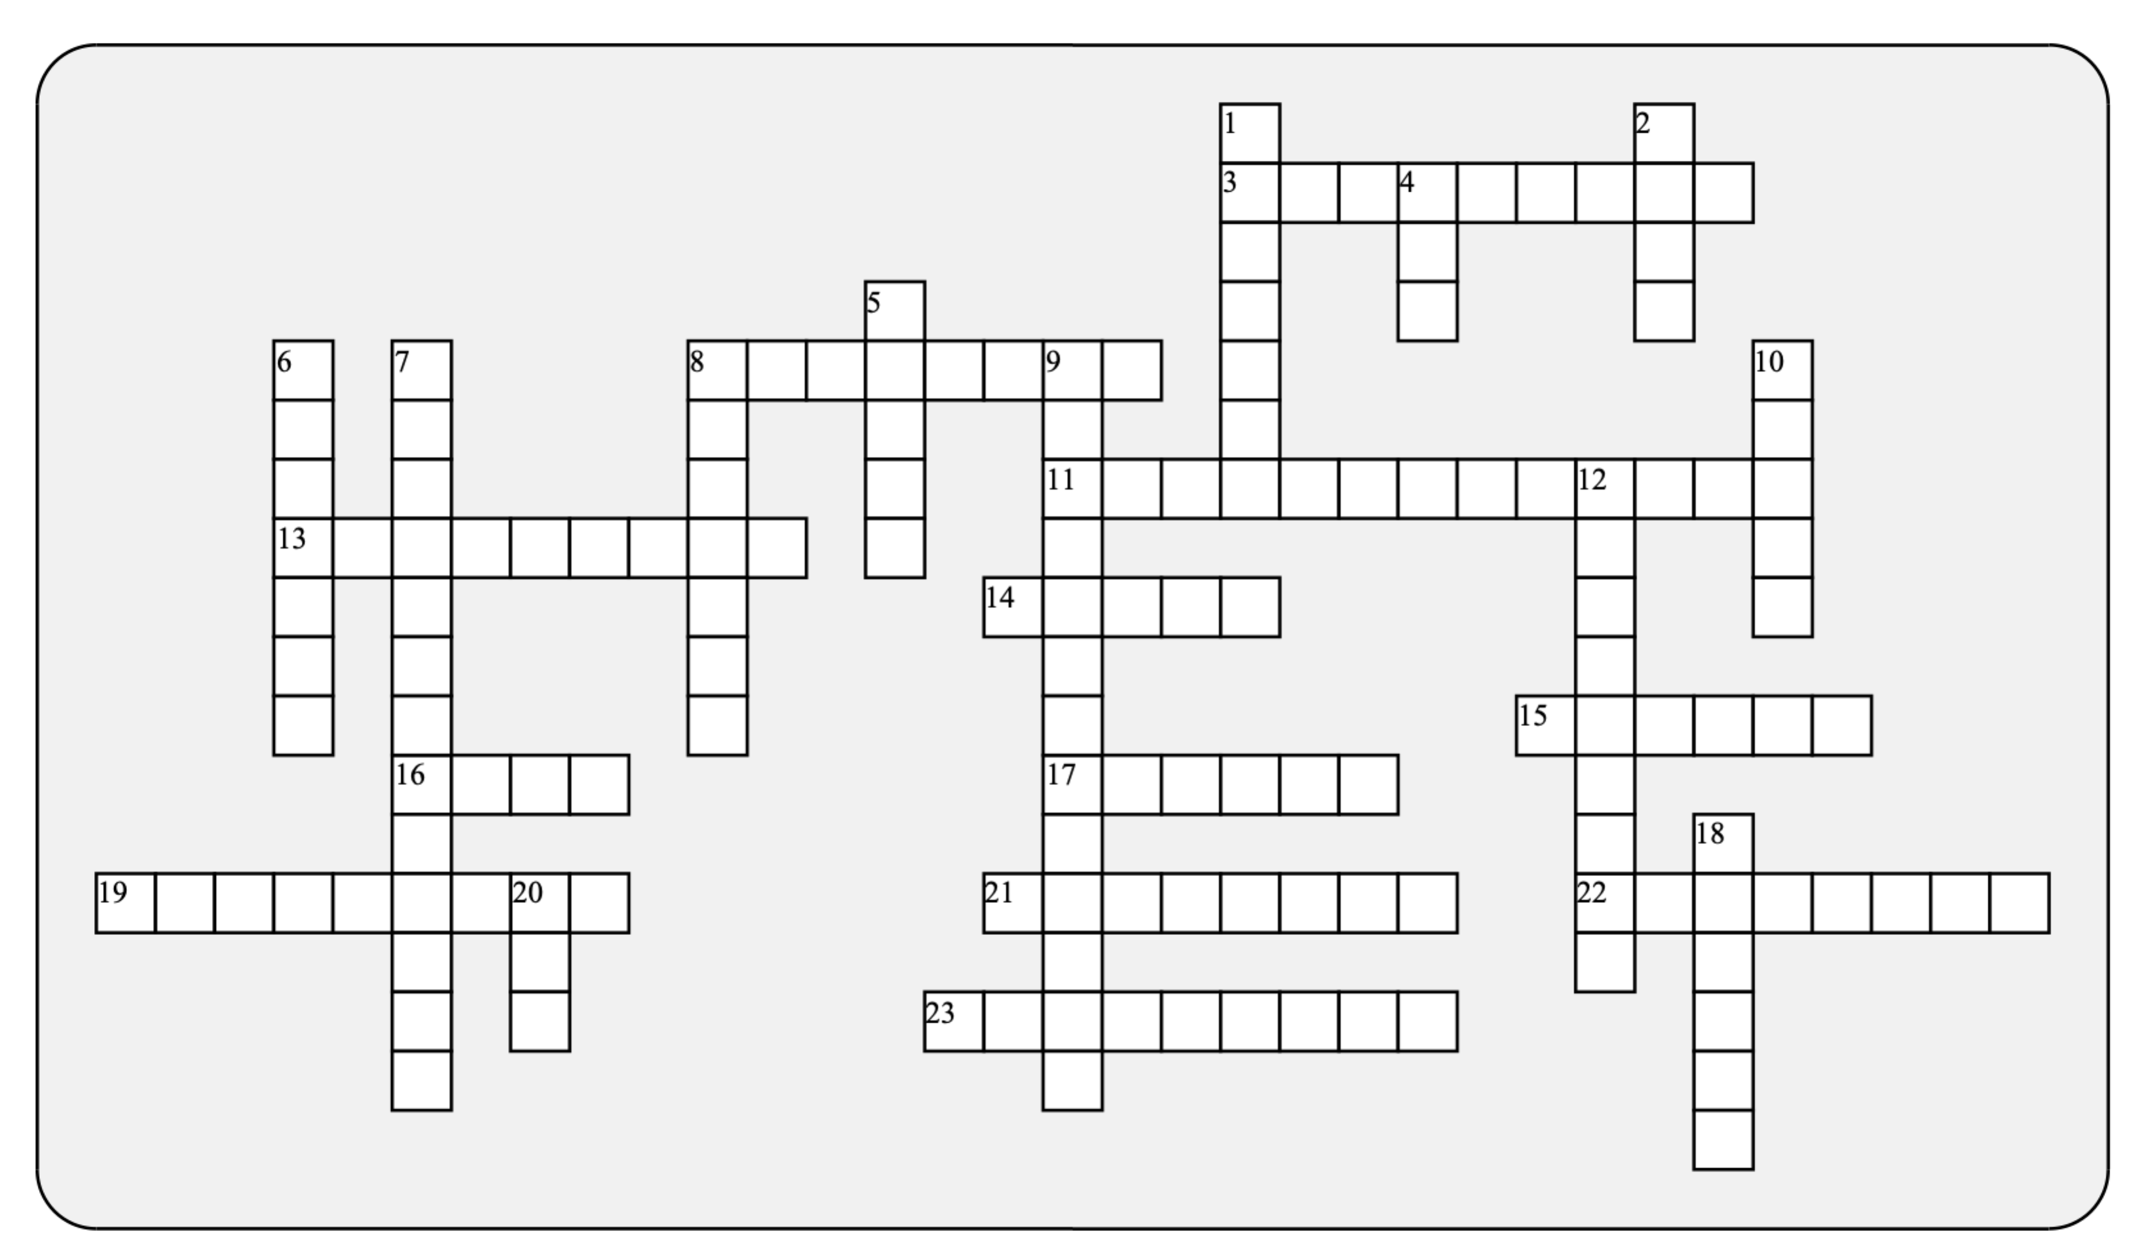

Across: | Down:
3 - The unsustainable kind of metabolism you do when you can't deliver enough oxygen to the muscles.  8 - The three carbon molecule at the end of glycolysis  11 - The space where protons get crammed together  13 - This functional group is widely used for energy transfer  14 - Results from the reduction of oxygen  15 - This kind of transport is required to get protons from the matrix to the intermembrane space.  16 - The reduced form of a key mobile electron carrier  17 - The final electron acceptor in the ETC  19 - ___________ level phosphorylations happen in glycolysis and krebs  21 - The enzyme/channel that makes ATP  22 - When NADH (or anything else) loses electrons, it's being  23 - The kind of phosphorylation that generates most of your ATP | 1 - The product of fermentation in muscle, or in milk-loving bacteria  2 - The reaction that brings pyruvate into the mitochondria and sets up Krebs  4 - For those who don't understand the wonders of the inner membrane, it only means "and so on."  5 - The mitochondrial membrane that touches the cytoplasm  6 - The ETC uses electron energy for doing this to protons  7 - An ATP-secreting endosymbiont  8 - Their accumulation makes ATP synthesis possible  9 - Another name for a the Citric Acid formed at the start of Krebs  10 - Each complete turn makes one ATP, 3 NADH, one FADH2  12 - What happens to NAD+, or FAD  18 - The sugar in ATP  20 - The net ATP yield of glycolysis
Possible Answers: ETC, NADH, Outer, Phosphate, Two, active, anaerobic, intermembrane, Krebs, lactate, link, mitochondrion, oxidative, oxidized, oxygen, protons, pumping, pyruvate, reduction, ribose, substrate, synthase, tricarboxylic, water

