Name: _____________________ Period: _____ Date: _________________

Nervous System, Student Learning Guide
Getting to the tutorials.
- Go to www.sciencemusicvideos.com; Use the College Bio, AP Bio, or Learning Guide Menus to find “The Nervous System”

Tutorial 1: Reflex Arcs
1. Read the Introduction. ☐
2. Read “Reflexes: What do you already know?” Then, respond to the prompt in the space below). Remember that you’re not expected to know the answer (that’s what this learning module is about), but you do know something.
Prompt: Discuss a) the biochemical and cellular mechanisms by which a sensory nerve cell transmits an impulse from your finger to your spinal cord, and b) how this message is transmitted to the motor nerve cell that controlled the reflex. | 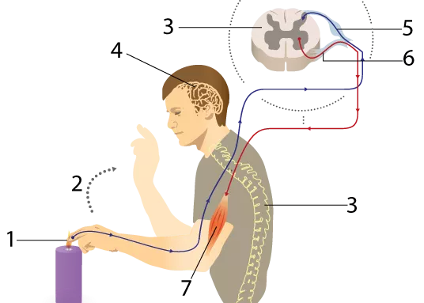

3. Read “The Nervous System: Some Basics,” and complete the “Major Nervous System Functions” quiz. ☐
Define/Describe the following terms or nervous system parts:
sensory neuron
interneuron
motor neuron
central nervous system
peripheral nervous system
integration
4. Read “Neurons, Synapses, and Reflex Arcs. ☐
5. Take the quiz “Reflexes, Checking Understanding.”☐
Make keys for each of the diagrams below. Don’t write on the diagram itself (because then you can’t study from it)
Diagram 1: a reflex arc
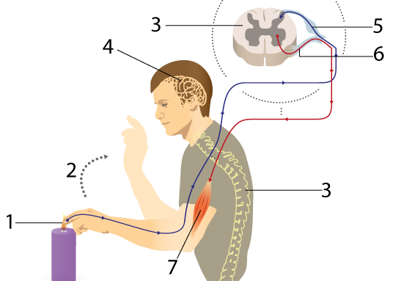

1
2
3
4
5
6.
7.
Diagram 2: Major Nervous System Divisions and Functions
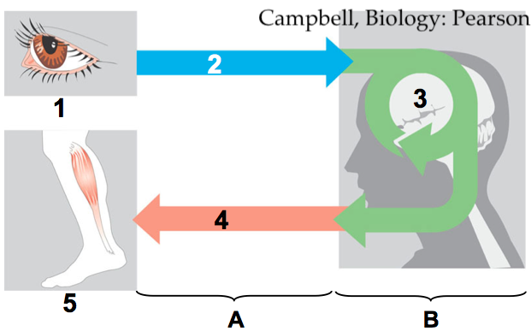
1
2
3
4
5
A.
B.

Diagram 3: A Synapse
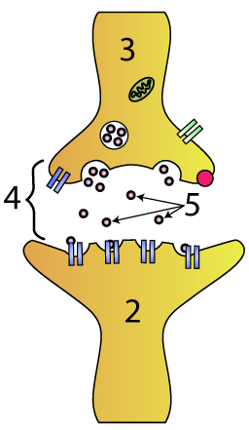 | 1.  2.  3.  4.  5.

Diagram 4: A neuron
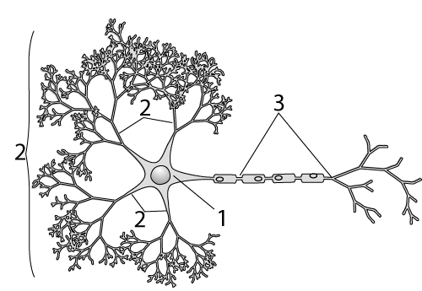 | 1.  2.  3.

Diagram 5: The Patellar reflex
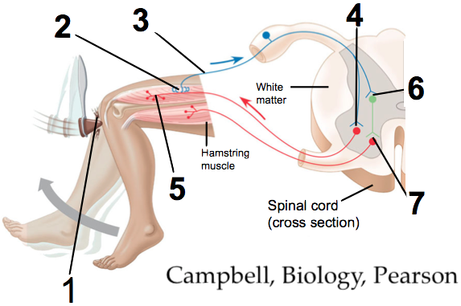
1.
2.
3.
4.
5.
6.
7.
Click the link to continue to Tutorial 2, How Neurons Conduct Nerve Impulses
Tutorial 2, How Neurons Conduct Nerve Impulses
1. Read the Introduction. ☐
2. Read “Nerve Impulses, the Big Picture. ☐
On a big picture level, what’s a nerve impulse?

3. Read the section entitled “Resting potential sets up the conditions...” As you do, you’ll complete an interactive reading, and take a quiz. ☐
Make a key for this diagram
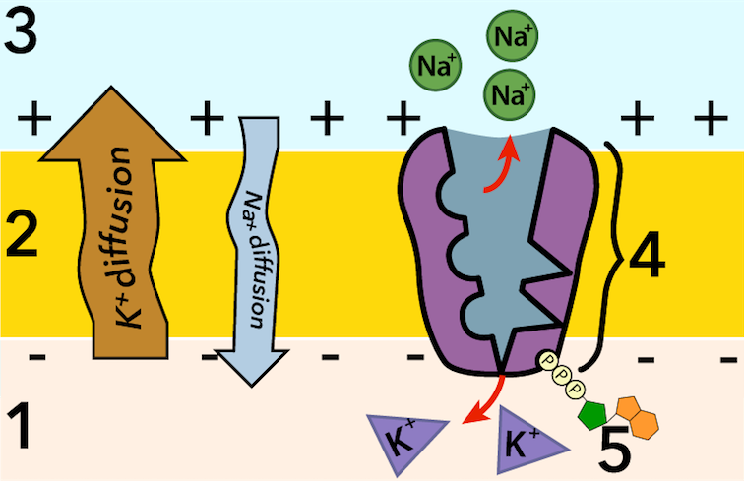 | 1.  2.  3.  4.  5.
And for this one:
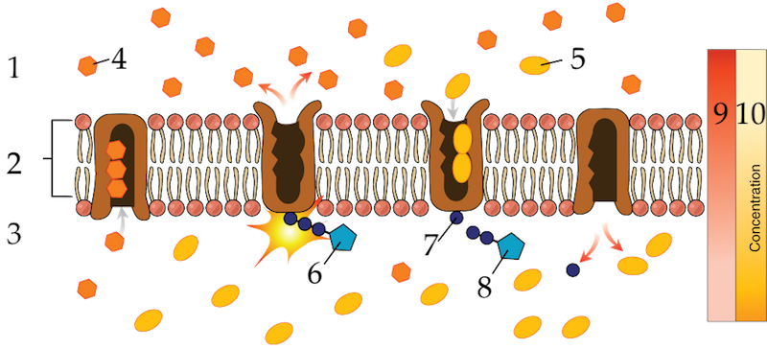
1.
2.
3.
4.
5.
6.
7.
8.
9.
10.
SUMMARIZE In the space below, write a short summary of what resting potential is, and how it works.

4. Read “Action Potential Overview.” ☐
5. Read “Gated Ion Channels.” ☐
Consolidate your learning:
- What’s an action potential?

- What’s a gated ion channel?

6. Read “Hyperpolarizations and Depolarizations.” ☐
Consolidate your learning: What’s the difference between an hyperpolarization and a depolarization?

7a. Read “Action potential the details.” As you read, take notes briefly describing what’s happening to the neuron membrane during...
resting potential
graded depolarization
rising phase of the action potential
falling phase of the action potential
Undershoot

7b. Take the “Action potential” Quiz.
Make a key for this diagram:
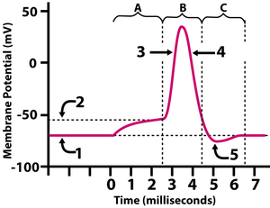 |  | 1.  2.  3.  4.  5.
A.
B.
C.
8. Read “Nerve Impulse Conduction” and complete the Nerve Impulse Propagation” interactive diagram.
Make a key for the diagram below.
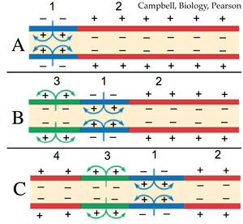 | 1.  2.  3.
Now, write a short explanation of how nerve impulses can move down the length of an axon.

8. Read “Saltatory Conduction ” and complete the “Saltatory Conduction” quiz
Make a key for the diagram below.
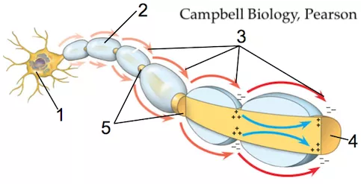 | 1.  2.
3.
4.
5.
In the space below, write a brief explanation of saltatory conduction.
Consolidate Your Learning
Explain how a nerve impulse gets from the tip of your finger (1) to your spinal cord (5). Your response should include an explanation of resting potential, action potential, how an action potential moves, and saltatory conduction.

Click the link to “Synapses and Summation.”

Tutorial 3: Synapses and Summation
1. Complete the interactive diagram that introduces this section. ☐
2. Read about synapses, and take “The Synapse” Quiz.” ☐
Label the diagram below.
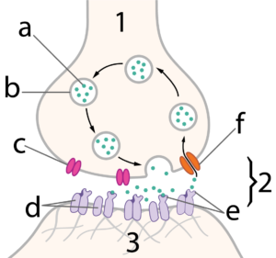 |  | a.  b.  c.  d.  e.  f.
1.
2.
3.

3. Read about summation. That includes completing the “Effects of Neurotransmitters” interactive diagram, and taking the “Summation Quiz.” ☐
Consolidate Your Learning
A. Define/describe all the processes listed in the table below.
summation
temporal summation
spatial summation
IPSP
EPSP
B. Write a short paragraph explaining how nerve impulses cross synapses.

Click the link to “Nervous System, Cumulative Assessment.”

Nervous System, Cumulative Assessment
1. Complete the multiple choice/fill in the blanks assessment. ☐
(please turn the page to complete the free response questions).
2. Answer the three free response questions. In each case, write out your own answer, check it against the answer that’s provided, and then go back and adjust your response as needed. Keep in mind that writing your own answer first is essential to your learning (and you won’t learn very much if you just copy the provided response”
A. Explain how a stimulus (such as a burning object) can generate an action potential. In your answer, 1) sketch an action potential, 2) fully describe what happens during an action potential (ending at the falling phase) and 3) explain how the membrane’s resting potential is restored.

b. Describe how an action potential can move down the length of an axon.

c. Explain how the message about the injury can be communicated from a sensory neuron to a motor neuron.

www.sciencemusicvideos.com | Name:________________________
Neurons and the Nervous System
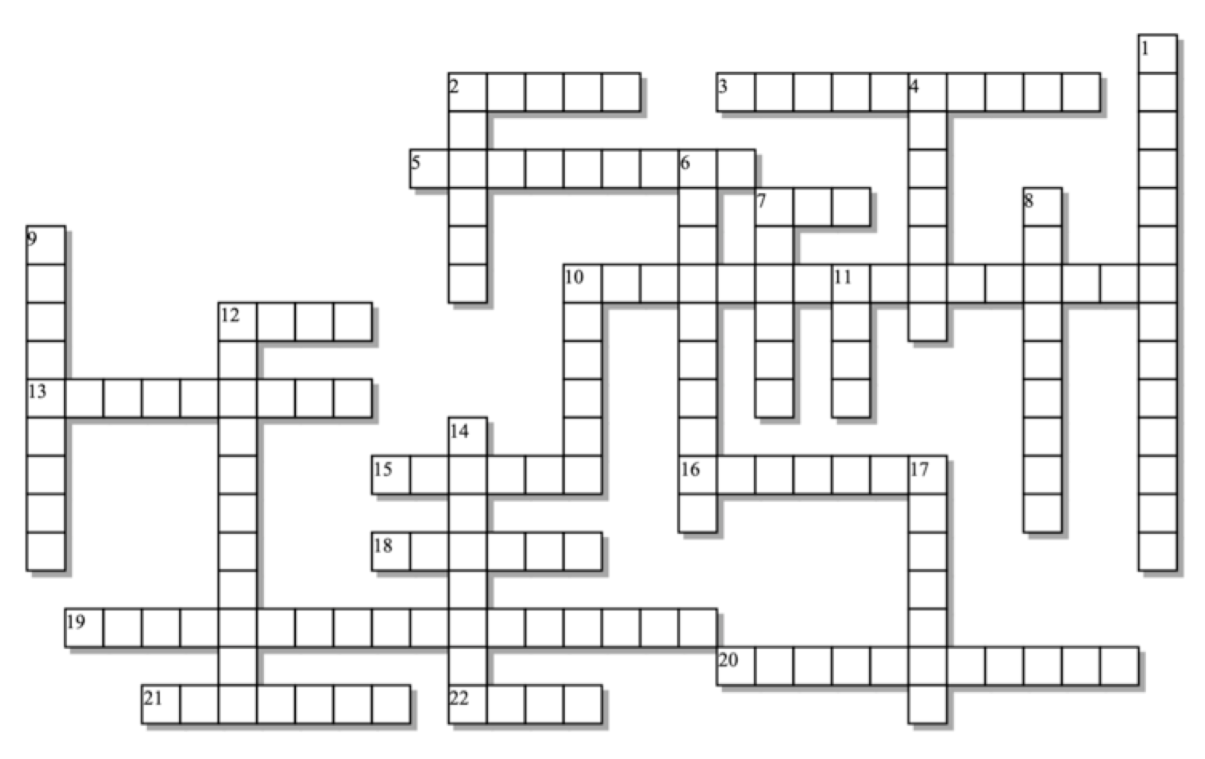

Across: | Down:
2 - _________ ion channels can open or close in response to changed conditions.  3 - The part of the action potential when the membrane becomes even more polarized than it was during resting potential.  5 - This kind of nerve impulse conduction jumps from node to node  7 - Powers the sodium-potassium pump.  10 - Released from the tip of an axon to stimulate the next neuron (or effector).  12 - Acronym for an impulse that opens potassium channels in a postsynaptic neuron.  13 - How a neuron adds up its inputs as it computes whether or not to fire.  15 - An insulating sheath created by the membranes of Schwann cells or oligodendrocytes.  16 - This node allows nerve impulses to jump, greatly increasing impulse speed.  18 - This ion is in higher concentration outside the neuron's membrane (compared to the inside).  19 - In a neuron is at rest, opening potassium gates causes a __________.  20 - The neuron before the synapse.  21 - The _________ nervous system consists of the brain and spinal cord.  22 - Acronym for an impulse that increases the chance that a postsynaptic neuron will generate an action potential. | 1 - Happens when sodium ions diffuse across the neuron's membrane.  2 - A slow, partial depolarization of the neuron's membrane is called a _________ depolarization.  4 - The gap between one neuron and the next one (or between a neuron and an effector).  6 - This period involves a few milliseconds during which the membrane cannot generate another action potential.  7 - An ________ potential involves a momentary reversal of membrane polarity.  8 - This ion is in lower concentration inside the neuron (compared to the outside).  9 - At about - 50 mV this is crossed, causing all sodium gates to open.  10 - A nerve cell  11 - Sends output from the cell body to an effector (or another neuron)  12 - The neuron in between a sensory neuron and a motor neuron.  14 - Brings input to the neuron's cell body.  17 - The neuron's __________ potential is about -70 millivolts
Possible Answers (try not to use this): ATP, Axon, EPSP, IPSP, Ranvier, Resting, action, central, dendrite, depolarization, gated, graded, hyperpolarization, interneuron, myelin, neuron, neurotransmitter, potassium, presynaptic, refractory, saltatory, sodium, summation, synapse, threshold, undershoot

