Name: _____________________ Period: _____ Date: _________________

Origin of Life, Student Learning Guide
Instructions:
1. Work in pairs (share a computer), because talking about the material below is going to deepen your understanding.
2. Go to www.sciencemusicvideos.com; Use the College Bio, AP Bio, or Learning Guide Menus to find “Origin of Life.” In the AP Bio curriculum, this is topic 7.13

Tutorial 1: Life, LUCA, and When Life Began
1. Read the Introduction: ☐
2. Complete the Interactive Reading: Life and LUCA: ☐
Respond to these questions. Remember that you’re just speculating, using preexisting knowledge from this course and other learning
a. What was the first living thing like?

b. When did life first arise?

c. How could life have arisen from non-living matter?

d. Where (on earth) did life first begin? Justify your response.

Checking Understanding
1. Describe NASA’s definition of life.

2. What was LUCA like? Briefly describe its characteristics.

1
2
3
4
5
6.
7.
8.
3. Read “When Did Life Begin?” ☐
3.1. What are the fossils of the earliest living things?
3.2. Use the diagram below to briefly describe how we know the age of ancient living things. Write your description to the right and below the diagram.
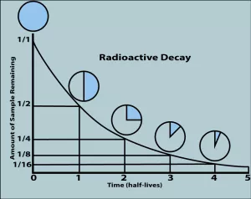

3.3. What is superposition, and how is it used in determining the age of a fossil?

3.4. The teams that have identified the fossils of the first living things used carbon isotope ratios as evidence for the microfossils having once been alive. Note that this is VERY different from radioactive dating. Explain.

3.5. What are Stromatolites, and how do they form?

4. Take the “Origin of Life, Part 1” Quiz☐
SUMMARIZE: When did life begin, and how do we know (write small)

Continue to “Early Earth, Key steps...”
Tutorial 2: Early Earth, Key steps in the Emergence of Life, Stanley Miller and the Primordial Soup
1. Read “Early Earth was Different from...” ☐
2. Take the quiz “Early Earth: Checking Understanding. ☐
SUMMARIZE: In the space below, describe how the early Earth was different from Earth today. Try to do this from memory. When you’re done, add to your notes as needed.

3. Read “Origin of Life, Key Steps,” and complete the interactive table. ☐
SUMMARIZE: From memory, try to recount the key steps for the emergence of life.

SPECULATE: Based on what you know, which of the steps would be most difficult. Justify your response.

4. Read “Abiotic Formation of Monomers...” ☐
5. Take the quiz about the Miller-Urey Experiment ☐
SUMMARIZE: What did Miller accomplish in his simulation?

Create a key to the parts of the Miller-Urey Experiment
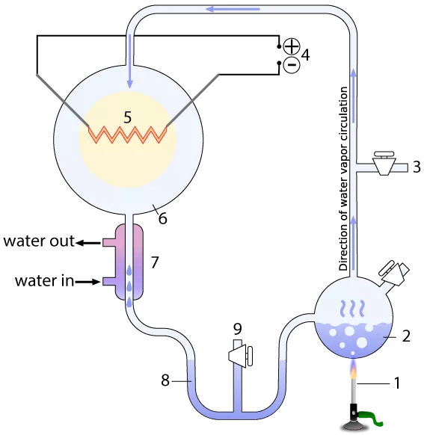
1.
2.
3.
4.
5.
6.
7.
8.

Continue to “Problematic Soup and Alkaline Hydrothermal...”
Tutorial 3: Problematic Soup and Alkaline Hydrothermal Vents
1. Read “After Making Monomers, Things get Harder...” ☐
In your own words, summarize the difficulties associated with
1a. Polymer formation

1b. Energy sources

2. Read “Darwin’s ‘Warm Little Pond’ and a few other...” ☐
3. Take the quiz: “Difficulties in Polymer Formation.” ☐
In your own words:
a. Summarize the difficulties with monomer buildup in a warm little pond.

b. Summarize the idea of directed panspermia.

c. Summarize the case for life originating on Mars, and how it would have arrived on Earth.

4. Read “Alkaline Hydrothermal Vents...” As you read, answer the following questions:
4a. Describe “black smoker” vents. How do they support life?

4b. Compare/contrast alkaline hydrothermal vents and black smoker vents in terms of each of the following:
- Location

- Internal structure

- Age

- Effluent (liquid released)

4c. Explain why ancient alkaline hydrothermal vents might have served as life’s hatchery. Specifically explain
- How were the oceans in Hadean/Archaean times different from the oceans today, and why was that important?
- List the key traits that would have made these vents so suitable for the emergence of life.

5. Watch the first three minutes of the “Origin of Life Video: Mike Russell and Bill Martin” ☐
6. Take the “Alkaline Hydrothermal Vents” Quiz.
SUMMARIZE
Pretend that you get home, and you’re asked: “What did you learn in school today.” Tell whomever asked, in some detail, what you learned about Stanley Miller’s experiment; about how life probably didn’t arise in warm little pond, and about how life may have arisen under the sea in an alkaline hydrothermal vent. Write small, but include lots of detail.

Continue to “The RNA World, and Making Cells...”
Tutorial 4: The RNA World, and Making Cells
1. Review the Steps in the Origin of Life Chart. ☐
2. Read “The Origins of Heredity: The RNA World,” and watch the video “What is the RNA World Hypothesis.” ☐
3. Take “The RNA World” Quiz. ☐
CHECKING UNDERSTANDING
Create a key for this diagram about the RNA World.
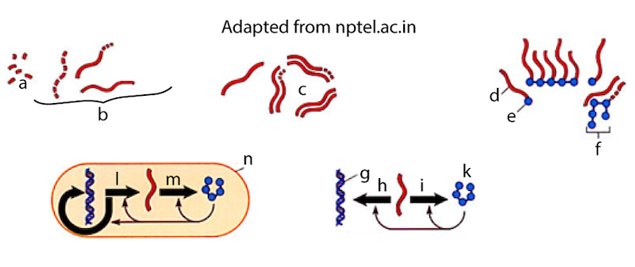
a.
b. | “Random RNA polymers”
c.
d.
e.
f. | protein
g.
h.
i.
j.
k.
l.
m.
n.
a. Write a few sentences comparing and contrasting RNA and DNA.

b. What are ribozymes, and what are some of the things they do in cells?

c. What is the RNA world hypothesis?

d. What are the strengths of the RNA world hypothesis, and what are its weaknesses?

4. Read the text and watch the video in the section entitled “Encapsulation: Forming Membranes and the First Cells.” ☐
5. Take the “Encapsulation, Forming Membranes” Quiz
CHECKING UNDERSTANDING
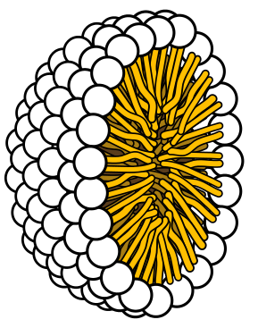 | 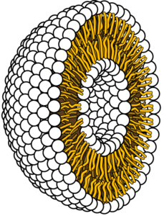
a. Label each of the structures above, and explain how they form.

b. How could fatty acids have formed abiotically?

5. Read “The Origins of Life’s Chemiosmotic Metabolism .” ☐
Checking Understanding
a. What’s chemiosmosis, and why is it so important?

b. Provide a context and an explanation for the image below. Where would it have been found? How would it have worked?
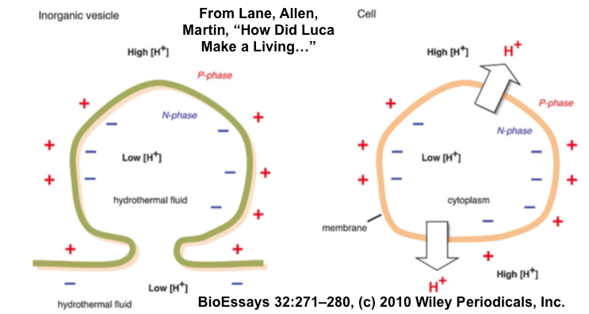

6. Read and watch “Returning to the Undersea Alkaline...”
7. Take the “Origins of Life, Cumulative” Quiz
CHECKING UNDERSTANDING:
a. Create a key to the diagram below.
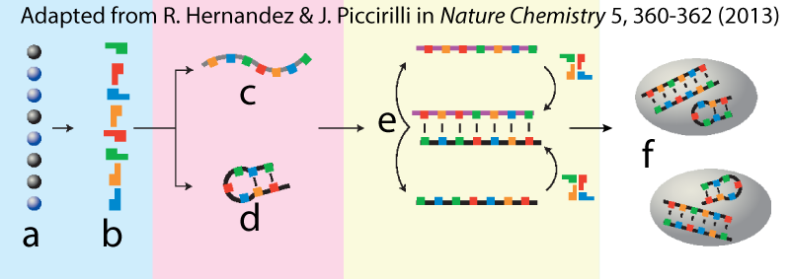
a.
b.
c.
d.
e.
f.

SUMMATIVE REFLECTION
Imagine this. Someone in another AP or college biology section finds a copy of this handout, and reads the quote below.
The last common ancestor of all life was not a free-living cell at all, but a porous rock riddled with bubbly iron-sulfur membranes that catalyzed primordial biochemical reactions. Powered by hydrogen and proton gradients, this natural flow reactor filled up with organic chemicals, giving rise to proto-life that eventually broke out as the first living cells – not once but twice, giving rise to the bacteria and the Archaea. (Nick Lane, The Cradle of Life: New Scientist, 17, October, 2009).
They say to you “This is the craziest thing I’ve ever heard! Life starting in a porous rock!!”
You coolly look them in the eye and say, “Well, nobody really knows how life started, but this is actually a reasonable hypothesis.” Explain it to them, in a lot of detail.

sciencemusicvideos.com | Name:________________________
Origin of Life
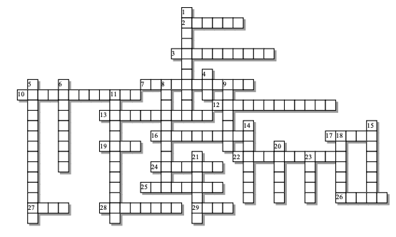

Across: | Down:
2 - A gas that wasn't in the early atmosphere  3 - The notion of directed __________ pushes the origin of life to another planet.  7 - The only type of rock that can contain fossils.  10 - How all life generates most of its ATP  12 - The fossil evidence for the first life is so small that these fossils have a special name.  13 - Early life had this type of cell (the kind found in both Archaea and bacteria)  16 - This is a soup that Oparin and Haldane hypothesized would have existed in earliest times.  17 - These acids probably were what the first membranes were made of.  19 - Some think that meteors from this planet could have seeded Earth with life  22 - The dating method by which we can determine the age of a fossil.  24 - Life started sometime before 3.5 ___________ years ago.  25 - Miller's experiment, and those that have followed, established that in the absence of life these building blocks of macromolecules could form.  26 - These building blocks of proteins were the primary product of the Miller-Urey experiment  27 - A metal which, when combined with sulfur, could have formed important early catalysts.  28 - Unlike today's atmosphere, the atmosphere used in the Miller experiment was a _______________ one.  29 - The ultimate great grandparent of us all. | 1 - The period of heavy _____________ would have made life at the early Earth's surface impossible.  4 - The best nucleic acid candidate for the original molecule of heredity.  5 - How life is powered in hydrothermal vents.  6 - Catalytic, enzyme-like RNAs.  8 - _____________ synthesis, which is how monomers become polymers, would have been difficult on the watery early Earth.  9 - Means "in the absence of life."  11 - Layered bacterial mats that can be found all the way back in Archaean times.  14 - Refers to the pH of the hydrothermal vents where life may have begun  15 - A gas that's emitted at alkaline hydrothermal vents.  18 - The domain with organisms whose membranes are NOT composed of phospholipids  20 - Life might have started as a ___________ rock filled with tiny cell-sized chambers.  21 - A ball of fatty acids, with the tails inside and the heads outside  23 - Because the moon was much closer, these were once much higher
Possible Answers: LUCA, Mars, RNA, abiotic, alkaline, amino, Archaea, billion, bombardment, chemiosmosis, chemosynthesis, dehydration, fatty, hydrogen, iron, micelle, microfossils, monomers, oxygen, panspermia, porous, primordial, prokaryotic, radiometric, reducing, ribozymes, sedimentary, stromatolites, tides

