Name: _____________________ Period: _____ Date: ________

sciencemusicvideos: Transcription and Translation
Getting to the tutorials
- Go to www.sciencemusicvideos.com; Use the College Bio, AP Bio, or Learning Guide Menus to find “Transcription and Translation”
- Start with “1. Transcription”

Tutorial 1: Transcription
1. Read the “Review: Transcription and Translation,” and complete the interactive diagram “DNA makes RNA makes Protein.” Check the box when you’re finished. ☐
2. Read “Three Types of RNA...” and take the “Tree Types of RNA…” Quiz ☐
CREATE A KEY FOR THE DIAGRAM BELOW
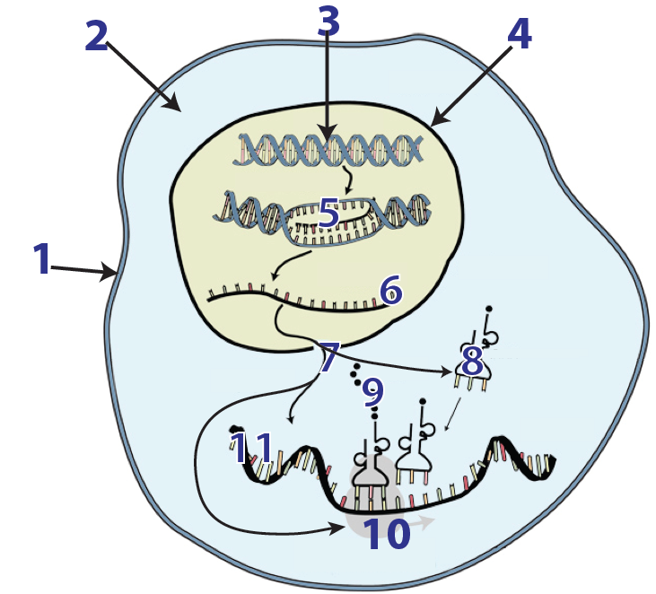 |  | 1
 |  | 2.
 |  | 3.
4
5
6
7
8
9
10
Describe the function(s) of
- mRNA

- tRNA

- rRNA

3. Read “RNA,” and complete all the exercises in this section ☐
4. Read “The Process of Transcription.” ☐
5. Take the quiz “Checking Understanding: Transcription.” ☐
6. Complete the flashcards “RNA and Transcription.” ☐
CHECKING UNDERSTANDING:
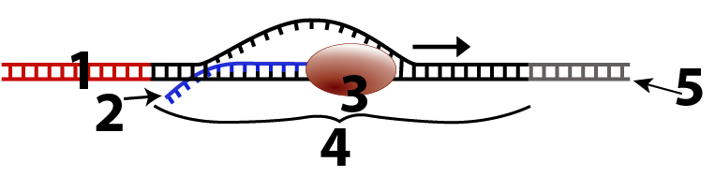
a. Create a key for the diagram above:
1
2
3
4
5

b. A friend says “I’ve never understood the difference between replication and transcription.” Explain it to them.

Click the link to “The Genetic Code, “ the next tutorial.

Tutorial 2: The Genetic Code
1. Read the Introduction: ☐
2. Take the “Coding Challenge.” Then read about what you did and why you did it. ☐
3. Read “Using a Genetic Code Dictionary.” ☐
4. Complete “Genetic Code Practice Problems 1: mRNA to Protein.” ☐
5. Complete “Genetic Code Practice Problems 2: DNA to Protein.” ☐
SUMMARIZE. On the top of the next page, explain how the genetic code works. In your explanation, include the terms codon, start codon, and stop codon.

Explanation of the genetic code:

Click the link to “Protein Synthesis Tutorial,“ which is the next tutorial in this series.
Tutorial 3: Protein Synthesis/Translation
1. Read the Introduction and complete the interactive diagram, “Transcription and translation.” ☐
2. Read “Making protein is the goal of translation.” ☐
3. Take the “Protein Chemistry Review Quiz.” ☐
SUMMARIZE:
Create a key to this diagram
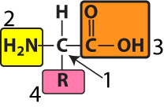 | 1.  2.  3.  4.
Now create a key for this diagram
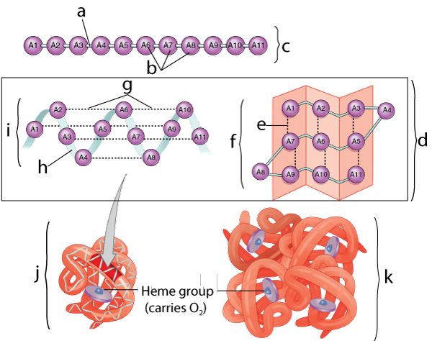
a.
b.
c.
d. secondary structure
e.
f.
g.
h.
i.
j.
k.
4. Read “Messenger RNA (mRNA) codes for proteins.” ☐
5. Read “Transfer RNAs…” ☐
6. Read “Ribosomes are general purpose protein factories” ☐
7. Read “An overview of translation” ☐
8. Watch “Protein Synthesis!” ☐
9. Complete the “Protein Synthesis!” Interactive Lyrics ☐
10. Complete the “Protein Synthesis/Translation” Flashcards ☐
11. Take the “Protein Synthesis/Translation” Quiz ☐
SUMMARIZE: Using the diagrams below, along with other necessary information you’ve learned, explain how protein synthesis works. Write small, and note that not all steps are shown. Part of your job is to fill in the gaps.
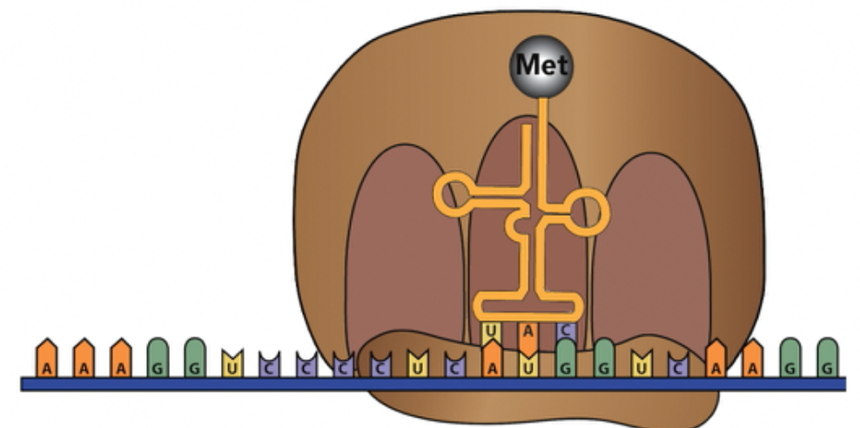
Initiation
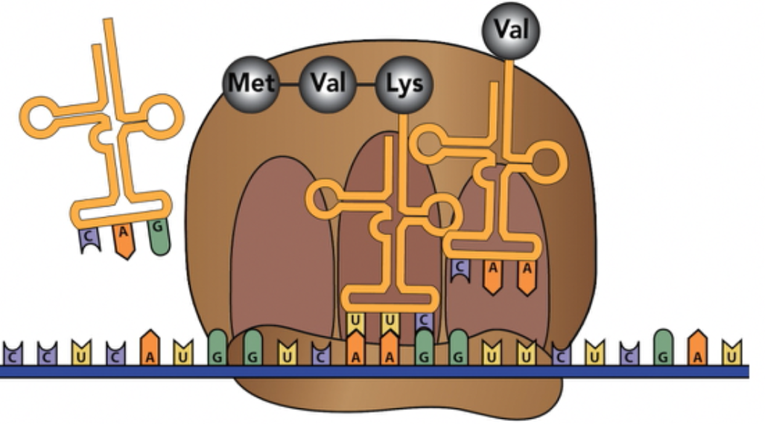
Elongation
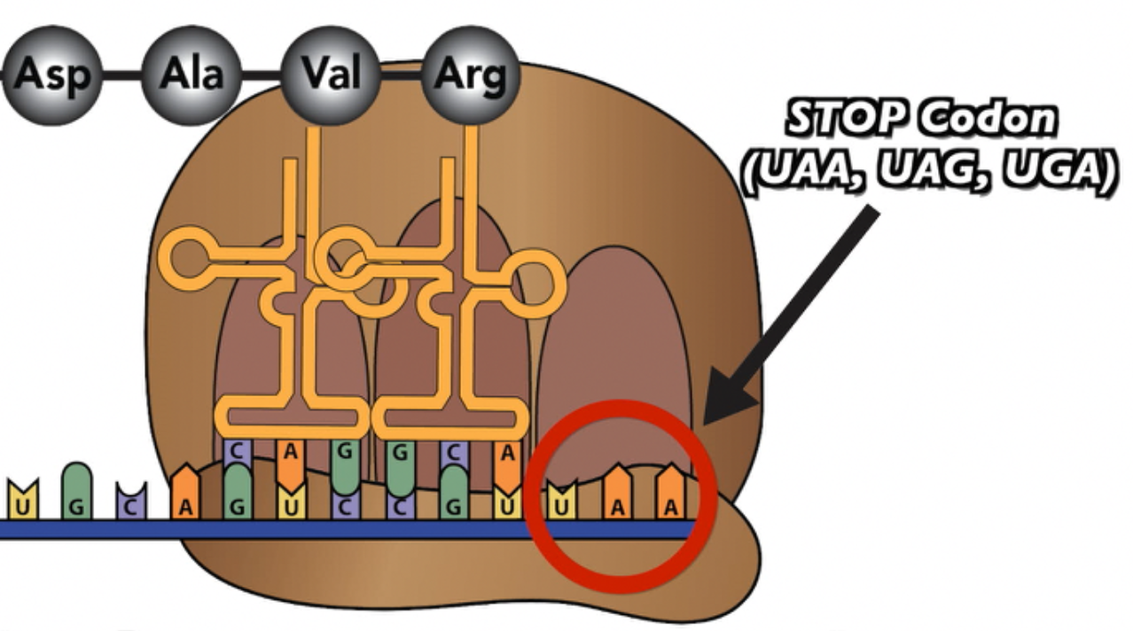
Termination 1
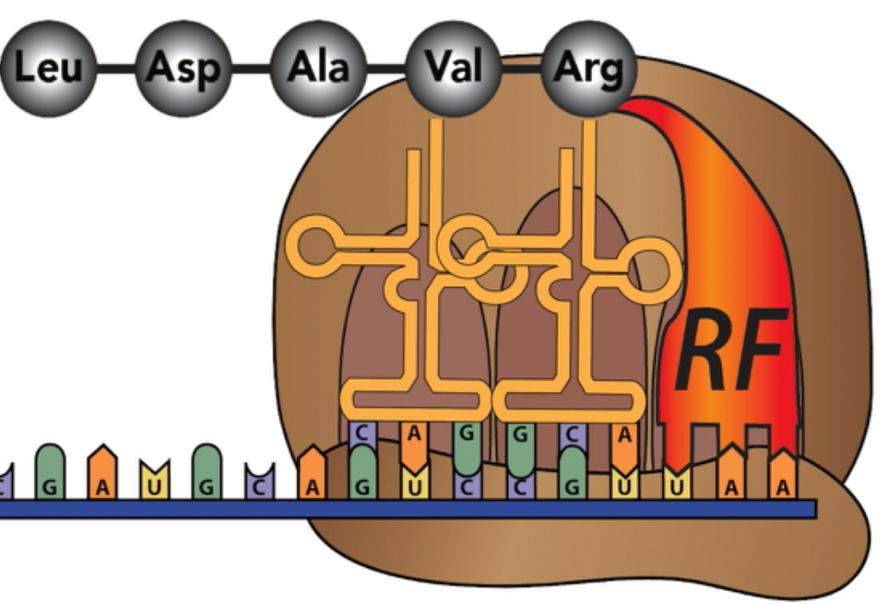
Termination 2

Click the link to “The Genetic Code,” the next tutorial.
Tutorial 4: How Proteins are Targeted to the Rough ER
1. Read the Introduction: “Free v. Bound Ribosomes,” and complete the “ER and Endomembrane System Review” Quiz. ☐
2. Read “How do proteins get made at the right ribosome…” SPECULATE: In the space below, speculate about a mechanism by which ribosomes that need to make their proteins at the rough ER find their way there.

3. Read the first part of “Protein targeting works through a signal polypeptide.” Then study the diagram, and write a short description of what you see happening.

Now continue by reading the text below the diagram

4. Take the “Protein Targeting” Quiz☐

Checking Understanding: Make a key to the diagram below
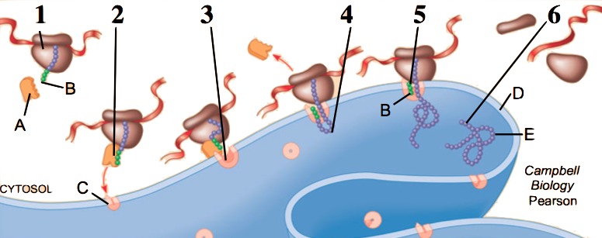

1
2
3
4
5
6
A
B
C
D
E
SYNTHESIZE YOUR LEARNING
Assume that the arrows next to number 8 show a protein that’s being exported from a cell. Beginning with mRNA leaving the nucleus, explain how this protein will be synthesized by a ribosome at the rough ER, and then make its way to the membrane, and finally out of the cell.
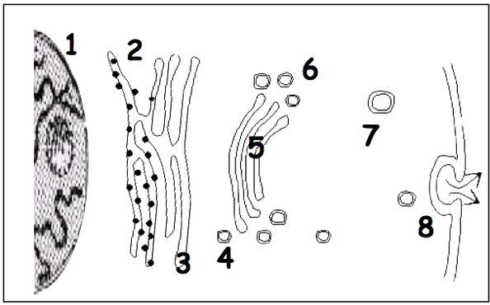
Include these content-related terms: (presented in alphabetical order: add other terms as needed) anti-codon, codon, elongation, exocytosis, Golgi apparatus, initiation, arge subunit, mRNA, release factor, ribosome, signal polypeptide, signal recognition particle, Small subunit, stop codon, termination, translocation complex, tRNA, vesicle.

Biology | sciencemusicvideos | Name:________________________
From Gene to Protein
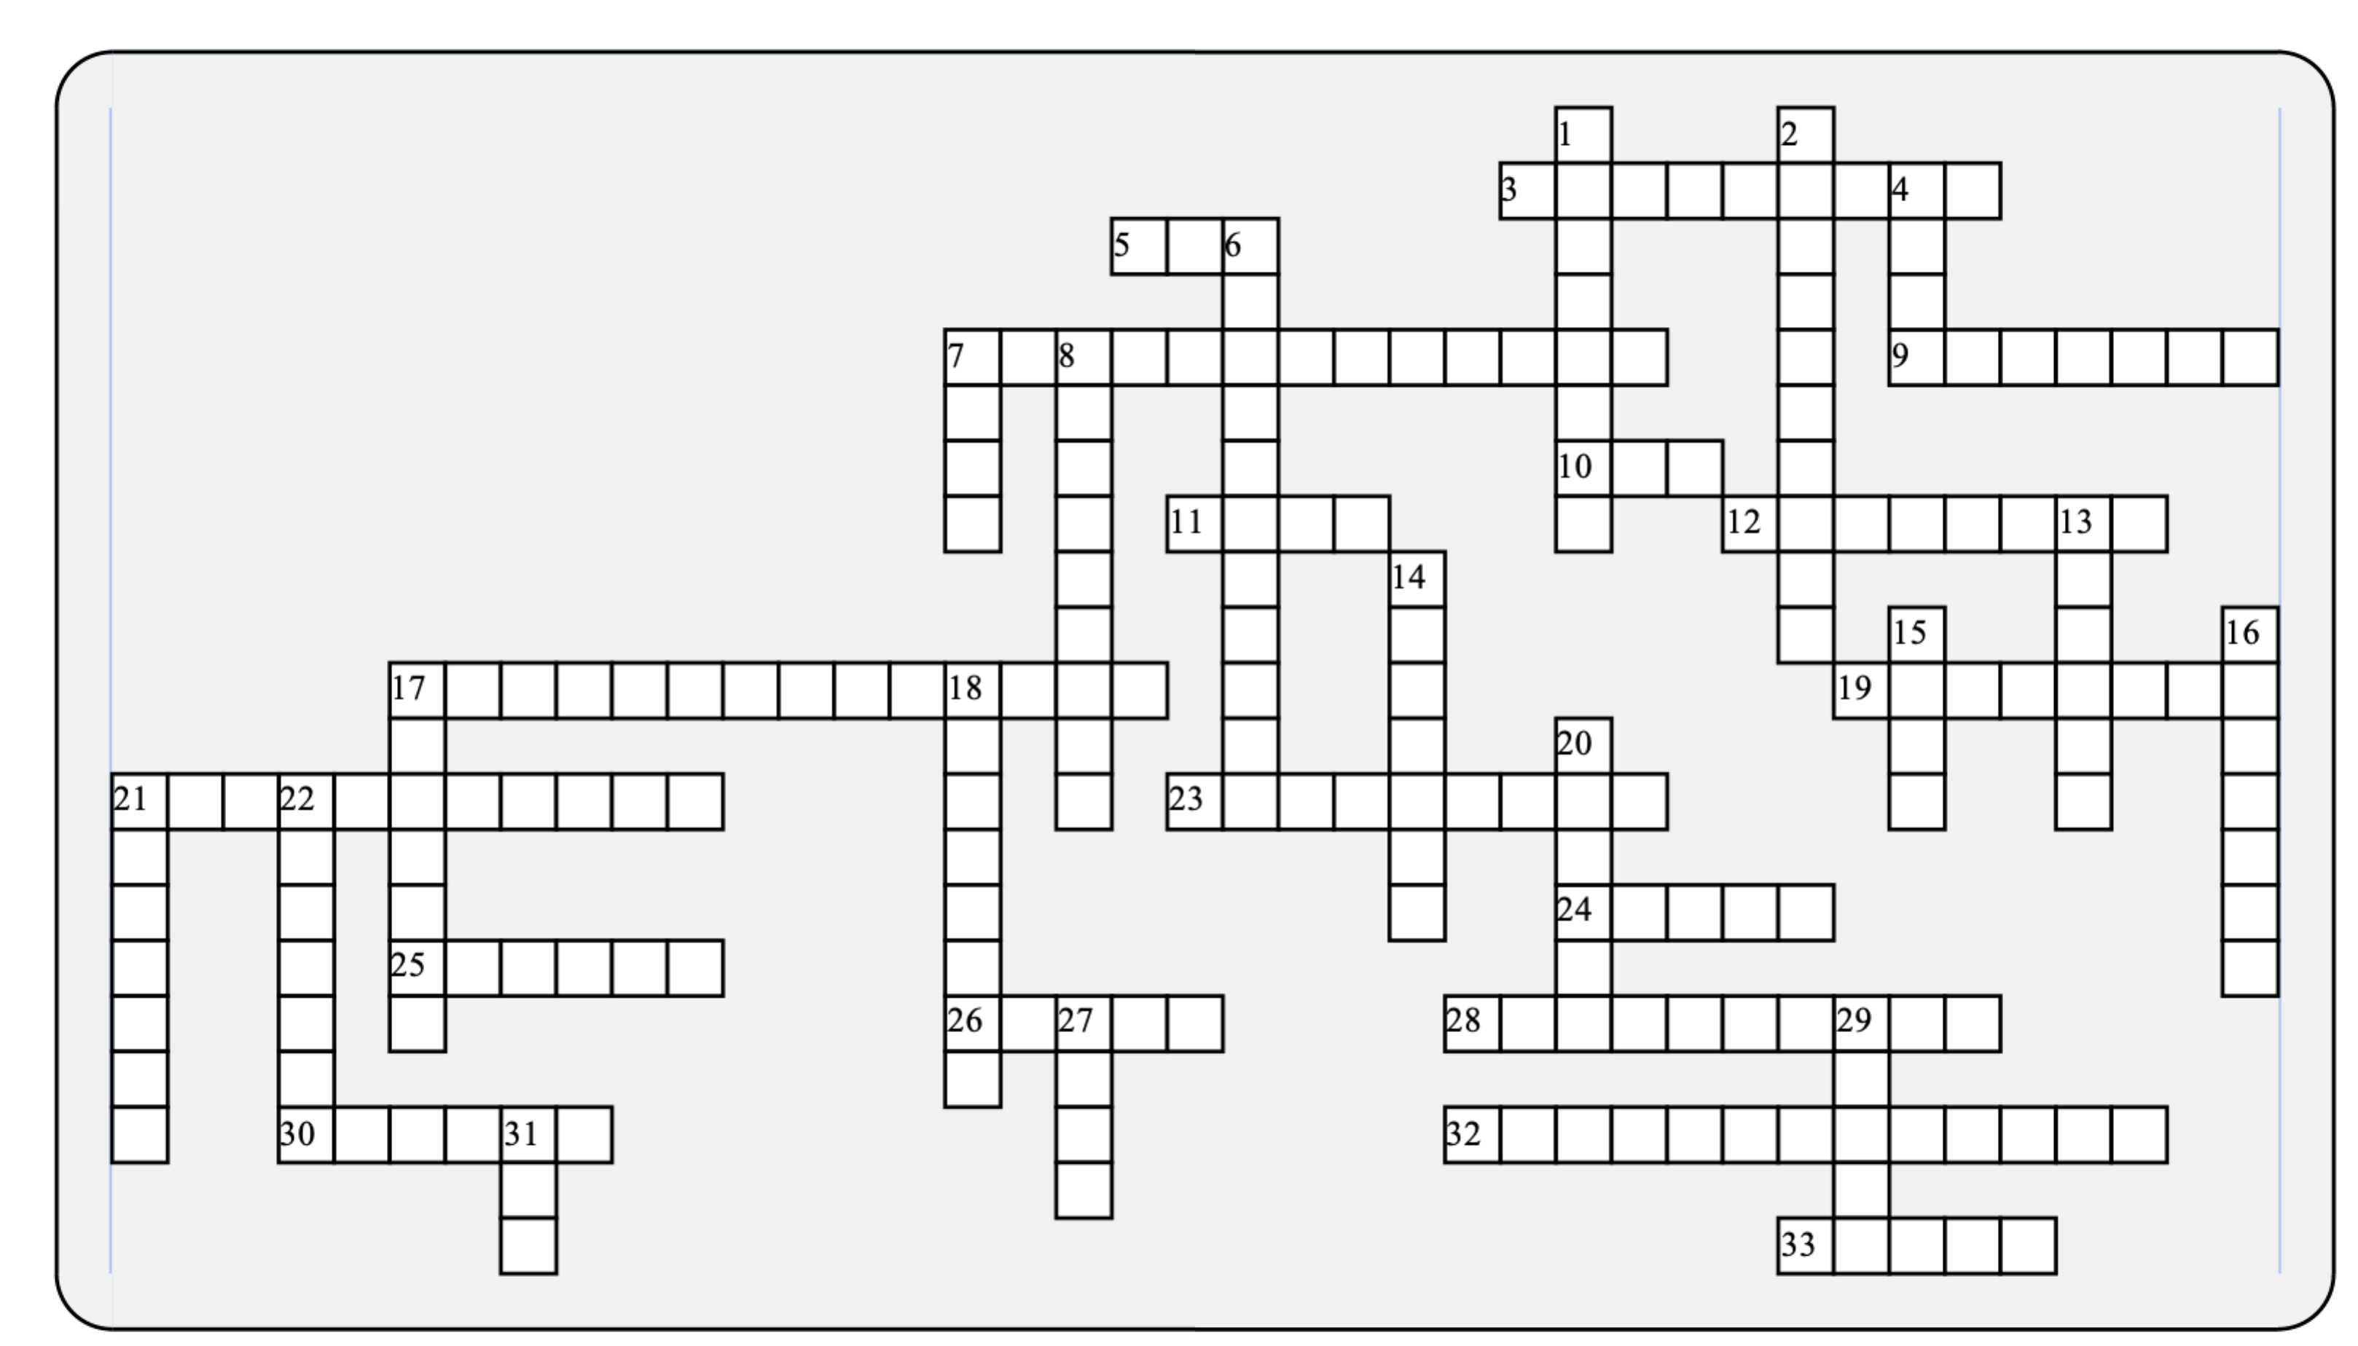

Across: | Down:
3 - Where free ribosomes are found.  5 - The particle that binds with a signal polypeptide.  7 - This complex enables ribosomes to bind with the ER.  9 - This type of bond is created by ribosomes as they bind amino acids together.  10 - The three binding sites on a ribosome, and a beleaguered government agency in 2017.  11 - A sequence of DNA that gets transcribed into RNA.  12 - The level of protein structure that results from interactions between side chains.  17 - The monomer of RNA.  19 - The spot on the DNA template where the RNA polymerase binds.  21 - Making protein from RNA.  23 - The level of protein structure that results from hydrogen bonds within a polypeptide chain.  24 - A sequence of three RNA bases that codes for one amino acid.  25 - Unlike DNA, RNA is a __________ stranded molecule.  26 - The number of nucleotides required to code for one amino acid.  28 - RNA _____________ is the key enzyme involved in transcription.  30 - Ribosomes that will be become bound synthesize a _________ polypeptide.  32 - Making RNA from DNA.  33 - Bound ribosomes create the __________ ER. | 1 - The bonds between an anticodon and a codon.  2 - Many representations of a tRNA molecule make it look somewhat like this lucky Irish plant.  4 - This type of codon codes for a release factor.  6 - A linear string of amino acids.  7 - Brings amino acids to the ribosome.  8 - The three letters on a tRNA that complement a codon.  13 - The sugar in RNA.  14 - The large __________ of the ribosome binds after the small one reaches the start codon.  15 - This RNA tells the ribosome what amino acids to stitch together, and in what order.  16 - The level of protein structure that is directly created by mRNA, ribosomes, and the rest of the protein synthesis system.  17 - The ________ factor is what binds with the stop codon.  18 - The _________ strand has DNA nucleotides that are complementary to the newly synthesized RNA molecules.  20 - In RNA, this nitrogenous base binds with adenine.  21 - This nitrogenous base is not found in RNA.  22 - Where transcription occurs in a eukaryote.  27 - Ribosomes are made of protein and _____.  29 - These acids are the monomers of proteins.  31 - The start codon.
Possible Answers: AUG, Amino, Anticodon, Cloverleaf, Codon, Cytoplasm, EPA, Hydrogen, Nucleus, Peptide, Polypeptide, Primary, Release, Rough, SRP, Secondary, Signal, Single, Stop, Subunit, Tertiary, Three, Transcription, Translation, Translocation, gene, mRNA, polymerase, promoter, rRNA, ribonucleotide, ribose, tRNA, template, thymine, uracil

